**A change in the system: implications of sheep production methods on lamb productivity**

**Application**: Hogget ewes may serve as a potential model for breeding sheep to increase productivity in farming systems through minimising the amount of time spent unproductive.

**Introduction**: Sheep are seasonal breeders, bred during the ovulatory period to lamb in spring. Breeding strategies include using sheep one-to-two years of age, known as hogget ewes or ewes, over two years of age to optimise reproductive efficiency. An essential part of the lambing season is the passive transfer of colostrum from ewe to lamb (Övet, 2023). Colostrum contains non-nutrient biologically active substances, such as the immunoglobin G (IgG), linked to the development of immunity, which can only be obtained through passive transfer to the lambs (Viola et al., 2022). Both the quality and quantity of colostrum produced impact the survival and weight gain of the lamb (Agenbag et al., 2021). Breeding hogget ewes within their first year can increase productivity and profitability for some production systems (Gaskins et al., 2005) by reducing the non-productive period (Kenyon and Corner-Thomas, 2022). The aim of the study was to investigate the productivity of lambs produced by hogget ewes versus ewes. This could influence farming parameters such as flock performance and economic sustainability.

**Materials** **and** **methods**: The study used New Zealand Romney’s (n=76), consisting of 41 ewes, all originating from the same flock, aged between 3 and 5 years old and 35 New Zealand Romney hogget ewes, aged 1 year. The study collected data in February 2023, with animals firstly being weighed using a Rappa weigh crate with TruTest M600 load bars and a TruTest XR5000 weigh head a month prior to the expected lambing date. After each birth, individual bonding pens were used to separate the ewe from her offspring to prevent lamb theft from occurring. Lambs were tagged with an electronic identification (EID) ear tag, and lambs were weighed. Approximately 60ml colostrum samples were collected three-to-six hours after birth before milk became present. The immunoglobulin content of colostrum was calculated by determining the specific gravity of the fresh colostrum sample using a Brix Refractometer. Lambs at four and eight weeks of age were weighed. Data was analysed using GenStat 22nd edition (VSNi) to examine the significance between age, IgG content of colostrum and daily average weight gain of lamb using a two-way T-test and a one-way ANOVA.

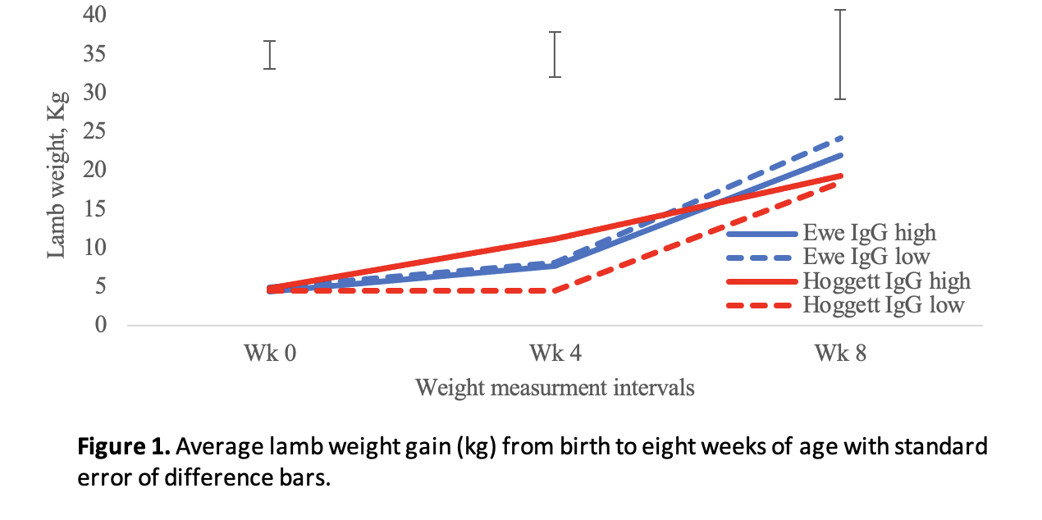**Results**: The prolificacy of ewes was greater, producing single lambs (n=12/84), twins (n=32/84), triplets (n=36/84) and quadruplets (n=4/84). In contrast, hogget ewes produced only single lambs (n=29/41) and twins (n=12/41). The IgG content of ewe colostrum (32.3 g/L) was higher (P < 0.01) than that of hogget ewe colostrum (23.7 g/L). Differences were shown in the trend of lamb weights collected in week four (Figure 2); hogget lambs had a greater average weight (10.6 Kg) than ewe lambs (7.9 Kg). Lambs born to hoggets with high IgG levels in colostrum maintained a constant weight gain up to eight weeks of age. Lambs born to hogget ewes with low IgG levels gained the least weight within the first four weeks; however, had an accelerated weight gain in the following four weeks. This was similar to the ewe lambs that also demonstrated an accelerated weight gain after week four. However, lambs born to ewes with low IgG levels weighed more at week eight than those born from high-level IgG.

**Conclusion**: Utilising New Zealand Romney hogget ewes showed a potential within production systems to produce a profitable system. However, does not provide the same prolificacy and thus is less efficient than ewes in this study flock. This study showed that colostrum IgG levels are not a primary influence on the weight gain of lambs; thus, other factors, such as age-related illnesses, may be present.

**References**: Agenbag, B., Swinbourne, A.M., Petrovski, K., van Wettere, W.H.E.J. (2021) Lambs need colostrum: A review. *Livestock Science*. 251, 104-624.

Gaskins, C.T., Snowder, G.D., Westman, M.K., Evans, M. (2005) Influence of body weight, age, and weight gain on fertility and prolificacy in four breeds of ewe lambs. *Journal of Animal Science*. 83, 1680–1689.

Kenyon, P.R., Corner-Thomas, R.A. (2022) Breeding Ewe Lambs: An Australasian Perspective. *Animals*. 12, 3207.

Övet, C. (2023) Colostrum induced passive immune transfer in lambs. *Journal of Istanbul Veterinary Sciences*. 7, 80–88.

Viola, I., Tizzani, P., Perona, G., Lussiana, C., Mimosi, A., Ponzio, P., Cornale, P. (2022) Hazelnut Skin in Ewes’ Diet: Effects on Colostrum Immunoglobulin G and Passive Transfer of Immunity to the Lambs. *Animals*. 12, 3220.