**MICROBIAL AND OOCYST COUNT IN FEACAL MATERIAL OF BROILER BIRDS ADMINISTERED PHYTOCHEMICALS (NARINGIN AND HESPERIDIN)**

**\*ADELEYE O.O1., T.M. OBUOTOR2, M.O. ABATAN1,O.A. DOSUMU3, A.O. KOLAWOLE2, AND R.A. AJADI4**

**1 Department of Animal Production and Health, Federal University of Agriculture, Abeokuta Ogun State, Nigeria.**

**2 Department of Microbiology, Federal University of Agriculture, Abeokuta Ogun State, Nigeria.**

**3 Department of Biochemistry, Federal University of Agriculture, Abeokuta Ogun State, Nigeria.**

**4 Department of Veterinary Medicine, Federal University of Agriculture, Abeokuta Ogun State, Nigeria.**

**\*Author for correspondence:** [**adeleyeoo@funaab.edu.ng**](mailto:adeleyeoo@funaab.edu.ng)

**ABSTRACT**

**APPLICATION**

The phytochemicals - Hesperidin and Narigin can be used as potential compounds in preventing coccidiosis as well as reduce microbial load in poultry in order to enhance growth performance.

**INTRODUCTION**

Avian coccidiosis affect poultry health and performance, leading to significant economic losses in many developing countries, including Nigeria. Due to the adverse side effects of antibiotics and vaccinations used to manage these diseases and the increasing demand for organic and healthy proteins from meat consumption, there is a need to explore alternative natural compounds. Hesperidin and naringin are flavonoids derived from citrus fruits. This study aims to investigate the preventive effects of hesperidin and/or naringin oncoccidiosis – induced toxicities as well its implication on microbial load in broilers.

**MATERIALS AND METHODS**

A total of 320 day – old broiler chicks were randomly divided into eight groups, with forty birds per group and in four replicates. Four groups were not inoculated with Eimeria oocysts but administered coccidiostat (T1A - D), hesperidin alone (T2A - D), naringin alone (T3A - D) and a combination of naringin and hesperidin (T4A – D) from day eight (8) to day fourteen (14) while four other groups (T5A – D to T8A – D) were inoculated with 2 x 104 oocysts per 0.5ml of *Eimeria* *tenella* on the 16th and 19th day of age after they were administered conventional antibiotics and coccidiostat, naringin (50mg/body weight), hesperidin (50mg/body weight) and a combination respectively from day 8 - 14. McMaster counting technique was used to count the oocysts while pour plate technique was used to determine the bacterial load.

**RESULTS**

The results as observed in figure 1 showed a steady increase in the growth performance of all the birds with an average weight ranging from 1.55kg ± 0.02 – 2.00kg ±0.04. The microbial load showed the presence of *Enterobacteriacae* in the population range of 3.5 x 104 - 4.5 x 104CFU/ml. The study also found that the administration of naringin and hesperidin to broiler birds inoculated with coccidia oocysts significantly reduced the feacal oocyst counts, with the lowest count in combined treatment (T8) (10%) and indicating a lower degree of coccidiosis infection in the treated groups whereas control group (T5) had the highest oocyst count (35%). Mortality and Morbidity rate was 0% as none of the bird showed signs and symptoms.

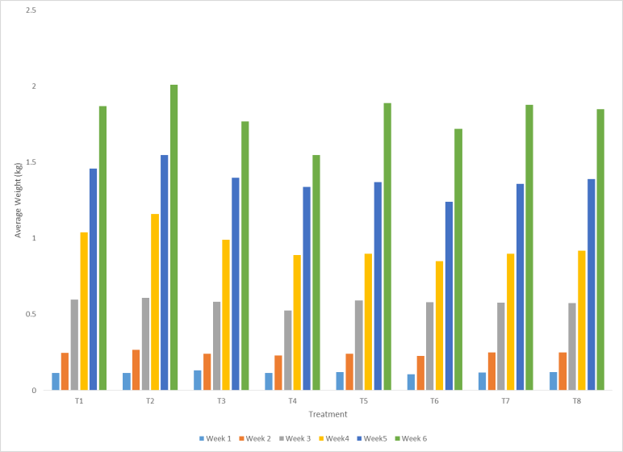

Figure 1: Average weight of broiler birds in different treatment groups for six weeks of treatment

Key: T1 = Control (uninfected) T2 = Hesperidin (uninfected) T3 = Narigin only (uninfected) T4 Narigin and Hesperidin(uninfected) T5 = Control (infected) T6 = Hesperidin(infected) T7 = Narigin (infected) T8= Narigin and Hesperidin(infected)

**CONCLUSION**

The result of this study showed a promising approach in poultry which would improve the organic production of antibiotic-free chickens and reduce the excretion of antibiotic residues into the environment, thereby improving environmental sustainability. The reduction in oocyst counts could help to strengthen the immune system of broiler birds and limit the severity of coccidiosis infection which could be an effective strategy for improving performance, immune function, and mitigating the impact of coccidiosis infection in broiler birds.