**Cow time budget: a novel method of data collation to support analysis of individual cow performance under pasture-based robotic milking systems**

**Application:** A high degree of inter-animal variability in cow performance while grazing often encourages adopters of robotic milking systems to confine their animals indoors throughout the year. This study proposes a new data collation method to identify the drivers of such variability, with a higher-level aim of facilitating the industry transformation to more pasture-based systems in the future.

**Introduction:** Automatic milking robots (AMR) are increasingly becoming integrated into pasture-based dairy systems in recent years to improve labour productivity. However, animal performance under a pasture-based AMR system is often lower than a housed AMR system, for which the technology was originally developed (Lyons et al., 2014). In Northern Ireland, where ~92% of farmed land area is grassland, recent research has also shown that grazed cows, on average, experience lower milk yields, milking frequency and number of non-milking visits to AMR (‘refusals’) than their housed counterparts. Nonetheless, some cows adapted better to a pasture-based AMR system and indeed outperformed most housed cows, thereby displaying a strong potential to effectively combine the AMR technology with rich grassland resources locally available (Rutherford et al, 2024). To facilitate this transformation requires a better understanding of the drivers behind the inter-animal variability in cow performance under grazing and, ultimately, identification of optimal intervention strategies to minimise such variability. As a first step towards this goal, the present study developed a novel method of data collation to elucidate the high-resolution (minute by minute) time budget allocation between activities by individual cows milked by AMR.

**Materials and methods:** The experiment was conducted at Agri-Food & Biosciences Institute, Hillsborough, over a 83-day period in the summer of 2020. Twenty-four (24) Holstein-Friesian cows were given daytime access to pasture and 24-hour access to AMR. The animals were subject to two-way grazing on a 21-day rotation, with access to block A from 04:00 to 12:00 and access to block B from 12:00 to 20:00. To mirror the typical land constraint faced by a local dairy farm (insufficient pasture for the ongoing stocking rate), all animals were kept indoors overnight. Cows had 24-hour access to the housing (i.e. an option *not* to be grazing during daytime) and total mixed ration (TMR) therein. Cow activities were continuously monitored through three data sources: (i) milking behaviour using AMR (Lely Astronaut, Lely, The Netherlands); (ii) grazing time and duration using gate sensors (Lely Grazeway, Lely, The Netherlands); and (iii) TMR intake using feedboxes (Feed Intake Controlling & Recording System, Bio-Control, Norway). Following the experiment, the three datasets were programmatically combined using R version 4.3.0 to create a complete time budget (24-hour behaviour diary) for each cow. These integrated data were further linked to the farm management database so that cows' grazing patterns could be compared against animal-level profitability.

**Results:** The final dataset thus compiled consisted of ~60,000 activity records (across 24 cows and 83 days), including milking, refusals, grazing, TMR visits, transition periods from one activity to the next, and time spent indoors but outside AMR/TMR (e.g. resting and ruminating). While the full data analysis is beyond the scope of the present study, a case study using the cow which recorded the lowest margin over feed costs (MOFC) is provided here to illustrate the potential value the final dataset. The cow (#352) had a mean daily milk yield of 22.3L and MOFC of £4.60. Two random dates within the same lactation stage were chosen for detailed examination: 15th and 20th August 2020. Milk yields on these dates were 26.7L and 22.5L, respectively. Figure 1 depicts the total daily time this cow spent on various activities on the two dates. A notable difference in grazing time was observed, particularly in the afternoon. In contrast, the percentages of time spent milking and consuming TMR were similar on both days. Further insights into these differences are provided in Figure 2, which summarises the chronological patterns in cow behaviour. On both days, the cow exhibited a consistent pattern of successful milking sessions. However, on the low-yield day (20th August), there was a notable reduction in afternoon grazing time and fewer TMR visits, accompanied by an increase in multiple refusals. These non-milking visits occurred during periods when the cow might otherwise have been grazing. By contrast, the cow spent more time outdoors on the high-yield day (15th August).

**Conclusions:** Maximising pasture utilisation is essential to for grassland-dominated regions to capitalise on their comparative advantage. It is hoped that the methodology developed herein will help identify key efficiency barriers in pasture-based AMR systems and provide opportunities for dual optimisation of feed and labour inputs. The initial case study seems to indicate the importance of time spent grazing, both in the morning and in the afternoon.

**References:**

Lyons, N.A., Kerrisk, K.L., & Garcia, S.C. (2014). *Livestock Science*, 159: 102-116.

Rutherford, N., Huson, K., McConnell, D., & Takahashi, T. (2024) *Animal – Science Proceedings* 15: 126-127**.**

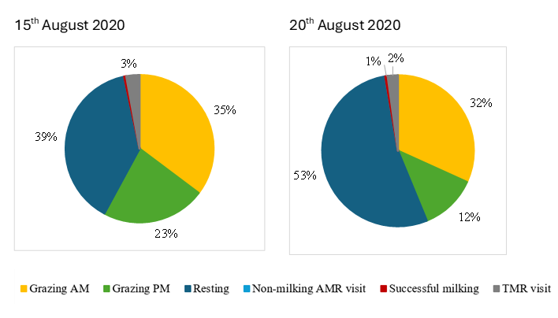**Figure 1**: Examples of daily time budget (cow #352, 15th/20th August 2020).

**Figure 2**: Examples of daily timeline (cow #352, 15th/20th August 2020).

