# **Needle-free intradermal vaccination, an opportunity to improve commercial pig welfare.**

***Application:*** Promoting high quality animal welfare for UK commercial pigs, using a needle free vaccinationdevice.

***Introduction:*** Livestock welfare has been placed at the forefront of both consumers and farmers which has increased the demands to promote positive welfare. This has driven the need to research strategies to improve animal welfare. Currently the UK has over 10,000 pig holdings, with piglets being vaccinated during production to prevent disease. Effective vaccinations are required for challenging pathogens, porcine circovirus type 2 (PCV2) and *Mycoplasma hyopneumoniae* that impact the health of pigs, the fattening phase and cause economic losses (López-Lorenzo *et al*, 2021). Vaccinations are commonly delivered by intramuscular injections which present multiple welfare concerns. Intramuscular needle vaccinations are associated with pain, especially from the reuse of needles, spread of disease and public health issues. An alternative method is intradermal vaccination which can be achieved using needle-free devices that have been reported to reduce the negative effects imposed by needle syringes (Có-Rives *et al*, 2023). Previous studies have demonstrated vaccines delivered using needle-free devices stimulate both a humoral and cell-mediated immune response and improve piglet welfare (Temple et al, 2020; Dalmau *et al*, 2021). This study aimed to explore the welfare benefits of a previously unreported intradermal needle-free vaccination on a commercial UK pig unit.

***Materials and Methods:*** Piglets (181) were split into two experimental groups across two trials (i) intramuscular (n=91); receiving Ingelvac CircoFLEX® (ii) Intradermal (n=90); receiving Mhyosphere® with a needle-free device Hipradermic 3.0. Piglet behaviours were observed at 1h or 24h post vaccination (n=600) using scan sampling, to assess piglet welfare. All observations were recorded using a CCTV system, using cameras placed above the experimental pens. Vocalisations of piglets during the point of vaccinations were recorded by observers. Piglet weights were recorded on the day of vaccination and one-week post-vaccination (piglets approx. 5 weeks old) to assess growth. Data was analysed using GenStat 22nd edition (VSNi) to examine behaviours (Two-way ANOVA), weights (T-tests) and vocalisations (Chi-square).

***Results:*** Piglets vaccinated using either the intramuscularly or intradermally route showed no statistically significant difference between the behaviours observed (Table 1). A higher percentage of piglets in the intradermal vaccination group, were standing or sitting versus those vaccinated intramuscularly at both 1h and 24h post vaccination. Piglets were observed spending more time drinking and feeding 24 hrs compared to 1 hr post-vaccination (P<0.001). Piglets vaccinated via the intramuscular route (51.1%) vocalised more compared to the intradermal route (43.8%), although this difference was non-significant (p=0.329). Pre-vaccination weights were similar across the two treatments; intradermal (7.71 ± 1.64 kg) and intramuscular (7.39 ± 1.79 kg), and post-vaccination intradermally vaccinated piglets were heavier (8.49 ± 1.79 kg) compared to intramuscular piglets (7.58 ± 1.79 kg).

***Conclusion:*** The use of a needle-free device to deliver a vaccine through a intradermal route did not reveal adverse effects on piglet welfare. Piglets in the intradermal group demonstrated an increase in weight that may be associated with avoiding invasive and stressful procedure. These findings support the literature that needle-free devices offer an alternative that provides advantages over needle-based delivery methods of vaccines.

***Acknowledgement:*** The authors are thankful to HIPRA for their support especially Jonathan Mckechnie and provision of the device. Funding received from Research England.

***References:***

Có-Rives, I., Chen, A.Y-A. 2023. Vaccines, 11 (2), 450

Dalmau, A., Sánchez-Matamoros, A., Molina, J.M., Xercavins, A., Varvaró-Porter, A., Muñoz, I., Moles, X., Baulida, B., Fàbrega, E., Velarde, A., Pallisera, J., Puigredon, A., Contreras-Jodar, A. 2021. Frontiers in veterinary science, 8, 715260.

López-Lorenzo, G., Prieto, A., López-Novo, C., Díaz, P., López, C. M., Morrondo, P., Fernández, G., & Díaz-Cao, J. M. 2021. Animals, 11 (6), 1553.

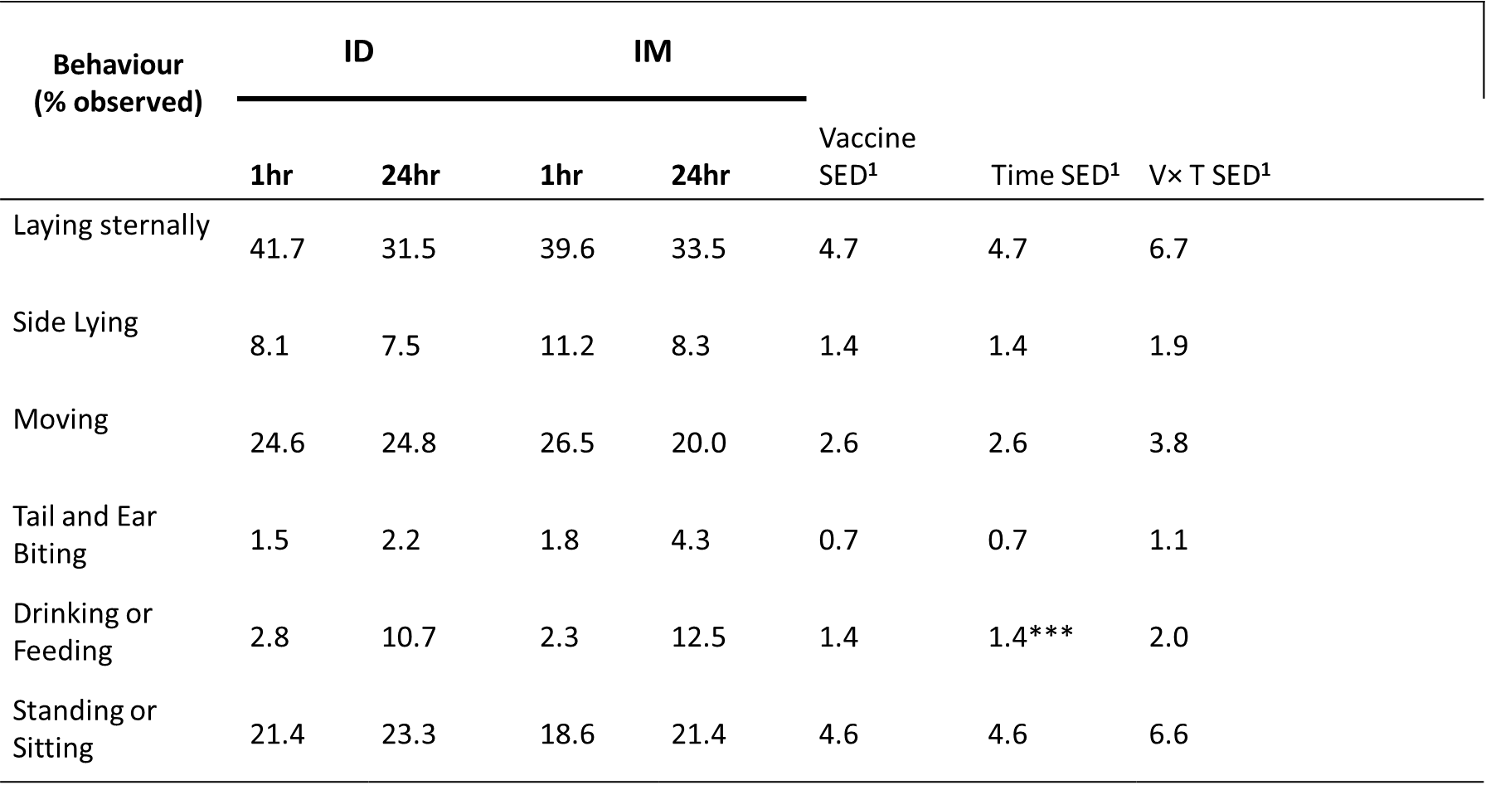Temple, D., Jiménez, M., Escribano, D., Martín-Valls, G., Díaz, I., & Manteca, X. 2020. Animals. 10 (10), 1898.

**Table 1.** Behaviours of piglets at two time points post-vaccination with either an Intradermal (ID) or Intramuscular (IM) vaccine.

1SED = Standard Error of Difference

*** indicates significance at *P*<0.001