**Application**

The zero emissions livestock project (ZELP) is advancing sustainable livestock management by introducing an innovative device designed to monitor methane (CH₄) and carbon dioxide (CO₂) emissions in cattle. This device allows for non-invasive, continuous measurement in natural settings, addressing the limitations of traditional respiration chambers and enabling more accurate data on greenhouse gas (GHG) emissions.

**Introduction**

Methane emissions from cattle contribute significantly to greenhouse gases, intensifying the need for effective monitoring to support environmental sustainability. Current gold-standard methods, such as respiration chambers, while precise, are resource-intensive, costly, and restrict natural behaviours due to confinement, potentially affecting emission data accuracy (Troy et al., 2016). By contrast, this novel device provides a field-deployable solution that collects emissions data in real-world conditions. The design overcomes respiration chamber limitations by enabling continuous and high-frequency monitoring across varied environments without disrupting animal behaviours or compromising welfare.

**Materials and Methods**

The device is equipped with an array of advanced sensors: Near Infrared optical and catalytic sensors for gas concentration, thermistors and thermocouples for temperature, and accelerometers and inertial measurement units (IMUs) for motion and position. These sensors are mounted on the animal’s head using a specially designed face sock and positioned near the nostrils to capture exhaled gases before significant dilution. The face sock, made from ventilated neoprene, has proven in lab and field tests to cause no abrasion and allows airflow to prevent sweat and dirt buildup.

Data is recorded continuously or intermittently, allowing detailed respiratory profiles and gas concentrations to be captured. The device supports both onboard data storage for extended offline processing and wireless transmission for real-time or scheduled updates, depending on connectivity and power availability.

To validate the device, a two-week trial was conducted in October 2024 at Hall Farm, Reading, England. Three Holstein Friesian heifers were involved, with two heifers tested each week and one heifer participating in both weeks with a one-week break between. Objectives included obtaining methane emissions data at a granular 15-minute interval, assessing device performance in comparison to respiration chamber readings, collecting high-quality thermistor data, and documenting prototype performance. The trial setup included two CCTV cameras per heifer for real-time behavioural observation, complemented by hourly respiration rate checks via visual inspection.

Data collected from the trial included respiratory rates, breath temperatures, gas concentrations, and heifer behaviours, with continuous monitoring by personnel to identify any welfare impacts. Statistical comparisons of methane emission data from the device and respiration chambers were performed, accounting for variables such as feed intake and activity level. Weight measurements were taken before and after the trials to monitor any adverse effects on animal health. Methane (CH₄) and carbon dioxide (CO₂) concentrations at the nostril were measured, and proprietary machine learning models were applied to estimate total emissions.

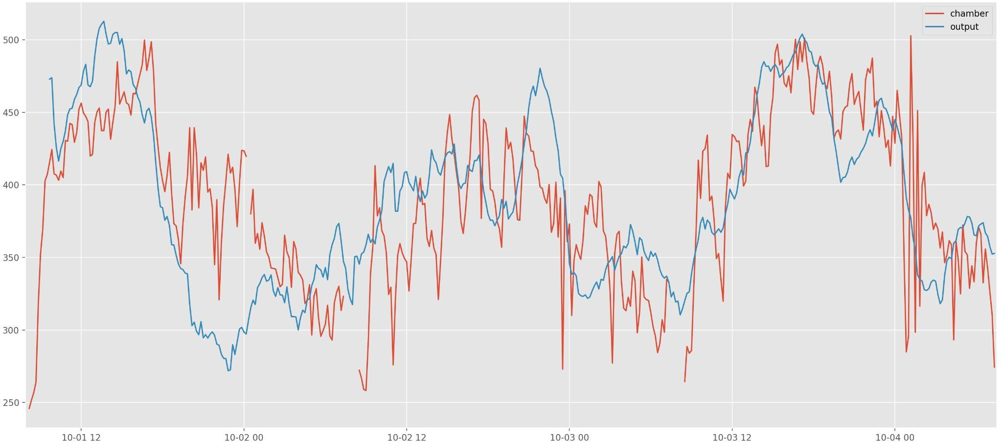

1.

*Figure 1:* Comparison between CH₄ measured in respiration chambers (red line) and CH₄ measured by the device (blue line) over a 3-day period, with a measurement error of approximately 14%. The x-axis depicts time and the y-axis depicts methane concentration.

**Results**

Preliminary results suggest that the device accurately mirrors respiration chamber data, providing comparable emission readings while capturing additional data in naturalistic environments. A moderate positive correlation (r = 0.612, p < 0.05) was found between the device’s methane emission measurements and those obtained from the respiration chamber, indicating a moderate strength relationship between the two methods. This suggests that the device can reliably replicate the emission data in natural settings while maintaining consistency with the more controlled chamber environment. Respiration rates remained within normal limits of 26–50 breaths per minute, the behavioural assessment showed no signs of distress, confirming that natural behaviours were maintained. A minor weight loss in heifers was observed, consistent with restricted feeding patterns in respiration chambers (Llonch et al., 2018).

**Conclusions**

The device demonstrates significant potential as an alternative to traditional respiration chambers, enabling scalable, accurate, and behaviourally relevant emissions monitoring. This technology could facilitate more widespread methane management in livestock, supporting the sector’s shift toward sustainable practices.

**References**

Llonch, P., Troy, S.M., Duthie, C.-A., Somarriba, M., Rooke, J., Haskell, M.J., Roehe, R., and Turner, S.P., 2018. Animal Production Science, 58(6), 1011.

Troy, S.M., Duthie, C.-A., Ross, D.W., Hyslop, J.J., Roehe, R., Waterhouse, A., and Rooke, J.A., 2016. Animal Feed Science and Technology, 211, 227–240.