
‘Grass Roots 8’ Educational Event
Fundamentals of Liquid Chromatography
University of Cumbria, Ambleside, Cumbria
Friday 14th-Monday 17th August 2026

 |  | 
 | 

In October 2016, as part of the Society’s Diamond anniversary celebrations, The Chromatographic Society held its first Grass Roots event in Grasmere in the Lake District. The course focussed on teaching the fundamentals of liquid chromatography to graduate students and novice chromatographers from industry. The event hosted over twenty attendees. The event was such a success that the Society repeated the course in Church Stretton in October 2017, with over twenty-five delegates from academia and industry attending.
Since then, five more Grass Roots courses have been held (Grass Roots 3 and 6; Small molecule method development, Grass Roots 4; Introduction to biopharmaceutical analysis, Grass Roots 5; Fundamentals of LC and Grass Roots 7; Characterisation of oligonucleotides) but with less liquid chromatography being taught on undergraduate chemistry courses, we wanted to return to our original content to better arm novice researchers working with this important analytical technique. This will be a four-day event relevant to post-graduate students (MSc, PhD and post-doctoral researchers new to the field) and novice industrial chromatographers. The course will focus on the fundamentals of liquid chromatography and how this can be applied practically in industry and academia. The event will be delivered by several chromatographers with extensive training and industrial experience (Prof. Mel Euerby (Shimadzu), Tony Taylor (Crawford Scientific), Dr Tony Edge (ChromSoc), Clementine Castel (AstraZeneca) and Prof. Paul Ferguson (AstraZeneca)). While the meeting will be primarily educational, there will also be extensive opportunities for networking and a walking social programme for those who wish to join us.
The event will be held in Ambleside at the University of Cumbria which is accessible by car, or by train to Windermere and a short bus or taxi journey from the train station. Direct trains run from Manchester international airport to Windermere for overseas colleagues interested in attending the event.
We are delighted that we have vendor companies and learned bodies sponsoring the event by providing full funding for a limited number of UK based post-graduate researchers (PhD/D.Phil) to attend (travel costs not included). Additionally, The Chromatographic Society will provide industrial bursaries for lecturers and chromatographers working in small and medium sized companies through our Ted Adlard industrial fund (£250) and student bursaries (£250) for PhD/DPhil students (when all vendor bursaries have been used) and post-doctoral researchers.
Registration may be found at: https://sasevents.eventsair.com/grass-roots-8/gr8reg

For sponsorship of this event and other queries, please contact us at paul.ferguson@astrazeneca.com.

Programme
The lecture programme will include approximately 17 hours of lectures alongside a social walking programme and evening events. The lecture programme will be ‘fixed’ content, but there is significant scope to include additional topics as requested by attendees and informal discussion during walks. We would also be happy to discuss any specific chromatographic queries or issues which you bring from your workplace. Attendees who wish to bring chromatography posters (or workplace challenges) to the event are welcome and these will be discussed as appropriate times linked to the programme.
Friday
Time | What?
15:00-17:30 | Registration
18:00 | Dinner
19:00 | Introduction to course and presenters
19:45 | Importance of physico-chemical analyte parameters in chromatography
20:45 | Thinking about the analyte and the separation
21:30 | Social event

Saturday
Time | What?
8:00 | Breakfast
9:00 | Fundamental LC theory  Chromatographic calculations and their practical relevance
10.30 | Useful chromatographic books & resources
10:45 | Tea break
11:00 | Anatomy of an LC  Hands on tour of the LC, columns and related components
13:30 | Walk including lunch (3.0 hours)
17:30 | Dinner
18:30 | Modes of chromatography – Reversed phase to normal phase and everything in between
21:30 | Social event – pub quiz

Sunday
Time | What?
8:00 | Breakfast
9:00 | Mobile phase preparation and considerations
10:00 | Sample introduction
11.30 | Tea break
11:45 | Understanding the resolution equation - Retention and Efficiency
13:30 | Lunch and vendor exhibition
14.30 | Walk (2.0 hours)
17:30 | Dinner
18:30 | Understanding the resolution equation – Selectivity  Mobile phase, stationary phase and temperature
21:30 | Free evening

Monday
Time | What?
8:00 | Breakfast
9:00 | Isocratic and gradient LC
11.15 | Tea break
11.30 | Selecting the right detection approach
12:30 | Practical hints and tips  Course close
13:00 | Lunch

Course content and timings may be subject to slight change and will reflect latest developments in the science.

Presenter biographies

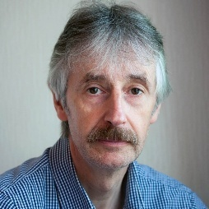
Mel Euerby is now retired but was the Principal of Shimadzu’s Centre of Excellence in Liquid Chromatography where he was responsible for inspiring and training young chromatographers for the future. He also held visiting Professorships at the University of Strathclyde and the Open University where he lectured for over 40 years! Previously, he held the position of Head of R & D and Training at Hichrom Ltd. Prior to that, he worked for twenty years in the pharmaceutical industry where he had global responsibilities for separation science at AstraZeneca. In 2007 he was awarded the Jubilee Silver Medal for chromatography by The Chromatographic Society.
Mel’s areas of interest include stationary phase characterizations, supercritical fluid chromatography, 2-dimensional LC, hydrophilic interaction chromatography, computerised method development, ultra-fast / high resolution LC and fundamental research into retention mechanisms in chromatography.


Tony Taylor has been a practicing chromatographer for 37 years. He hopes to get it right soon!
He has used HPLC and LC-MS techniques in the pharmaceutical, industrial chemical and contract research industries, dealing with a wide variety matrices and analytical challenges.
He is currently the Chief Scientific Officer of Element Lab Solutions, a UK based consumables and services provider.
He currently advises clients on HPLC(MS) and GC(MS) application development and problem solving. His current research interests include the classification of stationary phase selectivity, automated micro-extraction sample preparation techniques and advanced knowledge management database development. He has been a trainer in analytical science for over 20 years and is proud to be the founder of CHROMacademy (www.chromacademy.com), the world’s most popular online training and development platform for analytical chemists.
Tony has been involved with teaching on all of the previous Grass Roots events and was on the local organising committee for ISC2024 in Liverpool.


Tony Edge is now retired but had an extensive career working in industry (LGC, AstraZeneca), vendor organisers (including Agilent, Thermo Scientific) and enterprise software development (TetraScience). His main focus was developing new stationary phases with novel column formats, although recently he has been looking at the application of AI models in the chromatography environment. Tony’s experience in separation science won him many accolades. In 2008 he was awarded the Desty Memorial Lecture, as well as a Clinical Excellence award from AstraZeneca. He held an honorary fellowship of Liverpool University where he lectured on separation science and additionally, he lectured on Management in Analytical Science at Keele University.
In 2017 Tony became President of the Chromatography Society in the UK, driving international promotion and development of chromatography and separation techniques. He is also a member of the scientific committee for the International Symposium on Chromatography. He was Chairman of the successful ISC2024 conference in Liverpool.

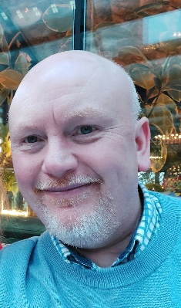
Paul Ferguson is a separation science specialist at AstraZeneca and leads the separation science strategy for Global Pharmaceutical Development division spanning both small and medium size (small peptides and oligonucleotides) novel therapies. He has worked in the pharmaceutical industry since 1999 (previously at Pfizer) following a post-doc at Imperial College London on capillary electrochromatography (CEC) with Dr Norman Smith. Paul has interests in UHPLC, SFC, CE, chiral separations, formulated drug sample preparation, green analytical chemistry and method development. He is a past winner of the Desty Memorial lecture prize (2002), a Fellow and Chartered Chemist in the RSC and lectured on the MSc Analytical Science for Industry course at Kings College London from 2009-2017, as well as other Universities. He holds a Chair in analytical chemistry at the University of Amsterdam.
Paul has served as the Honorary Secretary of The Chromatographic Society (2017-2024), Vice-President (2009 to 2014) and President (2014 to 2017). He has also organised or co-organised several successful symposia for the Society since 2007 including the inaugural Grass Roots event held in 2016 in Grasmere (and Grass Roots 3 to 7). More recently, Paul served on the local organising committee for ISC2024, Liverpool.

Registration fees
Attendee type | Cost
Industrial | £750
Industrial (for colleagues at SMEs) with Ted Adlard bursary | £500 (application required)
Academic (PhD/DPhil/post-doctoral researchers/academic lecturers) | £550
Academic (PhD/DPhil and post-doctoral researchers) with ChromSoc bursary or academic lecturers with Ted Adlard bursary | £300 (application required)
Academic (PhD/DPhil) with vendor sponsored bursary | Free (application required)

Course fees include
- Practically focussed 3-day training course
- 3 night’s accommodation (Friday, Saturday and Sunday evenings)
- All meals and course refreshments (breakfast, lunch and dinner – all dietary and faith considerations can be accommodated)
- Full set of course notes (electronic – sent in advance and on USB drive)
- Certificate of attendance

Venue

We are delighted to be holding the event at the University of Cumbria in Ambleside. The university campus is ideally situated close to all amenities and night life in the village. We will be using the Percival lecture theatre in the Langdale building (building 5 on the map) for teaching. Both the campus and accommodation have Wi-Fi available. The university is obviously ideally equipped for teaching activities and is close to the starting points of the (optional) walks we will be undertaking on Saturday and Sunday.
Another benefit of being at the university is the cost of hiring the facilities enables us to offer low registration fees for the event. The course fee includes all accommodation, meals, tea and coffee and course notes which we hope will encourage academic colleagues to attend.
We are also hoping that the weather in August will be kind – but we cannot guarantee this!

Travel to Ambleside
By car
The easiest way to reach Ambleside is to drive to the University, but parking can be limited on site. As the course is running at the end of term-time we are hoping to obtain free on-site parking permits for all delegates travelling by car. If this is not possible, there is parking on the campus at the main entrance (see map below). The chargeable period on site is from 08.00 – 18.00 (10 Hours). Each day will cost £9.60. It is possible to pay with cash, debit/card or pay-by-phone.
There is also a large public car park opposite the main campus entrance on Rydal Road. It is possible to get a three-day parking permit for the car park on £21.60. If a permit is bought on Friday at 3pm it will be valid until 3pm on Monday. See https://www.westmorlandandfurness.gov.uk/parking-streets-and-transport/parking/parking-permits-day-passes-and-season-tickets/how-buy-3-or-7-day-parking-pass for more details. Note, costs correct in January 2026.
By air
If travelling by air, the most convenient airport is Manchester airport. It is possible to take the train directly from the airport to Windermere train station. The journey time is approximately 2 hours and there are direct trains throughout the day (e.g. 11:29 train gets you into Windermere at 13.54 – check Trainline.com). Alternatively, it is possible to take other trains from the airport but you may have to change at Preston or Oxenholme (Lake District) and the journey time will be up to 2.5 hours. Train cost for a return ticket from the airport to Windermere is about £60. Some attendees in 2025 took taxis from Manchester airport to Ambleside, but this will obviously be very expensive (but possibly cheaper than a train if there are several colleagues from the same company).
By train
If travelling by train from the north or south (or from airports other than Manchester), it is necessary to travel to Windermere by changing trains at Preston or Oxenholme (Lake District).
Local bus services
For the approx. 6 mile journey from Windermere train station to the University in Ambleside, there are regular buses (e.g. 555, 599 to Ambleside, Grasmere or Keswick – the bus stops outside the University opposite the Ambleside medical centre – see map) with a journey time of approx. 30 minutes. Alternatively, it is possible to travel by taxi although this will obviously be more expensive. The cost for the bus journey is £3.00 for a single ticket.

Accommodation
The event will be held at the University of Cumbria which is on Rydal Road leading out Ambleside towards Grasmere. The university is ideally located to access village amenities (approx. 2 minutes walk to town centre) and the planned walks - while sufficiently far away from the bustle of the town centre.

Accommodation will be in the university’s halls of residence which is over the road from the campus. The accommodation is a mixture of new and old buildings and there is parking space next to this. The halls are 3 minutes walk from the campus restaurant and classroom.
For those who do not wish to join us for the walks, there are numerous other activities which may be of interest instead including Lake Windermere boat cruises, shopping, cinemas, numerous coffee shops, pitch and putt golf or taking a short bus journey to Grasmere where the famous poet William Wordsworth lived.

Grass Roots attendee testimonials
I will be using much of what I have learnt during the course of my PhD and future career, and I would highly recommend any future ‘Grass Root’ events to people working within the field of chromatography. Everyone involved in the weekend was helpful and friendly and the presenters made sure that you fully understood the material before moving on.  - Grass Roots 3, PhD student, University of Northumbria | 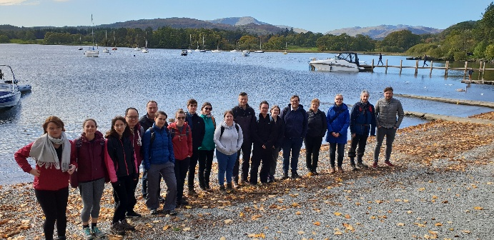
 | When the event runs again I would highly encourage anyone to go as it was an eye-opening experience which was so welcoming. I am planning on taking the knowledge gained and applying it to my own work I. Hope I can get the best out of my chromatography.  - Grass Roots 6, PhD student, University of Strathclyde
I am leaving this experience with a significantly improved understanding of current analytical technologies and advancements, as well as a much deeper comprehension of the systems I work with and the underlying theories. I wholeheartedly recommend this course organised by ChromSoc to both individuals in academia and industry, as it genuinely enriches your foundational knowledge and keeps you up to date with the latest developments in the analytical field.  - Grass Roots 6, PhD student, University of Sunderland | 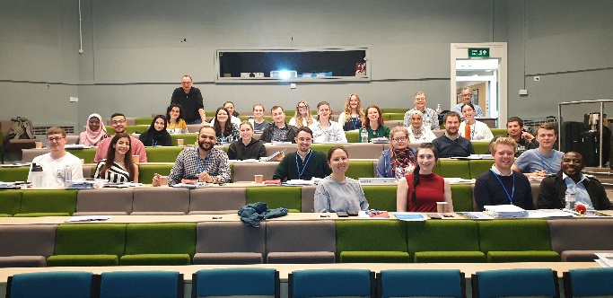
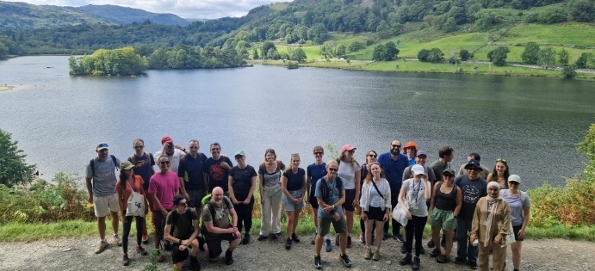 | I particularly appreciated the progression of the talks, each one building upon the last to create a complete picture of the analytical pipeline, from early discovery and development through to potential drug delivery systems. It was fascinating to see how advanced analytical approaches and regulatory guidance come together in the development of novel therapeutic products.  - Grass Roots 7, PhD student, University of Strathclyde
I would highly recommend the Grass Roots events to any fellow early-career scientists who want to broaden their understanding of chromatography. I found the content extremely useful and something that I will definitely use going forward in my career. Thank you to the Chromatographic Society and everyone involved with hosting this course!  - Grass Roots 7, SME industrial attendee | 