
2022 Crime Lab Symposium
October 4-5, 2022
Monona Terrace Convention Center | Madison
Sponsorship Opportunities

The 2022 Crime Lab Symposium will take place October 4th-5th at the Monona Terrace Convention Center in Madison, WI.

Questions on 2022 sponsor opportunities may be directed to Dawn Zanoni, Office of Marketing Services at (608) 266-3978 or dawn.zanoni@wisconsin.gov

Sponsorship Opportunities
PLATINUM SPONSOR: Only one available
- Exclusive sponsor of Vender Opening Reception - Includes 2–3-minute “welcome speech” opportunity during reception.
- Exclusive sponsor of participant promotional item
- Sponsor’s logo and/or name included on select promotional materials
- Rotating banner advertising on the Conference app
- 50-word company description and color logo on the Conference website and mobile app
- Recognition on select signage at the event
- 50-word company description and color logo in Conference program
- Full-page color ad, upgraded to premium positioning, in the conference program
- Exhibitor space in premium location increased to an 8’x20’ with complimentary electricity
- Complimentary conference registrations for five organization representatives
- Final list of attendees for promotional use
Cost of Platinum Level Participation - $20,000

GOLD SPONSOR: Only two available
- Exclusive sponsor of one of two Lunches – Includes 2–3-minute speaking opportunity during lunch.
- Prominent opportunity to distribute promotional pieces during lunch
- Sponsor’s logo and/or name included on select promotional materials
- Rotating banner advertising on the Conference app
- 50-word company description and color logo on the Conference website and mobile app
- Recognition on select signage at the event
- 50-word company description and color logo in Conference program
- Full-page color in the Conference program
- Exhibitor space in premium location with complimentary electricity
- Complimentary conference registrations for four organization representatives
- Final list of attendees for promotional use
Cost of Gold Level Participation - $15,000

SILVER SPONSOR: Only three available
- Recognized sponsor of one of one of three breaks
- Prominent opportunity to distribute promotional piece during selected event
- Sponsor’s logo and/or name included on select printed and digital promotional materials
- Rotating banner advertisement on the Conference app
- 50-word company description and color logo on the Conference website and mobile app
- Recognition on select printed and digital signage at the event
- 50-word company description and color logo in Conference program
- Full-page color ad in the Conference program
- Exhibitor space with complimentary electricity
- Complimentary conference registrations for three organization representatives
Cost of Silver Level Participation - $10,000

BRONZE SPONSOR: Only four available
- Collectively, sponsors of the Wake-Up Coffee Break
- Sponsor’s logo and/or name included on select printed and digital materials
- Recognition on printed and digital signage at the event
- 50-word company description and color logo on the Conference website and mobile app
- 50-word company description and color logo in Conference program
- Half-page color ad in the Conference program
- Exhibitor space with complimentary electricity
- Complimentary conference registrations for two organization representatives
Cost of Bronze Level Participation - $5,000

Printed Guide Ad Specifications

Dimensions
- Full Page (Platinum, Gold, and Silver Sponsors)
  - 5.57in w x 8.75in h (including 0.125in bleeds)
- Half Page (Bronze Sponsors)
  - 5.57in w x 4.5in h (including 0.125in bleeds)
- Footer Banner (Exhibitor Advertiser
  - 5.57in w x 2.5in h (including 0.125in bleeds)
Minimum Resolution: 300 dpi

Accepted File Formats: PDF, EPS, TIFF, PSD; CMYK color space

Note: Please keep all important type and images at least a quarter inch inside the ad dimensions (safe area)

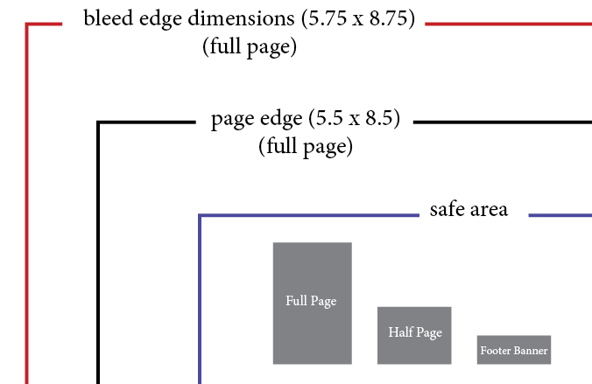

Mobile App Ad Specifications
(Gold and Silver Sponsors)

Dimensions: 640px w x 90px h

Minimum Resolution: 72 dpi

Accepted File Formats: JPEG, PNG, or other image files; RGB color space

