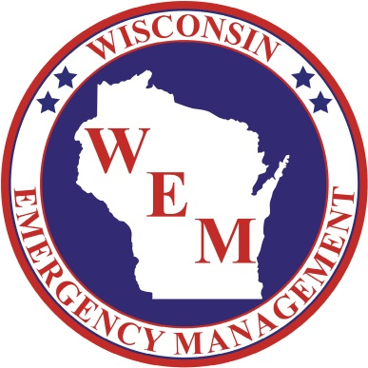

*56th Annual*

2024 Governor’s Conference on Emergency Management & Homeland Security

March 13 – March 15

The Grand Geneva Resort, Lake Geneva

****Exhibitor Opportunities****

The 2024 Governor’s Conference on Emergency Management & Homeland Security will take place March 13-15 at the Grand Geneva Resort in Lake Geneva.

Questions on the 2024 exhibitor opportunities may be directed to Paul Hughes at (608) 242-3309 or [paul.hughes@widma.gov](mailto:paul.hughes@widma.gov).

# Exhibitor Opportunities

EXHIBITOR ADVERTISER

* Digital footer banner in the conference app
* Exhibitor space for promotional use
* Exhibitor’s logo/name listed on select printed and digital promotional materials
* 50-word company description and logo on the Conference website and mobile app
* Complimentary conference registration for one organization representative

*Cost of Advertiser Participation - $750*

*Non-Profit Advertiser Rate - $300*

*Electrical Hook-Up - $50*

EXHIBITOR

* Exhibitor space for promotional use
* Exhibitor’s logo and/or name listed on select printed and digital promotional materials
* 50-word company description and logo on the Conference website and mobile app
* Complimentary conference registration for one organization representative

*Cost of Exhibitor Participation - $600*

*Non-Profit Exhibitor Rate - $150*

*Electrical Hook-Up - $50*

**Mobile App Ad Specifications**

(Gold and Silver Sponsors)

Dimensions: 640px w x 90px h

Minimum Resolution: 72 dpi

Accepted File Formats: JPEG, PNG, or other image files; RGB color space

