The Complex Interdependence of Torsion, Procurvatum, and Frontal Plane Angulation in Canine Distal Femoral Osteotomy: Limitations in Predicting Post-

Objective: Distal femoral osteotomy (DFO) is a cornerstone corrective procedure for managing canine patellar luxation, yet accurate prediction of post-correction alignment remains challenging due to the complex three-dimensional geometry of the femur. Previous studies have independently described femoral torsion, frontal plane angulation, and procurvatum, but the geometric interdependence among these parameters has not been quantified. The purpose of this study was to evaluate the covariance among femoral anteversion angle (AA), anatomical lateral distal femoral angle (aLDFA), and procurvatum to determine how correction in one plane influences alignment in the others. We hypothesized that these angular parameters are interdependent, and that modification of any one of them produces proportional, non-independent changes across the remaining planes. Understanding this relationship has direct clinical relevance for improving preoperative planning accuracy and minimizing unintended postoperative malalignment in canine DFO.
Study Design: Three-dimensional femoral models were generated from computed tomography (CT) data representing one anatomically normal canine femur, one with medial patellar luxation (MPL), and one with lateral patellar luxation (LPL). Models were digitally reconstructed in Blender software, and orientation was standardized using fixed viewpoint constraints to preserve geometric fidelity. Virtual distal femoral osteotomies were performed, and angular manipulations were applied in 5° increments to AA (experiment 1), aLDFA (experiment 2), and the proximal center of rotation of normal angulation (CORONA1, experiment 3) to simulate torsional, frontal, and sagittal corrections, respectively; each angular manipulation was performed between 30 degrees + and – for their respective experiements (i.e. AA were changed in 5° increments between 30° of retroversion and 30° of anteversion from baseline AA for experiment 1). For each manipulation, concurrent changes in the remaining two parameters were measured. Linear regression analysis and ANOVA were used to assess interdependence and differences among samples.
Results: Consistent, statistically significant linear relationships were identified among all femoral angular parameters. Changes in AA produced proportional changes in aLDFA (slopes 0.17–0.25, p < 0.01) and in sagittal plane procurvatum (aCdPFA; slopes 0.70–1.39, p < 0.01). Alteration of aLDFA produced inverse changes in AA (slopes −0.14 to −0.20, p < 0.01). Manipulation of CORONA1 also influenced aLDFA, particularly in the LPL femur (slope 0.28, p < 0.01). These findings confirm geometric interdependence between torsional, sagittal, and frontal plane femoral parameters, independent of pathology.
Conclusion: Femoral torsion, frontal plane angulation, and procurvatum are geometrically interdependent. Correction in one plane inherently modifies angular alignment in the others, challenging the assumption of planar independence in conventional DFO planning. Accounting for this covariance during pre-surgical planning may improve correctional accuracy and reduce postoperative malalignment. Although this study was limited to three digital specimens, these data support the use of three-dimensional modeling and simulation for precise correction planning. Further clinical validation is warranted to assess how these geometric interactions affect surgical outcomes and long-term limb function.
Figures:
Table 1:
Comparison |  | Sample 1 | Sample 2 | Sample 3 | Overall
AA (torsion) vs aLDFA | Slope | 0.24 | 0.19 | 0.17 | < 0.01
AA (torsion) vs aLDFA | p-value | < 0.01 | < 0.01 | < 0.01 | < 0.01
AA (torsion) vs ACdPFA | Slope | 0.93 | 1.39 | 0.70 | < 0.01
AA (torsion) vs ACdPFA | p-value | < 0.01 | < 0.01 | < 0.01 | < 0.01
alDFA vs AA (traditional) | Slope | -0.20 | -0.18 | -0.14 | < 0.01
alDFA vs AA (traditional) | p-value | < 0.01 | < 0.01 | < 0.01 | < 0.01
CORONA1 vs aLDFA | Slope | -0.05 | 0.00 | 0.28 | < 0.01
CORONA1 vs aLDFA | p-value | < 0.01 | 1.00 | < 0.01 | < 0.01

Figure 1:
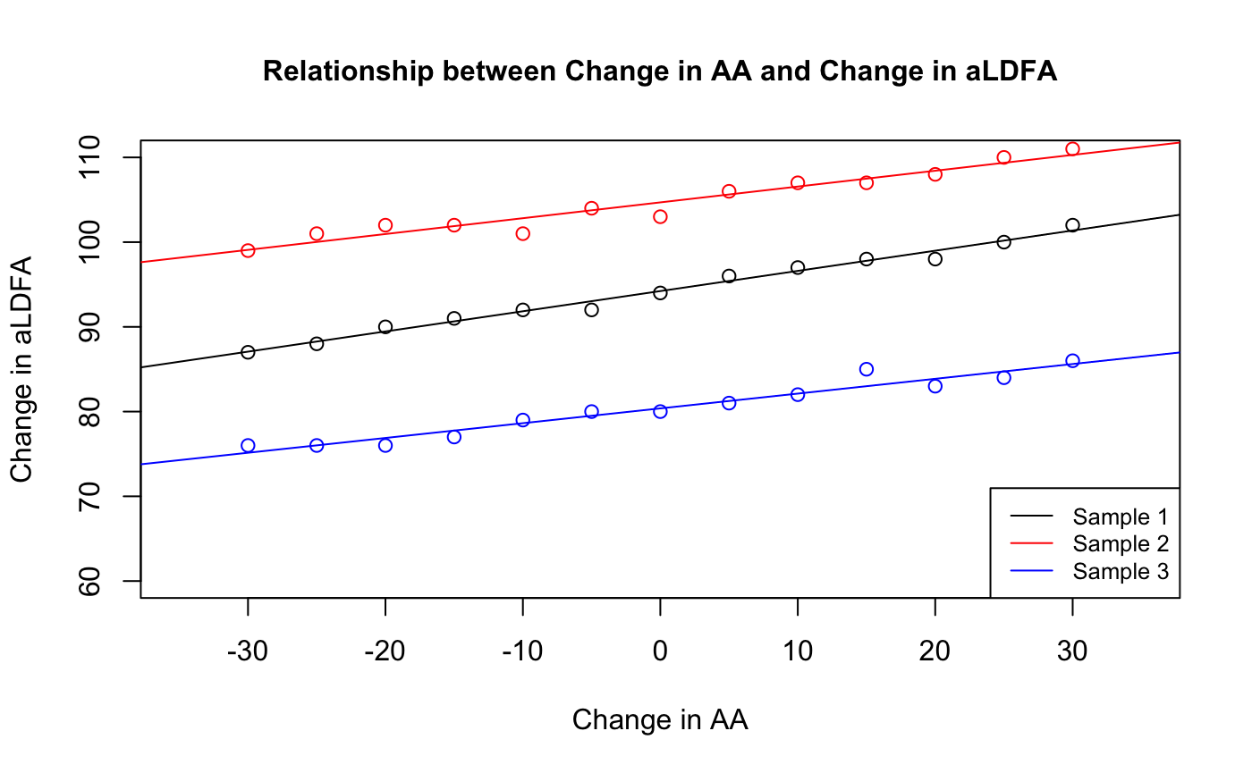
Figure 2: 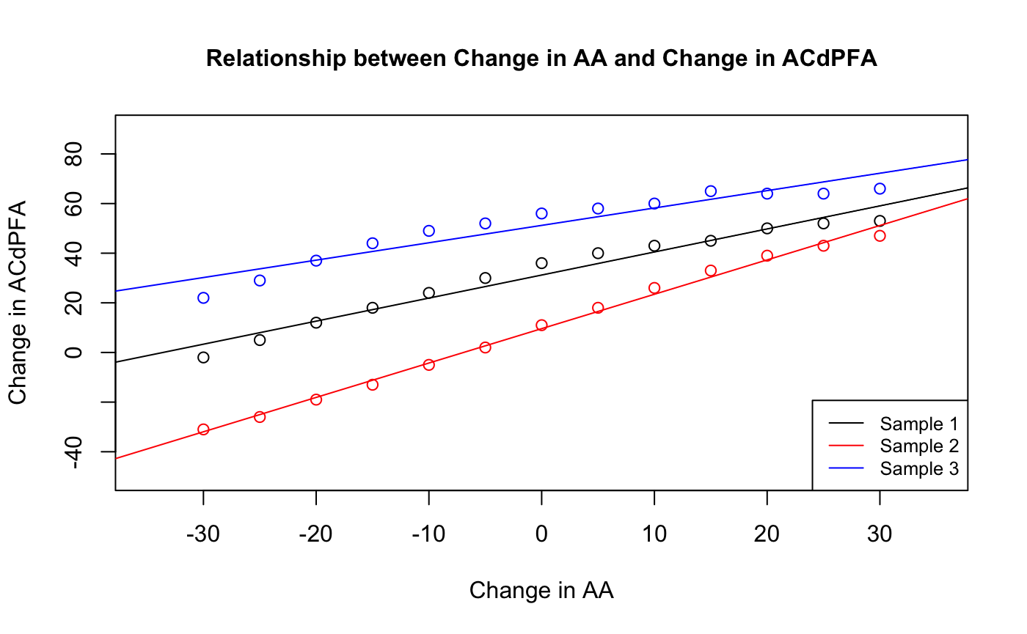
Figure 3:
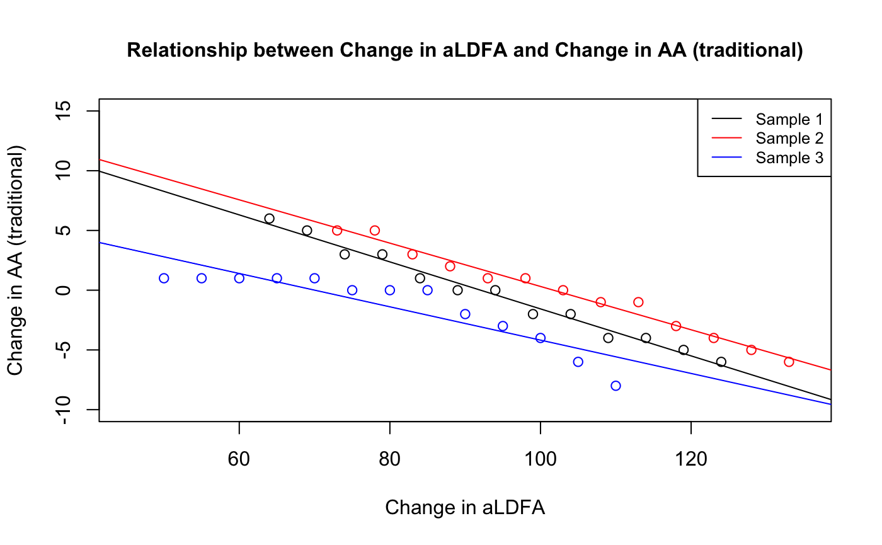

Figure 4: 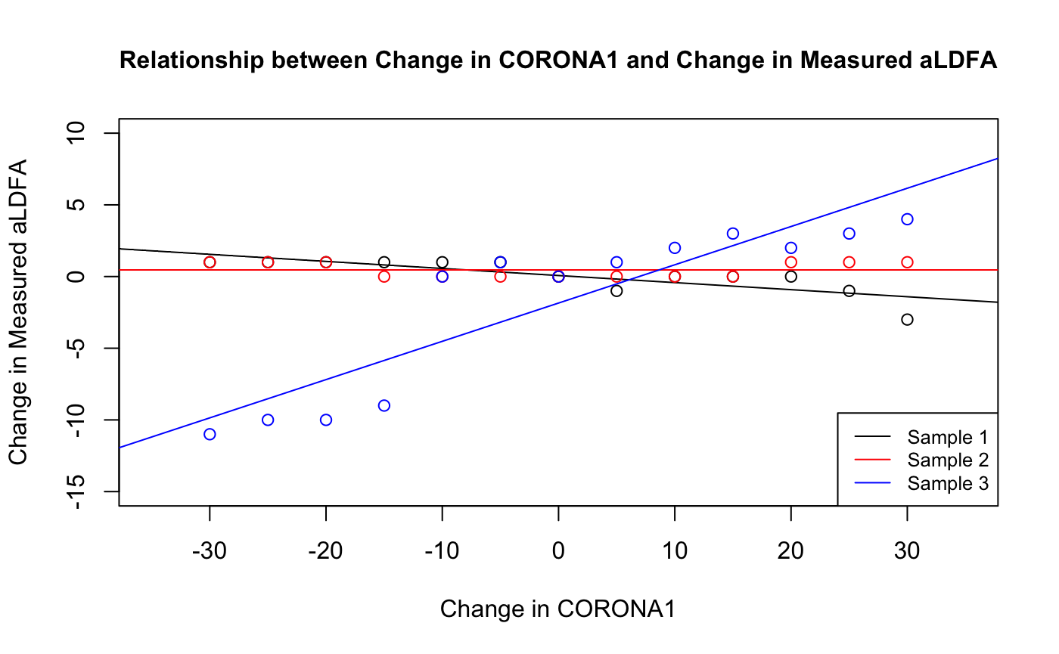
References:
1. Oxley B, Gemmill TJ, Pink J, et al. Precision of a novel computed tomographic method for quantification of femoral varus in dogs and an assessment of the effect of femoral malpositioning. Veterinary Surgery. 2013;42(6):751-758. doi:10.1111/j.1532-950X.2013.12032.x
2. Eby A, Bleedorn J. A computed tomographic graphical approach to guide correction of femoral torsion. Veterinary Surgery. 2020;49(5):1015-1023. doi:10.1111/vsu.13438
3. Hall EL, Baines S, Bilmont A, Oxley B. Accuracy of patient-specific three-dimensional-printed osteotomy and reduction guides for distal femoral osteotomy in dogs with medial patella luxation. Veterinary Surgery. 2019;48(4):584-591. doi:10.1111/vsu.13126
4. Adams RW, Gilleland B, Monibi F, Franklin SP. The effect of valgus and varus femoral osteotomies on measures of anteversion in the dog. Veterinary and Comparative Orthopaedics and Traumatology. 2017;30(3):184-190. doi:10.3415/VCOT-16-09-0138
5. Brower BE, Kowaleski MP, Peruski AM, Pozzi A, Dyce J, Johnson KA, Boudrieau RJ. Distal femoral lateral closing wedge osteotomy as a component of comprehensive treatment of medial patellar luxation and distal femoral varus in dogs. Vet Comp Orthop Traumatol. 2017 Jan 16;30(1):20-27. doi: 10.3415/VCOT-16-07-0103. Epub 2016 Dec 9. PMID: 27935008.

Acknowledgements: The authors declare no proprietary interest or specific funding for this project. This study was performed without external financial support.

