Synovial and Systemic Pharmacokinetic Analysis of Multidose Oral Administration of t-TUCB in Horses with Naturally Occurring Osteoarthritis Receiving t-TUCB and Firocoxib Alone and in Combination

Objective: Soluble epoxide hydrolase (sEH) is a novel target to control inflammation and pain associated with osteoarthritis in horses. Recent studies have demonstrated that sEH-generated dihydroxyeicosatrienoic acids (DHETs) induce chondrocyte apoptosis and have been associated with the progression of osteoarthritis (6, 7). The sEH inhibitor, trans-4-{4-[3-(4-trifluro-methoxy-phenyl)-ureido]-cyclohexyloxy}-benzoic acid (t-TUCB), is emerging as a promising disease-modifying treatment for osteoarthritis in veterinary species (1, 2, 8). However, there is minimal data in the literature evaluating the pharmacokinetics of t-TUCB in horses, including no multidose pharmacokinetics or synovial fluid analyses following oral administration. Previous studies have evaluated effects of single dose intravenous administration of t-TUCB on LPS-induced synovitis in horses (2), single dose pharmacokinetics (4), or effects of oral dosing in dogs (3). The objective of this study was to determine the synovial fluid concentration, time to reach plasma steady state concentrations, and elimination half-life of the soluble epoxide hydrolase inhibitor t-TUCB (500 mg/horse) following multi-dose oral administration in horses. We hypothesized that steady-state would be reached within 5 days of oral administration of t-TUCB, and that the elimination half-life following steady-state would not significantly differ from the reported half-life following single-dose administration.

Study Design: Six horses with radiographic evidence of osteoarthritis were utilized (five mares: four American Quarter Horses, one standardbred; one gelding: standardbred). The average weight shifted throughout the study; initial average weight was 456kg ± 46.9kg, and final weight measurements averaged 465kg ± 34.2kg. A 3-way crossover study with a two-week washout period was performed with ten days of oral administration of 1) t-TUCB (500mg/day), 2) Firocoxib (57mg/day), 3) t-TUCB/Firocoxib (TFC)(500 mg/28.5 mg per day). Plasma samples were collected at time: 0, 10, 24, 48, 72, 144, 216, 226, 240, 250, 264, 288, 312, 336, 384, 456 hours. Synovial samples were collected prior to drug administration on day -2 and approximately 24 hours following final drug administration. Plasma and synovial samples were mixed with 108 µL of a 1:1 methanol:acetonitrile. Samples were vortexed for 5 min, chilled at -20 °C for 30 min and centrifuged at 2500g for 5 min to remove protein precipitates. The supernatant was filtered through a 0.2 µm PVDF 96-well filter plate and collected for LC-MS/MS analysis. Analytes were separated on a 2.1 mm x 150 mm, 1.7 µm BEH C18 column (Waters, Milford, MA) and detected by electrospray ionization with multiple reaction monitoring on an API 6500 QTRAP (Sciex; Redwood City, CA). Data were analyzed using Multiquant 3.0.3 software (Sciex; Redwood City, CA). Residues were quantified against a 9-point calibration curve with internal standard methodologies as previously reported (5). Statistical significance was identified at p=0.05.

Results: Pharmacokinetics were similar between t-TUCB and TFC treatment (Fig 1). No carryover effect of drug was found between phases, with the 14 days being an adequate wash out period. Steady state concentration of t-TUCB in plasma was reached by 24-48hr. The overall steady state area under the curve (AUC) for t-TUCB dosing following final dose administration (hour 216-infinity)(AUC_{0-∞}) in plasma was 20,203.5 ng/ml*hr. The maximum concentration (Cmax) in plasma was 521 ng/ml, at 235.3 hour (Tmax). The average elimination half life (T_{1/2}) was 35.2 hr following final dosing. t-TUCB reached measurable concentrations, average 150ng/ml of t-TUCB, in synovial fluid following t-TUCB or TFC administration with a significant increase in synovial fluid following drug administration (p<0.0001)(Fig 2).

Conclusion: The sEH inhibitor, t-TUCB, has a more prolonged elimination half-life following multi-dose oral administration in horses compared to prior single dose pharmacokinetics. A previous equine study reported single dose oral t-TUCB half-life of 18 hours (4), as compared to 35.2 hours following multi-dose administration in the current study. McReynolds in 2019 reported no difference in half-life based on singe or multi-dose administration in canines. No drug carryover was noted, confirming 2 weeks is ample time for complete washout of the t-TUCB, and that any perceived clinical carryover effect from the parent study is not related to remaining drug following wash out. The joints analyzed in the study were chronically affected, with lower levels of active inflammation when compared to induced models. Guedes reported that t-TUCB was found at significantly higher concentrations in inflamed joints (1000ng/ml) with non-inflamed joints reaching >100ng/ml. Our data indicates concentrations of t-TUCB within joints with limited inflammation reached concentrations above 100ng/ml as well, thereby determining oral dosing achieves similar concentrations within the joint as intravenous dosing. This is promising for ease of administration of t-TUCB in the future.

Figures:
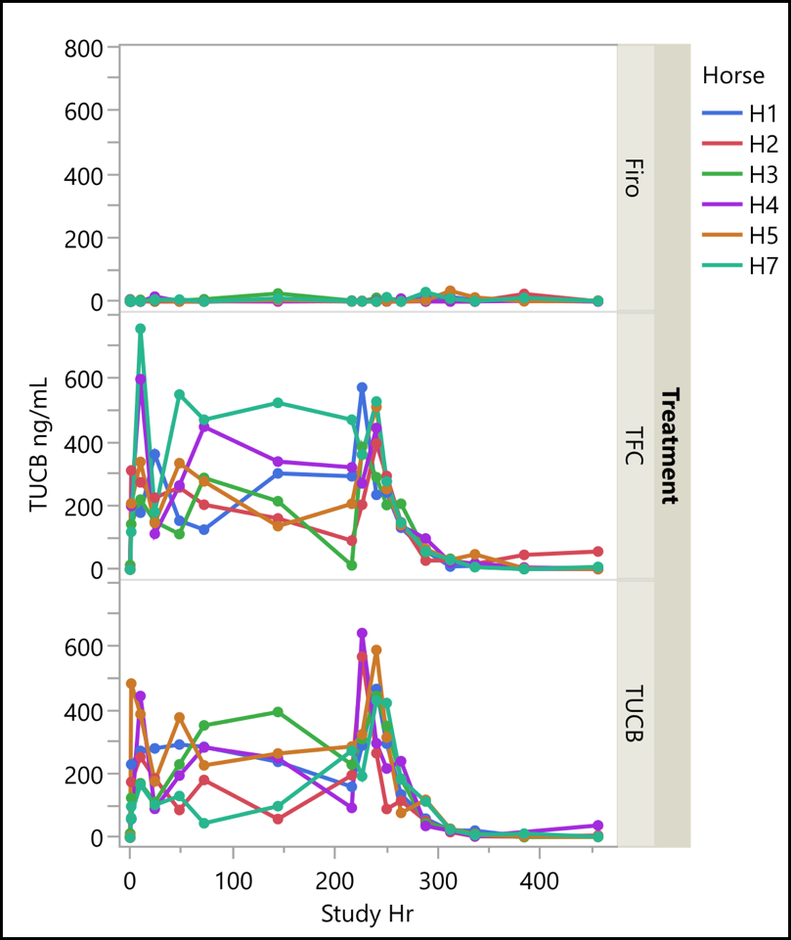
Figure 1. t-TUCB concentration in plasma following multi-dose oral administration of firocoxib (57 mg/horse), t-TUCB+firocoxib (500 mg/horse + 28.5 mg/horse), or t-TUCB (500 mg/horse) per horse. Treatment order was randomized.

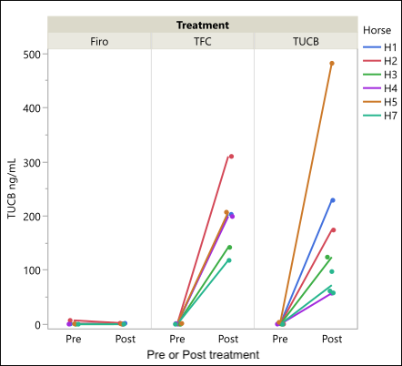
Figure 2. Synovial fluid concentration of t-TUCB from pre/post 10 days of treatment administration, as separated by treatment firocoxib (57 mg/horse), t-TUCB+firocoxib (500 mg/horse + 28.5 mg/horse), or t-TUCB (500 mg/horse).

References:
- Carlson, A., Johnson, P.J., Lei, Z. & Keegan, K.G. (2022). Anti-nociceptive efficacy of the soluble epoxide hydrolase inhibitor t-TUCB in horses with mechanically induced lameness. Res. Vet. Sci. 152, 504–509. http://dx.doi.org/10.1016/j.rvsc.2022.09.017.

- Guedes AGP, Aristizabal F, Sole A, Adedeji A, Brosnan R, Knych H, Yang J, Hwang SH, Morisseau C, and Hammock BD (2018). Pharmacokinetics and antinociceptive effects of the soluble epoxide hydrolase inhibitor t-TUCB in horses with experimentally induced radiocarpal synovitis. J Vet Pharmacol Therap. 41, 230–8.

- McReynolds CB, Hwang SH, Yang J, Wan D, Wagner K, Morisseau C, Li D, Schmidt WK, and Hammock BD (2019) Pharmaceutical effects of inhibiting the soluble epoxide hydrolase in canine osteoarthritis. Frontiers in Pharmacology 10:533.
- McReynolds, C.B., Yang, J., Guedes, A., Morisseau, C., Garcia, R., Knych, H., Tearney, C., Hamamoto, B., Hwang, S.H., Wagner, K. and Hammock, B.D. (2021) Species Differences in Metabolism of Soluble Epoxide Hydrolase Inhibitor, EC1728, Highlight the Importance of Clinically Relevant Screening Mechanisms in Drug Development. Molecules 26. http://dx.doi.org/10.3390/molecules26165034.
- Pedersen, T.L, I.J. Gray, J.W. Newman. 2020. Plasma and serum oxylipin, endocannabinoid, bile acid, steroid, fatty acid and nonsteroidal anti-inflammatory drug quantification in a 96-well plate format. Anal Chim Acta. 1143:189-200.
- Tucker L, Trumble TN, Groschen D et al. (2021). Targeting soluble epoxide hydrolase and cyclooxygenases enhance joint pain control, stimulate collagen synthesis, and protect chondrocytes from cytokine-induced apoptosis. Front Vet Sci 8. doi: 10.3389/fvets.2021.685824.
- Valdes, Ravipati, S., Pousinis, P., Menni, C., Mangino, M., Abhishek, A., Chapman, V., Barrett, D. A., & Doherty, M. (2018). Omega-6 oxylipins generated by soluble epoxide hydrolase are associated with knee osteoarthritis. Journal of Lipid Research, 59(9), 1763–1770. https://doi.org/10.1194/jlr.P085118

- Walters B, Trumble TN, Wendt-Hornickle E et al. (2022). Effects of cyclooxygenase and soluble epoxide hydrolase inhibitors on apoptosis of cultured primary equine chondrocytes. Research in Veterinary Science 147:44-49. https://doi.org/10.1016/j.rvsc.2022.04.002

Acknowledgements:
Funding was provided internally. The novel compound t-TUCB was provided by EicOsis.

