Prospective Evaluation of an Impaction Interference Bolt Design for Angle Stable Intramedullary Nail Fracture Fixation in Dogs
Objective: Angle stable intramedullary nailing provides excellent fracture stabilization with improved fracture healing when compared to traditional intramedullary nail designs.¹⁻² Achieving an angle stable, bolt-nail interaction, however, can be complex. Previous designs have relied on a morse-taper thread, thereby requiring novel measuring devices and customized bolt trimming with specialized tools. Each procedural step increases operative times and implantation complications, such as bolt cross-threading, are commonly encountered.³ An alternative bolt-nail design was developed to achieve angle stability with a simplified implantation process. A bolt was designed to be impacted into a nail hole for an angle stable interface, simplifying measurement and expediting implantation. Given prior demonstration of clinically acceptable mechanical characteristics with a previous design, this study’s objective was to evaluate clinical outcomes of our impaction interference bolt design for long bone fracture fixation in dogs.⁴ We hypothesized interlocking nail constructs with the impaction interference bolt mechanism would allow reliable implantation and promote consistent fracture healing without implant-related complications.

Study Design: Consecutive cases of traumatic long bone fractures in dogs amenable to fixation using 6 mm or 8 mm intramedullary nail implants were prospectively enrolled. This study was approved by the University of Florida Institutional Animal Care and Use Committee, and owner consent was obtained (IACUC 202200000490). Patient and fracture details, and orthogonal radiographs of the injured and contralateral, uninjured bones were acquired for each case. All fractures were stabilized using commercially available, veterinary intramedullary nails (Innovative Animal Products, Rochester, MN). Pilot holes were drilled and impaction interference interlocking bolts of appropriate length, based on standard depth gauge measurement, were seated using a custom bolt setter and mallet. Fracture reduction strategy, surgery time, bolt implantation complications, drilling accuracy, adjunct fracture fixation and nail modifications were recorded for all cases. Orthogonal radiographs of the operated limb were performed post-operatively and monthly until radiographic union was appreciated (Figure 1). Nail characteristics including frontal and sagittal plane canal filling and relative length were evaluated. Frontal, sagittal and torsional alignment of the operated limb was evaluated at time of repair and radiographic union and compared to the uninjured, contralateral bone. Bolt seating, cortical occupation and transcortical injury were evaluated post-operatively. Bolt backout, bending and adjacent bone lucency were evaluated on each post-operative radiographic set. All complications, bolt related or other, were classified and recorded.⁵ Time to radiographic union, observed lameness at the time of union and bolt palpation sensitivity were recorded.

Results: Thirteen cases totaling fourteen fractures were enrolled, with complete follow-up to radiographic union in all cases. Median subject age and weight were 18 months (range 5 to 96 months) and 26.1 kg (range 10 to 45.5 kg), respectively. Ten femoral and four tibial fractures were included, with three fractures classified as open. Eight fractures underwent open reduction, while six were reduced in minimally invasive fashion. No bolt implantation complications were encountered. Median surgical time was 105 minutes (range 90 to 180 minutes). Adjunct fracture stabilization was utilized in 4 fractures, each consisting of single loop cerclage use. Nail sizing and characteristics are summarized in Table 2. No clinically significant malalignment was appreciated in the operated limb at any time point (Table 3). Radiographic union was observed in all cases at a median time of 8.5 weeks (range 4.1 to 13.9 weeks) (Figure 1). Of the 55 bolts placed, inaccurate drilling occurred at a single site and was identified and corrected intraoperatively. Complete bolt seating was observed in 54/55 bolts and bicortical bolt engagement present in 53/55 bolts. Trans cortical injury was not appreciated at any site. Bolt loosening or backout was not observed at any time point. Minor complications occurred in three cases, consisting of individual cases of mild, proximal bolt bending, mild, superficial incisional infection and delayed union. No bolt site palpation sensitivity was appreciated at any time point. Lameness was mild or nonappreciable in all cases at the time of union, with return to full function observed in all cases.

Conclusion: The results of this study suggest the impaction interference bolt design can be effectively and safely implanted for fracture fixation in fractures amenable to stabilization with an interlocking nail. Of the 55 bolts placed in this study, no implantation difficulties or iatrogenic injury was caused through their impaction and a rigid interface between the bolt and nail were evidenced by lack of appreciable loosening of any bolt and excellent clinical outcomes in all cases. Low incidence of inaccurate drilling (1.8%), excellent and maintained post-operative bone alignment, and median time to union of 8.5 weeks is comparable to newer implant systems and may corroborate the importance of a rigid bolt-nail interface.^{6,7} Further studies are required to investigate system reliability in a broader population of patients, as well as its relative ease of use.

Figures:

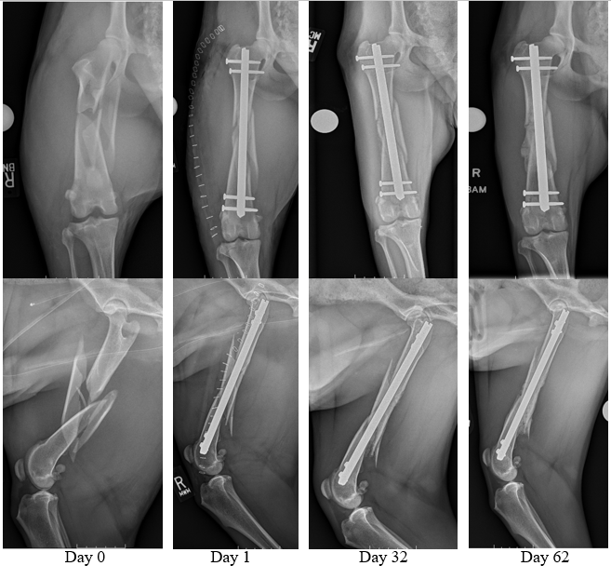
Figure 1: Preoperative and sequential post-fixation radiographs demonstrating acceptable and maintained fracture segment alignment, effective interlocking bolt placement and maintenance of bolt positioning without evidence of bolt related changes or complication through time. Radiographic union, indicated by radiographic evidence of osseous bridging of all cortices on orthogonal radiographs, is appreciable at day 62 post-operative.

Table 1 - Intramedullary Nail Characteristics and Sizing
Nail Size Utilized
8 mm | 7
6 mm | 7
Intraoperative Nail Modification | 4
Bent | 4
Shortened Distally | 1
8 mm Subject Weight (kg) | 34.5 (25.2, 45.5)
6 mm Subject Weight (kg) | 20.4 (10, 26.9)
Femoral Frontal Plane Canal Filling | 72.9% (59.0%, 92.6%)
Femoral Sagittal Plane Canal Filling | 68.4% (55.0%, 96.0%)
Tibial Frontal Plane Canal Filling | 77.9% (68.3%, 81.0%)
Tibial Sagittal Plane Canal Filling | 83.4% (75.8%, 92.9%)
Femoral Relative Nail Length | 85.6% (73.2%, 91.9%)
Tibial Relative Nail Length | 92.4% (87.6%, 97.7%)
Data reported as individual values or medians with associated range.

Values reported as median with associated range. Abbreviations: anatomic lateral distal femoral angle (aLDFA), mechanical lateral distal tibial angle (mLDTA).

References:
- Kaspar K, Schell H, Seebeck P, Thompson MS, Schütz M, Haas NP, Duda GN. Angle stable locking reduces interfragmentary movements and promotes healing after unreamed nailing. Study of a displaced osteotomy model in sheep tibiae. J Bone Joint Surg Am. 2005 Sep;87(9):2028-37.
- Déjardin LM, Cabassu JB, Guillou RP, Villwock M, Guiot LP, Haut RC. In vivo biomechanical evaluation of a novel angle-stable interlocking nail design in a canine tibial fracture model. Vet Surg. 2014 Mar;43(3):271-81.
- Grewal M, Hanlon J, Kim SE. Comparison of Implantation Accuracy and Efficiency Between Two, Angle Stable, Interlocking Bolt Designs for Intramedullary Nailing. Unpublished data, submitted to VOS 2026.
- Hanlon J, Kim SE. Mechanical evaluation of a threaded interference interlocking mechanism for angle-stable intramedullary nailing. Am J Vet Res. 2024 Jun 7;85(7):ajvr.24.03.0071.
- Cook JL, Evans R, Conzemius MG, Lascelles BD, McIlwraith CW, Pozzi A, Clegg P, Innes J, Schulz K, Houlton J, Fortier L, Cross AR, Hayashi K, Kapatkin A, Brown DC, Stewart A. Proposed definitions and criteria for reporting time frame, outcome, and complications for clinical orthopedic studies in veterinary medicine. Vet Surg. 2010 Dec;39(8):905-8.
- Perry KL, Wesslen R. Outcomes of 243 dogs with traumatic fractures treated with the I-Loc interlocking nail. Vet Surg. 2025 Jul 28.
- Roels J, Hebrard L, Saban C, Maggiar A, Ragetly G, Leperlier D, Pucheu B, Guillemot A, Viguier E, Gauthier O, Cachon T. Retrospective study of the early clinical experience with a precontoured angle-stable interlocking nail for fracture repair in dogs and cats. Am J Vet Res. 2024 Jan 27:1-10.

Acknowledgements: The authors are the sole creators of the impaction interference bolt design for angle stable intramedullary nailing. Funding for this project was generously provided through the DeBartolo family gift.

