Conservative Management of a Radial Fracture in a Foal with Medial to Lateral Instability Following Surgical Fixation Failure
A one day old warmblood colt presented with a simple, closed, complete, severely displaced, transverse, distal diaphyseal fracture of the right radius (Fig 1). The foal stood and nursed within an hour of being born, and, shortly after, the mare stepped on the colt, causing the injury. A single 12 hole 4.5 broad LCP plate was placed along the cranial aspect of the bone utilizing a combination of 4.0 locking and 4.5 cortical screws. Only one locking screw was used distal to the fracture, and a short unicortical cortical screw was placed close to the fracture (Fig 2). Amikacin impregnated calcium sulfate beads were placed along the implants. Post operatively the foal was maintained on potassium penicillin, gentamicin, and meloxicam. No behavior modifying drugs were utilized. The foal became progressively more energetic, bucking and playing in the stall. Two weeks following surgical repair, re-check radiographs showed significant lateral displacement of the distal aspect of the bone, and sedated palpation and manipulation demonstrated a severe lack of medial to lateral stability (Fig 3). The foal was not observed to be lame on the limb. The owner was opposed to a second surgery. The current author was consulted and an option for conservative management was offered, while still recommending a second surgery. The owner opted for conservative management.
The foal underwent general anesthesia for placement of a sleeve cast that extended from the elbow to the fetlock for medial to lateral stability (Fig 4). Waterproof Aqua Cast (AquaCast Liner LLC, Newark, DE) material was utilized in place of a stockinette as is described in people, and the cast padding was kept to a minimum. Behavior modifying drugs were implemented which were continued throughout his stay which included clonazepam (ineffective), trazodone (q 8-12 hrs), and/or alprazolam (q12 hrs). Antibiotics were discontinued. Casts were changed every 2-3 weeks. A mild sore formed over the accessory carpal bone, but this was managed with felt donuts under the cast. A shoe with medial and palmar heel extensions was utilized on the right front foot to support limb straightening and laxity. Following 8 weeks of casting, cast material was used to create a dorsal splint which was discontinued 2 weeks later. Reduced range of motion was present in the carpus, and passive range of motion exercises were instituted daily as possible.
The limb had severe laxity at the level of the carpus and a variety of orthotics were tried to support the carpus. An orthotic was dismantled to use the medial and lateral brackets placed medial and lateral along a bandage. At a bandage change, a sore was found over the distal cranial medial aspect of the radius, presumably from contact from the orthotics. After sterile preparation, a culturette was able to be easily passed through a pinpoint opening to the plate. Repeat cultures first identified a strep bacteria and later a staph. The foal was placed on oral chloramphenicol based on sensitivities. The wound drained a clear, serous odorless discharge. Orthotics were removed, and a light bandage was kept in place. The foal remained comfortable. Gradually walking was implemented, and the foal was weaned. The foal maintained on this management until 19 weeks post initial casting when the plate was removed (around 5 months of age)(Fig 5). Re-check culture found a staph still susceptible to chloramphenicol. The foal remained comfortable. The foal remains in hospital for ongoing care and rehabilitation to allow for the best chance at a level of athleticism.
Radial fractures are not typically conducive to management in a cast. Fracture repair has been described utilizing a single cranial plate in foals, although double plating is now typically recommended. The placement of the plate cranially allows for ideal use of the plate in tension. However, single plating does not provide significant medial to lateral stability. Following internal fixation, a cast is not typically recommended as it can change the forces through the limb and decrease the tension forces along the plate. However, in this case, the plate was still providing cranial to caudal stability, allowing the use of a cast to provide medial to lateral stability. While successful in this case, the care has been prolonged, costly, and there have been consequences to extensive casting, primarily decreased range of motion and excessive laxity leading to concerns for crushing of carpal bones. The use of orthotics can be beneficial, but have their own set of limitations and consequences due to the significant forces needed for an orthotic to support an equid limb. Overall, use of a cast to provide medial to lateral support in the event of ongoing cranial-caudal stability can be used to manage radial fractures in foals. This is the first report of successfully using a cast to support the radius following fracture repair failure of which the author is aware.
Figures:
Fig 1. A simple, closed, complete, severely displaced, transverse, distal diaphyseal fracture of the right radius in a 1 day old foal.
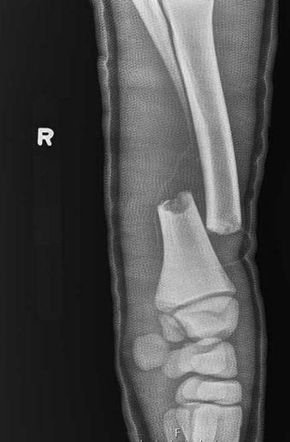
Fig 2. Intra-operative image of internal fixation.
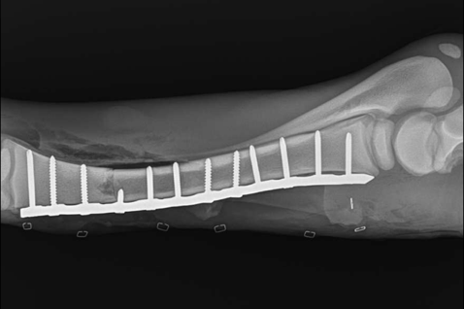
Fig 3. Medial to lateral failure of the surgical repair 2 weeks post initial surgery.
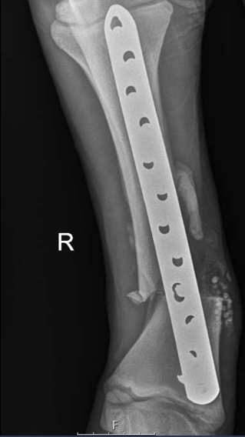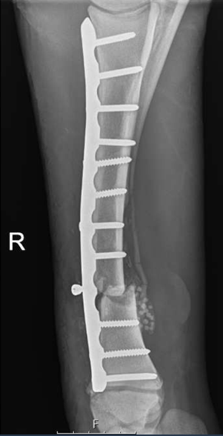
Fig 4. Reduction and casting following failure of the surgical repair. Reduction was only capable to a limited extent.

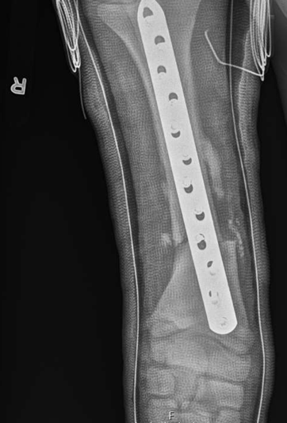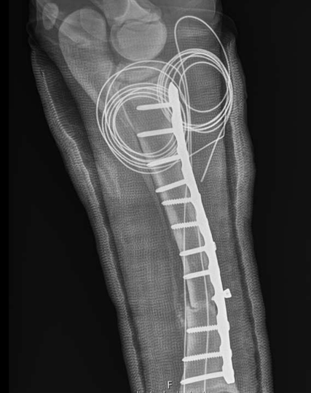
Fig 5. Radiographs following plate removal 19 weeks post initial casting (around 5 months of age).
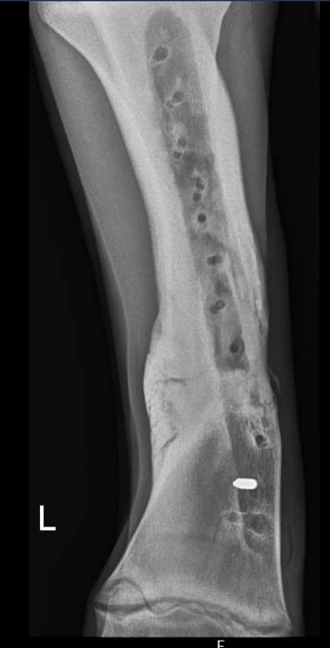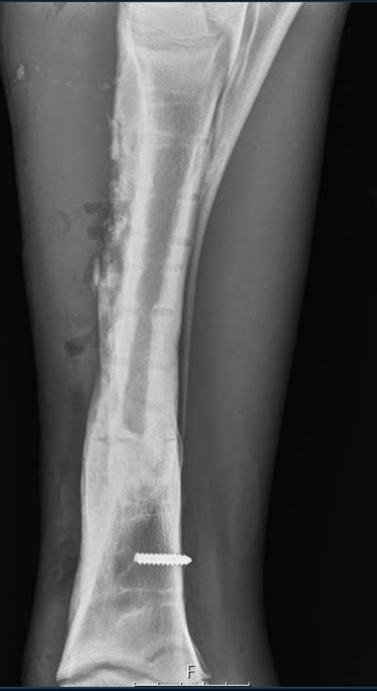
R
Acknowledgements: The author acknowledges a dedicated owner as being pivotal to success in this case.

