Development of a Protocol for Conscious Canine Computed Tomography to Evaluate Orthopedic Conditions in the Weight-Bearing Position.
Objective: Conscious Canine Computed Tomography (CC-CT) is a new approach to conventional CT enabling musculoskeletal structure assessment while standing. Weight-bearing can significantly influence joint congruence, and laxity; thus standing CT facilitates dynamic evaluation of orthopedic conditions such as elbow and hip dysplasia.¹⁻⁴ Recent research showed that thoracic limb alignment varies in standing versus recumbent imaging, and standing CT imaging revealed postural abnormalities, without osseous deformities, in dogs with grade 2 medial patellar luxation.^{1,4}
However, standing positioning alters beam trajectory through tissues, increasing artifact potential and reducing image quality. To date, no research has optimized CC-CT protocols.
This study aimed to develop a restraint device and imaging protocol to assess major canine joints under weight-bearing conditions and evaluate clinical use.
Study Design: This research was performed in 3 stages: restraint device development, clinical application, and imaging protocol optimization. During device development, various configurations based on previously described CC-CT devices were tested, including soft-shell carriers, screens, and plastic boxes, while avoiding heavy materials and metal (Images 1-4).⁴⁻⁶ Accessories tested, included commercial grooming harnesses (ATESON, Shenzhen) and calming hoodies (KOESON, Shenzhen). For a prototype to be considered successful, patients needed to remain immobile for >15 seconds, reflecting CT scan time.
In the clinical phase, 25 client-owned dogs of varying sizes, energy levels, and clinical indications for CC-CT were enrolled. Eight dogs from each size group (small <15 kg, medium 15–25 kg, and large >25 kg), over 12 months old, healthy or with well-controlled systemic disease, and without marked aggression or anxiety were included. Stress parameters were measured at rest, during physical exam and while assessing restraint device without CT. Investigators monitored stress through heart rate fluctuations (Apple Watch Series 2; Apple Inc., Cupertino) and Fear, Anxiety, and Stress (FAS) scores using the “Fear Free FAS scale”.⁷ Patients exhibiting sinus tachycardia (>180 bpm), or FAS (>3) were considered too stressed and recorded as unsuccessful. Pre-visit anxiolytics were prescribed for evening prior and morning of the scan (Tables 1-2, Figure 1).
Patients were then offered whole-body CC-CT. Patient cooperation was assessed as “Yes” (completed successfully), “No” (attempted- not tolerated), or “Not Attempted” (due to anxiety- inability to tolerate restraint). A maximum of three scans was allowed, minimizing radiation exposure.⁸ CC-CT imaging parameters (135 kVp, 310 mA, 0.75 s, and 0.813 pitch) were determined from published literature and consultation with board-certified radiologists.⁴⁻⁶
For protocol optimization, two cadavers were imaged using eight protocols with varying parameters (Table 3). Three blinded radiologists assessed image quality and artifact presence using two Likert Scales (Tables 4-5). The metacarpophalangeal/metatarsophalangeal, elbow, shoulder, hip, and stifle joints were evaluated individually, and average scores for each protocol determined optimal settings for standing imaging.
Results: Study population – A mixed population of dog breeds and energy levels were chosen to represent the general population (primarily mixed-breed dogs, with several purebreds represented). The average body weight was 20.5 ± 9.1 kg (range 3.8–40 kg). Gabapentin (17 ± 13 mg/kg; range 0–52 mg/kg) and/or Trazodone (6.5 ± 2 mg/kg; range 0–11 mg/kg) usage varied with anxiety levels.
Device development – The final product involved a hammock-style restraint system to maintain standing position during the scan (Image 5). To minimize distractions, the device was enclosed on all sides except the front, using wooden lateral panels with foam padding, fabric on top, and attachments for securing the grooming harness. Additions for comfort included anti-anxiety vests, traction mats, and a white-noise machine.
Clinical device testing – Dogs tolerated the restraint device fitting well. One patient was excluded for marked anxiety (FAS >3; n=1/25; 4%), 88% demonstrated mild anxiety (FAS 0-1; n=22/25) and 8% moderate (FAS 2–3; n=2/25). FAS scores during restraint device testing were consistent with baseline values, indicating that the device did not increase anxiety beyond typical in-hospital levels. Heart rates remained stable, with only minor fluctuations between baseline (99.8 ± 19.2 bpm), exam (105.1 ± 18.1 bpm), and restraint (99.3 ± 17.5 bpm) indicating negligible physiologic stress. Of the remaining 24 dogs, 18 (75%) successfully completed full-body CC-CT scans, 2 (8%) attempted but could not complete the scan, and 4 (17%) were not attempted due to pre-scan anxiety (Table 6).
CT imaging protocol – Protocol 7 (Table 7a-b; Figure 2) produced the best image quality and minimized artifacts resulting in minor noise/loss of detail and clear visualization of anatomical structures. Minimal windmill and beam-hardening/streaking artifacts were noted, preserving diagnostic utility. Minor improvements were noted in stifle and shoulder joint assessment by doubling pitch, but Protocol 7 achieved the lowest score across all joints (Table 7b).
Conclusion: This study presents a device and protocol of diagnostic utility for CC-CT. These findings show feasibility of CC-CT to assess weight-bearing effects on dynamic orthopedic conditions, advancing diagnostic and therapeutic approaches. Future studies may adjust pitch, field of view, and slice thickness to improve distal joint visualization and scanning efficiency while balancing radiation exposure.
Figures:
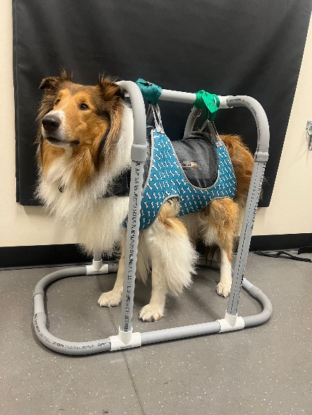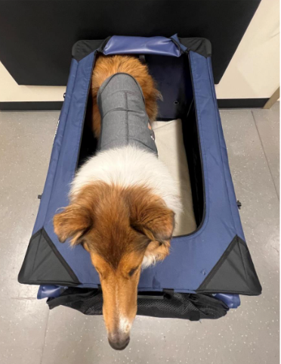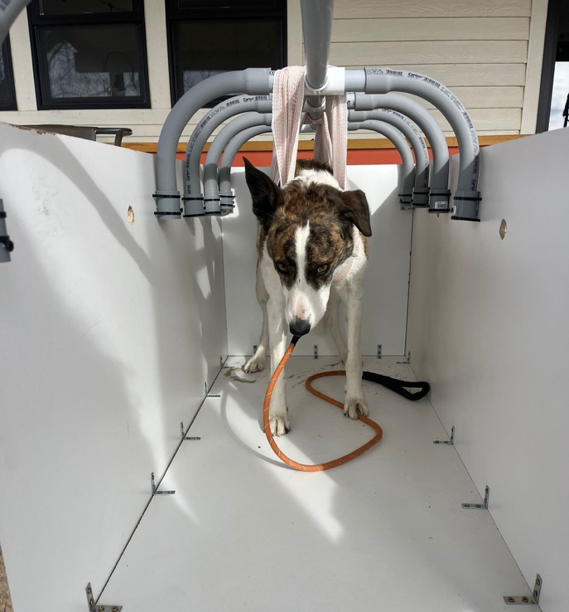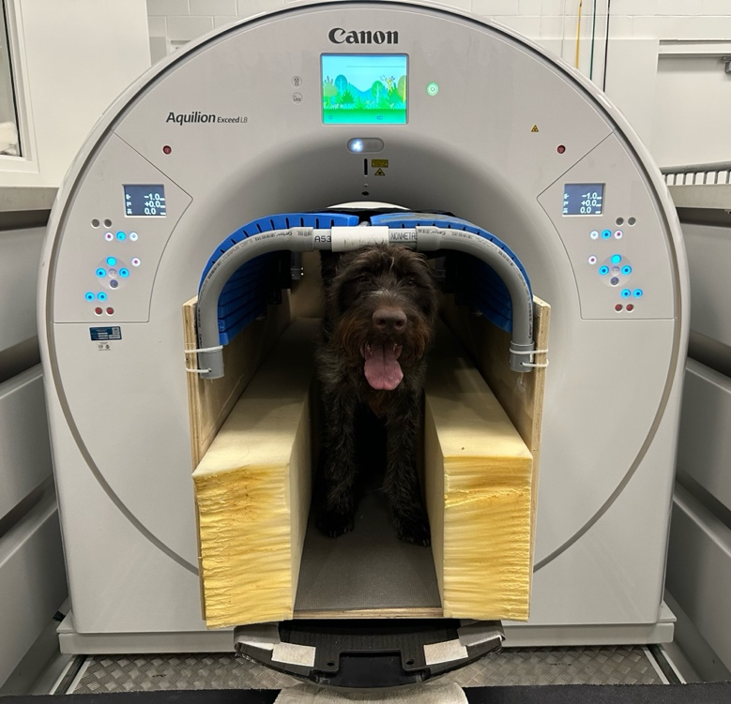
Images 1-4: Dogs shown in prototype restraint devices evaluated during development of the standing CT system.

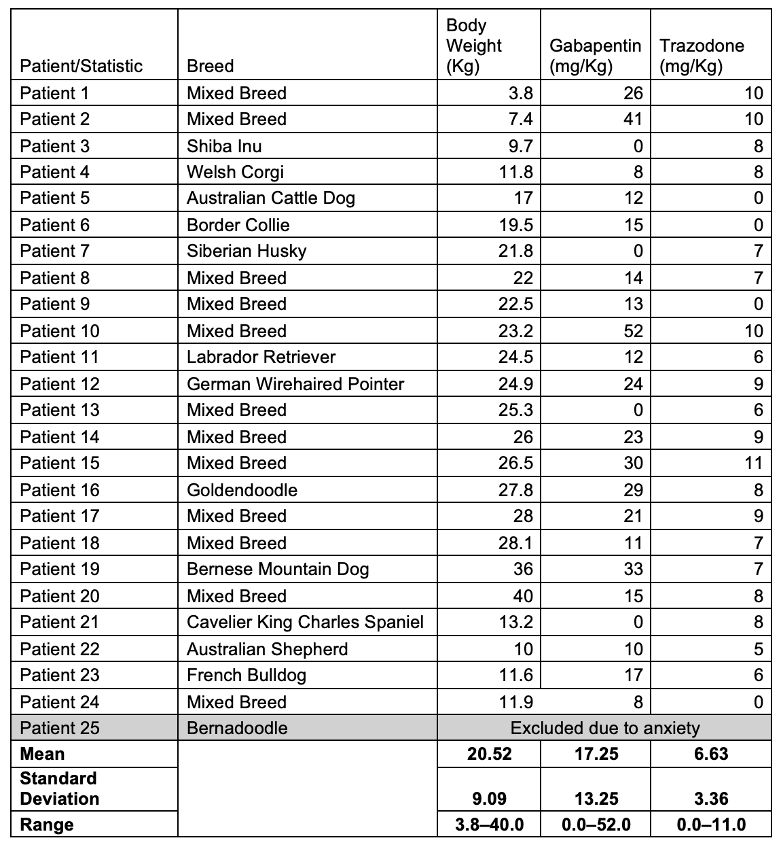
Table 1: Individual patient data and summary statistics for breed, body weight, and pre-visit anxiolytic dosages. Mean, standard deviation (SD), and range values are shown for body weight and anxiolytic medication dosages.
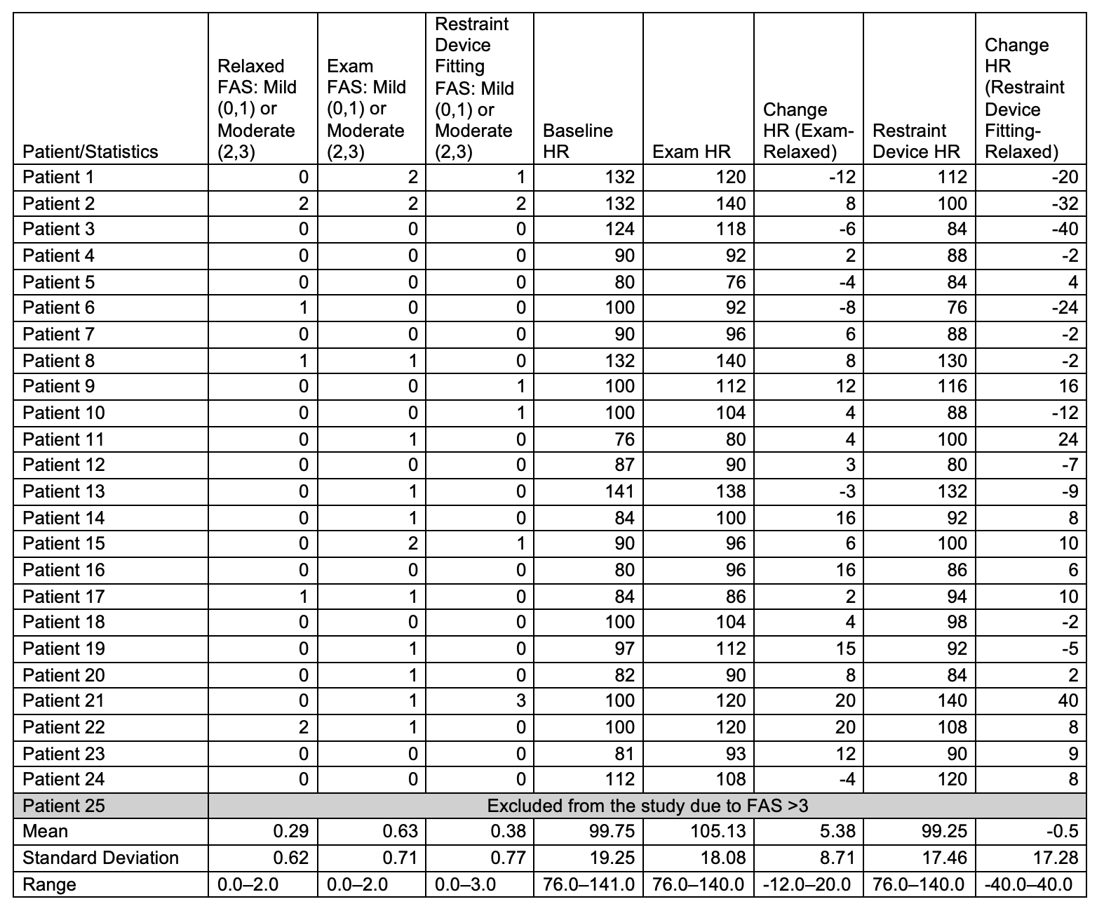
Table 2: Fear, Anxiety, and Stress (FAS) scores and heart rate (HR) changes during initial appointment through exam and restraint device fitting.
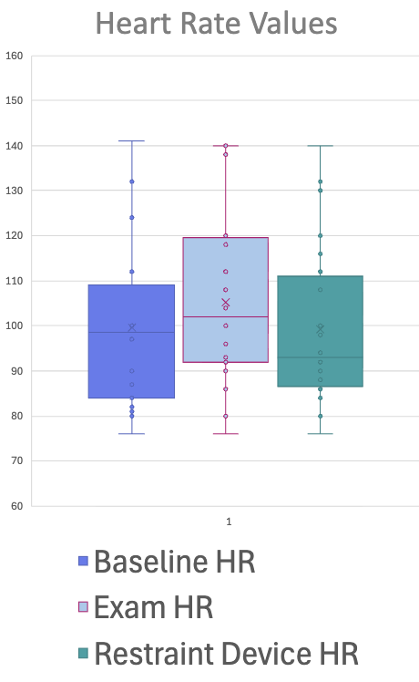
Figure 1: Heart rate comparison across evaluation phases. Box plot showing baseline, exam, and restraint device heart rate (HR) values.
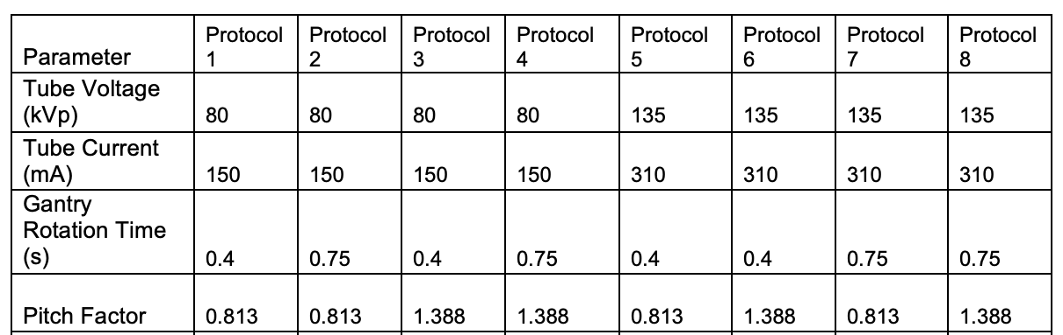
Table 3: Computed tomography (CT) imaging parameters tested across eight acquisition protocols varying by tube voltage (kV), tube current (mA), gantry rotation time, and pitch factor. A 160-slice helical gantry was used with the following parameters were held constant: 1 mm slice thickness, 55cm field of view (FOV), and 80 mmx 0.5 mm collimation. Bone and soft tissue reconstruction kernels with 1 mm thickness using AiCE image reconstruction were created.
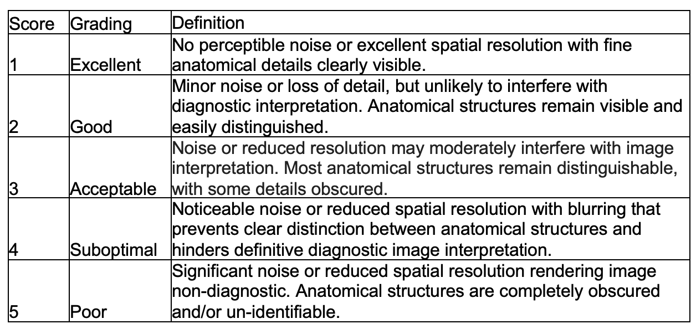
Table 4: Five-point Likert Scale for image quality assessment of cadaver images.
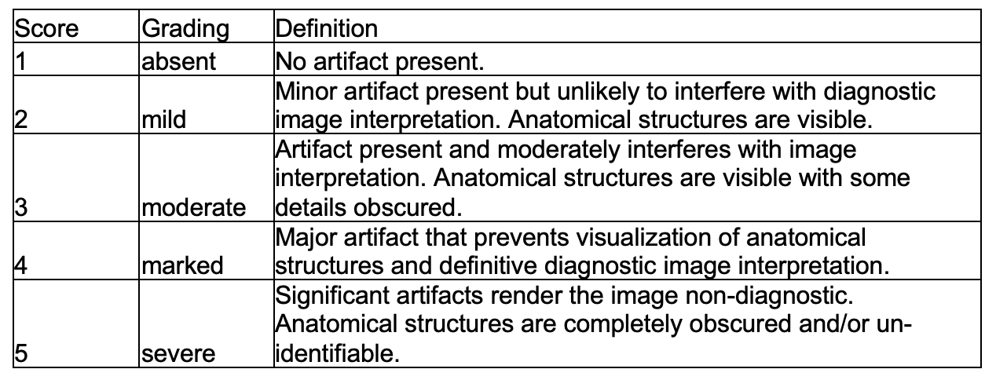
Table 5: Five-point Likert Scale for image artifact assessment of cadaver images.
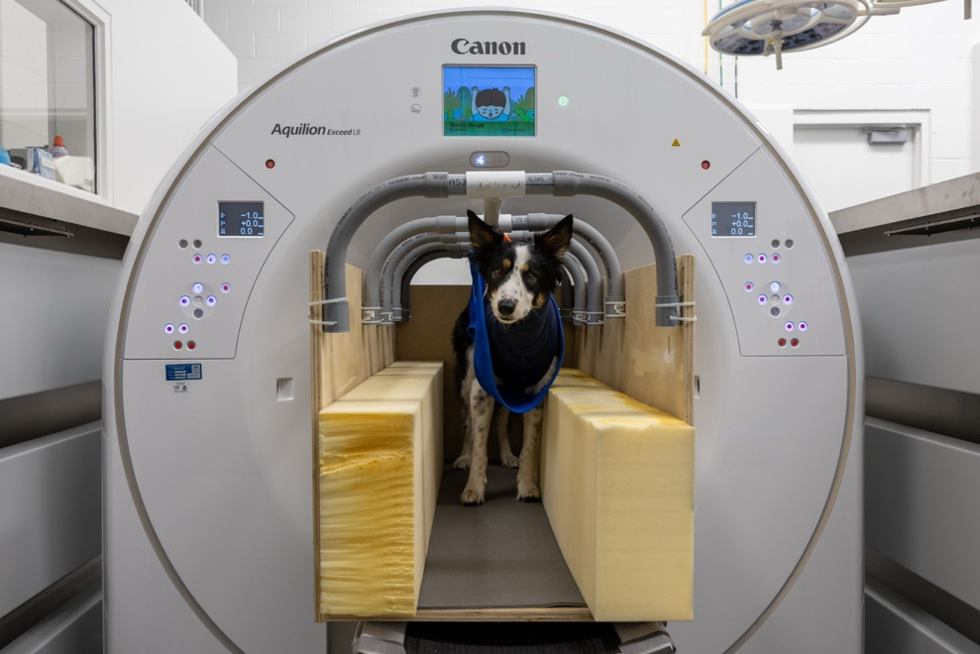
Image 5: Final standing CT restraint device prototype within the CT gantry. The top blanket cover has been removed in this image for visibility.
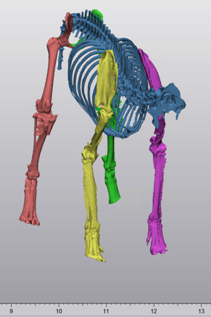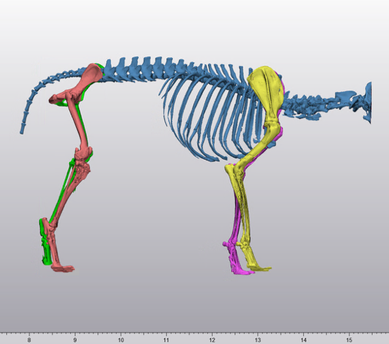
Image 6-7: Three-dimensional reconstruction of standing CT images demonstrating utilization for future clinical applications.
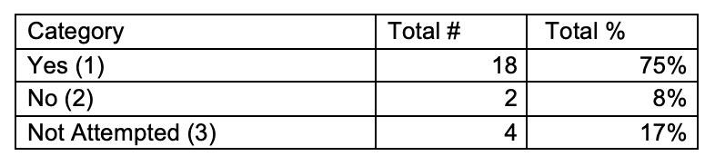
Table 6: Standing CT scan tolerance and completion rates. “Yes” indicates patients that tolerated and completed the scan; “No” indicates patients that attempted but could not complete the scan; and “Not Attempted” indicates patients unable to tolerate the restraint before scanning.
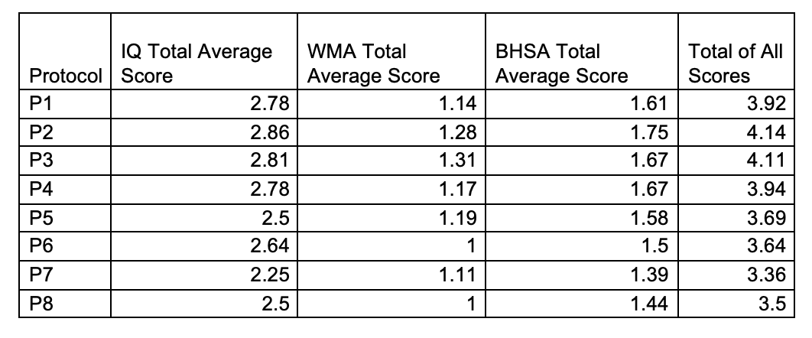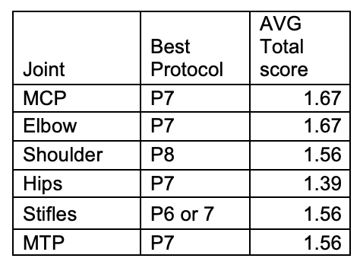
Table 7a and b: Total average image quality-IQ, and artifact presence (windmill-WMA and beam hardening/streaking- BHSA) across all eight CT protocols and six major canine joints.
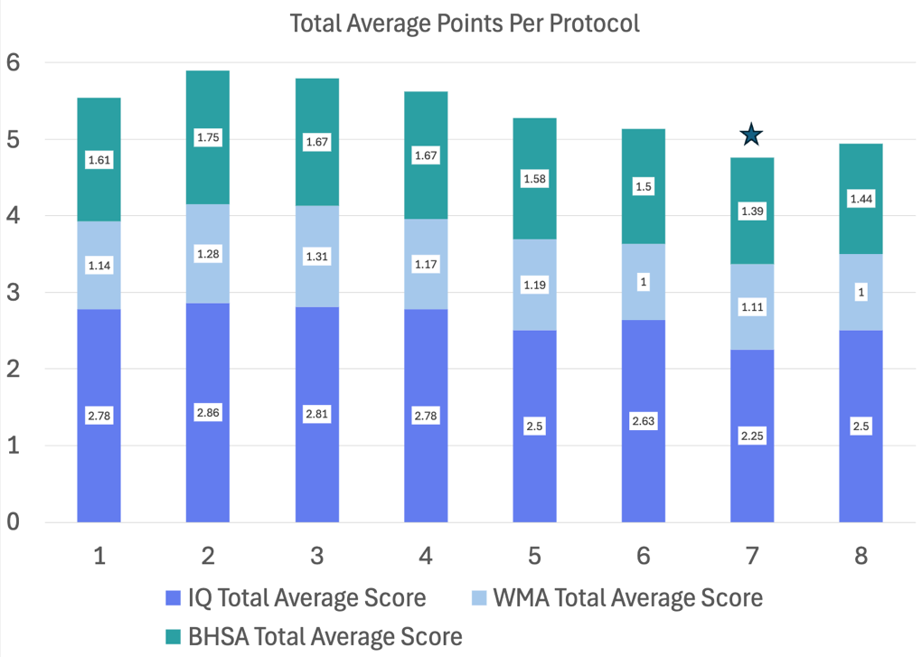
Figure 2: Total average image quality-IQ, and artifact presence (windmill-WMA and beam hardening/streaking- BHSA) across all eight CT protocols. Protocol 7 is marked with a star to indicate the overall best imaging protocol with the lowest cumulative score.
References:
1. Goodrich ZJ, Norby B, Eichelberger BM, et al. Thoracic limb alignment in healthy Labrador Retrievers: Evaluation of standing versus recumbent frontal plane radiography. Vet Surg 43:791–803, 2014.
2. Farese JP, Todhunter RJ, Lust G, et al. Dorsolateral subluxation of hip joints in dogs measured in a weight-bearing position with radiography and computed tomography. Vet Surg 27:393–405, 1998.
3. Fujiki M, Misumi K, Sakamoto H. Laxity of canine hip joint in two positions with computed tomography. J Vet Med Sci 66:1003–1006, 2004.
4. Tomo Y, Yamazaki A, Tanegashima K, Seki M, Asano K, Tinga S, Hayashi K. Evaluation of hindlimb deformity and posture in dogs with grade 2 medial patellar luxation during awake computed tomography imaging while standing. Vet Comp Orthop Traumatol 35:261–269, 2022.
5. Lee K, Heng HG, Jeong J, et al. Feasibility of computed tomography in awake dogs with traumatic pelvic fracture. Vet Radiol Ultrasound 53:412–416, 2012.
6. Oliveira CR, Ranallo FN, Pijanowski GJ, et al. The VetMousetrap: A device for computed tomographic imaging of the thorax of awake cats. Vet Radiol Ultrasound 52:41–52, 2011.
7. Mandese WW, Griffin FC, Reynolds PS, et al. Stress in client-owned dogs related to clinical exam location: A randomised crossover trial. J Small Anim Pract 62:105–112, 2021.
8. Taylor N, Renfrew H. Does dose matter? Ionizing radiation exposure of the veterinary patient from computed tomography: A discussion. Top Companion Anim Med 51:100697, 2022.
Acknowledgements: Partial funding was provided by a private foundation. A coauthor has an affiliation with the company that provided the CT equipment used in this study.

