Effect of Osteotomy and Plate Orientation on Rock-Back Following Tibial Plateau Leveling Osteotomy Using a Tibial Gap Model

Objective
While TPLO is considered highly successful, the rate of major complications remains at 3-15%.¹⁻³ One such complication, known as tibial plateau rock-back (RB), describes a postoperative secondary loss of reduction due to fixation failure.⁴ While RB may result in an increase in tibial plateau angle (TPA) without clinical repercussion, stifle instability, valgus deformity, fibular fracture and delayed or non-union have been reported in severe cases. While RB has been anecdotally identified, its etiology remains speculative⁵ (Figures 1, 2).
We surmise that osteotomy orientation and bone plate inclination have an impact on RB. Osteotomy orientation in relation to the caudal tibial cortex (CTC) has been described as uphill, downhill or normal (Figure 3). With an uphill cut, often achieved when using small diameter saw blades, the tibial plateau tends to center itself toward the lowest point of the osteotomy during loading. While this could increase interfragmentary stability, rotation may be challenging. Conversely, with a downhill cut, often seen when using larger diameter saw blades, disruptive interfragmentary shear forces predisposing to RB may be generated. A normal cut, which is oriented 90° to the CTC, may strike a balance between ease of rotation while minimizing interfragmentary shear force. Regarding plate inclination, optimal stability is theoretically achieved when the plate long axis is parallel to the tibial mechanical axis (TMA). Yet to optimize screw purchase in the widest part of the tibial plateau, plates are often oriented obliquely to this axis. Under compressive loads, this may generate a disruptive force couple, increasing the risk of RB (Figure 4).
Our objective is to evaluate the effect of osteotomy orientation and plate inclination on RB using a 3D printed tibial gap model. We compared RB between 1) osteotomies (uphill, downhill, normal) in relation to the CTC and 2) bone plate orientations (parallel, 20° inclination) in relation to the TMA. We hypothesize that the greatest RB occurs with a downhill osteotomy and inclined plate and smallest RB occurs with an uphill osteotomy and straight plate.

Study Design
The right tibia of an ~26 kg dog with a TPA of 26° was segmented from a CT. Models of the tibia featuring one of three osteotomies with a 1mm interfragmentary gap were created. A spherical depression centered on the tibial eminences and a cylindrical base were designed for loading. The tibial plateau was then digitally rotated to a TPA of 5°. For each osteotomy, the Computer-Aided Design model of a 2.7 mm Depuy-Synthes TPLO plate was overlaid on the medial tibial cortex. Plates were oriented parallel to or at a 20° incline to the TMA. Pilot holes were designed to follow the predetermined screw trajectories. A model specific cast was designed for each of the six groups (two plate inclinations for each osteotomy orientation – Figure 5). Specimens and casts were then 3D printed. Models were stabilized with a 2.7 mm TPLO plate. Specimens were mounted in a custom loading press featuring a fixed base and a proximal loading sphere coupled to a universal joint⁶.
Electromagnetic sensors were applied to the tibial plateau and crest. Specimens were cyclically loaded to 400N (Figure 6) while angular displacements of the tibial plateau in all planes were recorded. Mean (± SD) RB between groups was compared using a two-factor ANOVA and Tukey’s post-hoc pairwise comparison when significance, set at p<0.05, was found.

Results
Regardless of osteotomy orientation, RB was consistently 1.5 times greater with inclined plates than with plates parallel to the TMA (p<0.0001). Mean ± SD RB was 3.2° ± 0.3° (inclined) and 2.1° ± 0.1° (straight). Osteotomy orientation alone did not have a significant effect on RB, however when comparing the interaction between the osteotomy orientation and plate inclination, the greatest RB occurred with the inclined plates in the downhill osteotomy group.

Conclusion
Our findings support our first hypothesis and demonstrate that the magnitude of tibial plateau rock-back increases with plate inclination. This likely results from generation of a disruptive force couple, during which the moment arm between plate and TMA increases with plate inclination. In contrast, our second hypothesis was rejected with no significance found for osteotomy orientation. This finding may be explained by using a gap model as contact between fragments did not occur even at higher loads, which may mitigate the anticipated sliding motion of the tibial plateau. A low sample size could also explain this finding. However, the interaction between groups did show a trend for the greatest RB with a downhill osteotomy and inclined plate.
Limitations of this study include the use of 3D printed bone models rather than native bone and use of a gap model that may have prevented interface contact during loading.
This study aims at increasing our understanding of TPLO biomechanics and reducing postoperative complications. Future studies could evaluate the effect of interfragmentary gap, plate design and loading conditions on experimentally induced RB.

Acknowledgements
This research was funded by the MSU Endowed Research Fund. DePuy-Synthes donated the implants used in this study. There was no conflict of interest for this project. We would like to acknowledge Ranjan Mukherjee and Mahmoud Abdullatif from the MSU College of Engineering for their assistance during mechanical testing as well as Sichao Wang for the statistical analysis.

Figures:

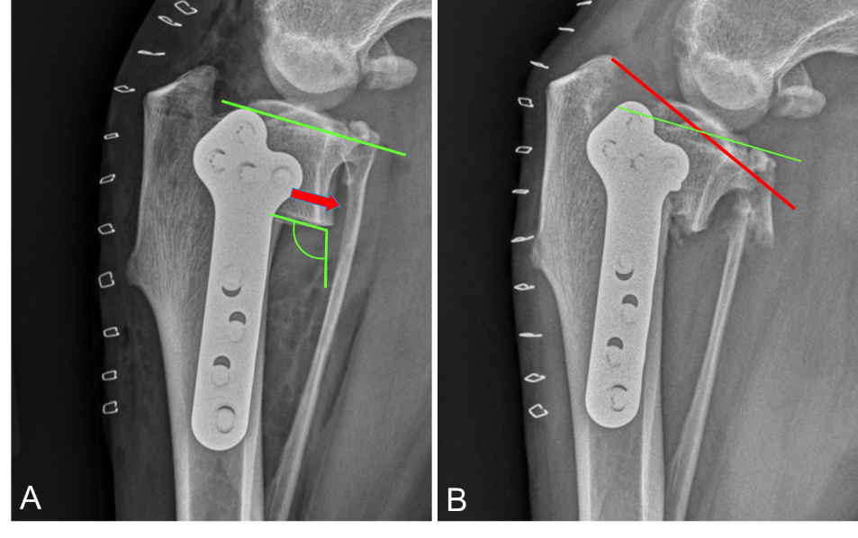

Figure 1. Radiographs of a clinical case illustrating the effect of tibial plateau rock-back. A – immediate postoperative radiograph showing an 8° TPA. Note the downhill osteotomy orientation with respect to the caudal tibial cortex. B – eight-week postoperative radiograph illustrating tibial plateau rock-back with a 27° TPA as well as fixation and bone failures.

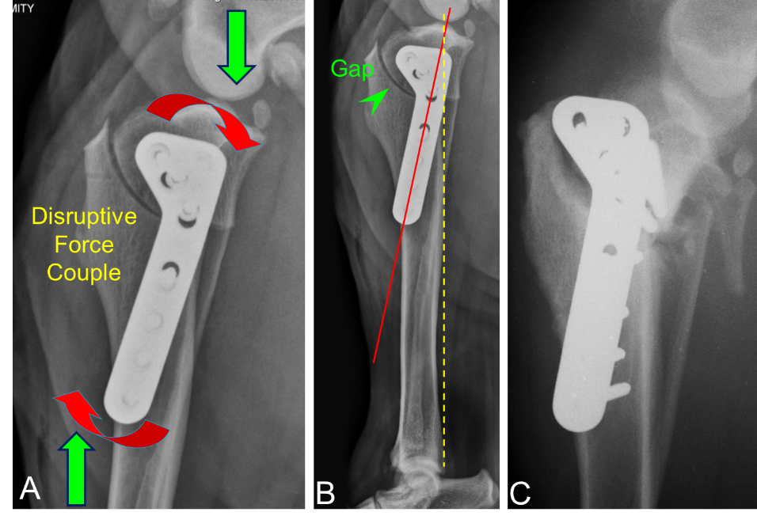

Figure 2. Radiographs of a clinical case illustrating tibial plateau rock-back. A – immediate postoperative radiograph showing the bone plate substantially inclined in relation to the tibial mechanical axis. Compressive loads generate a disruptive force couple that can be amplified by plate inclination. B – Note also the presence of an osteotomy gap. C – two-week postoperative radiograph illustrating tibial plateau rock-back and catastrophic fixation failure, namely bone failure including fibular fracture and implant loosening associated with screw fatigue failure.

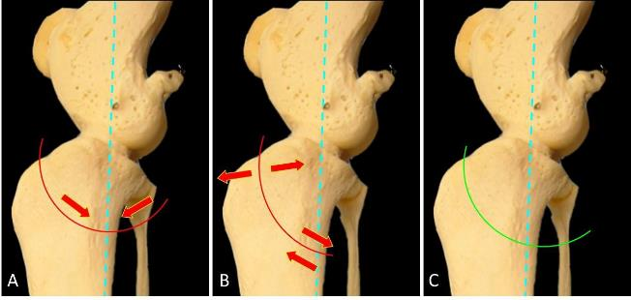

Figure 3. Potential effects of various osteotomies on interfragmentary stability A – uphill cut, tibial plateau centering toward the bottom of the osteotomy may improve postoperative stability. B – downhill cut, a disruptive force couple may promote fragment separation along the osteotomy and may lead to rock-back. C – normal cut, may represent a compromise between fragment stability and ease of tibial plateau rotation. Dotted line: tibial mechanical axis.

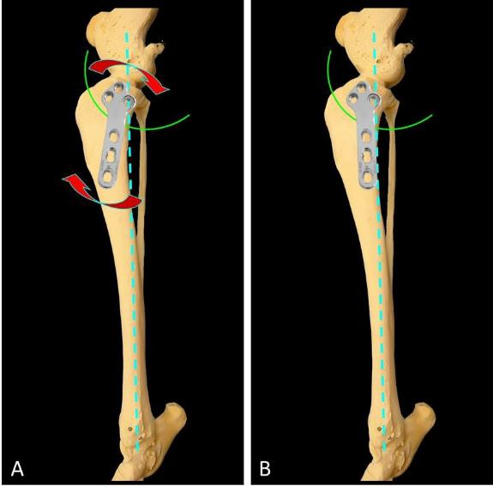

Figure 4. Illustration of the potential effect of two plate inclinations on interfragmentary stability. A – an inclined plate in relation to the tibial mechanical axis (dotted line) may generate a disruptive force couple that increases the risk of rock-back. B – by eliminating this disruptive force couple, a plate parallel to the tibial mechanical axis could reduce the risk of rock-back.

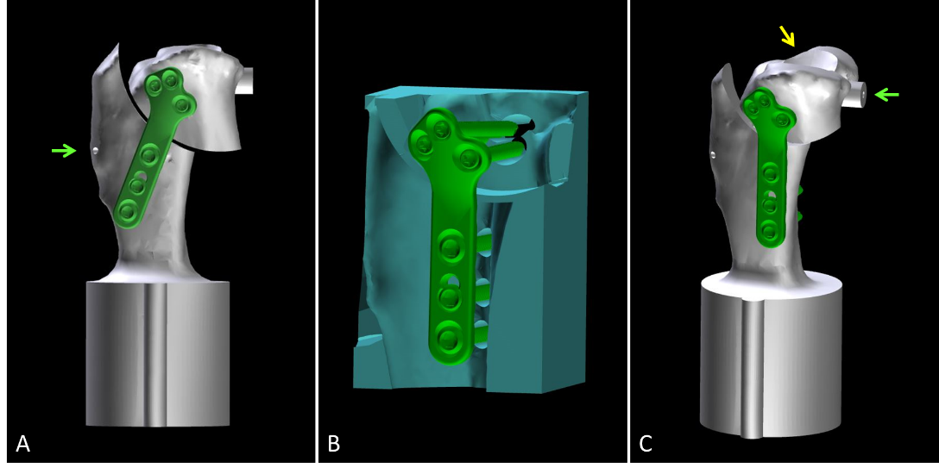

Figure 5. Computer-Aided Design of tibial gap models generated from CT data. A – lateral view of a downhill osteotomy model with an inclined TPLO plate. B – CAD of TPLO plate and tibial cast illustrating the screw trajectories of a parallel plate in an uphill osteotomy model. Model specific casts maintained tibial segment alignment during plate application. C – isometric view of an uphill osteotomy with a parallel TPLO plate. A spherical depression centered on the tibial eminences allows unconstrained loading of the specimens (yellow arrow). The green arrows (A and C) indicate the electromagnetic sensor locations.

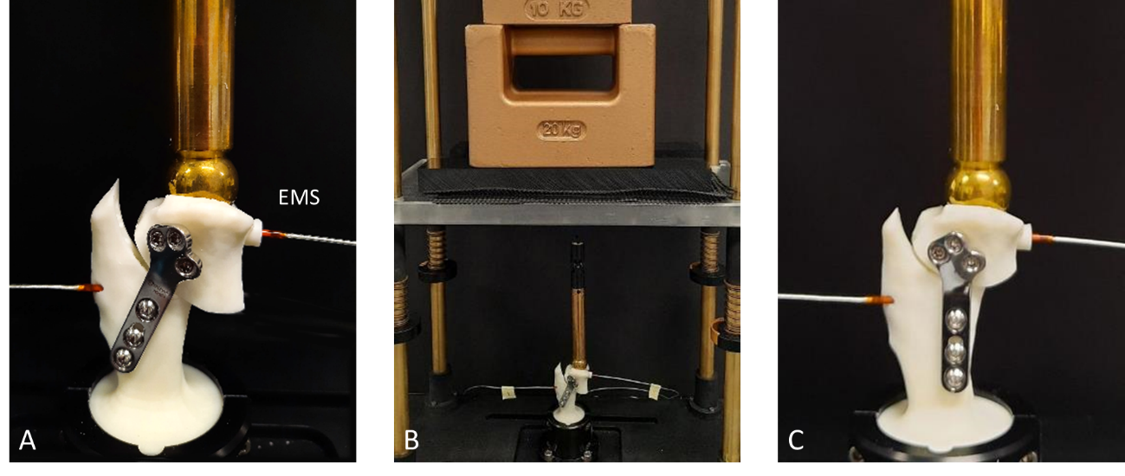

Figure 6. Printed models showing a downhill osteotomy with an inclined plate (A) and an uphill osteotomy with a parallel plate (C) mounted in a loading press (B). Electromagnetic sensors have been placed on each tibial segment (i.e. tibial plateau and tibial crest) to capture angular displacements of the tibial plateau.

References:
- Coletti TJ et al. Complications associated with tibial plateau leveling osteotomy: A retrospective of 1519 procedures. Can Vet J. 2014; 55: 249-254.
- Gatineau M et al. Retrospective study of 476 tibial plateau levelling osteotomy procedures. Vet Comp Orthop Traumatol. 2011; 24: 333-341.
- Pacchiana PD et al. Surgical and postoperative complications associated with tibial plateau leveling osteotomy in dogs with cranial cruciate ligament rupture: 397 cases (1998-2001). J Am Vet Med Assoc. 2003; 222(2): 184-193.
- Kim SE et al. Tibial Osteotomies for Cranial Cruciate Ligament Insufficiency in Dogs. Vet Surg. 2008; 37: 111-125.
- Kloc II PA et al. Biomechanical Comparison of Two Alternative Tibial Plateau Leveling Osteotomy Plates with the Original Standard in an Axially Loaded Gap Model: An In Vitro Study. Vet Surg. 2009; 38: 40-48.
- Warzee CC et al. Effect of Tibial Plateau Leveling on Cranial and Caudal Tibial Thrusts in Canine Cranial Cruciate-Deficient Stifles: An In Vitro Experimental Study. Vet Surg. 2001; 278-286.

