Objective:
Impinging or overriding spinous processes (ISPs) are a common cause of back pain in performance horses¹. Diagnostic analgesia is considered the gold standard for confirming clinical relevance; however the accuracy of thoracolumbar spinous region analgesia remains poorly characterized²⁻³. Local anesthesia of the interspinous or paraspinous regions of the thoracolumbar spine is intended to selectively desensitize ISPs; however, adjacent structures may also be desensitized due to anatomical proximity. In comparison to other regional diagnostic analgesia techniques, diagnostic analgesia of the thoracolumbar spine is poorly understood, and the described techniques and volumes used vary widely⁴. Improved understanding of the accuracy and diffusion of these injections is critical for diagnosis and interpretation of clinical response. This study aimed to evaluate the accuracy of midline thoracic interspinous space injection at T15-T16 in equine cadavers using three injectate volumes, assessed by computed tomography (CT) and anatomical dissection. We hypothesized that (1) injectate would not remain confined to the interspinous space, (2) injectate would disperse to multiple adjacent, clinically relevant structures such as thoracolumbar articular process joints, and (3) increasing injectate volume would correlate positively with the increased spread in both craniocaudal and dorsoventral directions.
Study Design:
Ex vivo experimental study conducted at a university equine referral center. Thoracolumbar segments (T12-L2) from ten adult horses were collected post-euthanasia under IACUC approval, following pre-mortem radiographic screening to exclude specimens with < grade 3 ISPs at T15-T16. The T15-T16 interspinous space of each specimen was injected under radiographic guidance with 5, 10, or 20 ml of a 3:1 iohexol:methylene blue solution using a 20-gauge, 3.5-inch spinal needle inserted dorsoventrally along midline (Figure 1). Injection volumes were randomly assigned, and needle placement was confirmed radiographically. Within 30 minutes, helical CT imaging was performed to evaluate contrast distribution. CT was assessed in multiple planes for distribution of contrast to several structures including the interspinous ligament, thoracic articular process joints (TAPJs), intervertebral foramina, interarcuate ligament, epidural space, and surrounding musculature. Following CT, specimens were frozen and serially sectioned at 0.8–1 cm intervals for gross evaluation of methylene blue dispersal. The relationship between injectate volume and craniocaudal or dorsoventral injectate spread was analyzed using Bayesian linear regression.
Results:
Injectate remained confined to the T15-T16 interspinous space in 6/10 specimens. Periarticular spread to > 1 TAPJ occurred in 9/10 specimens (Figure 2), and injectate was observed within > 1 intervertebral foramen in all specimens (Figure 3). Epidural spread occurred in 2 specimens (10 ml and 20 ml injectate volumes) (Figure 4). Median [range] dorsoventral spread was 54 [48-74] mm for 5 ml, 59.6 [50.9-77.2] mm for 10 ml, and 75.7 [47.6-86.8] mm for 20 ml. Median [range] craniocaudal spread was 82.7 [81.4-97.3] mm for 5 ml, 86.2 [62.5-149.7] mm for 10 ml, and 120 [102.8-203] mm for 20 ml (Figure 5). Increasing injectate volume was associated with greater craniocaudal spread (+4.02 mm per ml; 95% credible interval 0.09-8.15) but not associated with dorsoventral spread.
Conclusion:
Results supported the first two hypotheses and partially supported the third. Injectate frequently dispersed beyond the T15-T16 interspinous space to adjacent structures, including TAPJs and intervertebral foramina. Larger injectate volumes increased craniocaudal spread, reducing specificity. Midline T15-T16 injections were variable and may desensitize multiple anatomical sites, limiting the specificity of diagnostic interpretation. Low volume injection may improve the accuracy for the interspinous space. This study demonstrates that interspinous injection at T15-T16 can diffuses to surrounding anatomical structures. These findings may help inform the clinical approach to diagnostic analgesia of the thoracolumbar region. Further in vivo studies are needed to refine thoracolumbar injection techniques.
Acknowledgements:
The authors thank the Firestone/Tamworth/Raker-Tulleners Grant and the Allam Center for Equine Sports Endowment Fund for funding support. Appreciation is extended to the technicians and support staff at the New Bolton Center, University of Pennsylvania.
References:
(1) Jeffcott LB. Disorders of the thoracolumbar spine of the horse — a survey of 443 cases. Equine Vet J 1980; 12:197–210. https://doi.org/10.1111/j.2042-3306.1980.tb03427.x.
(2) Walmsley JP, Pettersson H, Winberg F, McEvoy F. Impingement of the dorsal spinous processes in 8 two hundred and fifteen horses: case selection, surgical technique and results. Equine Vet J 2002; 34:23–8. https://doi.org/10.2746/042516402776181259.
(3) Zimmerman M, Dyson S, Murray R. Close, impinging and overriding spinous processes in the thoracolumbar spine: The relationship between radiological and scintigraphic findings and clinical signs. Equine Vet J 2012; 44:178–84. https://doi.org/10.1111/j.2042-3306.2011.00373.x
(4) Derham AM, Schumacher J, O’ Leary JM, Kelly G, Hahn CN. Implications of the neuroanatomy of the equine thoracolumbar vertebral column with regional anaesthesia and complications following desmotomy of the interspinous ligament. Equine Vet J 2021; 53:649–55. https://doi.org/10.1111/evj.13402.

Table
Horse | Injectate volume | Laterality | Dorsoventral distance (mm) | Craniocaudal distance (mm) | Interspinous space | Periarticular (<5mm) | Interarcuate ligament | Epidural space | Intervertebral foramina
1 (P) | 10ml | R | 50.9 | 86.2 | T15-16, T16-17 | R T15-16 | N | N | R T15-16, T 16-17
2 | 5ml | R | 48 | 82.7 | N | R T16-17 | N | N | R T15-16, T16-17
3 | 5ml | R | 54 | 97.3 | N | R T15-16 | N | N | R T15-16, R T16-17
4 | 10ml | M | 77.2 | 62.5 | T15-16 | N | Y | Y | B T16-17
5 | 20ml | M | 75.7 | 102.8 | T15-16 | R T16-17 | Y | N | B T15-16, B T16-17, R T17-18
6 | 20ml | L | 47.6 | 203 | N | L T17-18 | N | N | L T17-18, L T18- L1
7 | 10ml | R | 55.6 | 149.7 | N | R T16-17, R T17-18 | N | N | R 15-16, R16-17, R 17-18
8 | 10ml | M to L | 63.5 | 95.3 | T15-16 | L T15-16 | N | N | L T17-18, R T16-17
9 | 20ml | M | 86.8 | 120 | T15-16 | B T15-16, B T16-17 | Y | Y | B T15-16, B T16-17
10 | 5ml | M to L | 74 | 81.4 | T15-16 | B T15-16, B 16-17 | N | N | L T16-17

Figures:
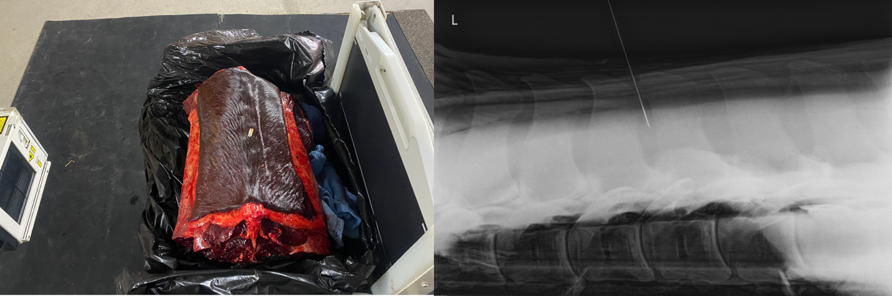
Figure 1. (A) Thoracolumbar specimen positioned on a table for interspinous injection with radiographic guidance. (B) Lateral to lateral radiograph of the thoracolumbar specimen showing placement of the spinal needle in the T15-16 interspinous space at a depth of approximately half the length of the adjacent dorsal spinous process.

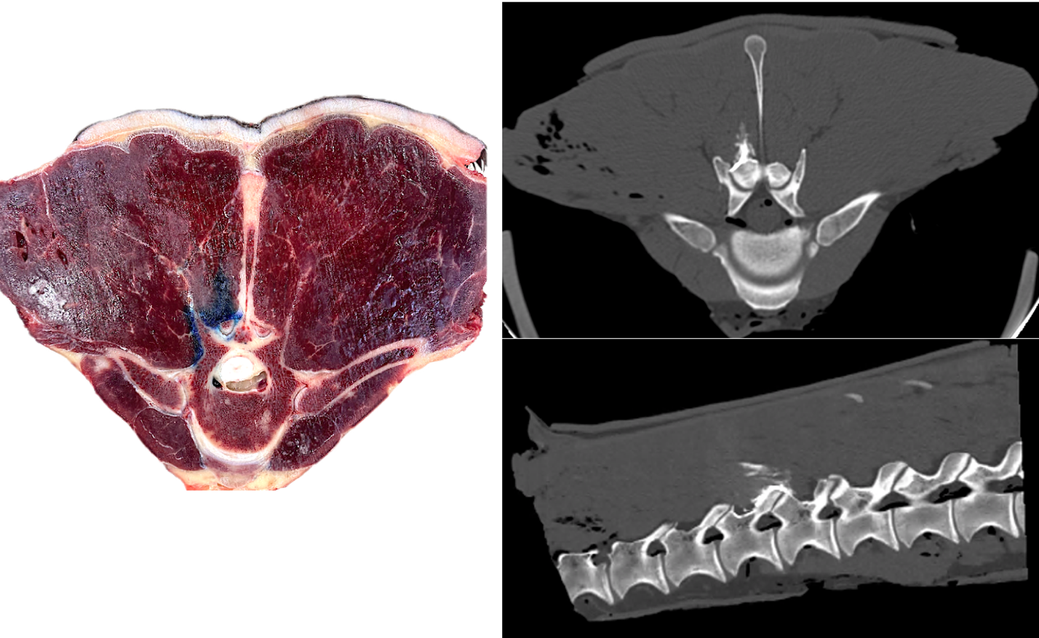
Figure 2. (A) Transverse section of the frozen thoracolumbar specimen at the level of T15-T16 process joint in the pilot horse showing methylene blue within the right multifidus with distribution periarticular to the right T15-16 articular process joint. (B) The corresponding computed tomographic transverse image at T15-16 demonstrating matching dispersal of iodinated contrast.

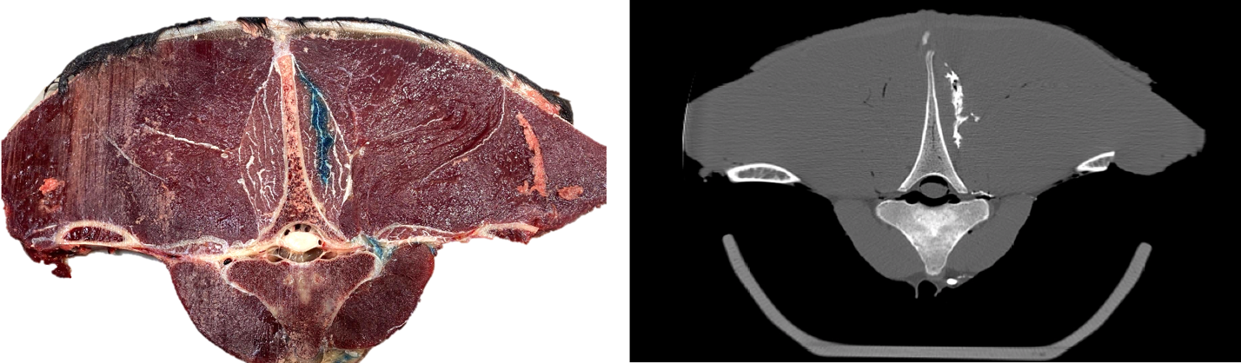
Figure 3. (A) Transverse section of the frozen thoracolumbar specimen at the level of T16-17 intervertebral foramen and T17 dorsal spinal process in Horse 2 showing methylene blue within the right multifidus and within the right intervertebral foramen at the exit of the spinal nerves. (B) The corresponding computed tomographic transverse image demonstrating matching dispersal of iodinated contrast.

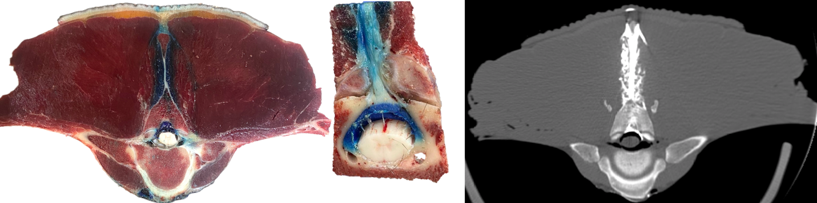
Figure 4. (A) Transverse section of the frozen thoracolumbar specimen at the level of cranial T16 vertebral body and costovertebral joints in Horse 3 showing methylene blue within the interspinous space and travelling distally through the interarucate ligament, the interarcuate space, and into the epidural space (B) The corresponding computed tomographic transverse image demonstrating matching dispersal of iodinated contrast (C) The corresponding computed tomographic sagittal image demonstrating matching dispersal of iodinated contrast.

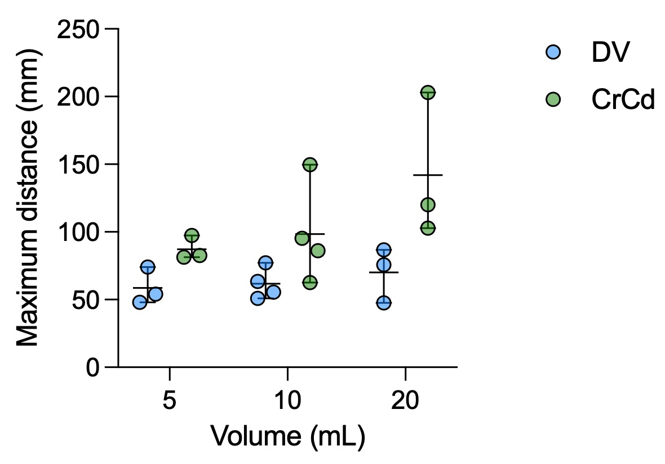
Figure 5: Scatter plot with median and range (whiskers) showing the relationship between injectate volume (mL) and distribution distance in dorsoventral (DV, blue circles) and craniocaudal (CrCd, green circles) directions.

