Comparison of Implantation Accuracy and Efficiency Between Two, Angle Stable, Interlocking Bolt Designs for Intramedullary Nailing

Objective: Angle-stable bolt-nail interfaces for intramedullary nailing creates robust torsional stability and can improve fracture healing, however, achieving angle-stability requires complex instrumentation and implant design.¹⁻³ The commercially available, Morse-taper, threaded bolt system (I-Loc) commonly used in veterinary patients utilizes a novel depth gauge, transient stabilization with pegs, and a specialized bolt cutter. Implantation requires numerous steps including application of temporary pegs, taking two measurements per hole, and cutting both ends of each bolt. Intraoperative complications of the system include inaccurate drilling and bolt cross threading. To reduce complexity, an impaction interference bolt system (IIB) was created, utilizing simplified measuring methods and bolts designed to be impacted into a nail hole for an angle stable interface.^{4,5} The objective of this study was to assess timing and accuracy of the IIB system for drilling and bolt placement in comparison to the I-Loc instrumentation and design. We hypothesized the IIB system would reduce drilling, measuring, bolt preparation and bolt implantation time, as well as overall drilling and bolt implantation time compared to the I-Loc system. Our null hypothesis for accuracy was that both bolt designs would achieve complete seating, bicortical engagement and suitable bolt lengths.

Study Design: For each participant, four, 3D, hollow bone models were designed and printed with varying proximal and distal bone diameters using ABS material (Figure 1, 2). Two models were used for 147 mm long, 6mm I-Loc (Biomedtrix, Whippany, NJ) nails and two for the 160 mm long, 6 mm Original Interlocking Nails (Innovative Animal Products, IAP, Rochester, MN). Four, board-certified, veterinary surgeons with I-Loc system experience were included in this study. Participants were provided instructional videos and practice models/implants for both systems prior to testing. The nail and respective targeting guide were pre-assembled, ensuring proper alignment, and placed within bone models prior to testing. In random order and adhering to manufacturer protocol, each participant performed bolt placement in two, pre-assembled, I-Loc nail-bone models using Morse-taper bolts (MTB) and two, pre-assembled IAP nail-bone models using the IIB. Each round of bolt placement was timed and recorded. Drilling, measuring, preparation, and implantation times were noted for each bolt and combined, total time for drilling, measuring, and placing all bolts for each sample were recorded. Following completion, bolt placement evaluation for appropriate bolt seating and appropriate length was performed. Implanted bolt characteristics assessed included cortical occupation and protrusion evaluation; defined as ideal (complete, bicortical bolt occupation with < 4 mm of cis or trans cortical protrusion), or not ideal, if one or more defining characteristics were not met. MTBs were evaluated for premature seating within the nail (cross threading), indicated by increased threads visible on the cis-cortical side of the nail. Wilcoxon-signed rank test and paired t-test were performed for non-normal and normally distributed data respectively. A Chi-square test was performed for categorical variables. Significance was set at p < 0.05.

Results: Sixteen nail–bone models were tested for this study. Bolt placement was performed in eight nail-bone models for the I-Loc system (n=32 bolts), and eight nail-bone for the IIB system (n=32 bolts). Four models were excluded from assessment: two I-Loc nail–bone models due to uncorrected missed bolts, and their two, corresponding, paired IAP nail–bone models. Therefore, 24 bolts in each group were analyzed in the study. The drilling, measuring, bolt preparation, and bolt implantation times per bolt, as well as the total time for drilling and placement of all bolts, were significantly shorter with the IIB system compared to the I-Loc system (Table 1, 2). Ideal bolt dimensions and cortical occupation was achieved in 8/24 (33%) MTBs compared to 20/24 (83%) IIBs (p = 0.001). MTB cross-threading was identified in 2/24 bolts. Of the 24 bolts placed in the I-Loc system, inaccurate drilling occurred in 2 sites and was noticed and corrected in each.

Conclusion: The study found that the IIB system significantly reduced drilling, measuring, bolt preparation, and implantation times compared with the I-Loc system. Overall, the total median implantation time was reduced by 55%, largely due to the IIB system’s integrated steps and the elimination of cut-to-length bolts. Ideal bolt dimensions and cortical engagement were achieved more frequently with IIBs than with MTBs, indicating that the IIB implantation was more consistent. Additionally, cross-threading was observed in 2 MTB bolts, further demonstrating the inherent challenges associated with achieving appropriate bolt measurement and placement with the MTB and I-Loc design. Distal bolt holes were missed in 2 I-Loc constructs, which may be attributable to inaccurate drill guide positioning. Comparative clinical studies are warranted to assess implantation time and accuracy of both systems.

Figures:
Figure 1: 3D hollow bone model with varying proximal and distal bone diameters using ABS material with associated 160 mm long, 6 mm Original Interlocking Nail (Innovative Animal Products, Rochester, MN) with pre-assembled nail and targeting guide.

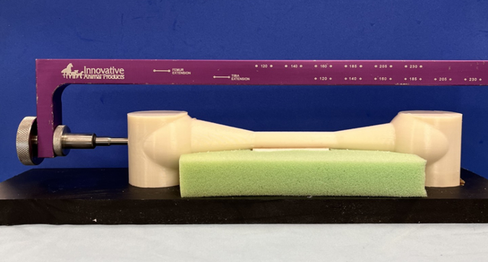

Figure 2: 3D hollow bone model with varying proximal and distal bone diameters using ABS material with associated 147 mm long, 6mm I-Loc (Biomedtrix, Whippany, NJ) nail with pre-assembled nail and targeting guide.

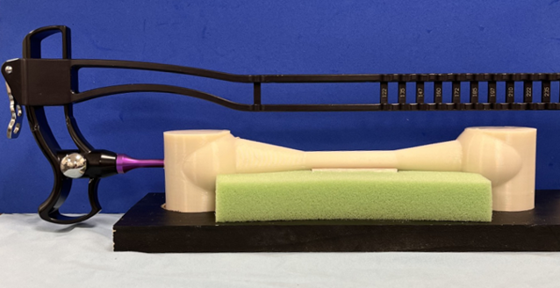
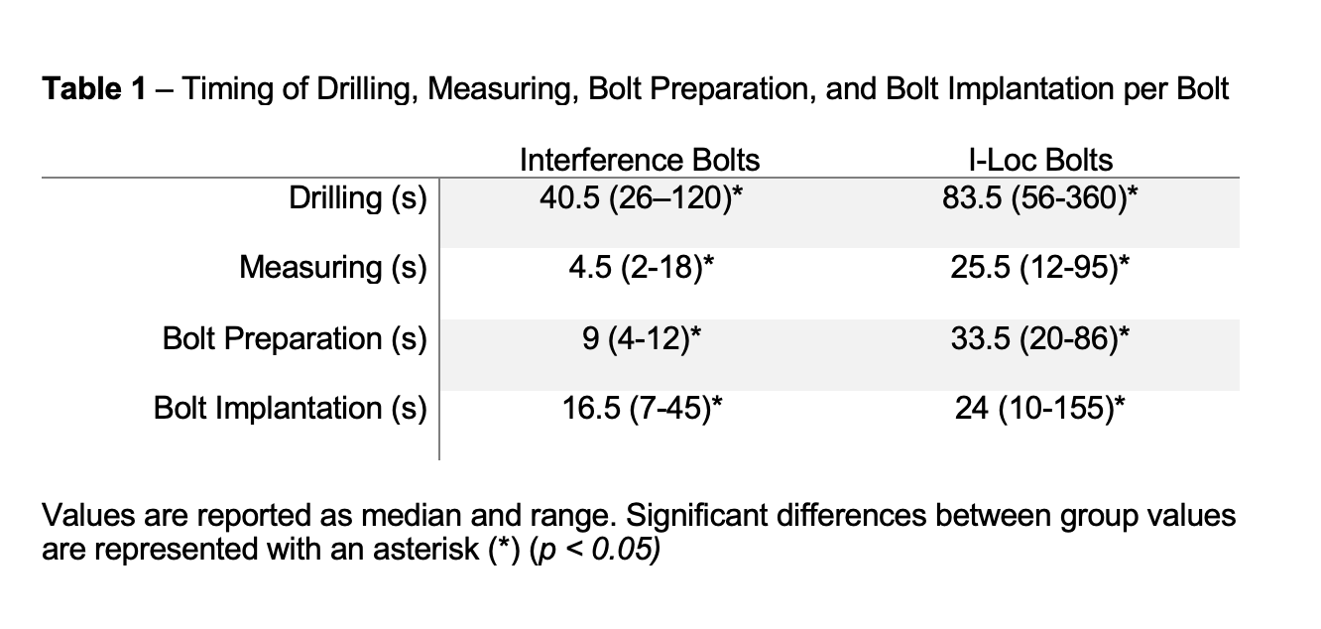
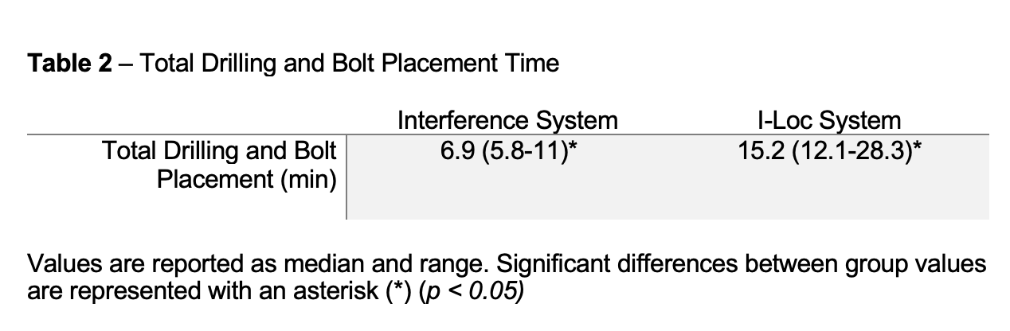

References:
- Kaspar K, Schell H, Seebeck P, Thompson MS, Schütz M, Haas NP, Duda GN. Angle stable locking reduces interfragmentary movements and promotes healing after unreamed nailing. Study of a displaced osteotomy model in sheep tibiae. J Bone Joint Surg Am. 2005 Sep;87(9):2028-37.

- Déjardin LM, Cabassu JB, Guillou RP, Villwock M, Guiot LP, Haut RC. In vivo biomechanical evaluation of a novel angle-stable interlocking nail design in a canine tibial fracture model. Vet Surg. 2014 Mar;43(3):271-81.

- Kubacki MR, Verioti CA, Patel SD, Garlock AN, Fernandez D, Atkinson PJ. Angle stable nails provide improved healing for a complex fracture model in the femur. Clin Orthop Relat Res. 2014 Apr;472(4):1300-9.

- [redacted] Prospective Evaluation of an Impaction Interference Bolt Design for Angle Stable Intramedullary Nail Fracture Fixation in Dogs. Unpublished data, submitted to VOS 2026.

- [redacted] Non-Destructive Torsional Evaluation of an Impaction Interference Bolt Design for Angle Stable Intramedullary Nailing. Unpublished data, submitted to VOS 2026.

Acknowledgements: The authors are the sole creators of the impaction interference bolt design for angle stable intramedullary nailing. Funding for this project was generously provided through the DeBartolo family gift.

