Evaluation of Dorsal and Ventral Atlantoaxial Stabilization in Toy-Breed Dogs: A Comparative Finite Element and Cadaveric Study
Objective:
Atlantoaxial instability (AAI) in toy-breed dogs remains a major surgical challenge due to congenital dens malformations, ligamentous laxity, and the extremely small bone corridors available for safe fixation. Ventral stabilization is generally considered the gold standard but may be associated with severe perioperative risks related to airway and esophageal proximity. The dorsal approach avoids these structures yet is often criticized for inferior mechanical rigidity and higher complication rates.
This study aimed to perform a harmonized biomechanical and procedural comparison of patient-specific dorsal and ventral stabilization systems using finite element analysis (FEA) and cadaveric validation. The hypothesis was that both configurations would achieve biomechanically acceptable stability, while the dorsal technique would provide faster instrumentation.
Study Design:
A combined computational and cadaveric study. Two patient-specific C1–C2 stabilizers (dorsal and ventral) were designed from clinical toy-breed geometries. CT data ( with a slice thickness of 0.625 mm) were segmented and virtually reduced to restore normal alignment. Each construct was modeled using a unified CAD–FEA workflow with 3–5 million tetrahedral elements. Locking 1.5 mm screws were positioned along validated safe corridors.
Material properties were defined as linear-elastic and isotropic for Ti-6Al-4V implants, and cortical bone parameters were obtained from published small-breed datasets. Surface-to-surface contact interactions simulated frictional interfaces between bone and plate (μ = 0.3–0.46), while plate–screw and screw–bone contacts were bonded to replicate locked fixation.
Both models were subjected to identical boundary conditions and loading vectors reflecting the physiological biomechanics of the atlantoaxial segment. Output variables included von Mises stress within implants and strain distribution in the cortical bone.
Complementary cadaveric trials were performed in nine toy- and small-breed dogs (3–12 kg). Both stabilizers were applied sequentially using patient-specific drill guides and printed implants. Surgical duration was recorded from incision to final screw placement, and results were compared using paired t tests (α = 0.05).
Results:
Both constructs maintained mechanical safety across the entire load range (5–25 N). The overall mechanical behavior differed substantially between designs.
In the ventral configuration, stresses were concentrated primarily within the metallic implant (max ≈ 350 MPa), while the cortical bone around C1–C2 experienced moderate stress levels (20–50 MPa). This indicated an implant-centric load-transfer mechanism, with the plate functioning as a rigid bridge across three vertebrae (C1–C3) that effectively shielded the bone from overload.
In contrast, the dorsal construct exhibited lower stresses within the plate (< 30 MPa) but markedly higher cortical bone stresses, reaching up to 90 MPa in the dorsal arch of C1 and the lamina of C2. This represented a bone-centric load-sharing mechanism, where the construct relied on osseous support rather than implant stiffness.
Although both systems remained well below material yield thresholds, their contrasting stress patterns highlight different stabilization philosophies: the ventral plate provided greater protection to bone tissue through higher structural rigidity, while the dorsal configuration achieved stability through bone engagement and minimized metallic stress.
The cadaveric evaluation confirmed significant procedural differences. The dorsal approach required less extensive dissection and orientation, resulting in a markedly shorter mean surgical time (12.9 ± 1.0 min) compared with the ventral approach (21.2 ± 1.8 min; p < 0.001). All procedures were completed without guide instability or misalignment. A positive but non-significant correlation was noted between body weight and operating time, suggesting increasing complexity in larger specimens.
Conclusion:
This study presents the first harmonized biomechanical and procedural comparison of patient-specific dorsal and ventral atlantoaxial stabilization in toy-breed dogs. Both constructs provided adequate mechanical stability within physiological loads but differed in stress distribution and surgical complexity.
The ventral configuration provided a more uniform and predictable stress environment, distributing forces through the implant and minimizing cortical loading, whereas the dorsal construct relied on bone-mediated load sharing, resulting in higher local stresses but facilitating a simpler, faster, and less invasive procedure.
From a clinical perspective, both approaches are feasible when guided by accurate preoperative planning and drill-guide technology. The dorsal approach may serve as a valuable alternative in cases where ventral access is anatomically restricted or high-risk due to airway considerations.
Further studies integrating cyclic mechanical testing, experimental loading, and clinical follow-up are warranted to confirm long-term outcomes and to establish patient selection criteria for optimized management of atlantoaxial instability in miniature and toy-breed dogs.
Figures:
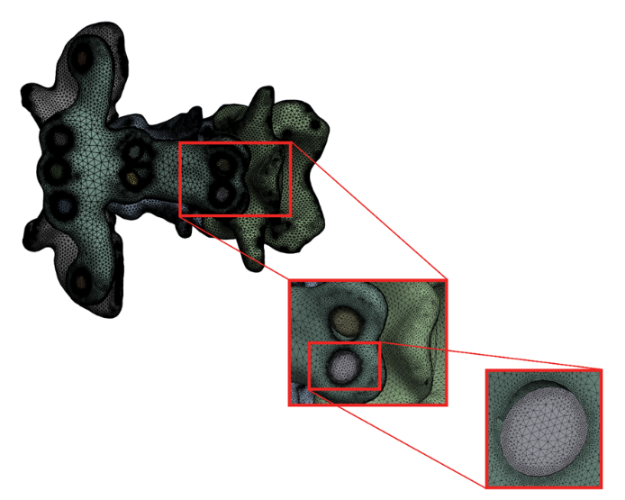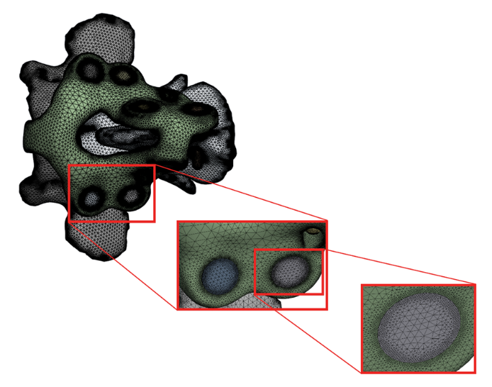
Figure 1: Finite-element mesh for dorsal and ventral models.

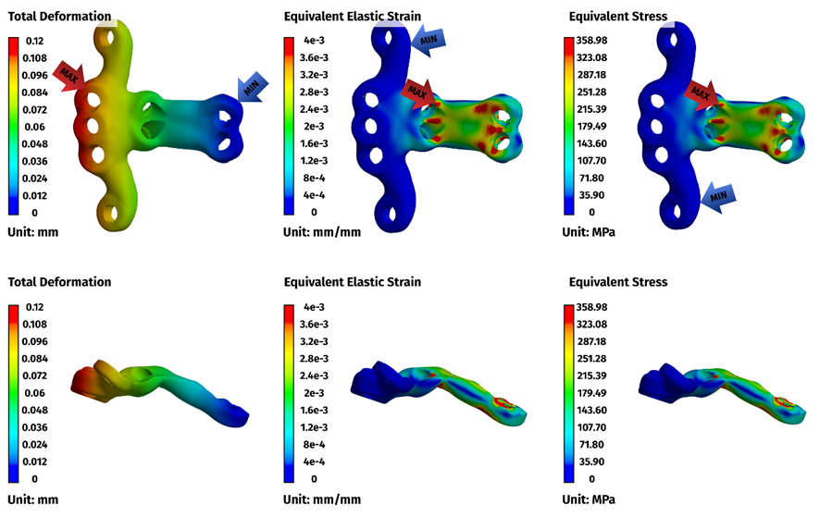
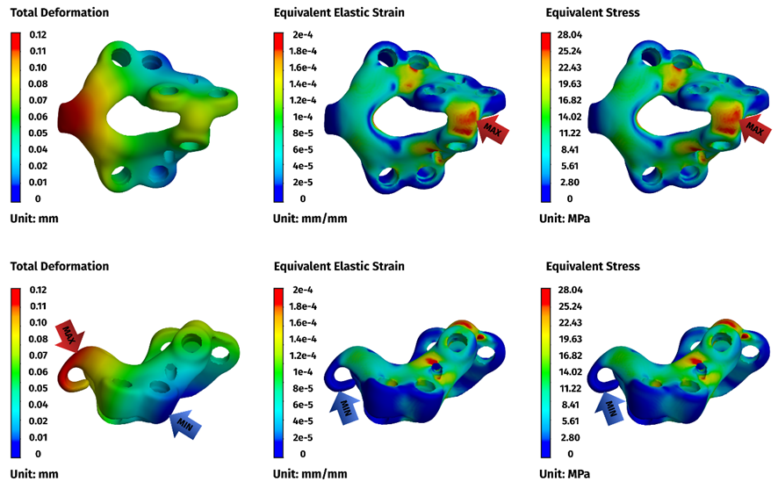
Figure 2: Deformation, Strain and Von Mises stress distribution (25 N) for both constructs.
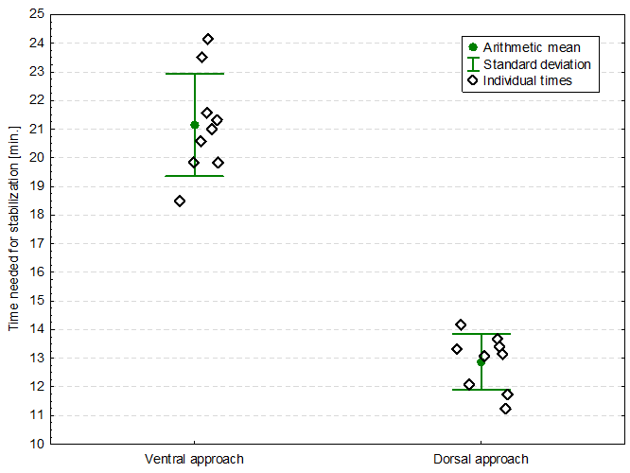
Figure 3: Cadaveric study surgical time comparison graph.
References:
1. Seon Y, Cho C, Jung C, Lim JH, Kim SY, Kang BJ. Atlantoaxial joint stabilization using patient-specific 3-D–printed drill guides and 3-D–printed titanium plates or polymethyl methacrylate is effective in toy-breed dogs. Am J Vet Res [Internet]. 2024 July 1 [cited 2025 Oct 29];85(7). Available from: https://avmajournals.avma.org/view/journals/ajvr/85/7/ajvr.24.02.0023.xml
2. Clinical application of 3D printing technology to the surgical treatment of atlantoaxial subluxation in small breed dogs | PLOS One [Internet]. [cited 2025 Oct 29]. Available from: https://journals.plos.org/plosone/article?id=10.1371/journal.pone.0216445
3. Biomechanical evaluation of three ventral fixation methods for canine atlantoaxial instability: a cadaveric study [Internet]. [cited 2025 Oct 29]. Available from: https://www.jstage.jst.go.jp/article/jvms/78/12/78_16-0160/_article/-char/ja/
4. Stalin C, Gutierrez-Quintana R, Faller K, Guevar J, Yeamans C, Penderis J. A review of canine atlantoaxial joint subluxation. Vet Comp Orthop Traumatol. 2015;28(1):1–8.
5. Atlantoaxial Instability - Veterinary Clinics: Small Animal Practice [Internet]. [cited 2025 Oct 29]. Available from: https://www.vetsmall.theclinics.com/article/S0195-5616(15)00150-3/abstract
6. Cabreira AP, Diamante GAC, Bregadioli T, Arias MVB. Development and Finite Element Analysis of a Patient-Specific Implant for Atlantoaxial Joint Stabilization via Dorsal Approach in Dogs. Vet Comp Orthop Traumatol [Internet]. 2025 Apr 2 [cited 2025 Oct 29]; Available from: http://www.thieme-connect.de/DOI/DOI?10.1055/a-2551-3374
Acknowledgements:
N/A

