Objective:
The high complication rate following tibial plateau leveling osteotomy (TPLO) remains a challenge. Though this procedure comes with a greater than 90% success rate for full return to function in most patients, complications develop in approximately 10 to 34% of cases. Incision site complications comprise the vast majority (1, 2). Progressive concerns for antibiotic resistance make prevention of surgical site infections (SSI) paramount (2). Previous studies on use of temporary compression bandages have evaluated low patient numbers with high interobserver error. They have failed to yield statistical significance for reduction of perioperative swelling. Hence, the benefit of bandage placement remains controversial (3, 4). This study aims to assess the impact of bandages during hospitalization on postoperative swelling and incision healing following TPLO in a larger population of dogs. A wound-tracking application for surgical site evaluation provided an innovative solution for objective evaluation (5). It is hypothesized that compression bandages decrease swelling, improve incision healing and decrease complications during postoperative hospitalization following TPLO.

Study Design:
This randomized prospective clinical trial compared measurements of 47 patients to assess outcomes of those who received a soft padded bandage postoperatively with unbandaged control patients. Coin flip was used to determine if a patient received a bandage. Any patient that received a TPLO was included with no age, breed, sex or size restriction. Patients who would not tolerate bandaging due to temperament were excluded. Bandage slippage during hospitalization or lack of overnight hospitalization also prompted exclusion. Bandages consisted of a Telfa pad overlying the incision site, cotton padding, cling gauze, self-adhering bandage material, and a semipermeable surgical sleeve applied overtop to provide a moisture barrier.

A single observer applied bandages, obtained measurements and assessed incision sites via the ImitoAG wound application at two institutions. TPLOs were routinely performed by multiple board-certified surgeons. Three anatomical measurements of the surgical limb were recorded at four separate timepoints to track swelling. Circumferential measurements were taken in normal weight bearing stance at the top of the tibial crest (site #1), the mid-tibia (site #2) and at the level of the hock (site #3) using a Gullick II tension-calibrated measuring tape. Measurements were completed preoperatively (baseline), immediately postoperatively (PO), one day postoperatively (D1) and at the incision site recheck weeks postoperatively (2W). A wound-tracking application (ImitoAG) was used to analyze incision site healing at two timepoints (D1 and 2W).

Results:
All study dogs tolerated bandage placement. The median patient age was 6.8 years (range 1.3-13.7, mean 7.0 years, standard deviation (SD) 3.0). The mean weight of patients was 28.8 (SD 8.3). The study included 30 spayed females, one intact female, 14 neutered male and two intact male dogs. Breeds included 14 mixed breed, six Labrador Retrievers, five Golden Retrievers, four Australian Cattle Dogs, four German Shepherd Dogs, four Pit Bull Terriers, three Bernese Mountain Dogs and one each of the following: Australian Shepherd, Border Collie, Cairn Terrier, Cavalier King Charles Spaniel, Corgi, English Pointer and Jindo. Ten patients were left unbandaged while 37 received a bandage. A left TPLO was completed in 24 patients while 23 had a right TPLO.

A repeated measures ANOVA was completed for each of the changes from baseline at each location to prevent patient size from affecting the differences (see Table 1). Patients who received a bandage were less swollen at all time points and the proximal tibial crest measurement demonstrated a change in size over time (Figures 1-3). Wound tracking software documented objective and visible change between bandaged versus unbandaged patients in degree of bruising, edema and healing of surgical sites (Figure 4).

With longer term follow-up extending past the eight-week recheck for osteotomy site radiographs, complications occurred in 12.8% of total patients (six of 47 cases). These complications included seroma formation in three dogs, SSIs identified by culture in three dogs and one of the SSI patients experienced dehiscence. Five of six complications occurred in the unbandaged group (50% of unbandaged cases) while one received a bandage (2.7% of bandaged patients). The one patient that experienced a complication following bandage placement self-traumatized the incision site approximately one week postoperatively to result in SSI and dehiscence that was repaired with skin staples. One of the unbandaged cases required explant for methicillin-resistant Staphylococcus pseudointermedius infection at the level of the implants.

Conclusion:
Bandage placement on patients while hospitalized postoperatively resulted in decreased swelling following TPLO. Complication rates were higher in patients that did not receive a bandage. Wound app tracking software revealed improved incision site healing in patients that received a bandage. Bandage placement following TPLO improves outcomes by keeping the surgical site clean and compressed to avoid edema, bruising and subsequent pain.

Limitations of this study include an unequal distribution of bandaged versus unbandaged patients due to randomization. Another limitation of this study included lack of blinded study design.

Acknowledgments:
There was no proprietary interest or funding provided for this project.

Change from  Baseline (Pre-op) | Mean (SD)  No bandage | Mean (SD) Bandaged
Immediate post-op tibial crest | 2.1(1.1) | 2.1(1.3)
Immediate post-op middle tibia | 1.2(1.0) | 0.7(1.1)
Immediate post-op hock | 1.1(1.1) | 0.3(0.9)
Day 1 post-op tibial crest | 2.8(2.1) | 2.2(2.0)
Day 1 post-op middle tibia | 1.2(1.9) | 0.7(1.5)
Day 1 post-op hock | 1.2(1.4) | 0.2(1.1)
2 week post-op crest | 2.3(1.9) | 1.1(2.1)
2 week post-op middle tibia | 0.8(1.6) | 0.2(1.8)
2 week post-op hock | 0.7(1.0) | 0.1(1.2)
Table 1: Repeated measures ANOVA for each of the changes from baseline per measurement location at each timepoint of measurement.

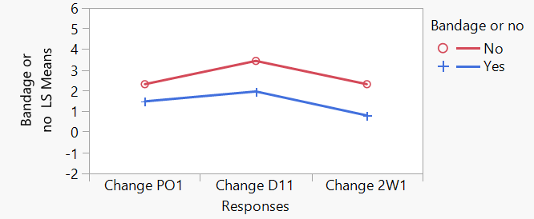
Figure 1: Proximal tibial crest measurements over time for bandaged (blue) versus unbandaged (red) patients: Bandage effect P<0.01; change over time P>0.01. PO1 = Immediate post-op tibial crest circumference, D11 = Day 1 post-op tibial crest circumference, 2W1 = Two weeks post-op tibial crest circumference.
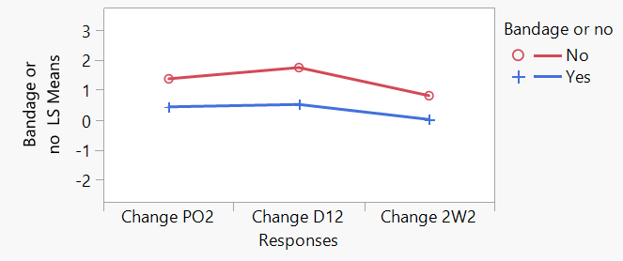
Figure 2: Middle tibia measurements over time for bandaged (blue) versus unbandaged (red) patients: Bandage effect P=0.02; change over time P>0.05. PO2 = Immediate post-op middle tibia circumference, D12 = Day 1 post-op middle tibia circumference, 2W2 = Two-week post-op middle tibia circumference.

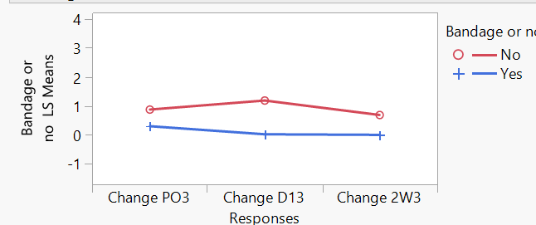
Figure 3: Hock measurements over time for bandaged (blue) versus unbandaged (red) patients: Bandage effect P=0.03; change over time P>0.05. PO3 = Immediate post-op hock, D13 = Day 1 post-op hock circumference, 2W3 = Two-week post-op hock circumference.

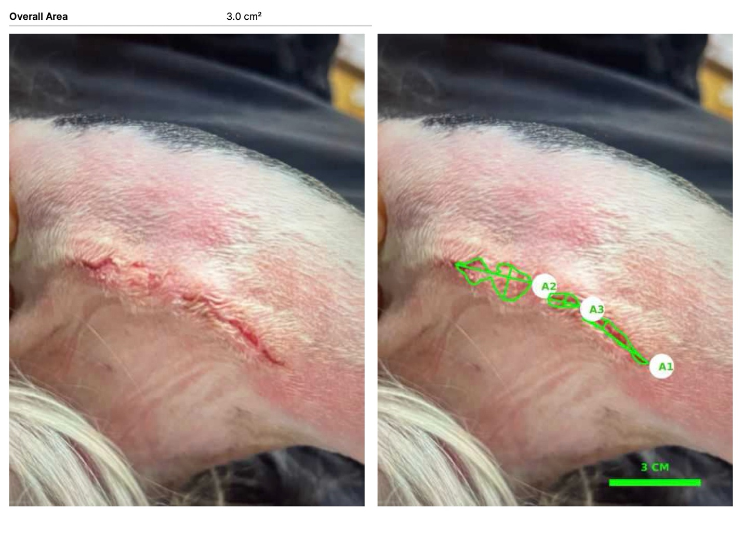

Figure 4: Incision site analysis using the ImitoAG wound application allows for precise measurement and evaluation of surface area of healing. This patient’s incision site demonstrates evaluation at one day post-op following bandage placement and demonstrates minimal edema and no bruising.

References
- Coletti TJ, Anderson M, Gorse MJ, et al. Complications associated with tibial plateau leveling osteotomy: A retrospective of 1519 procedures. Can Vet J 2014; 55(3):249-254.
- Husi B, Overesch G, Forterre F, et al. Surgical site infection after 769 tibial plateau leveling osteotomies. Front. Vet Sci 2023; 10:1133813.
- Kieves NR, Bergh MS, Zellner E, et al. Pilot study measuring the effects of bandaging and cold compression therapy following tibial plateau levelling osteotomy. JSAP 2016; 57:543-547.
- Unis MD, Roush JK, Bilicki L, et al. Effect of bandaging on post-operative swelling after tibial plateau levelling osteotomy. VCOT 2010; 23:240-244.
- Chen MY, Cao MQ, Xu TY. Progress in the application of artificial intelligence in skin wound assessment and prediction of healing time. Am J Transl Res 2024:16(7)2765-2776.

