Title: Validation of Digital Templating for Assessing Angle of Lateral Opening and Truncated Face Version.
Objective: The most reported complication in canine total hip replacement is luxation. Acetabular component malorientation increases the risk of post-operative luxation. Acetabular component position varies within three orthogonal axes: Angle of Lateral Opening (ALO), angle of version, and angle of inclination. Previous studies have described ideal acetabular component positioning with an ALO between 40-50°, inclination between 10-25° declined from the ilio-ischial axis and 15-30° of open face retroversion. At present, there is no digital templating process described to assess the position of the BFX acetabular component nor one that allows categorization of ALO and version. The objective of this study was to determine if the use of a digital template and planning software would allow categorization of ALO and truncated face version of a 28 mm BFX acetabular component. We hypothesized that an inexperienced observer would be able to correctly categorize ALO and truncated face version at least 90% of the time using a series of digital templates and planning software.
Study Design:
A digital template was created for the 28 mm BFX acetabular component representing ALOs from 30-55° in 5° increments as viewed in a ventrodorsal (VD) radiographic projection. Images were added to the Veterinary Orthopaedic Preoperative Planning template library (VPOP). A 28 mm BFX acetabular component was mounted into a custom plexiglass jig with a tilt-top designed to rotate around a single axis, with a dual-plane digital inclinometer accurate to +/- 0.3°, affixed to the tabletop. Inclination was fixed to imitate 20° declination from the ilio-ischial axis.
A 3D printed overlay was designed to encompass the acetabular component. Six linear depressions wide enough to fit a 0.045 K-wire were designed into the overlay at 5° increments to represent the cranial to caudal plane and truncated face version angles of -15 (retroversion) to +10 (anteversion) relative to the K-wire (cranio-caudal plane).
The tilt table was adjusted to position the acetabular component at ALO values of 30, 35, 40, 45, 50 and 55 using the digital inclinometer. The K-wire was sequentially placed in each cutout to represent six different version angles (-15, -10, -5, 0, +5, +10). The cup was imaged at each of the six ALO values with the K-wire placed in each slot to represent each version angle, creating 36 unique images (Figures 1, 3, 5). A power calculation was performed which determined 175 images were needed to demonstrate 90% correct categorization of ALO and truncated face version. The 36 unique images were duplicated and randomized to form 175 study images, with no fewer than three repeats of each image. The images were uploaded into VPOP. A single-blinded observer categorized each image using the ALO digital templates to determine best fit. A straight line was drawn along the truncated surface of the template. A second line was drawn over the K-wire representing the version. The angle created between the two lines was recorded to the nearest 5° (Figures 2, 4, 6).
We applied a statistical test described by Bailey (1997) which estimates the probability of a failure event occurring when no failures were observed in the collected data. This method uses a P6 estimator which provides an upper bound on failure probability under the assumption of a binomial process with zero events. Given that each image contained a minimum of three repeated measurements, we obtained a sample of 77 (n = 77) to use in the P6 estimator.
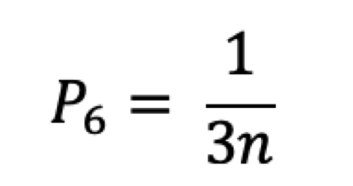
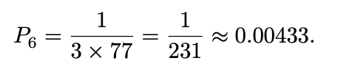
This formula determines the probability of failing to categorize the ALO and/or truncated face version correctly.
Results:
There was 100% agreement in categorization of ALO and version in the 175 images. Using the formula described above, there is a 0.4% chance of incorrect categorization of ALO and/or truncated face version.
Conclusion:
Successful outcome of total hip arthroplasty depends on clinically appropriate implant position. This study describes the use of a virtual planning tool for post-operative evaluation of the acetabular component. We demonstrated that using a digital template, we were able to correctly categorize ALO and truncated face versions in 175 out of 175 images, showing perfect agreement. We calculated the chance of incorrectly categorizing the ALO and truncated face version using a zero-failure statistical method and determined that there is a 0.4% chance of incorrect categorization. Combined with a known value of inclination, this technique can be used to determine open face version from orthogonal radiographic images. Both the calculation of open face version and accuracy in clinical cases will be subjects of future investigation. This is an ex vivo study and not an evaluation of clinical patients. The digital template used was specific to the 28 mm BFX acetabular component and was only tested in a single planning software.

Acknowledgements: There was no proprietary interest or funding provided for this project.
References:
Bailey, Robert T. 1997. Estimation from Zero-Failure Data. Risk Analysis 17 (3): 375–380. https://doi.org/10.1111/j.1539-6924.1997.tb00876.x
Bilmont, Alexis; Pink, Jonathan; Clarke, Stephen. (2024). Assessment of BFX cup version in a three-dimensional model simulating the ventrodorsal radiographic view. Veterinary surgery: VS. 54.10.1111/vsu.14139.

