Objective:
Accurate assessment of the stifle joint is essential for effective management of stifle pathology. Arthroscopy offers superior joint evaluation compared to traditional arthrotomy by providing magnified visualization of articular surfaces, thereby enhancing diagnostic accuracy and therapeutic precision in cases of osteoarthritis⁵. While palliative arthroscopy combined with meniscal intervention and medical management of osteoarthritis generally yields a favorable prognosis, a recognized limitation is that irrigation fluid used during arthroscopy can remove not only debris but also key components of synovial fluid, including hyaluronic acid, which are critical for cartilage health and metabolism. To mitigate this, administration of intra-articular (IA) biologics such as hyaluronic acid, corticosteroids, and platelet-rich plasma has been shown to alleviate pain, reduce inflammation, and promote joint homeostasis when administered following arthroscopy in human medicine ⁴. Although IA biologics therapy is gaining traction in veterinary medicine due to their potential benefits, their retention and efficacy following stifle arthroscopy in dogs remain unstudied.

The joint capsule is critical for maintaining primary joint stability, and its closure is essential for restoring normal anatomy and function ³. However, interportal capsulotomy closure is not routinely performed following stifle arthroscopy in dogs. A recent study of elbow arthroscopy compared retention between joints that underwent arthroscopy—undergone interportal capsulotomy—and those that did not ¹. The arthroscopy group demonstrated increased extravasation compared to joints receiving standard intra-articular injections, highlighting the potential impact of capsulotomy on retention. The primary objective of this study is to determine the effect of joint capsule closure of interportal stifle capsulotomies on fluid extravasation following intra-articular injection post-stifle arthroscopy. We hypothesized that closure of the joint capsule would reduce the loss of IA injectate compared to leaving the capsule unclosed. Although a previous study demonstrated that stifle cartilage volume and surface area increase linearly with body weight ², the physiological synovial fluid volume of the canine stifle has not yet been quantified. A secondary objective was therefore to determine the optimal injection volume to maximize immediate intra-articular retention and therapeutic efficacy. We hypothesized that a lower injection volume would result in greater intra-articular retention compared to a higher volume.

Study Design:
A total of 28 canine cadaveric hindlimbs were randomly assigned to one of four groups: Group 1, 4 mL intra-articular (IA) contrast injection without joint capsule closure; Group 2, 4 mL IA contrast with joint capsule closure; Group 3, 2 mL IA contrast without closure; and Group 4, 2 mL IA contrast with closure. All stifles underwent pre-injection radiography and computed tomography. A standard three-portal stifle arthroscopy was performed by a board-certified surgeon using a conventional technique (Figure 1). Interportal capsulotomies were closed using 0 PDS in a simple interrupted pattern according to group assignment. Subcutaneous tissues and skin were apposed in all stifles using 3-0 PDS in a cruciate pattern. Following arthroscopy, IA injections of iodinated contrast were administered according to group allocation. Stifles were then subjected to range-of-motion exercises to promote even contrast distribution, followed by repeat radiography and CT imaging. Post-contrast images were independently reviewed by a blinded board-certified veterinary radiologist to assess intra-articular contrast presence and evaluate extravasation using a previously published scoring scale¹ (Figure 2).
Results:
Mean extravasation scores were calculated for each group and imaging modality. On CT, the mean extravasation scores were 1.86 for Group 1, 1.57 for Group 2, 1.14 for Group 3, and 1.71 for Group 4. On radiographs, the mean scores were 1.71 for Group 1, 1.43 for Group 2, 1.43 for Group 3, and 1.57 for Group 4.
Conclusion:
Joint capsule closure following stifle arthroscopy did not consistently reduce intra-articular extravasation in canine cadaveric stifles. Closure modestly improved retention with higher injection volumes (4 mL), partially supporting the hypothesis that capsular closure enhances intra-articular retention. In contrast, at smaller volumes (2 mL), closure was associated with slightly greater extravasation, suggesting that altered intra-articular pressure dynamics may counteract its benefits. These results indicate that the effect of capsular closure is volume-dependent. Although the physiological synovial fluid volume of the canine stifle remains unquantified, the results highlight that smaller injection volumes may distribute more favorably within the joint space, whereas higher volumes may benefit from capsular closure to limit leakage.
Limitations include the cadaveric nature of the study, absence of physiologic fluid turnover, and lack of dynamic joint loading. Future in vivo investigations are warranted to evaluate how closure influences the distribution and efficacy of intra-articular therapeutics. Clinically, routine closure of interportal capsulotomies may not be necessary and should be tailored based on injection volume, biologic characteristics, and therapeutic goals.

Figures:
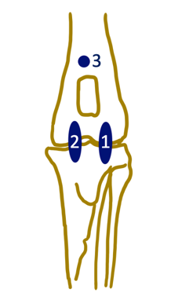

Figure 1. Cranial View of Portal locations of canine stifle arthroscopy. 1, arthroscopy portal region; 2, instrument portal region; 3, outflow portal region

Extravasation Score | % of contrast extravasation outside joint
0 | No extravasation
1 | <25%
2 | 25%-50%
3 | 50%-75%
4 | >75%

Figure 2. Extravasation Scoring Scale (0–4)

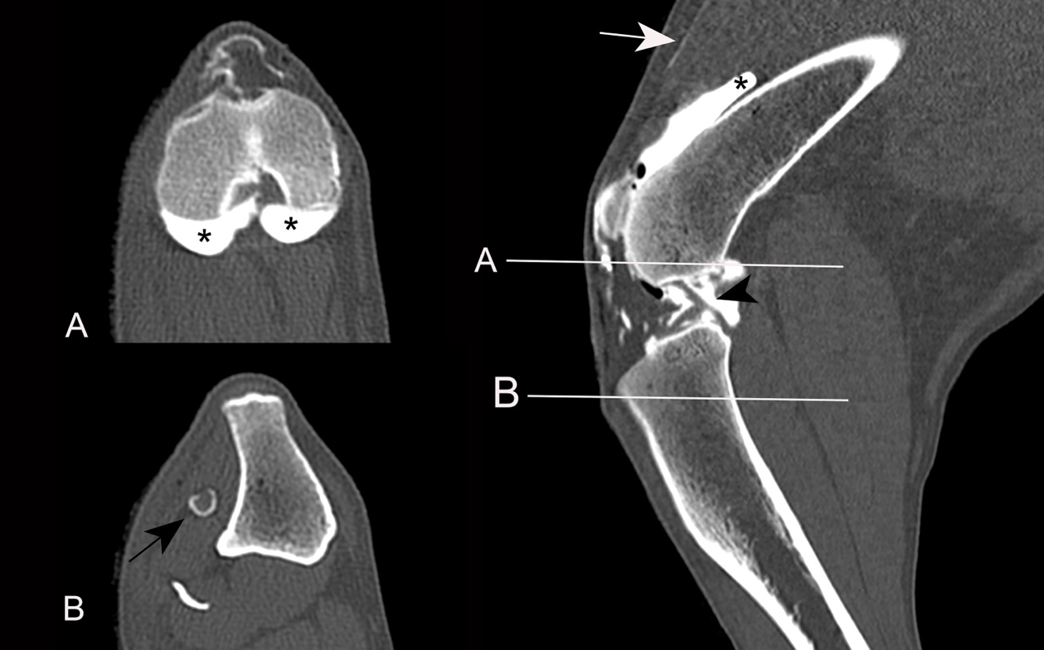

Figure 3. CT image of the right stifle demonstrating an extravasation score of 1 following a 2 mL intra-articular injection without capsule closure. Minimal contrast is visible outside the joint capsule (White arrow) and capsule distention (*).

Figure 4. CT image of the left stifle demonstrating an extravasation score of 3 following a 2 mL intra-articular injection with capsule closure. Moderate contrast is visible outside the joint capsule (White arrow).

References:
- Blumhagen EM, Spector DI, Fischetti AJ. Impact of arthroscopy on post-procedure intra-articular elbow injections: a cadaveric study. Vet Surg. 2024;53(6):988–998. doi:10.1111/vsu.14122. Epub 2024 Jun 6. PMID: 38841876
- Dhollander A, Malone A, Price J, Getgood A. Determination of knee cartilage volume and surface area in beagle dogs: a pilot study. J Exp Orthop. 2017;4(1):35. doi:10.1186/s40634-017-0109-1. PMID: 29105014; PMCID: PMC5673056
- Di Benedetto P, Zangari A, Giardini P, Mancuso F, Castriotta L, Causero A. Capsular closure after hip arthroscopy: our experience. Acta Biomed. 2020;91(4-S):92–97. doi:10.23750/abm.v91i4-S.9664. PMID: 32555082; PMCID: PMC7944825
- Hempfling H. Intra-articular hyaluronic acid after knee arthroscopy: a two-year study. Knee Surg Sports Traumatol Arthrosc. 2007;15(5):537–546. doi:10.1007/s00167-006-0260-1
- Pozzi A, Hildreth BE, Rajala-Schultz PJ. Comparison of arthroscopy and arthrotomy for diagnosis of medial meniscal pathology: an ex vivo study. Vet Surg. 2008;37:749.

Acknowledgements:
There was no funding provided for this project.

