Abstract Title:
Intra- and inter-observer precision of two different methods for measuring version and angle of lateral opening of a BFX cup utilizing lateral radiographs

Objective:
Two different methods have been proposed for assessing version and angle of lateral opening (ALO) of BFX acetabular prostheses on a lateral radiograph. One methodology utilizes the use of a custom cup position assessment device (CPAD). Ex vivo studies have shown substantial agreement between measures of version and ALO using a CPAD and measurements made using CT, directly on cadavers, and ex vivo using an inclinometer¹. Although promising, the technique has not been assessed for intra- and inter-observer repeatability and has not been assessed across numerous, particularly smaller, cup sizes. In addition, this technique requires use of a device that is not currently commercially available.

Alternatively, use of an ellipse method has been described for assessing version and ALO using a CFX cup². Furthermore, it was stated that this ellipse methodology could be used with BFX cups². If such methodology were repeatable, and accurate, it would be appealing in that no CPAD is needed.
The aim of this study was to evaluate the intra- and inter-observer precision of measurements of version and ALO of these two different methods. We hypothesized that the use of a CPAD would have high intra- and inter-observer repeatability, defined as ICCs > 0.8. Conversely, we hypothesized that the ellipse method would have low intra- and inter-observer repeatability (ICCs < 0.5) because we believed it would be difficult to define an ellipse fit to a BFX cup.

Study Design:
Three BFX cups (20mm, 22mm, 26mm) were manually placed in a canine cadaver pelvis (20mm and 22mm) or a canine sawbones pelvis (26 mm). The BFX cups were placed with varying degrees of inclination, retroversion, or angle of lateral opening. A lateral radiograph was obtained for each BFX cup with superimposition of the ischiatic tuberosities and dorsal/ventral surfaces of the ilium to ensure lateral positioning. Placement of the cup, radiography, and removal of the cup was performed three times per BFX cup, such that a total of 9 lateral radiographs were obtained.

Two 0.35 wires were then added to each BFX cup similar to a previously described CPAD. One wire spanned the two points of cup truncation, and the second wire was placed perpendicular to this first wire. The lengths of the wires were measured prior to application, and the wires were secured in position using adhesive. The BFX cups were then manually placed into the cadaver pelvis or sawbones pelvis, and lateral radiographs were repeated as mentioned above to obtain 9 lateral radiographs with the positioning bars (i.e. CPAD).

Each of the 18 radiographs were then measured three times by three different observers, for a total of 162 different measurements. For the 9 radiographs with a CPAD the measured lengths of the craniocaudal and ventrodorsal bars were used to calculate version and ALO respectively using equations established by Dalbeth et al.¹ (See Figure 1).

Version and ALO were measured on the 9 radiographs without a CPAD using an ellipse methodology. For such methodology a circle was fit to the dorsal surface of the BFX silhouette, and another circle was fit to the ventral portion of the silhouette. The two points of intersection of these two circles defined the long axis of the ellipse. The angle between this line and that of the pelvis defined the version angle². The greatest width of the silhouette along this axis (i.e. parallel to this axis), and the greatest width of the silhouette perpendicular to this axis, were used to then calculate the ALO using previously established equations for the ellipse methodology² (Figure 2).

The 162 different measurements were then used to calculate intra- and inter-class correlation coefficients (ICC) using IBM SSPS Statistics.

Results:
Both intra- and inter-observer repeatability were moderate for the CPAD measure of version and were high for intra- and inter-observer repeatability for the CPAD measure of ALO and the ellipse methodology for both version and ALO (see Table 1 and Figures 3-6).
Conclusion:
Based on ICC values calculated in this study the ellipse method of measuring version and ALO and the CPAD method for calculating ALO had good to excellent repeatability between and within observers. The CPAD method for calculating version was moderately precise, scoring the lowest for intra- and inter-observer precision. Limitations include that the CPAD method we used was meant to mimic the previously reported CPAD, but it is not the same as there is no commercially available standard CPAD and this could have resulted in less repeatable results. Nonetheless, these results were unexpected and prompted us to reject both of our hypotheses. In conclusion, inter- and intra-observer repeatability of ALO and version were moderate to high with both methods utilizing BFX cups from 20-26 mm. The high precision of the ellipse methodology described herein warrants assessment of this method's accuracy, which is now ongoing.

Figures:

Table 1: Intra- and Inter-ICC values for each observer for both methods of lateral radiographic measurement. 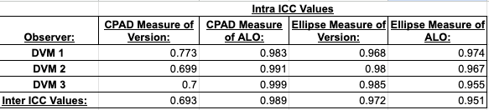

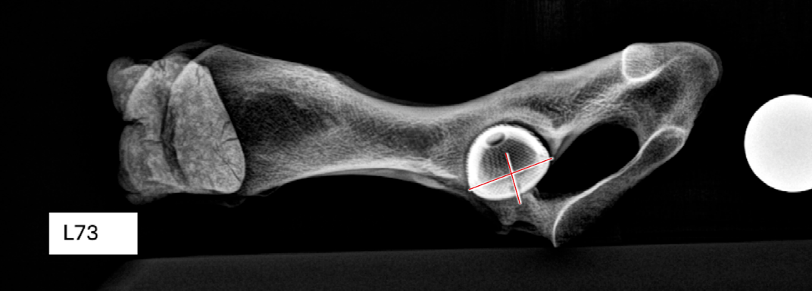
Figure 1: Radiograph of custom cup position assessment device showing how measurements of bars were obtained.

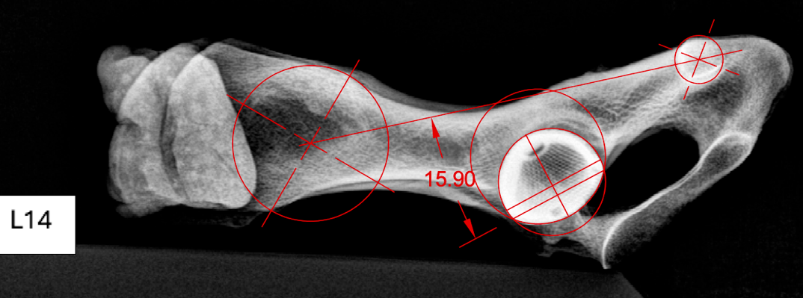
Figure 2: Radiograph demonstrating ellipse methodology measurements. Briefly, the long axis of the pelvis was defined using methods previously described. Next, two circles were fit to the BFX cup, one to the dorsal surface of the silhouette and the other to the ventral surface of the cup silhouette. The two points of intersection of these circles defined the axis of this ellipse. This line was duplicated, and the greatest length of the cup (along this axis) was quantified. A line perpendicular to this was then used to measure the greatest dorsal-ventral dimension of the cup. The ALO was calculated using these craniocaudal and dorsoventral dimensions of the cup and the version was measured as the angle between the axis of the pelvis and the long axis of the ellipse.

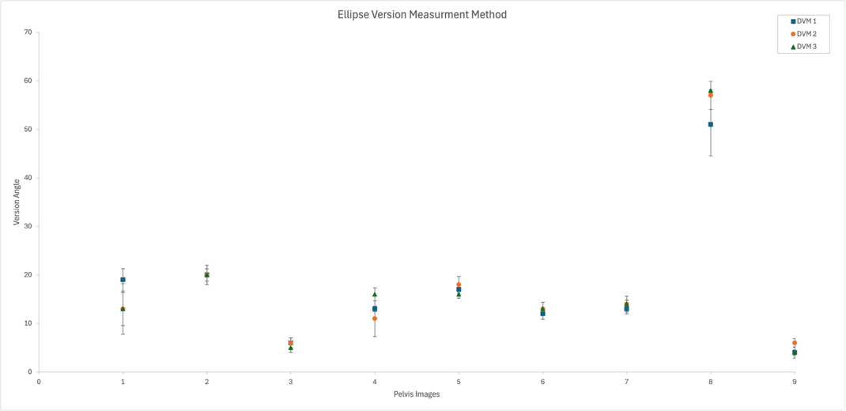
Figure 3: Scatter plot graph describing the mean and standard deviation for each DVM’s radiographic measurement of version angle for each pelvic image utilizing the ellipse method of measurement.

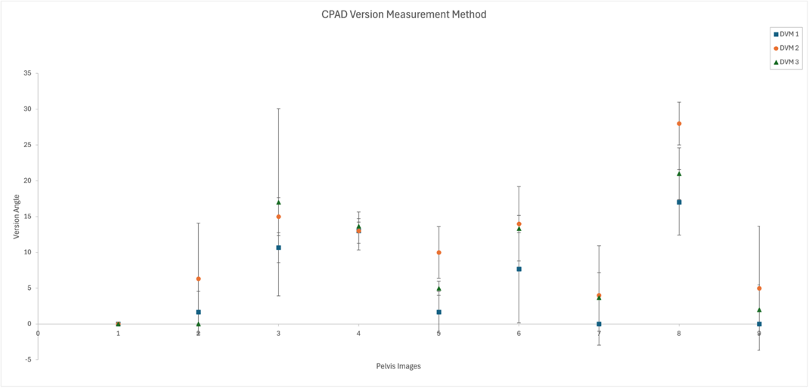
Figure 4: Scatter plot graph describing the mean and standard deviation for each DVM’s radiographic measurement of version angle for each pelvic image utilizing methods of measurement with the CPAD.

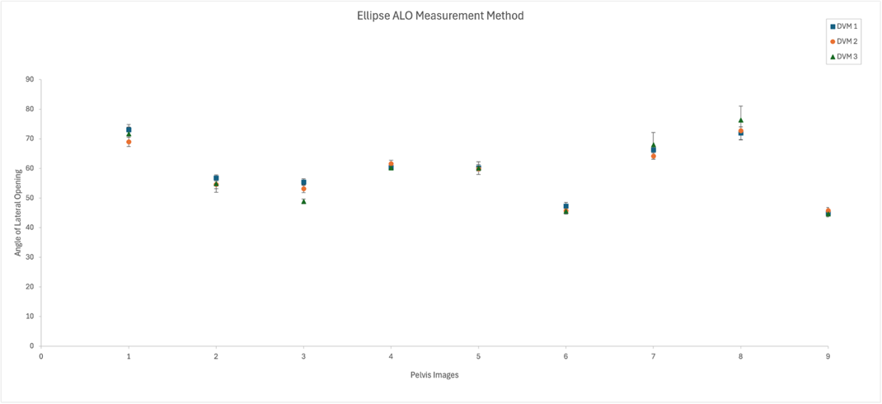
Figure 5: Scatter plot graph describing the mean and standard deviation for each DVM’s radiographic measurement of angle of lateral opening for each pelvic image utilizing the ellipse method of measurement.

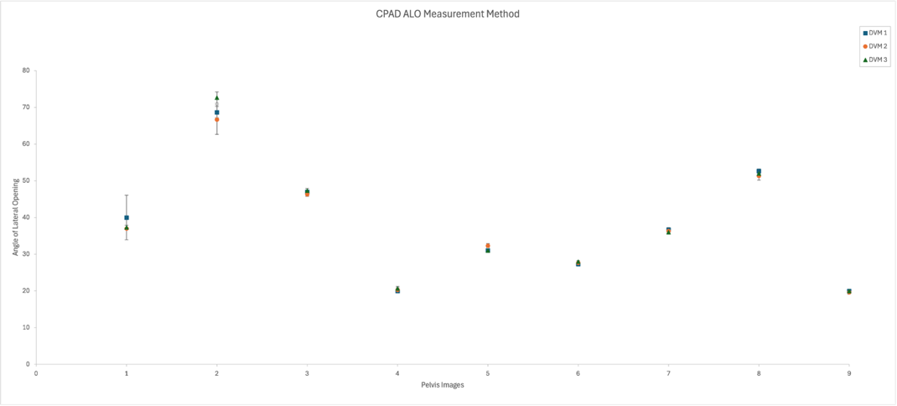
Figure 6: Scatter plot graph describing the mean and standard deviation for each DVM’s radiographic measurement of angle of lateral opening for each pelvic image utilizing methods of measurement with an CPAD.
References:
1. Dalbeth BN, Karlin WM, Lirtzman RA, Kowaleski MP. Measurement of Acetabular Component Position in Total Hip Arthroplasty in Dogs: Comparison of a Radio-Opaque Cup Position Assessment Device Using Fluoroscopy with CT Assessment and Direct Measurement. Veterinary and Comparative Orthopaedics and Traumatology. 2020;33(05):340-347. doi:https://doi.org/10.1055/s-0040-1714412
2. ‌Aman AM, Wendelburg KL. Assessment of Acetabular Cup Positioning from a Lateral Radiographic Projection after Total Hip Replacement. Veterinary Surgery. 2012;42(4):406-417. doi:https://doi.org/10.1111/j.1532-950x.2012.01075.x
‌Acknowledgements: There was no proprietary interest or funding provided for this project.

