Pressure Diffusion Over the Point of the Elbow Using Commercially Available Elbow Pads

OBJECTIVE:
Hygromas, wounds, and surgical wounds can be problematic on the olecranon because of minor repeated trauma typically from laying on hard surfaces with no padding in the sphinx position (elbows tucked at sides while in ventral recumbency).¹ Repeated trauma increases the risk of dehiscence or trauma to the sight.² Conservative management includes thick, soft bedding or more recently, commercially available elbow pads that claim without evidence to decrease pressure on the elbows.³ The purpose of this study was to determine if 2 popular elbow pads decrease pressure over the olecranon when dogs are in the sphinx position as advertised, and if so, is one pad better. The Neoalley (Pad 1) and Harikaji (Pad 2) elbow pads were selected based on Amazon customer reviews and combined retail sale of the pad at pet stores and Chewy, respectively. The hypothesis was that Pad 1 would significantly reduce pressure on the elbow, but Pad 2 would not.

STUDY DESIGN:
A randomized 3 way crossover study was conducted using Neoalley (commercially available pad #1) and Harikaji (commercially available pad #2) elbow pads on large or giant breed dogs weighing over 27 kilograms, or 60 pounds. Twelve dogs were included in the study with a priori sample size calculation using a standard deviation of 15.4, power of 0.8, difference of 0.05, and clinical difference of 20 mm Hg, based on previous sub-bandage pressure measurement with the same sensors. Inclusion criteria were dogs that were trained or easily trainable to lay still in a sphinx position and in the lateral position for 10 second intervals. Dogs with forelimb amputations were excluded. Signalment data (age, weight, BCS, breed) were collected.

Order of the position and with or without padding was randomized using a random number generator. The Tekscan sensors were cut to accommodate the shape of the elbow and fixed with tape over the bony prominences of a randomized elbow and connected to a computer. Treats and minimal restraint were used to coerce the dog into allowing placement of the elbow pads and the positions required for measurement. Each dog was measured in 2 positions (sphinx and lateral with measured leg up) for 3 conditions (no pads, commercially available pad 1, commercially available pad 2) for 10 seconds each (Figure 1). Elbow pad sizes were selected and applied as directed by the manufacturer and the dogs laid on vinyl flooring with no padding to mimic a typical environment. The sphinx position peak pressure was normalized by subtracting the lateral position peak pressure to remove sensor changes from placement alone. Statistical evaluation included descriptive statistics and matched pairs evaluation using Wilcoxin signed rank test.

RESULTS:
All 12 dogs were recruited and measured for this study. However, measurements from 2 dogs during analysis appeared spurious for the no pad. For example, 1 dog had a lateral no pad pressure of 199 mm Hg which is over twice what was expected. Table 1 lists the medians and ranges for the signalment data and normalized peak pressures for each condition with all dogs and with the 2 outliers eliminated. Medians and ranges were chosen because data was not normal. The elbow pads were significantly pressure relieving over no pad (Pad 1:P=0.004, Pad 2: P=0.03) if the outliers were excluded. The pads were not significantly pressure relieving if the outliers were left in the analysis. However, if each pad were labeled individually as a success (at least 20mm Hg of relief over no pad) or failure, pad 1 had 8 successes and 2 failures, whereas pad 2 had 6 successes and 4 failures. The outliers would be considered failures if included.

CONCLUSION:
Our hypothesis was partially supported if the outliers were removed from the analysis as both pads provided pressure relief over all statistically. However, it must be noted that even though overall they were better than nothing, pad 2 failed to give pressure relief in 4 dogs and pad 1 failed in 2. In addition, the 2 outliers would not only have been failures to pressure relief, but they also increased pressure by over 20 mm Hg which puts them into the harmful category. Although the authors are currently investigating the potential for aberrant sensor readings, if this is a true pressure increase, these dogs would be at risk for worsening disease or pressure sores. This study is limited by the variation in sensors and sensor placement, and the small sample size. Normalizing the sensors to the lateral position helped to remove some variation.

FIGURES:

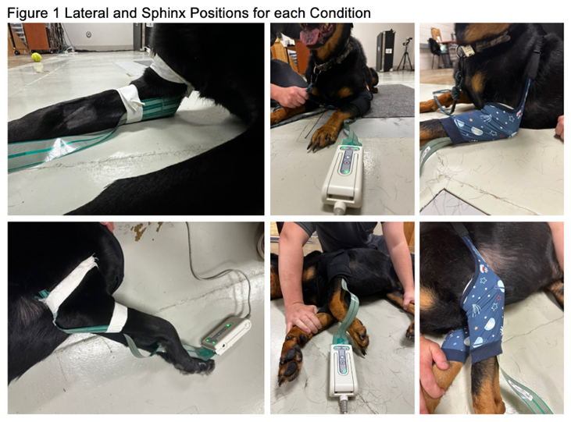

Table 1 Medians and Range of Signalment and Pressure Data
 | Median (n=12) | Range (n=12) | Median (n=10) | Range (n=10)
Age (Y) | 6.5 | 0.5-15 | 7.5 | 2-15
Weight (kg) | 34 | 28-50 | 34.35 | 28-50
BCS (9 point scale) | 5 | 4.5-6 | 5 | 4.5-6
Elbow Circumference (cm) | 8.25 | 7.25-9 | 8.25 | 7.3-9
Elbow Length (cm) | 9 | 8-12 | 9 | 8-12
Chest Circumference (cm) | 30.8 | 28-34 | 31.5 | 29.5-34
Limb Cuff Circumference (cm) | 5.5 | 4.5-8 | 5.375 | 4.5-6.5
No Bandage Normalized Peak Pressure (mmHg) | 220 | 114-267 | 224 | 181-267
Pad 1 Normalized Peak Pressure (mmHg) | 169.5 | 68-241 | 160 | 68-241
Pad 2 Normalized Peak Pressure (mmHg) | 206 | 78-263 | 206 | 78-263

REFERENCES:
- Brooks W. Elbow Hygromas in Dogs. Veterinary Partner. 2024
- Pavletic MM. Use of commercially available foam pipe insulation as a protective device for wounds over the elbow joint area in five dogs. JAVMA. 2011;239(9):1225-1231.
- Canapp SO, Campana DM, Fair LM. Orthopedic coaptation devices and small-animal prosthetics. Veterinary Surgery: Small Animals Eds. St Louis, MO. 2012;638-639.

ACKNOWLEDGEMENTS:
There was no proprietary interest or funding provided for this project.

