Intra-Articular 2.5% Polyacrylamide Gel in an Equine Preclinical Osteoarthritis Model: The Slippery Slope to Symptom- and Disease Modification

Objective: This study was to test the efficacy a 2.5% PAAG injected intra-articularly in the middle carpal joint (MCJ) of horses utilizing the carpal osteochondral chip fragment model to simulate OA.
Study Design: Sixteen skeletally mature horses, free of musculoskeletal disease, underwent subjective lameness assessment to determine baselines prior to surgery. At Day0, arthroscopy was performed on one randomly selected MCJ using a well-established model.¹ An 8mm osteochondral fragment was created on the distal aspect of the radial carpal bone and the fragment gap widened to 15mm using a motorized burr. Diagnostic arthroscopy was performed in the contralateral MCJ to ensure no lesions were present. Following suture removal (Day10), horses underwent subjective lameness evaluation and were ranked by lameness score for assignments to one of two groups: control or treatment. Control horses (n=8) had both MCJs aseptically injected with 2 mL phospate buffered saline (PBS). Horses in the treatment group (n=8) had 2 mL PAAG aseptically injected into the chipped MCJ while the opposite sham MCJ received an equal volume of PBS. All treatments were performed by a clinician not performing the lameness examinations. Horses were treated on Day14, stall rested until Day16, and began high-speed treadmill exercise (6 mins, 5 days/week) for the remainder of the study.
Subjective lameness evaluations were performed weekly, beginning 1 week prior to surgery (week -1) by trotting the horses [graded 0 (no lameness) to 5 (non-weight bearing)]. Response to carpal flexion [grade 0 (none) to 4 (severe)], MCJ effusion [grade 0 (none) to 4 (severe)], carpal range of motion [grade 0 (normal) to 3 (severely restricted)] and objective goniometric ROM of the carpal joint were also evaluated.
Radiographs (5 views per joint: LM, DP, DMPLO, DLPMO, flexed LM) were obtained of both carpi at week -1, Day14 and Day70. Radiographs were scored by a board-certified radiologist and analyzed for radial carpal bone enthesopathy, subchondral lysis and subchondral sclerosis of the radial carpal bone, subchondral sclerosis of the third carpal bone and osteophyte formation. A total radiographic score was calculated for each limb based on a summation of the scores (0-20).
Synovial fluid (SF) was collected from both MCJs every other week (Day0,14, 28, 42, 56, 70) for analysis of total protein, differential and total cell counts, color, clarity, and cytological analysis. Post-mortem evaluation included arthroscopy and macroscopic evaluation of the MCJ. Endpoint arthroscopic grading entailed grading each MCJ carpal bone for severity of erosion (0-3), extent of erosion (0-4) and cartilage fibrillation (0-4). A total arthroscopic cartilage score was calculated by summing the scores of all bones. Fragment healing (0-4), synovial hyperplasia (0-3) and synovial hypertrophy (0-3) was also graded. The MCJ was disarticulated and graded for synovial hypertrophy, synovial hemorrhage, and full and partial thickness cartilage erosion, each on a numerical scoring scale [0 (none) to 4 (marked)]. A total erosion score was calculated by summing the scores of hemorrhage and partial and full thickness erosion (0-12). Stiffness of the synovial membrane was assessed on a rheometer by incrementally increasing shear strain.
Statistical analysis was run using a mixed Model ANOVA for clinical outcomes and a pairwise comparison Tukey method for lameness with statistical significance set a <0.05.
Results: Following surgery, prior to treatment, the Day14 mean lameness grade was significantly higher for the treatment (1.75±0.89) versus the control (0.75±0.46) group (p=0.003). Compared to Day14, at endpoint, mean lameness grade did not change in the control group but decreased in the treatment group (1.25±0.71; p=0.68). Mean effusion scores in the treatment group remained constant from Day14 through Day56 and then decreased, but not significantly, by Day70; the control group was unchanged from Day14 to Day70. Carpal range of motion scores were only mildly increased at Day14 but returned to normal in both groups by Day70. Response to carpal flexion peaked in both groups at Day14, decreased at Day28 and remained minimally changed thereafter. Total radiographic scores increased over time but there were no significant differences between groups.
In all treated horses, 2.5% PAAG was visible in the synovial membrane (Figure 1) with no significant differences in synovial histology scores between treatment and control and no differences in nerve count across groups. Cartilage histopathology and SOFG scores were improved significantly for treated versus control joints (p<0.05) (Figure 2). Stiffness of the synovial membrane harvested from saline treated joints significantly increased (worsened; p<0.05) relative to the contralateral sham joints versus synovial membrane from treated joints which remained similar in stiffness to the synovial membrane from contralateral joints (Figure 3).
Conclusions:
Treating OA with intra-articular 2.5% PAAG may result in improvement in histological outcomes of the cartilage and biomechanical outcomes of the synovial membrane.
Figures:
Figure 1: H&E stain of 2.5% iPAAG (darker purple material) within the synovial membrane of the joint.
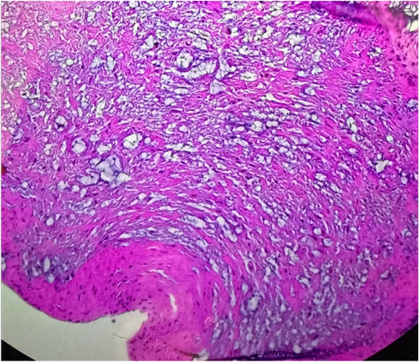
Figure 2: In the 3rd carpal bone, horses treated with 2.5% PAAG had significantly lower (better) total cartilage scores (A) and significantly lower (better) safranin O fast green staining scores in the intermediate cartilage layer (B) compared to saline-treated controls.
(A)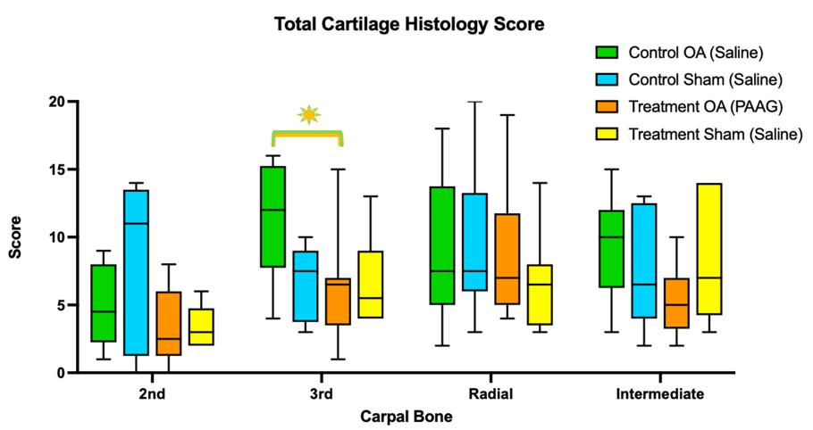
(B)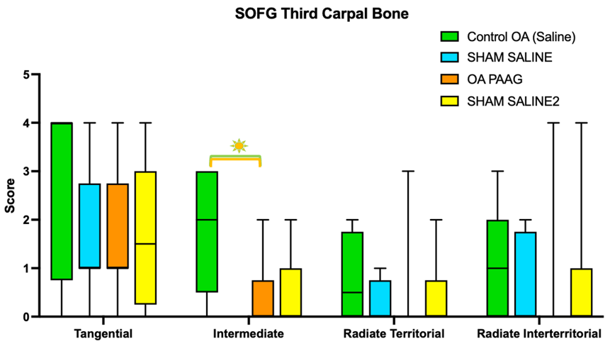
Figure 3: Stiffness of synovial membranes significantly increased in OA-saline treated samples (1824±1105 Pa) compared to contralateral sham controls (1002±495 Pa, p=0.043). In contrast, OA-PAAG treated tissues (1099±647 Pa) exhibited stiffness similar to their respective sham controls (1184±504 Pa, p=0.718), indicating no significant difference.
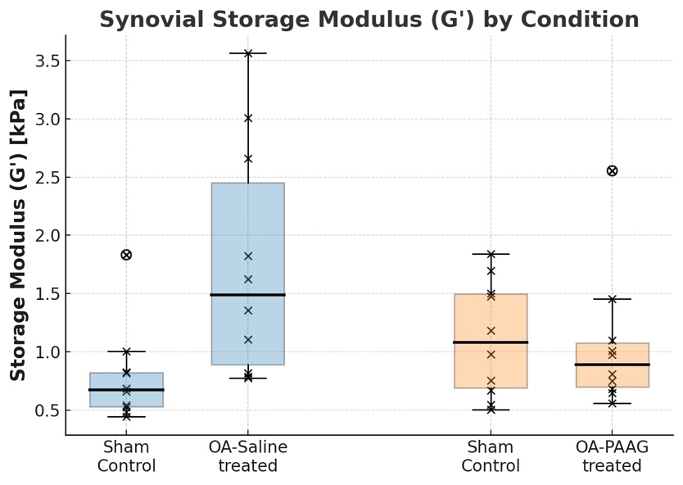
References:
- Goodrich LR, McIlwraith CW, Grieger J, Kraus VB, Stabler T, Werpy N, Phillips J, Samulski RJ, Frisbie D. IL-1ra gene therapy in equine osteoarthritis improves physiological, anatomical, and biological outcomes of joint degeneration. J Am Vet Med Assoc. 2024 Apr 22;262(S1):S109-S120. doi: 10.2460/javma.24.02.0078. PMID: 38631386.
Acknowledgments: The authors would like to acknowledge the support staff at XXX (removed for blinding purposes) for their help with all aspects of study design, data collection and sample analysis. Additionally, we acknowledge XXX (removed for blinding purposes) for his help with additional statistical analysis.
Declaration of Ethics: The authors have adhered to the Principles of Veterinary Medical Ethics of AVMA. The project was approved by the institutional animal care and use committee.
Conflicts of Interest: The authors have no conflicts of interest.
Funding Sources: Funding for this study was provided by ConturaVet.

