Total hip arthroplasty in a dog with a malunion acetabular fracture using a 3D printed custom acetabular guide

CASE REPORT:
Total hip arthroplasty (THA) is an effective treatment for a various conditions affecting the coxofemoral joint in dogs. Accurate positioning of the acetabular cup is critical to the success of THA, as malpositioning is associated with increased risks of luxation, abnormal implant wear, and early implant loosening in both human and veterinary patients.¹ Intraoperative placement of the acetabular cup relies on a stable pelvic position on the surgical table and the identification of reliable local bony landmarks to guide orientation.
Pelvic fractures that heal as malunions can significantly complicate THA. The resulting deformity of the hemipelvis and acetabulum disrupts normal pelvic anatomy, making it challenging to achieve correct intraoperative patient positioning and identify standard bony landmarks for assessing acetabular cup orientation.

The application of 3D-printed custom surgical guides (CSGs) in THA is still in its early stages of development. Several studies have demonstrated the feasibility of a CSG for femoral stem placement. No studies have described the use of a CSG specifically designed for acetabular cup placement in canine THA. ²
The purpose of this case report is to describe the use of three-dimensional (3D) virtual surgical planning and a CSG to achieve accurate implantation of an acetabular cup during THA in a dog with an acetabular fracture malunion.
An 8-year-old female spayed Foxhound mix presented for evaluation of hip pain as the result of unknown trauma to the pelvis prior to adoption several years earlier. Orthopedic exam revealed a grade 1/5 left pelvic limb lameness, moderate atrophy of the left pelvic limb, with discomfort and restricted extension of the hip. Radiographs of the pelvis revealed a fracture malunion of the left hemipelvis with dorsomedial displacement of the acetabulum. There was moderate left-sided coxofemoral osteoarthritis.
A computed tomography (CT) scan of the pelvis and femurs was performed. Digital imaging and communications in medicine (DICOM) files were uploaded into the imaging viewing software (Horos, Horos Project). Segmentation of the region of interest (pelvis) was performed, and the images were translated into a 3D surface model. The model was exported as a stereolithography (STL) file to the CAD software (Fusion, Autodesk). In the CAD software, the pelvis was oriented using the contralateral hemipelvis such that the anatomic median plane was aligned with the YZ plane (figure 1) and the ilioischial axis of the normal, contralateral hemipelvis was aligned 25 degrees (ischium displaced ventrally) from the XY plane (Figure 2). Due to geometric changes from the malunion affecting midline pelvic anatomy, alignment was performed visually, incorporating landmarks such as the ilial wings, dorsal spinous processes of L7 and the sacrum, obturator foramina, and pubic symphysis.

To facilitate accurate intraoperative placement of the acetabular cup, a CSG was designed in the CAD software. The guide had three registration posts that contacted the acetabular rim at approximately 8 o’clock, 12 o’clock and 4 o’clock (Figure 3). The guide had two tunnels to guide placement of two parallel 0.062” pins, marking the cranial and caudal acetabular pillars. The flat lateral face of the guide was parallel to the planned orientation of the truncated face of the acetabular cup (Figure 4). The guide system was designed such that the guide would be placed, the pins placed, and then the guide removed, leaving the two pins as location and orientation landmarks to guide acetabular reaming (Figure 5A&B). Once the cup was seated, the guide could be rotated 180 degrees and slid back over the pins. In this new orientation, the flat surface of the guide would be in close proximity to the truncated face of the acetabular cup, and the latter was used to assess for parallel to the former (Figure 6).
The guide was fabricated in polycarbonate (PC Blend, Prusa Research) using a fused-deposition modeling 3D printer (Prusa Mini, Prusa Research). THA was performed using the CSG for the acetabular preparation, and a 28mm BFX acetabular cup (BioMedtrix, Whippany, New Jersey) was implanted. A #6 BFX femoral stem with lateral bolt was implanted.
Post-operative radiographs revealed that, compared to the virtual plan, the acetabular cup was positioned mildly cranially, and oriented with mildly increased declination, mildly decreased retroversion, and mildly decreased ALO (Figure 7).

The patient underwent a standard 12-week post-operative convalescent period. At the 12- week recheck examination, no appreciable lameness was noted. The left hip allowed for near normal extension (150 degrees) with no evidence of discomfort. Radiographs confirmed stable implants. The owners reported that their dog had significantly improved activity levels and excellent limb use.

Acetabular fractures that heal as a malunion can pose a significant challenge in both patient positioning and implant alignment in dogs undergoing THA. Virtual surgical planning and CSG led to accurate implantation of an acetabular cup based off the normal contralateral hip and a successful total hip arthroplasty in a dog with a malunion acetabular fracture.

Figures:

References:
1. Dyce J, Wisner ER, Wang Q, et al. Evaluation of risk factors for luxation after total hip replacement in dogs. Vet Surg. 2000;29(6):524-532.

2. Fracka AB, Zindl C, Allen MJ. Three-Dimensional Morphometry of the Canine Pelvis: Implications for Total Hip Replacement Surgery. Vet Comp Orthop Traumatol. 2023.

Acknowledgements:
There was no proprietary interest or funding provided for this project.

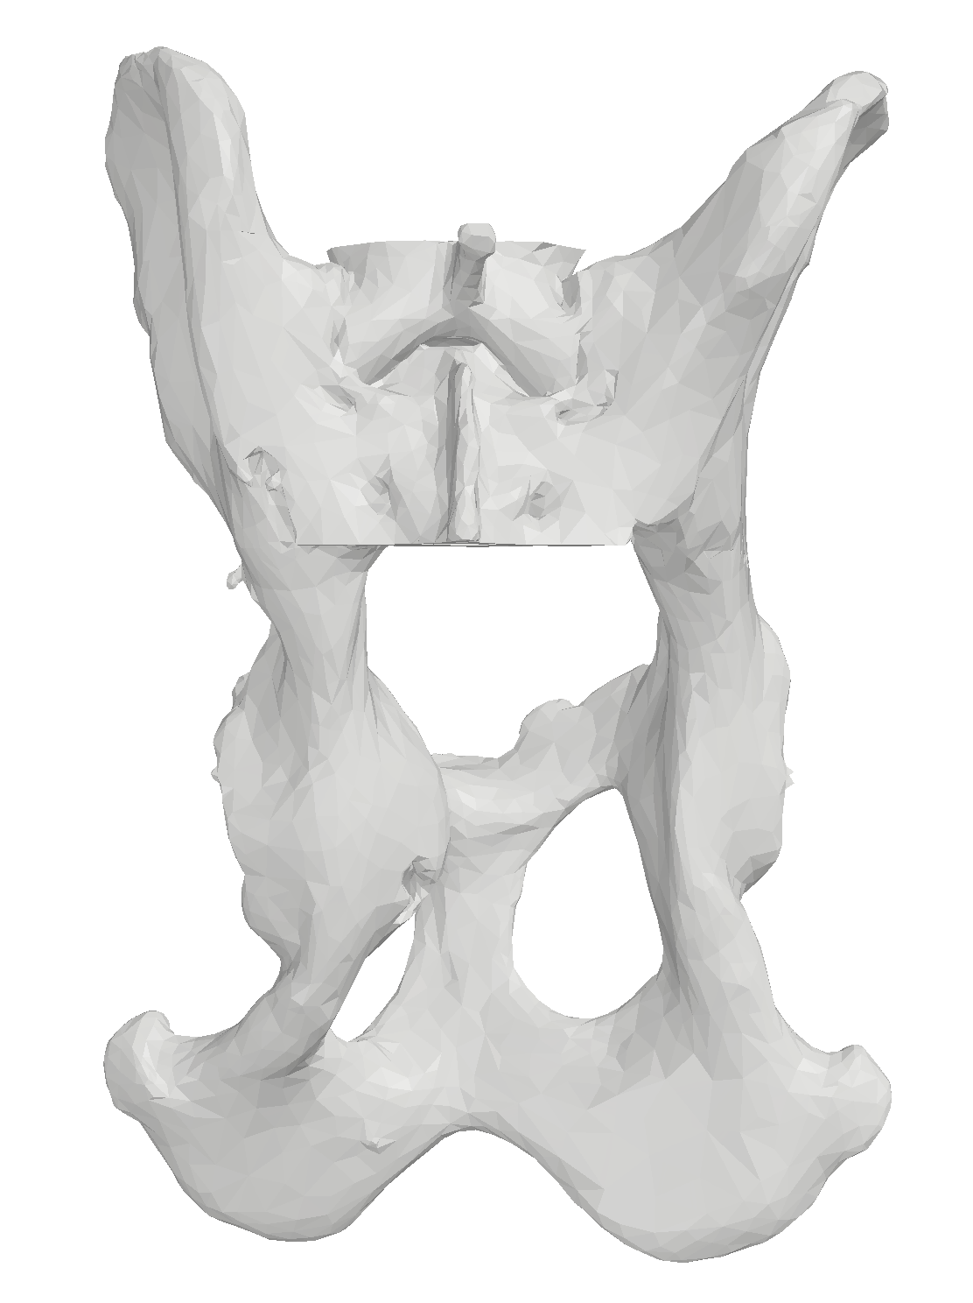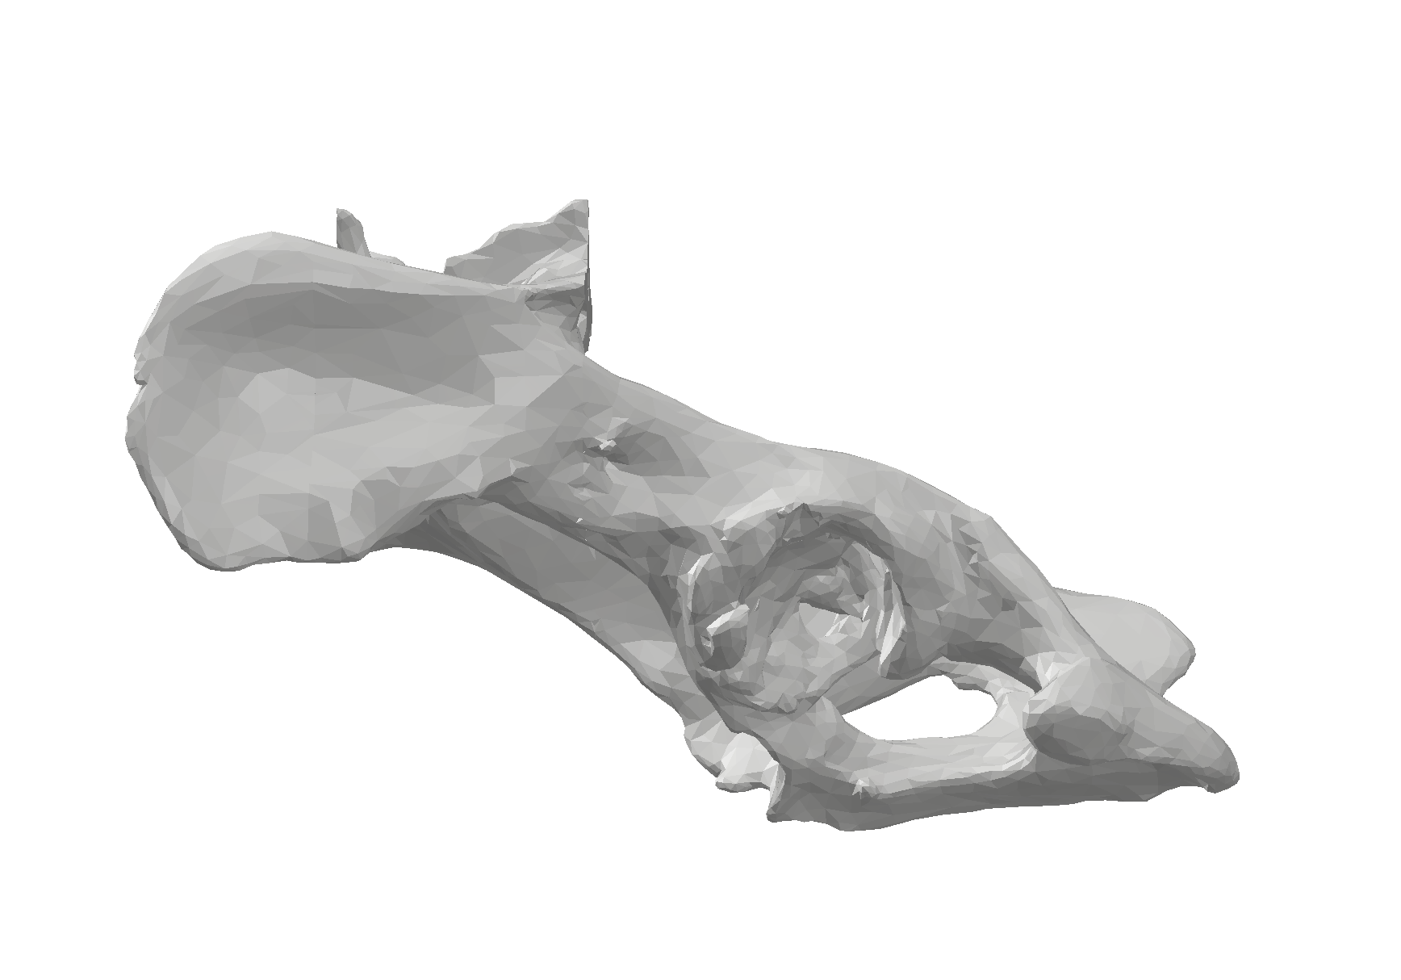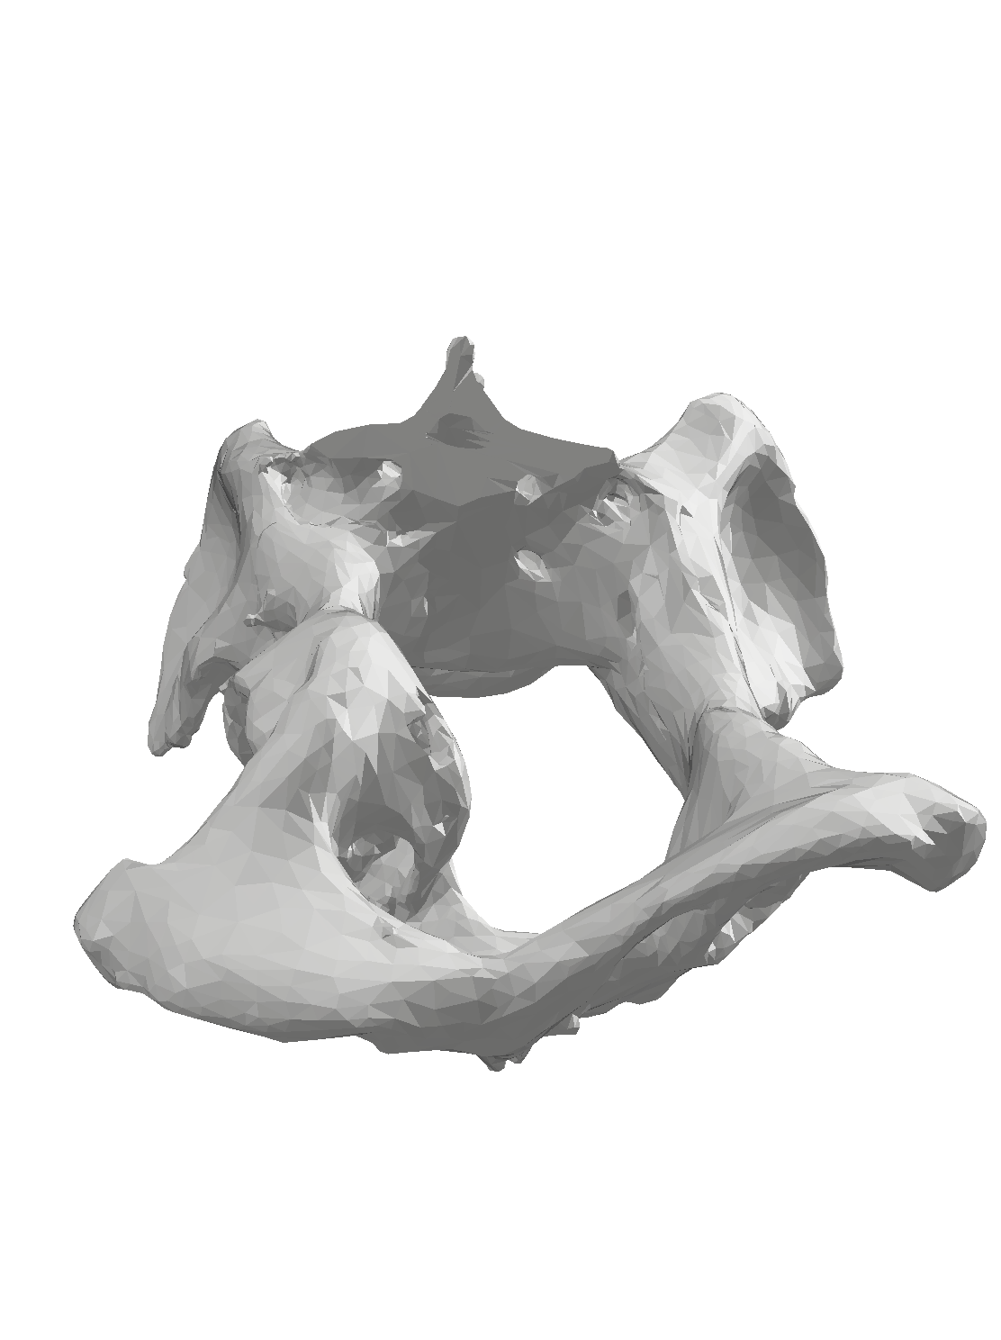
Figure 1: Dorsoventral, left lateral and caudocranial views of the 3D model of the pelvis.

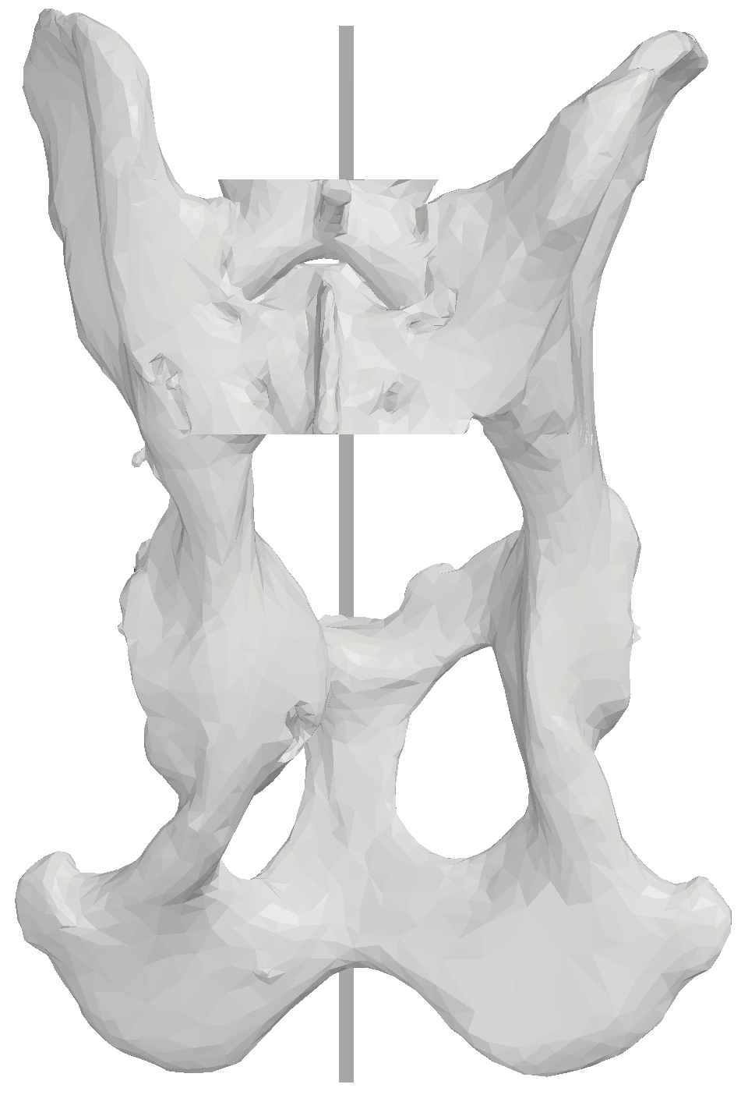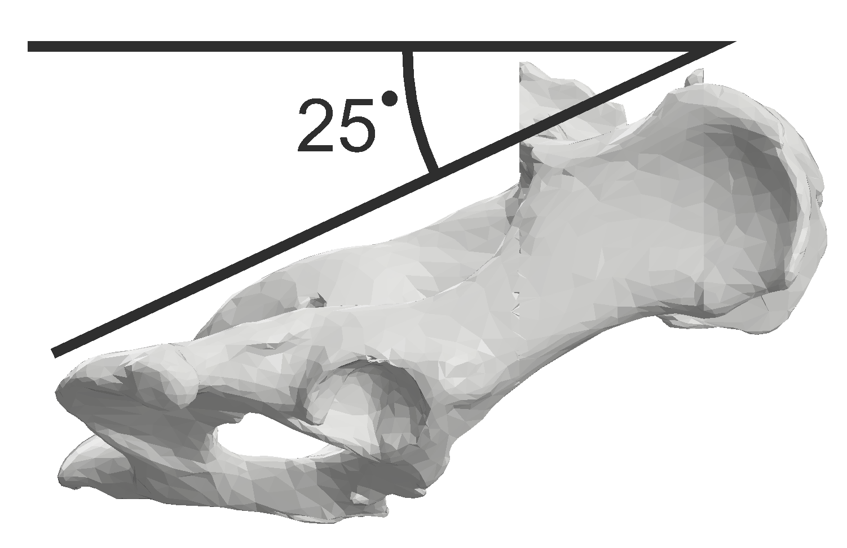
Figure 2: The pelvis is oriented with the median anatomic plane parallel to the Y axis and with the ilioischial axis of the normal, contralateral right hemipelvis 25 degrees from the XY plane.

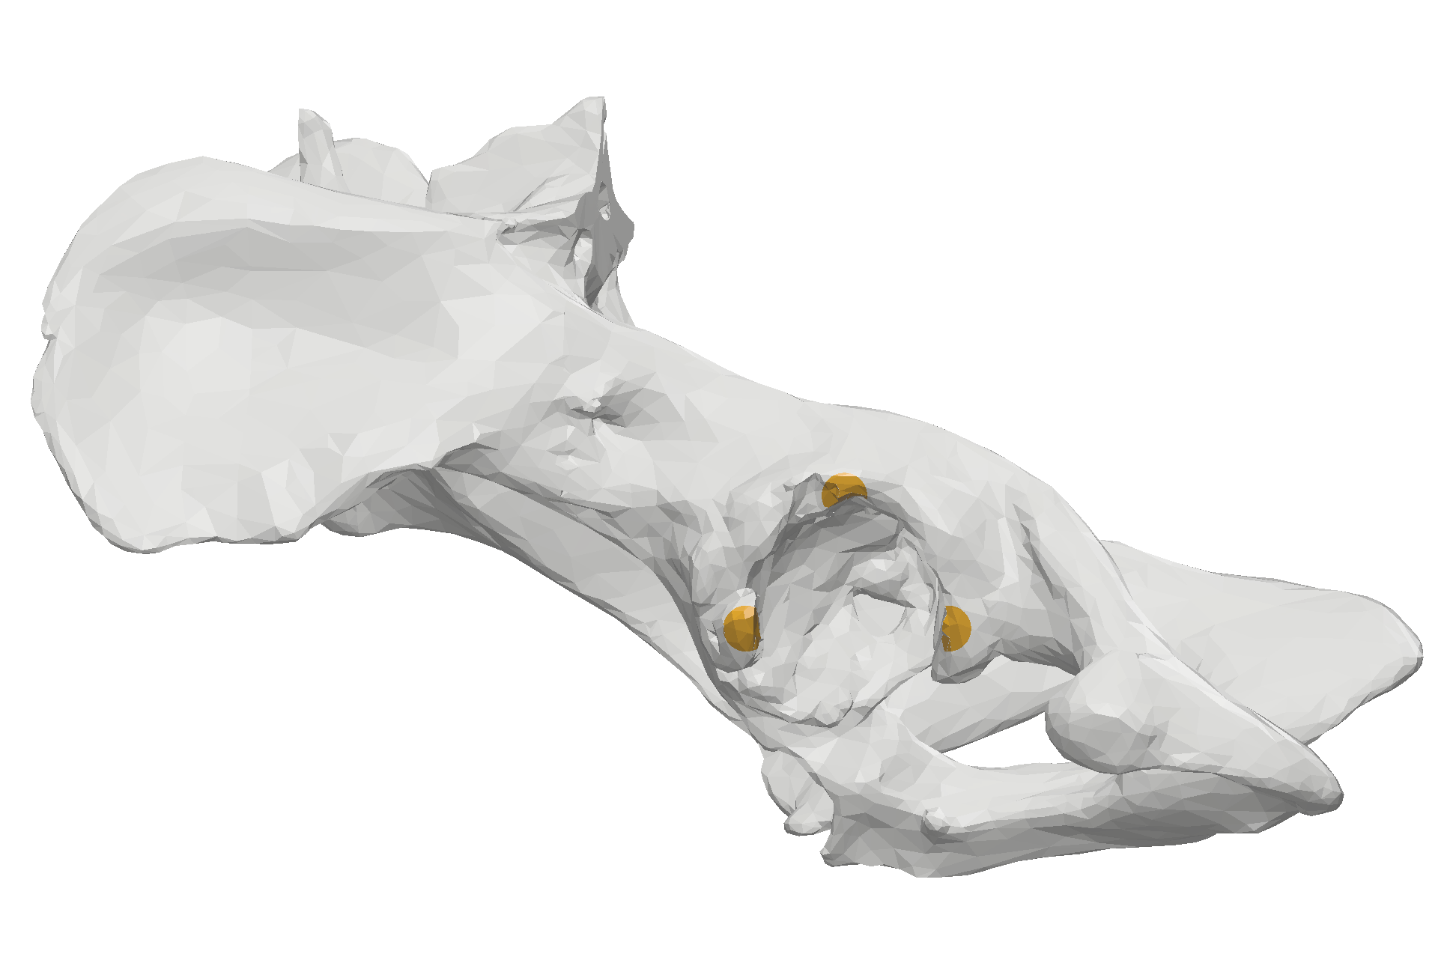
Figure 3: The “footprint” showing the three registration spots where the guide contacted the acetabular rim.

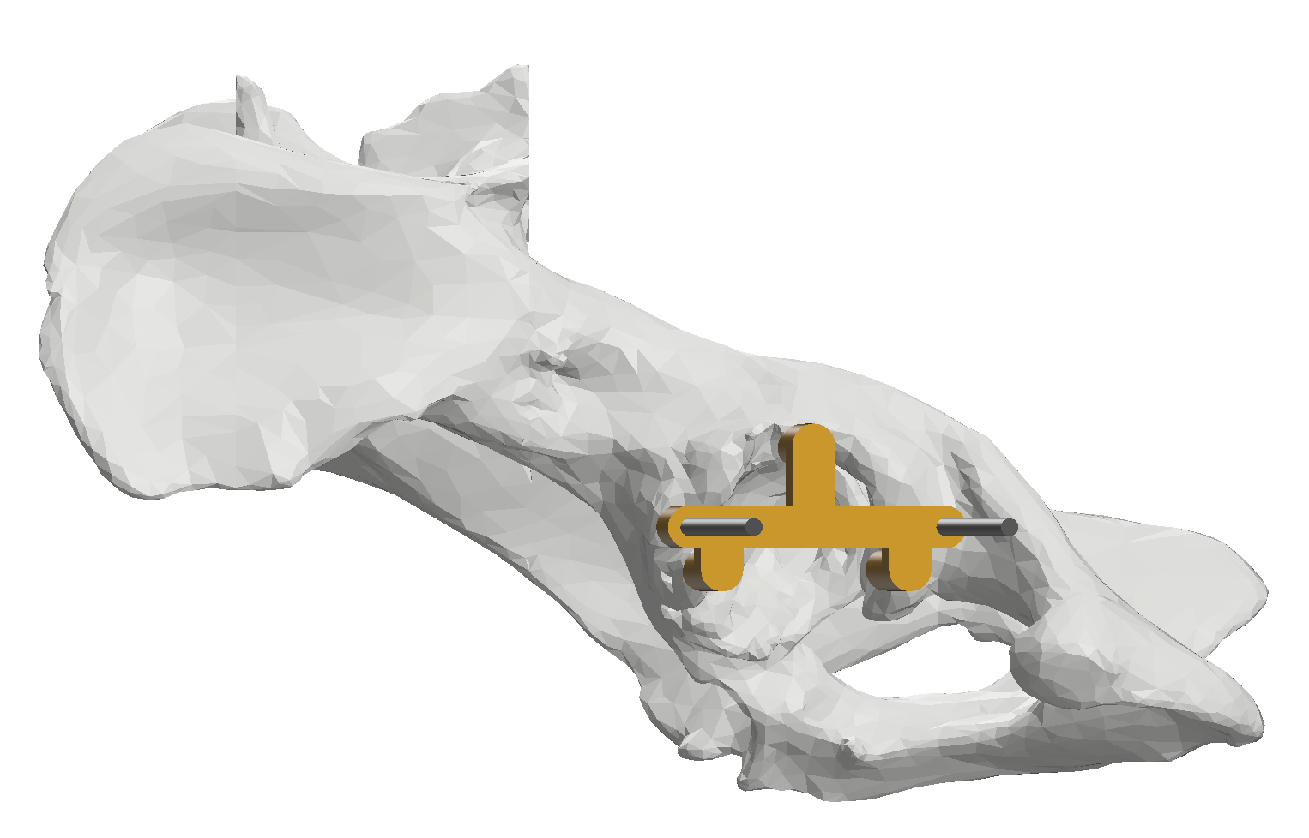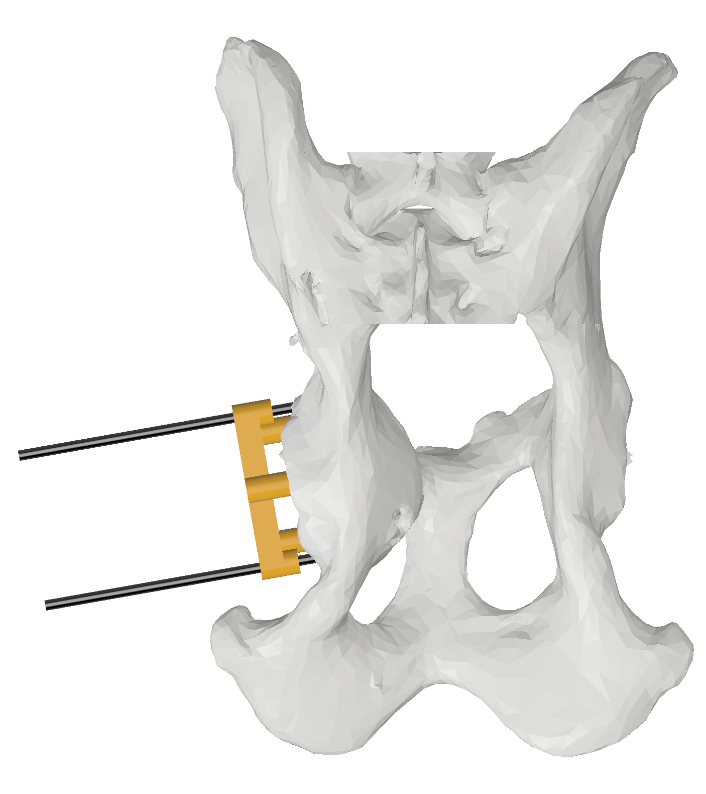
Figure 4: The guide in place with the two pins placed through the guide tunnels into the bone.

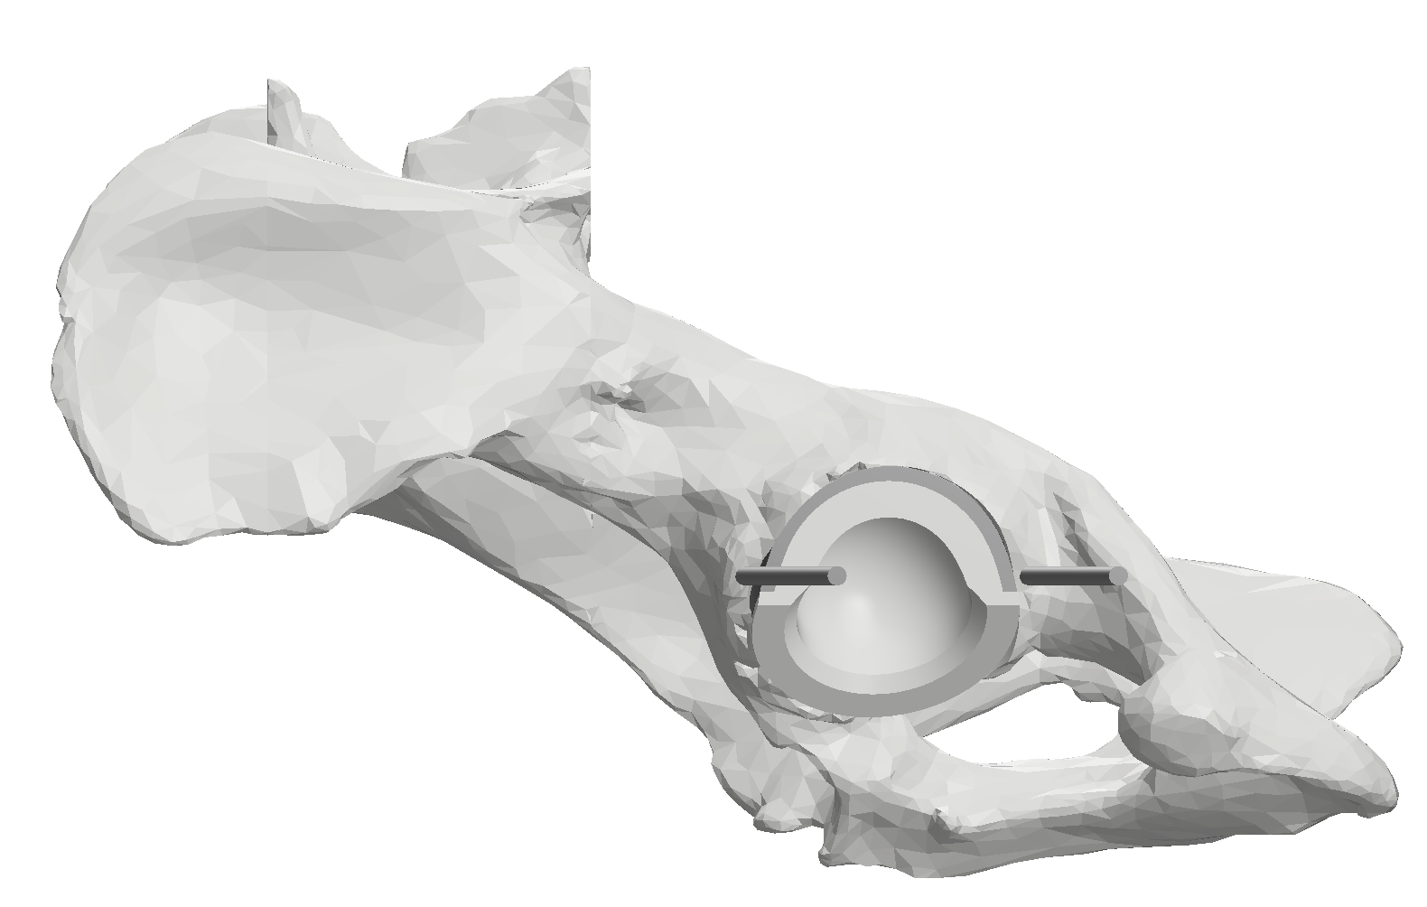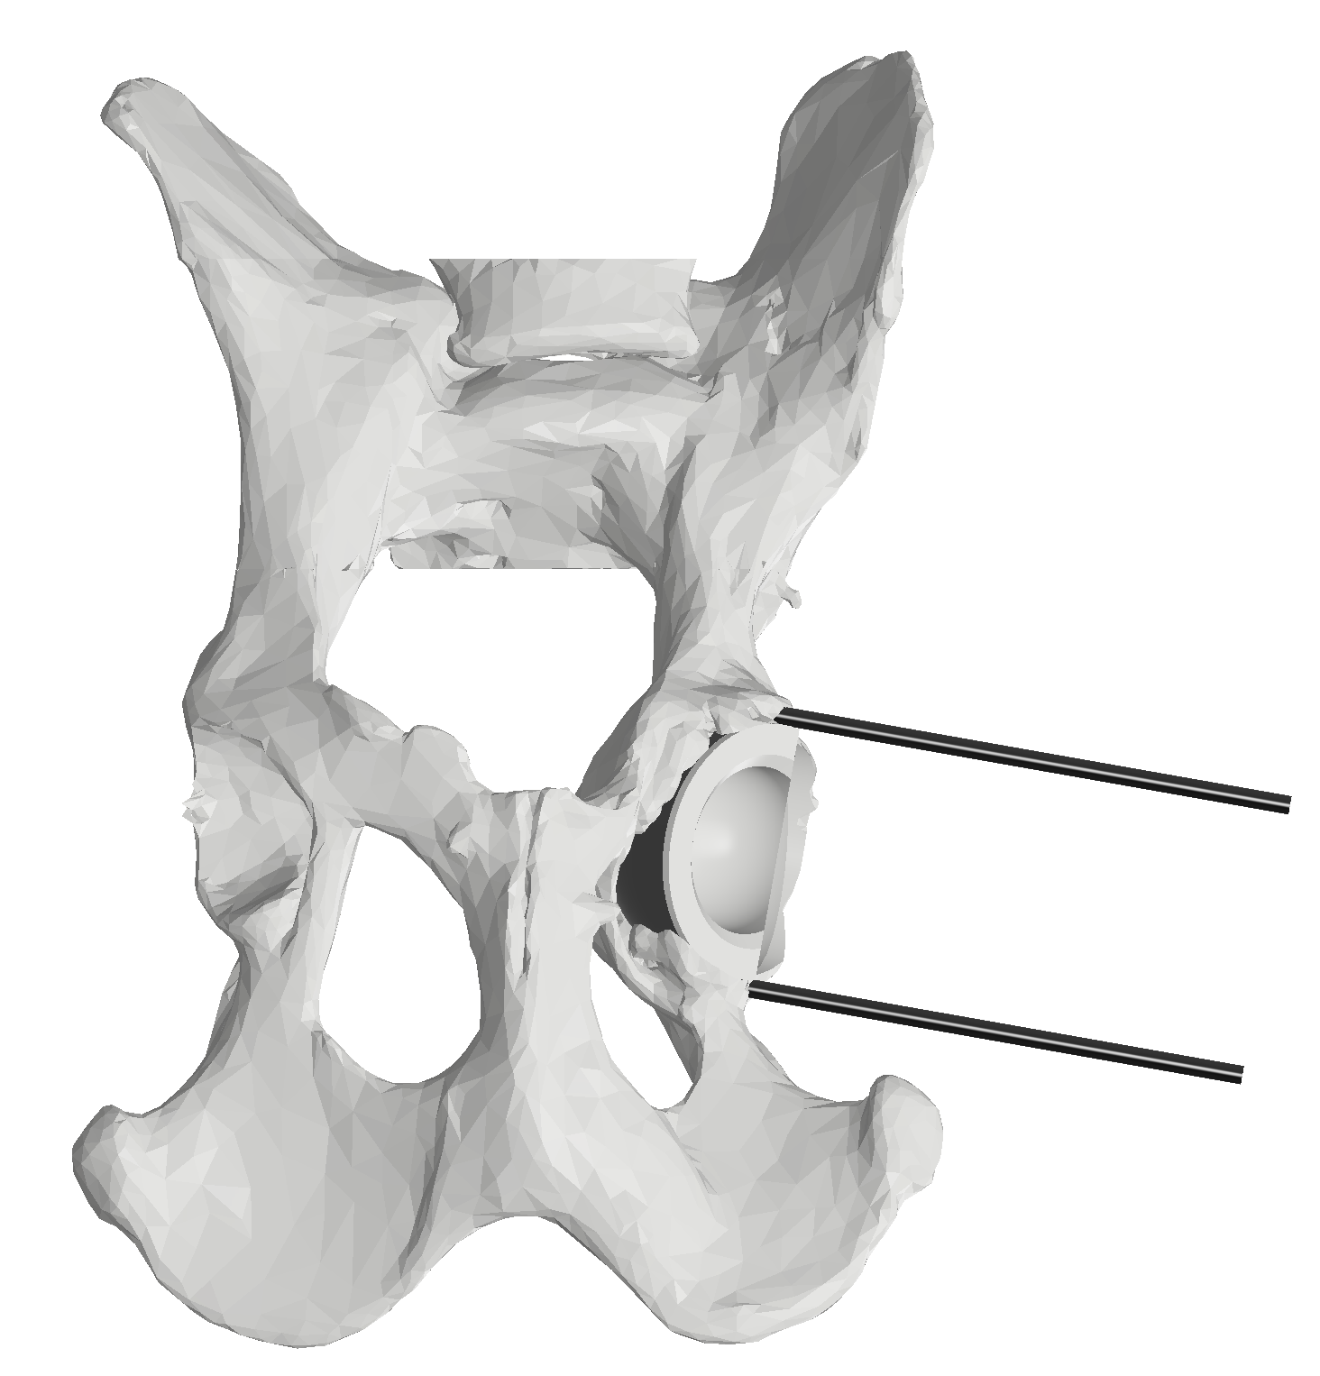
Figure 5: The guide is removed, leaving the pins in place. The acetabulum is then reamed and the cup placed.

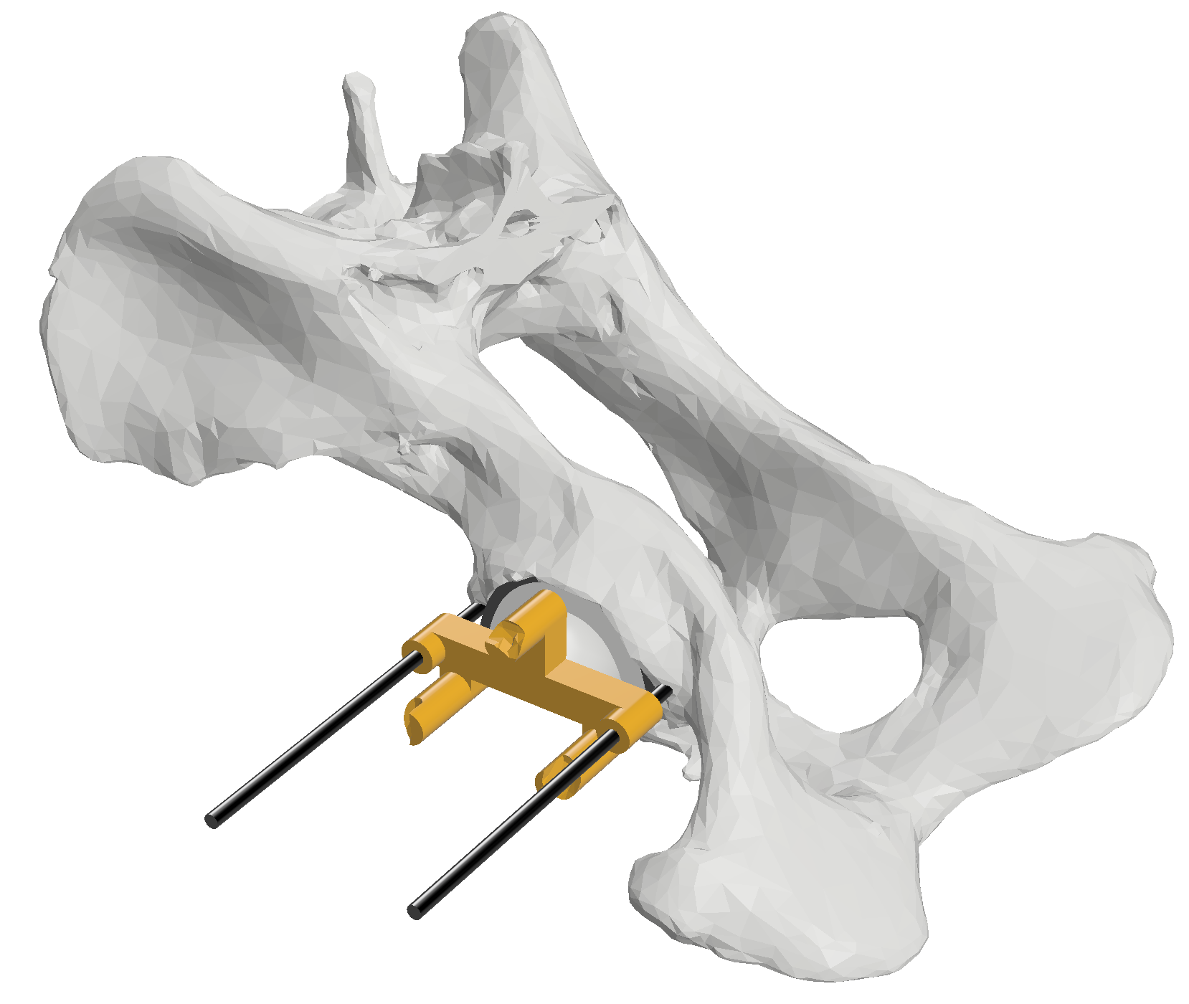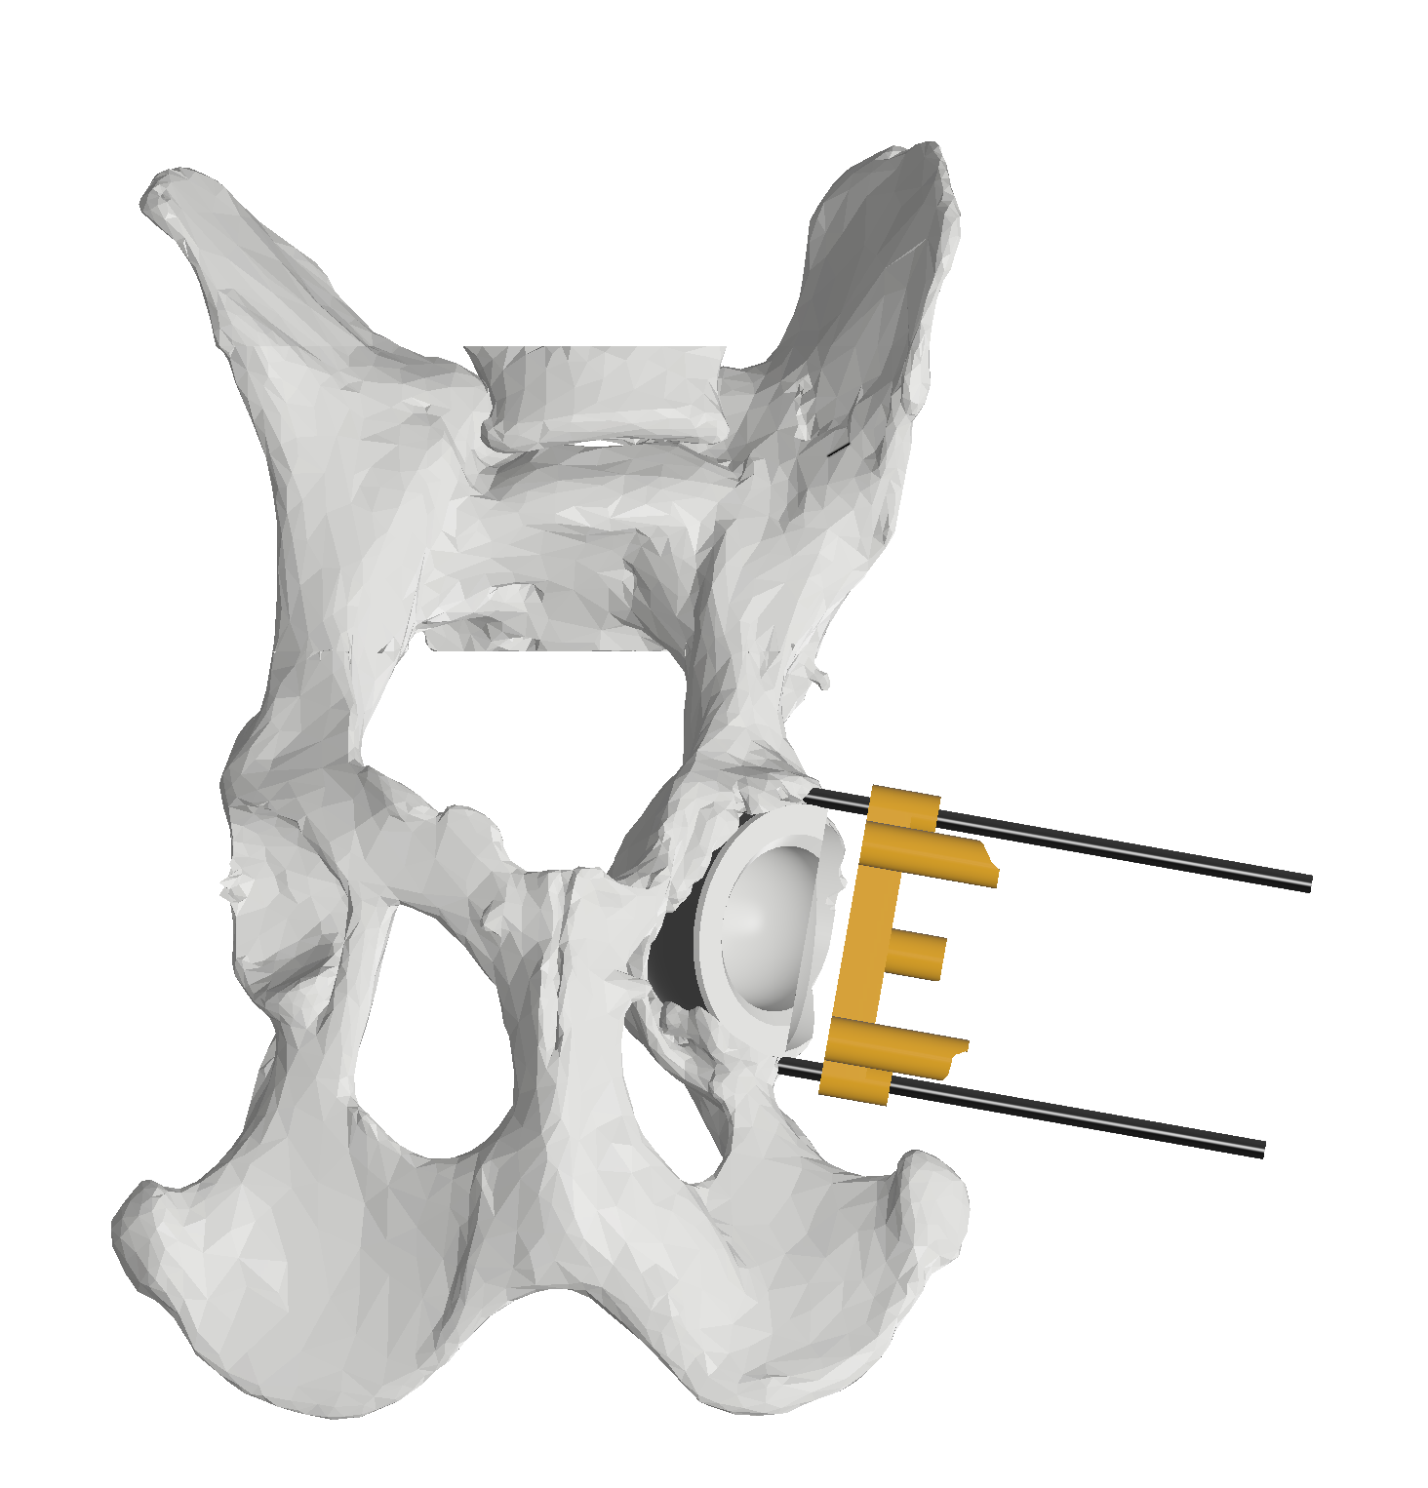
Figure 6: The guide is rotated 180 degrees and slid back over the pins. If the cup is oriented correctly, the truncated face of the cup should be parallel to the adjacent flat face of the guide.
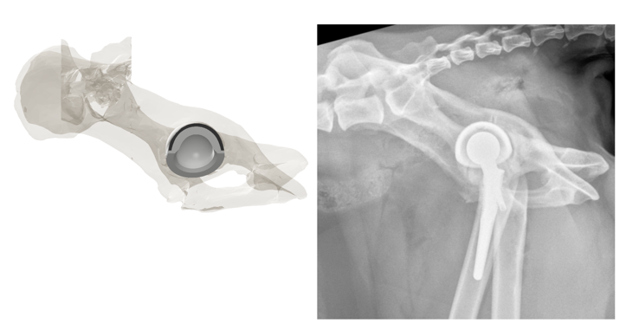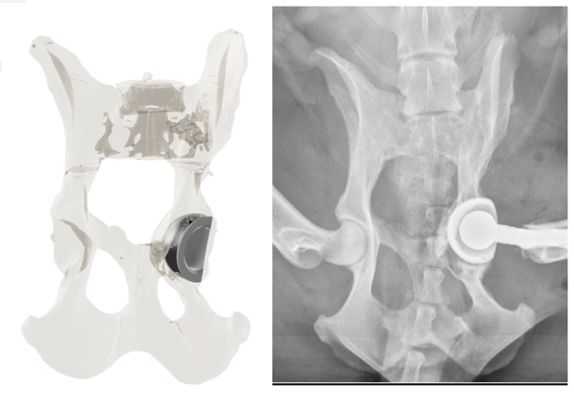

Figure 7: Post operative radiographs in comparison to the virtual plan.

