**Guidedwave Phased Array Technology for Tank Bottom Inspection**

**Cody Borigo1, Russell Love1, Alex Reese1, and Steven Owens1**

1Guidedwave

450 Rolling Ridge Drive

Bellefonte, PA 16823, USA

(717) 309-9537; email cborigo@gwultrasonics.com

ABSTRACT

Guided wave phased array (GWPA) technology and custom Hanford probe designs have recently completed qualification testing of their as part of the Remote Air Slot Volumetric Inspection System (RAVIS) for inspection of primary liner floors of the double shell high-level waste (HLW) tank farm at the Hanford nuclear site. The Hanford DSTs are critical assets for storing and staging waste, but the ageing carbon steel infrastructure will require unprecedented service life extension efforts, including volumetric inspection. The RAVIS technology has been engineered to overcome primary tank floor inspection challenges posed by the refractory concrete pad located between the floor plates of the primary tank and secondary liner, and a key part of this system is the GWPA technology, which electronically steers and sweeps a concentrated ultrasonic guided wave beam out into the test structure away from the probe and in 360° around the probe, which remains stationary during testing. This beam steering is accomplished using a small array of highly-specialized guided wave sensor elements packed into custom-designed GWPA probes that can fit within the small refractory air slots. The GWPA scans can detect corrosion and cracking in open plate areas and welds, and a full inspection of the primary liner floor is possible with access to less than 10% of the tank bottom via the air slots.

**Keywords:** guided wave, ultrasonic, corrosion, tank, inaccessible, remote, new methods

INTRODUCTION

Guided wave phased array (GWPA) technology and custom Hanford probe designs have recently completed qualification testing of their as part of the Remote Air Slot Volumetric Inspection System (RAVIS) for inspection of primary liner floors of the double shell high-level waste (HLW) tank farm at the Hanford nuclear site in Eastern Washington; see Figure 5. This qualification testing and robotic system integration was part of a multi-year, on-going, DOE-funded effort overseen by Washington River Protection Solutions and the Pacific Northwest National Lab (PNNL). Field trials of the RAVIS technology are anticipated for 2024 or 2025, and the GWPA technology is being further evaluated for DST primary liner side wall inspection.

The Hanford DSTs are critical assets for storing and staging waste, but the 37- to 53-year-old carbon steel infrastructure will require unprecedented service life extension efforts in the form of inspection, corrosion control, and potentially in situ refurbishment to maximize the chances that they can support the Hanford cleanup mission for another 4-5 decades (i.e., a second lifetime). The 3/8- to 7/8-inch-thick carbon steel plates that comprise the primary tank liners must be volumetrically inspected (full plate thickness) while the they contain waste. Inspection tools must be robotically deployed to reliably detect corrosion-induced flaws (pits, wall thinning, and stress-corrosion cracks) to provide early warnings of wall loss, i.e., before flaws become leaks. The RAVIS next-generation robotic ultrasonic inspection technology has been engineered to overcome primary tank floor inspection challenges posed by the refractory concrete pad located between the floor plates of the primary tank and secondary liner. The refractory pad limits under-tank access to only 10% of a tank floor area through air ventilation slots with cross-sectional dimensions similar to those of a 3-oz Dixie™ cup. The newly engineered inspection system uses Guidedwave’s GWPA sensing technology that will be robotically deployed in the narrow strips of tank floor plate accessible via the air-slot under the tank – to inspect inaccessible/untouchable parts of the tank from the remote standoff sensor positions.

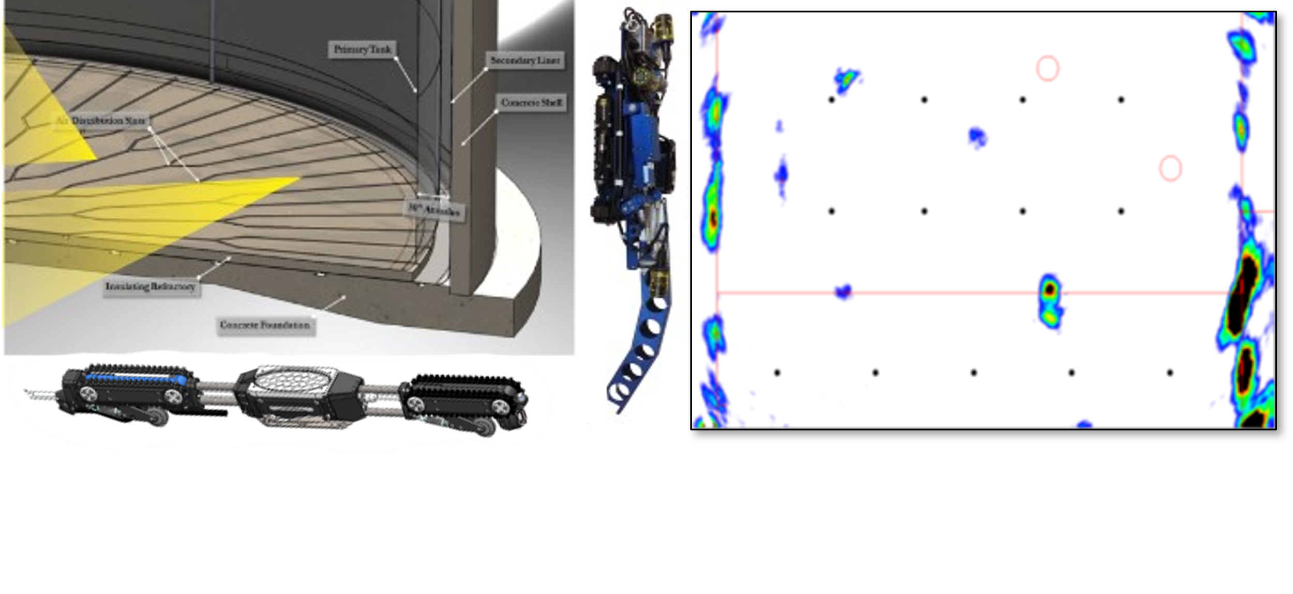

Figure 1: (Left) Illustration of a Hanford HLW DST showing the network of air slots beneath the primary liner, as well as the wall crawling deployment robot (vertical) and marsupial GWPA-deploying air slot robot (horizontal); (right) a composite image result from GWPA verification testing as part of the DOE-funded technology maturation and qualification process.

GUIDED WAVE PHASED ARRAY TECHNOLOGY

Guided waves provide the ability to inspect hidden and inaccessible regions of structures, such as structures under soil, water, coatings, insulations, and concrete because of the inspection capability from a single remote probe position. The best example of guided wave success is in long-range ultrasonic pipeline inspection, where the technology has been accepted commercially for years. The GWPA technology (Figure 3) electronically steers and sweeps a concentrated ultrasonic guided wave beam out into the test structure away from the probe and in 360° around the probe, which remains stationary during testing. The resulting guided wave sector scan (GS-scan), which takes a matter of seconds to generate, displays information on the position and extent of any flaws in the test area that reflected ultrasonic energy back to the probe.

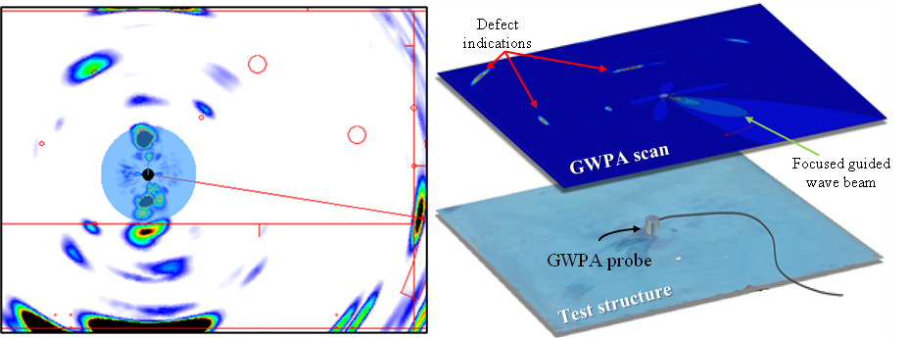

Figure 3: A typical guided wave phased array scan (left) generated with a compact phased array probe and a phased array pulser/receiver system to electronically steer and focus a guided wave beam around a plate-like structure (right); corrosion, cracks, and other anomalies can all be detected.

The guided wave beam steering is accomplished using a small array of highly-specialized guided wave sensor elements packed into an array in a GWPA probe and applying signals to these elements with predetermined time delays using a portable, battery-powered tone-burst phased array pulser/receiver system and advanced processing algorithms. The concept of guided wave phased array technology was explored by J.L. Rose at Penn State University (5),by P. Wilcox, et al. at Imperial College of London (6) (7), and by V. Giurgiutiu at the University of South Carolina (8) in the early- and mid-2000’s. Practical implementation of the GWPA technology (3) was made possible through the utilization of a specialized omnidirectional shear ring piezoelectric element, which generates the fundamental shear-horizontal (SH0) guided wave mode, which is completely non-dispersive, has a constant velocity as a function of frequency, and is unaffected by the presence of water or other liquids in contact with the surface (4). The beam steering allows the sensor to detect the presence of defects at distances of 5-10 feet in all directions around the probe. GWPA scans can cover an area of 50-100 ft2, or more in some cases, in less than 60 seconds. Analysis can be performed on a single GS-scan image or by analyzing a composite image generated from a combination of GS-scans collected at multiple test locations. The technology does not provide an exact thickness map of the structure, but it does allow the user to rapidly locate and categorize the severity of near-side and far-side flaws over a large area, even in difficult-to-access areas of in-service structures. Examples of the beam steering profiles achieved with the Hanford A’ probe design, which was customized for the Hanford DST inspections to fit within the air slots, are provided in Figure 2. The elliptical shape allows the probe to fit in the air slots but results in a reduction in beam resolution along the probe axis. In order to achieve dry coupling (ultrasonic coupling without the use of liquid couplants) for the remote inspection of the DST primary liners, a membrane solution has been implemented that utilizes a viscous shear couplant covered by a sealed aluminum foil layer over the face of the probe; coupling is achieved by mechanical pressure applied to press the probe face against the underside of the tank floor by the RAVIS air slot robot.

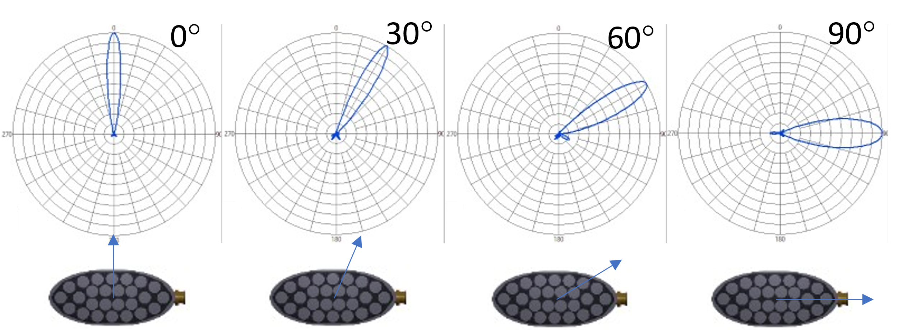

Figure 2: The layout of the Hanford A’ probe design used for Hanford RAVIS qualification testing and the beam profiles when steering 150-kHz SH0 guided waves in steel at several different angles relative to the probe.

Data Processing and Scan Interpretation

One of the most important aspects of an NDE method is the user interpretation of the data provided by the instrument and sensor. For the case of the GWPA technology, as with other guided wave methods, the user is often interpretation sensor data that covers a large area of a structure and may include a variety of structural features like welds, attachments, joints, and geometry changes in addition to potential flaws. Throughout the course of the Hanford technology maturation and qualification process, improvements to the GWPA technology have been implemented to aid in efficient, accurate, and repeatable data interpretation.

While the GWPS user can interpret individual GS-scans, it is often advantageous to compile multiple GS-scans into a single composite image, which can be automatically generated by the software based on user-defined scan locations; one example of a composite image is provided in Figure 3. Both the composite images and GS-scans can be overlaid onto a structural reference drawing uploaded by the user; this aids in scan interpretation and determining the true location of flaw indications. The GWPA software also assists the user in identifying beam focusing artifacts based on proprietary algorithms that evaluate the reflected guided wave data in comparison to the predicted beam profile of the GWPA probe. Guidedwave is coordinating with partners at PNNL to develop automated GWPA data characterization models based on machine learning algorithms trained with the Hanford verification and qualification test data sets and supplemented with analytically-generated data. As part of the Hanford RAVIS technology maturation project, a complete inspection procedure has been developed for the robotically-deployed GWPA data collection and analysis process. This procedure includes sensor signal checks, data collection recommendations, scan quality checks, and user analysis guidelines. The implementation of the PNNL-developed machine learning models will provide further assistance to users as part of this process.



Figure 3: Composite GWPA image from an approximately 5x10-foot section of a Hanford primary liner floor mock-up at PNNL; indications of plate and weld flaws are labeled in red. Welds are indicated by a red line. The image’s color scale from blue to black indicates the severity of individual flaws.

Future Work

Although GWPA qualification testing is complete for the Hanford DST project, field trials have not yet occurred; these are scheduled for 2024/2025. The machine learning algorithm development and data processing refinement efforts will continue. Guidedwave, WRPS, and PNNL are also exploring additional opportunities to leverage the GWPA technology for Hanford DST sidewall inspection, and Guidedwave has recently conducted preliminary mock-up testing for in-service above-ground storage tank floor inspection form the chime plate lip with excellent results. Certainly, the experience and data gained from DST primary liner floor inspections at the Hanford tank farms, as well as data gathered from additional applications, will provide valuable fodder for on-going enhancements to the GWPA technology.

REFERENCES

1. Rose, J., Borigo, C., Owens, S., Reese, A., 2017, “GWPA Scan: Rapid Large Area Inspection from a Single Sensor Position,” *Materials Evaluation* (Feature Article), 75(6), pp. 671-678.
2. Rose, J.L., 2014, *Ultrasonic Guided Waves in Solid Media*, Cambridge University Press, Cambridge, UK.
3. Yan, F. and Rose, J.L., 2007, “Guided wave phased array beam steering in composite plates,” *Proc. SPIE Health Monitoring of Structures and Biological Systems*, 6532.
4. Wilcox, P.D., 2003, “Omni-directional guided wave transducer arrays for the rapid inspection of large areas of plate structures,” *IEEE Trans. on Ultrasonics, Ferroelectrics, and Freq. Control*, 50(6), pp. 699-709.
5. Fromme, P., Wilcox, P.D., Lowe, M.J.S, and Cawley, P., 2006, “On the development and testing of a guided ultrasonic wave array for structural integrity monitoring,” *IEEE Trans. on Ultrasonics, Ferroelectrics, and Freq. Control*, 53(4), pp. 777-785.
6. Giurgiutiu, V. and Bao, J., 2004, “Embedded-ultrasonics structural radar for in-situ structural health monitoring of thin-wall structures,” *Structural Health Monitoring*, 3(2), pp. 121-140.