**Physics-informed clustering: A case study for the detection of different porosity levels in AlSi10Mg additively manufactured samples**

**Michail Skiadopoulos1, Lalith Sai Srinivas Pillarisetti1, Evan Peter Bozek1, and Parisa Shokouhi1**

1Department of Engineering Science and Mechanics, Pennsylvania State University

University Park, PA 16802, United States

Email [mbs6742@psu.edu](mailto:mbs6742@psu.edu), ljp5518@psu.edu, epb5246@psu.edu, [pxs990@psu.edu](mailto:pxs990@psu.edu)

**ABSTRACT**

The formation of subsurface porosity due to gas entrapment or unmelted powder particles is a common defect in additively manufactured components [1], [2], [3] that significantly compromises the mechanical behaviour, such as strength and hardness [4]. Moreover, the fabricated component is susceptible to fatigue failure, since pores act as crack initiation sources [5]. Analytical models [6], [7], [8] describing the wave scattering mechanism in a porous medium have established the dependency of wave speed and attenuation on the volumetric porosity fraction, motivating the use of ultrasonic testing for porosity detection and quantification. However, these analytical models assume simple pore shapes and do not account for the effect of the randomness in pore positioning and orientation. Alternatively, the extensive suite of machine learning (ML) algorithms can be leveraged to link ultrasonic features to porosity. Supervised ML models have been previously used to predict the porosity value by using extracted features from the recorded waveform [9], [10], [11]. While supervised models are useful for explicit quantification of a sample’s porosity, in some cases, it may only be necessary to identify samples with a porosity volume fraction above a reference value or group the samples based on a similar porosity volume fraction. To that front, some studies have also implemented deep learning classification [12], [13] to identify groups of samples with the sample porosity levels. However, these models are not always easily interpretable and require a large, labelled training dataset to avoid over-fitting.

To address these challenges, clustering algorithms, which are effective even with small and unlabelled datasets, could be employed to form clusters with similar porosity values using ultrasonic features (wave speed and attenuation) extracted from the porous test sample as inputs. To test this hypothesis, a set of 42 prismatic AlSi10Mg samples using laser power bed fusion is manufactured, which includes programmatically induced cylindrical pores. There are seven sets of six samples with the same porosity value in the range 0 - 1.5% (0, 0.25, 0.5, 0.75, 1.0, 1.25, and 1.5). In each sample, ultrasonic pulse-echo testing is performed using a P-wave transducer over five locations to extract the wave speed and the attenuation, resulting in a total of 210 wave speed-attenuation pairs corresponding to different porosity values (see Fig. 1). Instead of using wave speeds directly as inputs, the fractional change in wave speeds with respect to the case of no porosity are used as normalized inputs for clustering algorithms along with normalized attenuation values. The dataset is split 80%-20% between learning the model parameters and testing the model’s performance, respectively.

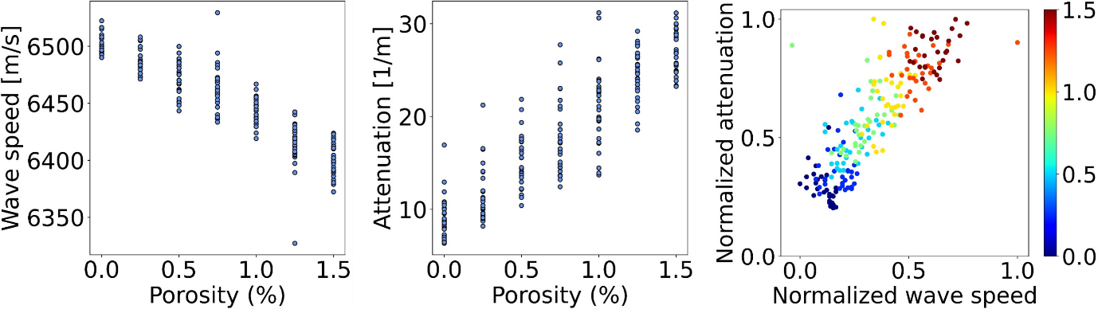

**(a) (b) (c)**

**Fig. 1** Dataset presentation; **(a)** Plot of extracted wave speed vs. porosity levels of the AlSi10Mg test samples; **(b)** Plot of extracted attenuation vs porosity levels of the AlSi10Mg test samples **(c)** Plot of the normalized attenuation vs the normalized relative wave speed for the different porosity levels of the AlSi10Mg test samples. The colour difference indicates a different porosity level.

Initially, the k-means and agglomerative clustering algorithms are implemented. Although these are unsupervised learning methods, their performance is assessed using the true porosity labels; cluster numbers between 1 and 7 are assigned, where a higher cluster number corresponds to higher porosities. The inefficiency of the traditional clustering algorithms to identify the porosity clusters is illustrated in Figs 2 and 3, motivating the introduction of physics equations into the clustering algorithm to improve its performance. A physics-informed clustering (PIC) algorithm is proposed, modifying k-means algorithm so that the clustering criterion depends not only on the L2-norm between a data point and cluster centroids but also on the difference between their porosity values. To calculate the respective porosity values, we manipulate the scattering equations described by C.M. Sayers [6] to solve for one equation that connects porosity to the wave speed and attenuation in the porous medium. The calculated porosity value may not correspond to the true porosity value, but it acts as a correcting factor for the clustering criterion. The proposed modification results in a big performance increase of the clustering procedure and outperforms both the k-means and the agglomerative clustering. It is observed that in the case of PIC, the confusion matrix (see Fig. 2) tends to be more diagonal, indicating its increased accuracy. Moreover, the incorrect identifications tend to be closer to the corresponding true label, meaning that the predictions are placed more closely to their actual porosity group.

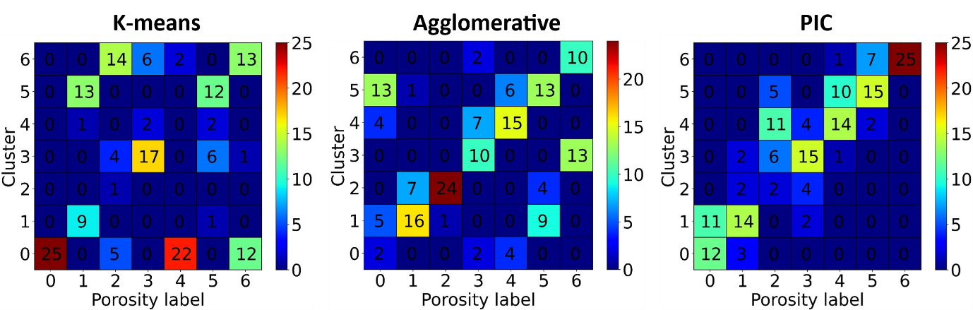

**(a) (b) (c)**

**Fig. 2** Performance comparison with the form of confusion matrix for the different clustering algorithms in the training dataset; **(a)** K-means**; (b)** Agglomerative clustering**; (c)** PIC.

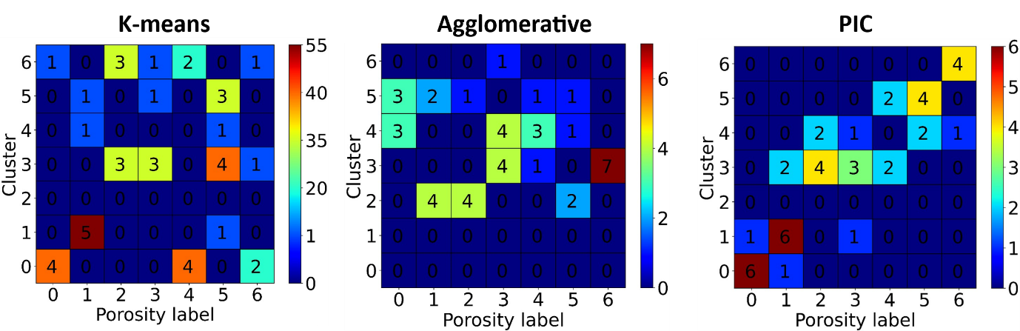

**(a) (b) (c)**

**Fig. 2** Performance comparison with the form of confusion matrix for the different clustering algorithms in the testing dataset; **(a)** Kmeans**; (b)** Agglomerative clustering**; (c)** PIC.

PIC has been previously used implemented to analyse high-speed reacting flow fields [14]. However, to the authors’ best knowledge, this method is the first to introduce physics-based information in a clustering algorithm for non-destructive evaluation, since in other studies claiming to perform PIC, the physics features are calculated after the clustering is completed, as a means of interpreting the results [15]. The proposed clustering algorithm can be used for fast quality control regardless of the material and manufacturing method. As a future work, it will be attempted to develop a PIC that also learns the material dependent constants involved in the equations described by C.M.Sayers [6].

**REFERENCES**

[1] Z. Snow, A. R. Nassar, and E. W. Reutzel, “Invited Review Article: Review of the formation and impact of flaws in powder bed fusion additive manufacturing,” *Additive Manufacturing*, vol. 36, p. 101457, Dec. 2020, doi: 10.1016/j.addma.2020.101457.

[2] C. Du *et al.*, “Pore defects in Laser Powder Bed Fusion: Formation mechanism, control method, and perspectives,” *Journal of Alloys and Compounds*, vol. 944, p. 169215, May 2023, doi: 10.1016/j.jallcom.2023.169215.

[3] N. Sanaei and A. Fatemi, “Defects in additive manufactured metals and their effect on fatigue performance: A state-of-the-art review,” *Progress in Materials Science*, vol. 117, p. 100724, Apr. 2021, doi: 10.1016/j.pmatsci.2020.100724.

[4] W. H. Kan *et al.*, “A critical review on the effects of process-induced porosity on the mechanical properties of alloys fabricated by laser powder bed fusion,” *J Mater Sci*, vol. 57, no. 21, pp. 9818–9865, Jun. 2022, doi: 10.1007/s10853-022-06990-7.

[5] Y. Cui, J. Cai, Z. Li, Z. Jiao, L. Hu, and J. Hu, “Effect of Porosity on Dynamic Response of Additive Manufacturing Ti-6Al-4V Alloys,” *Micromachines*, vol. 13, no. 3, p. 408, Mar. 2022, doi: 10.3390/mi13030408.

[6] C. M. Sayers, “Ultrasonic velocity dispersion in porous materials,” *J. Phys. D: Appl. Phys.*, vol. 14, no. 3, pp. 413–420, Mar. 1981, doi: 10.1088/0022-3727/14/3/012.

[7] P. C. Waterman and R. Truell, “Multiple Scattering of Waves”.

[8] C. F. Ying and R. Truell, “Scattering of a Plane Longitudinal Wave by a Spherical Obstacle in an Isotropically Elastic Solid,” *Journal of Applied Physics*, vol. 27, no. 9, pp. 1086–1097, Sep. 1956, doi: 10.1063/1.1722545.

[9] K. Mohanty, O. Yousefian, Y. Karbalaeisadegh, M. Ulrich, Q. Grimal, and M. Muller, “Artificial neural network to estimate micro-architectural properties of cortical bone using ultrasonic attenuation: A 2-D numerical study,” *Computers in Biology and Medicine*, vol. 114, p. 103457, Nov. 2019, doi: 10.1016/j.compbiomed.2019.103457.

[10] L. Lin, W. Zhang, Z. Ma, and M. Lei, “Porosity estimation of abradable seal coating with an optimized support vector regression model based on multi-scale ultrasonic attenuation coefficient,” *NDT & E International*, vol. 113, p. 102272, Jul. 2020, doi: 10.1016/j.ndteint.2020.102272.

[11] Z. Ma, L. Sun, Y. Chen, and L. Lin, “Ultrasonic prediction of thermal barrier coating porosity through multiscale-characteristic-based Gaussian process regression algorithm,” *Applied Acoustics*, vol. 195, p. 108831, Jun. 2022, doi: 10.1016/j.apacoust.2022.108831.

[12] S.-H. Park, J.-Y. Hong, T. Ha, S. Choi, and K.-Y. Jhang, “Deep Learning-Based Ultrasonic Testing to Evaluate the Porosity of Additively Manufactured Parts with Rough Surfaces,” *Metals*, vol. 11, no. 2, p. 290, Feb. 2021, doi: 10.3390/met11020290.

[13] D. Chen, Y. Zhou, W. Wang, Y. Zhang, and Y. Deng, “Ultrasonic signal classification and porosity testing for CFRP materials via artificial neural network,” *Materials Today Communications*, vol. 30, p. 103021, Mar. 2022, doi: 10.1016/j.mtcomm.2021.103021.

[14] M. Ullman, S. Barwey, G. S. Lee, and V. Raman, “Segmentation of high-speed flow fields using physics-informed clustering,” *Applications in Energy and Combustion Science*, vol. 15, p. 100181, Sep. 2023, doi: 10.1016/j.jaecs.2023.100181.

[15] A. Chakravarty, S. Misra, and C. S. Rai, “Visualization of hydraulic fracture using physics-informed clustering to process ultrasonic shear waves,” *International Journal of Rock Mechanics and Mining Sciences*, vol. 137, p. 104568, Jan. 2021, doi: 10.1016/j.ijrmms.2020.104568.