Scattering Analysis for Crack-like Defects using Laser Ultrasonic Array
Peter Lukacs¹, Geo Davis¹, Jie Zhang² and Theodosia Stratoudaki¹

¹Department of Electronic and Electrical Engineering
University of Strathclyde
Glasgow, G1 1XW, UK
Peter.lukacs@strathclyde.ac.uk

²Department of Mechanical Engineering
University of Bristol
University Walk
Bristol, UK, BS8 1TR
ABSTRACT
Laser Induced Phased Arrays use lasers for generation and detection of ultrasound, enabling remote, non-contact, couplant-free inspection on complex objects. In previous work LIPAs have been utilized to detect and locate omni-directional and specular reflectors within metallic samples by capturing the full matrix and performing the total focusing method. This study explores defect characterization through the use of scattering matrices. Scattering matrices, acquired by measuring the scattering amplitude of a defect as a function of insonification and scattering angle, contain information relating to the shape, size and orientation of a defect. Previously, scattering matrices have assumed omnidirectional sources and receivers, for the case of transducer-based phased arrays. Experimental scattering matrices can be correlated well with theoretical scattering matrices that are obtained via simulations. Laser ultrasonics generation and detection directivity patterns at the non-destructive, thermoelastic regime are more directional than transducers and can defer for different wave modes. In this work we are applying a sensitivity matrix, which provides information about directivity amplitudes at varying insonification and scattering angles for the specific location of the defect. The sensitivity matrix is based on the angular laser generation and detection efficiencies and enables correlation of theoretical scattering matrices to the experimental laser ultrasonic data. Four machined slots are considered at orientation angles 0°, 15°, 30°, 45° and 60° relative to the inspection surface, in an aluminum sample and four LIPAs were synthesized, capturing the full matrix. The data were used to extract scattering information and form the experimental scattering matrix. The experimental results are compared to the sensitivity-weighted theoretical scattering matrices for the corresponding defects. Overall, good agreement was observed between the theoretical and experimental scattering matrices allowing for characterization of the slots.

Keywords: laser ultrasound, phased arrays, scattering, crack characterization, laser phased arrays.

INTRODUCTION
The ability to non-destructively characterize cracks is critical for ensuring the integrity of solid components. One method of crack characterization in ultrasonic testing is through measuring the scattering matrix of cracks [1]. The measurement is then compared with simulated scattering matrices for possible crack sizes, shapes and orientations to find the best possible match [1]. The method has been well-documented for transducer-based phased arrays [1-2].
Laser Induced Phased Arrays (LIPAs) generate and detect ultrasound, using lasers, compared to conventional transducer-based arrays [3]. Lasers have a small footprint, can be coupled through optic fibers, can conform to complex shapes and do not require physical contact with the test objects, thus LIPAs offer distinctive advantages. LIPAs have previously been used for detecting and locating omni-directional [4] and specular reflectors [5], while, the characterization of cracks has not been the focus of previous studies.
For transducer-based phased arrays, with sufficiently small element size, close to omni-directional directivity is observed. Thus, experimental scattering matrices can be correlated well with theoretical scattering matrices that are obtained via simulations, assuming omnidirectional sources and receivers. In contrast, laser ultrasound directivity patterns are more directional and can defer for different wave modes and excitation regimes [3]. In order to account for this, we propose the concept of sensitivity matrices, which provides information about directivity amplitudes at varying insonification and scattering angles for the specific location of the defect.
In this work, we demonstrate the defect characterization capabilities of LIPA inspection, through the use of scattering matrices for the first time. These matrices enable the comparison of theoretical laser ultrasonic scattering matrices to experimentally obtained ones, accounting for the ultrasound directivities, via the sensitivity matrices. The method is demonstrated on four crack-like, through thickness slots at varying orientations relative to the inspection surface, on an aluminum sample.

Laser Ultrasonic Sensitivity-Weighted Scattering Matrices
The paper discusses the case where laser ultrasound is generated at the non-destructive, thermoelastic regime. In this regime ultrasound is generated by the rapid heating of the skin layer of the inspected component. The directivity of such an ultrasonic source for shear waves is defined by
$$G_{T}\left(θ\right)=\frac{\sin{2θ}\cos{2θ}}{\cos{2θ^{2}}\sin{2θ}{\left(κ^{2}-{\sin{θ}}^{2}\right)}^{1/2}+{\left(κ^{2}-{\sin{2θ}}^{2}\right)}^{2}}$$ | (Eq. 1)
where
$θ=$ angle relative to the surface normal,
$κ=$ ratio of longitudinal to shear acoustic velocity of the test object.
The directivity function of an out-of-plane laser ultrasonic detector for shear waves is defined by:
$$D_{T}\left(θ\right)=\frac{\sin{2θ}{\left(κ^{2}{\sin{θ}}^{2}-1\right)}^{1/2}}{F_{0}\left(κ\sin{θ}\right)}$$ | (Eq. 2)
where
$$F_{0}\left(ξ\right)={\left(2ξ^{2}-κ^{2}\right)}^{2}-4ξ^{2}{\left(ξ^{2}-1\right)}^{1/2}{\left(ξ^{2}-κ^{2}\right)}^{1/2}$$ | (Eq. 3)
Then the sensitivity matrix is obtained by
$$S_{m}\left(G,D\right)=G_{T}\left(θ_{G}\right)D_{T}\left(θ_{D}\right)$$ | (Eq. 4)
The generation ($θ_{G}$) and detection ($θ_{D})$ angles for the generation (G) and detection (D) elements for a given point in the image (i.e. location of the defect), located at x and z, can be calculated by the following equation
$$θ_{i}\left(x,z\right)=\tan^{-1}\left(\frac{\left(x-x_{i}\right)}{z}\right)$$ | (Eq. 5)
where
$x_{i}=$ location of the $i^{th}$ array element.
An example theoretical scattering matrix of a 3 mm wide, 1 mm thick slot, for an angular range of -45° to 45°, is shown in Figure 1 A). This figure shows the scattering behavior of the slot for longitudinal waves, assuming omni-directional generation and detection directivities. Further details regarding the simulation that was carried out to produce this scattering matrix are presented in [1]. Figure 1 B) shows the laser ultrasonic sensitivity matrix for the slot assuming the same angular range of -45° to 45°. The product of Figure 1 A) and B) provides Figure 1 C), which is the theoretical scattering matrix for the slot described in this section, using the laser ultrasound directivities.
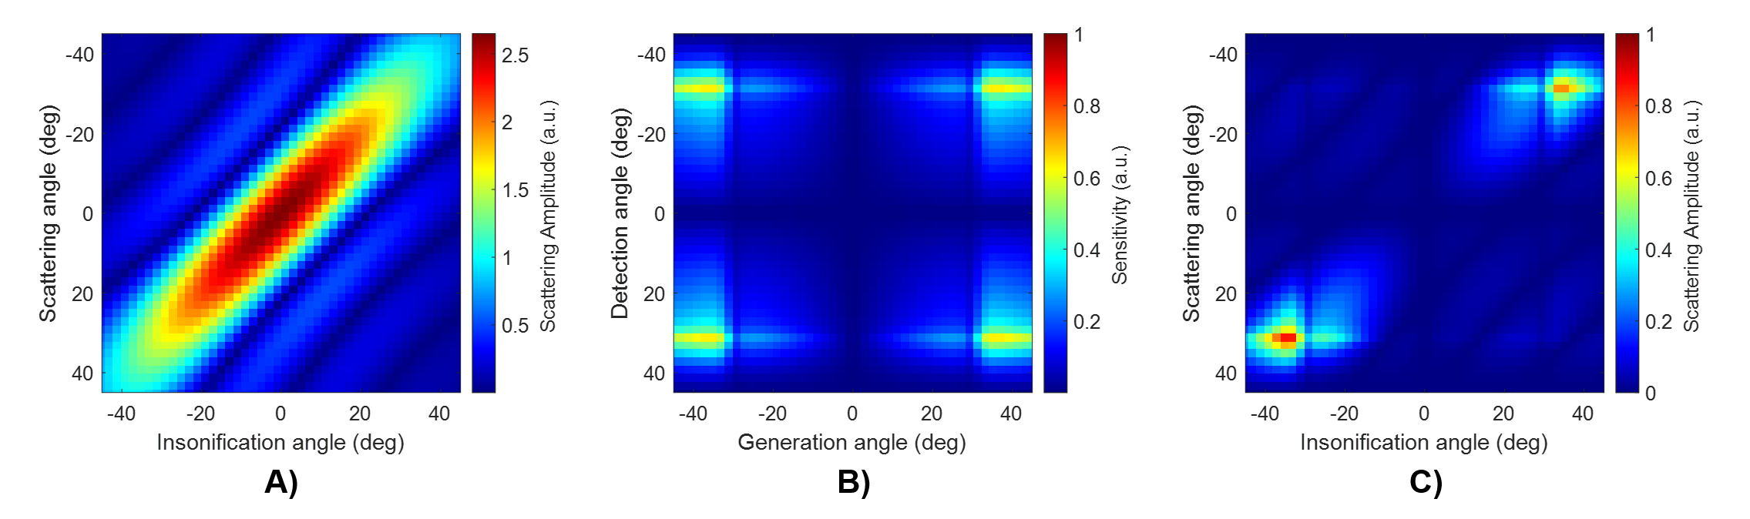
Figure 1: Scattering matrix for a 3 mm wide, 1 mm thick slot using omnidirectional sources and receivers (A)) and laser ultrasound sensitivity matrix (B)) for a point 20 mm deep at the centre of the array. The scattering matrix predicted for a laser ultrasound array, obtained by combining A) and B) is shown in C).
Scattering Matrix Extraction from Full Matrix Dataset
Experimentally, scattering matrices are obtained by extracting information from the Full Matrix at time corresponding to the ray path to and from the defect considered. This time can be found by initially locating the defect on the ultrasonic image produced from the Full Matrix dataset. Using the coordinates of the defect location (x,z), the times are computed using
$$τ_{GD}\left(x,z\right)=\frac{{\left({\left(x-x_{G}\right)}^{2}+z^{2}\right)}^{1/2}+{\left({\left(x-x_{D}\right)}^{2}+z^{2}\right)}^{1/2}}{c}$$ | (Eq. 6)
where
$x_{G}=$ location of the $G^{th}$ generation array element,
$x_{D}=$ location of the $D^{th}$ detection array element,
$c =$ acoustic velocity in the target material.

EXPERIMENTAL SETUP, SAMPLE AND LIPA SYNTHESIS
The experimental setup consists of two lasers; one for generation and the other for detection of ultrasound. The generation laser is a 1064 nm, 23 ns pulsed laser, and the detection laser is a 532 nm continuous laser. A cylindrical lens is used in the generation beam path to focus the beam into a line. The detection laser is used with an interferometric system that has a bandwidth of 1 – 66 MHz and is capable of measuring out-of-plane displacements.
The sample used for the experiment was an aluminum block of dimensions 90 mm x 50 mm x 20 mm (see Fig. 2). The sample consists of 1 through hole of 1 mm diameter and 5 through slots of dimensions 3 mm x 1 mm. The five slots are oriented at angles of 0°, 15°, 30°, 45° and 60°, respectively, with respect to the longer edge of the sample and separated by 10 mm between each other.
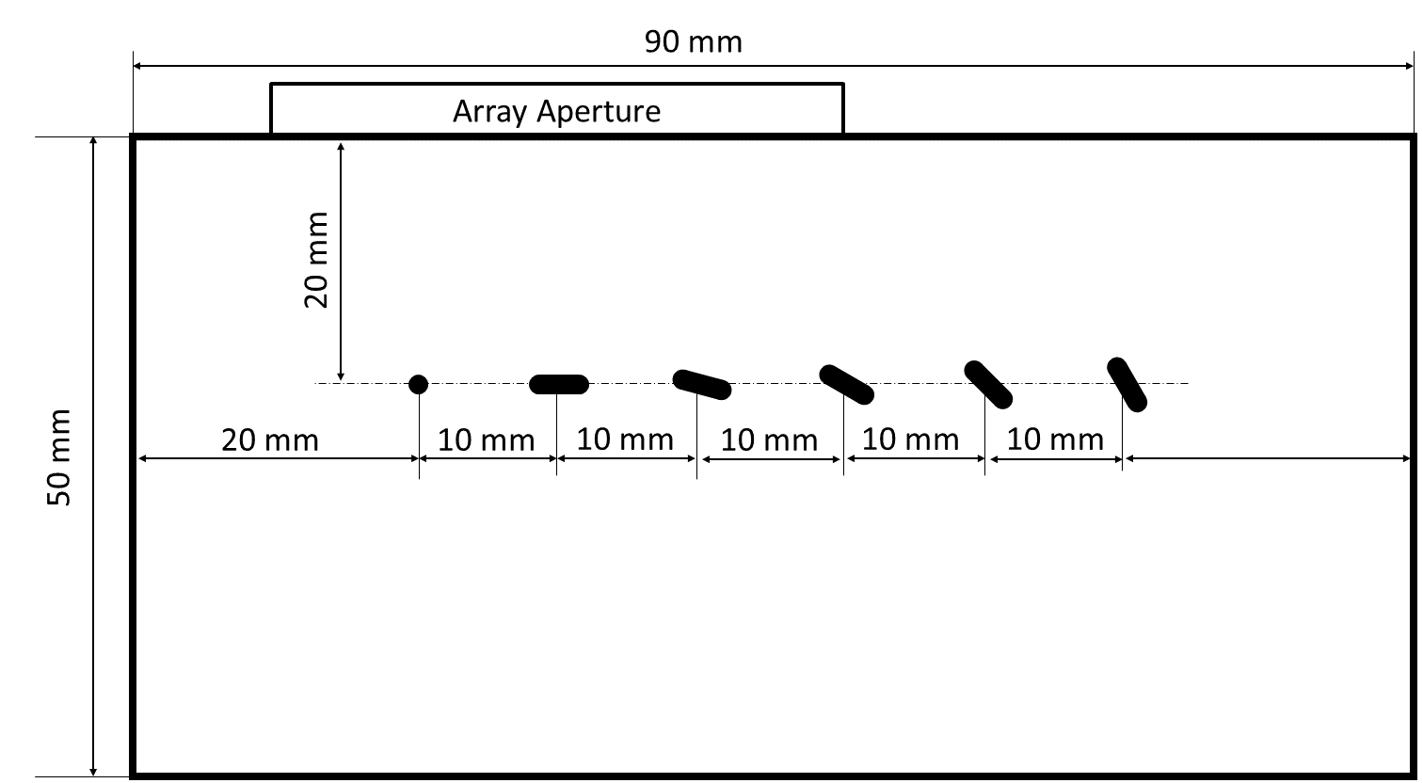
Figure 2: Sample geometry showing the 1 mm diameter through hole and five, 3 mm x 1 mm slots. The array aperture depicted is targeted for the first slot (located 30 mm from the left edge).
Four linear, equidistant LIPA of 81 elements with a pitch of 0.5 mm were synthesized (and centered) above the 0°, 15°, 30° and 45° slots on the surface of the sample. This was achieved by scanning the lasers on the surface of the sample, thus enabling full matrix data acquisition. The setup uses a galvo mirror and a linear stage to achieve scanning of the generation laser and detection laser, respectively. Every signal acquired was averaged 512 times and digitally bandpass filtered at 5 MHz center frequency and 200% bandwidth.

RESULTS AND DISCUSSION
The results from the four LIPAs synthesized can be seen in Figure 3, for theoretical (A)-D)) and experimental (E)-H)) cases. In [1] the combination of signals from subarrays was utilized for individual points of the scattering matrix, which is similar to applying a smoothing filter. In this work, a Gaussian filter was applied to the experimental scattering matrices with a standard deviation value of 3. Figure 3. E)-H) show the filtered matrices.
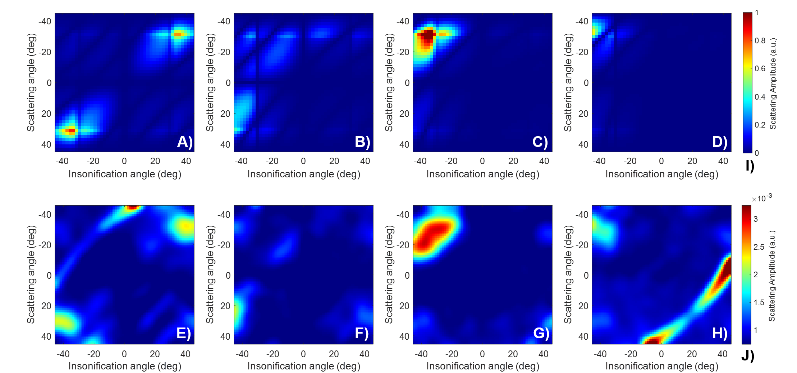
Figure 3: Theoretical (A) - D)) and experimental (E) - H)) scattering matrices for the 0° (A), E)), 15° (B), F)), 30° (C), G)) and the 45° (D)-H)) slots. The color bars for the theoretical and experimental scattering matrices are shown in I) and J), respectively.

Overall, good agreement can be observed between the theoretical and experimental scattering matrices shown in Figure 3, allowing for characterization of the slots. Some artefacts are observed on the experimental scattering matrices, appearing as arcs in the top left and bottom right corners of Figure 3 E) and H) respectively. These artefacts are due to the reflection of the high amplitude surface acoustic waves, generated by the laser, which arrive at the same time as reflections of the bulk waves from the defect. These two artefacts are symmetrical along the right diagonal because the corresponding defects are located the same distance away from the two corresponding edges of the sample. It is also important to note that the theoretical scattering matrices are for longitudinal waves, while experimental ones are for shear waves. However, [2] demonstrates that while the shear and longitudinal scattering matrices are not identical, they show good agreement.
As shown in Figure 1, the laser ultrasonic sensitivity matrix limits the amount of information that can be observed in the scattering matrix due to certain regions having low sensitivity. In future work we aim to utilize multi-modal scattering matrix inspection, each with their unique sensitivity matrix, enabling extraction of more information from a single full matrix data set.

REFERENCES
(1) Zhang, J., B. W. Drinkwater, and P. D. Wilcox, 2008, "Defect characterization using an ultrasonic array to measure the scattering coefficient matrix." IEEE Transactions on Ultrasonics, Ferroelectrics, and Frequency Control 55(10), pp 2254-2265.
(2) Zhang, J., B. W. Drinkwater, P. D. Wilcox, and A. J. Hunter, 2010, "Defect detection using ultrasonic arrays: The multi-mode total focusing method." NDT & E International 43(2), pp 123-133.
(3) Stratoudaki, T., M. Clark, and P. D. Wilcox, 2016 "Laser induced ultrasonic phased array using full matrix capture data acquisition and total focusing method." Optics Express 24(19) pp 21921-21938.
(4) Lukacs, Peter, Geo Davis, Theodosia Stratoudaki, Stewart Williams, Charles N. MacLeod, and Anthony Gachagan, 2021, "Remote ultrasonic imaging of a wire arc additive manufactured Ti-6Al-4V component using laser induced phased array." In 2021 IEEE International Instrumentation and Measurement Technology Conference (I2MTC), pp 1-6. IEEE.
(5) Lukacs, Peter, Geo Davis, Theodosia Stratoudaki, Yashar Javadi, Gareth Pierce, and Anthony Gachagan, 2021, "Remote, volumetric ultrasonic imaging of defects using two-dimensional laser induced phased arrays." In Quantitative Nondestructive Evaluation, vol. 85529, p. V001T18A001. American Society of Mechanical Engineers.

