**Deep Learning for Weld Measurement Extraction via Ultrasonic   
Monitoring of the Resistance Spot Welding Process**

**Ryan Scott1, Vlad Tusinean1, Danilo Stocco1, Andriy M. Chertov1, and Roman Gr. Maev1**

1The Institute for Diagnostic Imaging Research

688 University Avenue West

Windsor, Canada, N9A 5R5

rscott@uwindsor.ca

ABSTRACT

Efficiency, lightweighting, and electrification endeavors have necessitated an increasing use of next-generation materials, dissimilar material joints, and unconventional stackups in automotive body-in-white assembly and resistance spot welding (RSW). These changes have brought forth novel engineering challenges which reduce the applicability of open-loop RSW control based on institutional knowledge and common RSW practices. Consequently, monitoring the RSW process, evaluating and tracking its outcomes, and leveraging massive data via analytics to derive feedback for closed-loop control have never been so crucial in automotive manufacturing. Despite these industry needs, statistical destructive and nondestructive tests still remain common.

In recent years, advancements in computing, artificial intelligence (AI), and most notably deep learning (DL), have enabled the interpretation of data from nondestructive evaluation (NDE) at throughput and performance levels required by the automotive industry. DL continues to establish the state of the art in many computer vision and natural language processing applications, and consequently it continues to be increasingly studied and applied in NDE. In this work, we developed semantic segmentation approaches for post-process and in-process interpretation of ultrasonic data from RSW process monitoring. Algorithms were then developed that estimate measurements from the segmentation mask data leveraging prior knowledge about the weld. For both AI systems, correlation analyses were conducted between ultrasonically-measurable properties and physical measurements from cross-sectioning of dissimilar-material 2- and 3-sheet RSWs.

This work demonstrates that AI can enhance, facilitate automation of, and provide new value to well-established NDE methodologies. AI and other smart manufacturing technologies enable new NDE use cases, enable innovative vehicle body designs, facilitate the use of novel joining technologies, improve vehicle safety, improve manufacturing efficiency, and reduce waste – consequently, they are poised to make NDE 4.0 a reality in automotive manufacturing.

**Keywords:** ultrasound, deep learning, semantic segmentation, resistance spot welding

INTRODUCTION

NDE 4.0 is the next generation of NDE in which modern technologies are leveraged to enable automation and full connectivity of NDE systems with broader manufacturing ecosystems. NDE 4.0 is a vital component to Industry 4.0 – the current industrial revolution – as NDE 4.0 provides new value by enabling the extraction of unprecedented amounts of data about products and processes. AI is a key technology which enables Industry/NDE 4.0 by automating data processing, rapidly and accurately extracting consistent information and insights, and automating decision-making. AI thereby enables NDE systems to produce closed-loop feedback in manufacturing processes by monitoring and analyzing these processes and their products.

RSW is one such key process in automotive manufacturing, as it is used about 4000-6000 times per vehicle due to its relatively low cost, low added weight, simplicity, flexibility, and throughput. RSW engineering is becoming increasingly complicated due to use of novel advanced materials (e.g. using advanced high-strength steels and aluminum alloys), dissimilar-material combinations (e.g. joining mild with high-strength steel), and unconventional stackups (e.g. three-sheet welds with both thin and thick sheets) [1, 2]. These complications lead to welding configurations that are extremely sensitive to external changing parameters (e.g. part curvature, electrode cap wear, etc.), difficult to consistently replicate, or needlessly inefficient. Thus, novel NDE solutions are sought after to enable RSW quality control, RSW process monitoring, and adaptive closed-loop RSW feedback.

Despite these industry needs, RSW inspection data are still largely acquired using statistical destructive and nondestructive methods. These statistical approaches are offline, slow, expensive, wasteful, and low-coverage (<1%). Thus, an inline solution for real-time ultrasonic process monitoring for RSW was developed [3-5]. Recent works have demonstrated the applicability of DL to ultrasonic data interpretation via semantic segmentation for post-process (after weld completion) quality control [6] and in-process (real-time) weld assessment [7]. This work expands upon these previous works to derive meaningful measurements of the weld from the ultrasonic process monitoring data in a manner that incorporates segmentation uncertainties to enhance trustworthiness of the system. In both the post-process quality control and in-process assessment use cases, the effectiveness of the system for measurement extraction was studied via correlation analyses against weld cross-section measurements.

METHOD

The ultrasonic process monitoring system consists of a single-element 12MHz probe embedded in a welding electrode, sampling A-scans every 1ms throughout the weld duration in pulse-echo mode. A sequence of A-scans can be converted to greyscale and stacked horizontally to form a 2D M-scan, which is a signature of the weld process, most importantly representing the position and size of the molten pool between the welding electrodes over weld time. Over 10000 RSWs were created with real-time ultrasonic process monitoring active. The welds covered 2- and 3- sheet combinations of 0.65-3.0mm mild and high-strength steel sheets, with weld schedules having force of 300-1000kN, current ranging from 6-13kA, and weld times of 75-600ms. The M-scans resulting from process monitoring of these 10000 RSWs were annotated with ground truth data for multilabel semantic segmentation – binary classification per pixel for nugget and stack classes – and subsequently used to train DL models for in-process (i.e. assessing sequences of 1D A-scan signals in real time as they arrive from the ultrasonic monitoring system) and post-process (i.e. assessing M-scans as 2D images) multilabel semantic segmentation.

An uncertainty quantification (UQ) approach was developed using binary entropy per voxel in the output segmentation mask volume, and uncertainty levels were derived per class (nugget/stack), A-scan (i.e. in time), and per interface (nugget top and bottom, stack top and bottom) extracted from the ultrasonic data. Measurements were extracted from the segmentation mask data leveraging known material properties and weld geometry. Finally, further welds were conducted for specific difficult-to-weld stackups. These welds were cross-sectioned and correlated against the ultrasonic M-scan data. For select welds, physical measurements were extracted and correlated against measurements derived from the ultrasonic data by the AI system.

RESULTS AND DISCUSSION

In-process semantic segmentation AI yielded overall intersection-over-union (IoU) >0.970, while the post-process variant achieved IoU >0.980. The in-process AI has limited contextual information at any moment during the welding process as it can only infer from historical data in the weld sequence, while the post-process AI has the entire 2D M-scan weld process signature at its disposal (Figure 1). Additionally, stronger computational constraints are imposed during in-process assessments such that the AI can keep up with the rate of ultrasonic data collection, enabling an actionable feedback mechanism. Thus, the in-process assessment AI is relatively lightweight, processing scans at a rate of ~0.4ms/A-scan, while the post-process AI operates at ~70ms/M-scan.

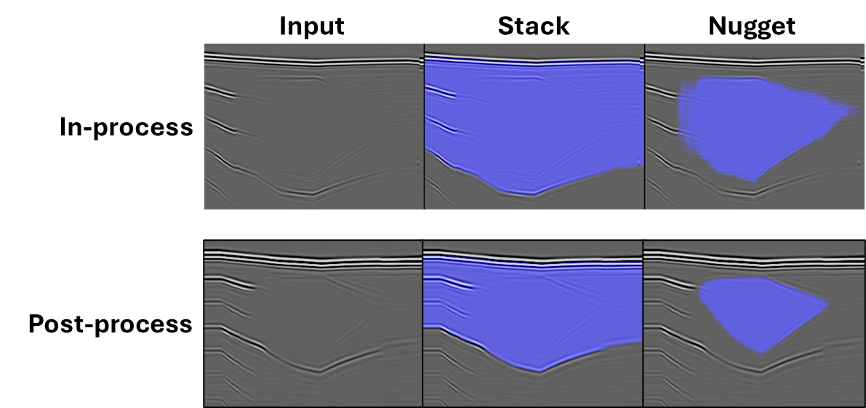

**Figure 1: Example in-process (top) vs. post-process (bottom) semantic segmentation AI outputs. Note the crisp edges in post-process AI nugget mask output compared to some hazy edges observed in the in-process output.**

In both in-process and post-process weld assessments, the uncertainty outputs yielded strong and intuitive qualitative results, highlighting regions of high uncertainty on the ultrasonic data which align with uncertainties of human analysts (Figure 2). Quantitatively, uncertainty outputs were consistent in providing actionable information for downstream data analysis, enhancing trustworthiness of the segmentation AI outputs.

**Figure 2: Example uncertainty quantification outputs from semantic segmentation masks. Top row is a perfectly legible M-scan with no process non-conformities, middle row is initially legible but cooling water flow is restricted causing water boiling and diminishing imaging quality, third row shows minor misalignment leading to diminished nugget visibility. Top two rows show uncertainty per A-scan, while bottom row shows uncertainty per interface.**

Correlation analyses showed a strong agreement between cross-section measurements, ultrasonic M-scan images, and measurements derived from ultrasonic data via mask outputs from both in-process and post-process semantic segmentation AI. The in-process penetration measurements serve as a strong basis for adaptive welding feedback (Figure 3), by providing accurate molten nugget position and growth rate information to adaptive welding systems.

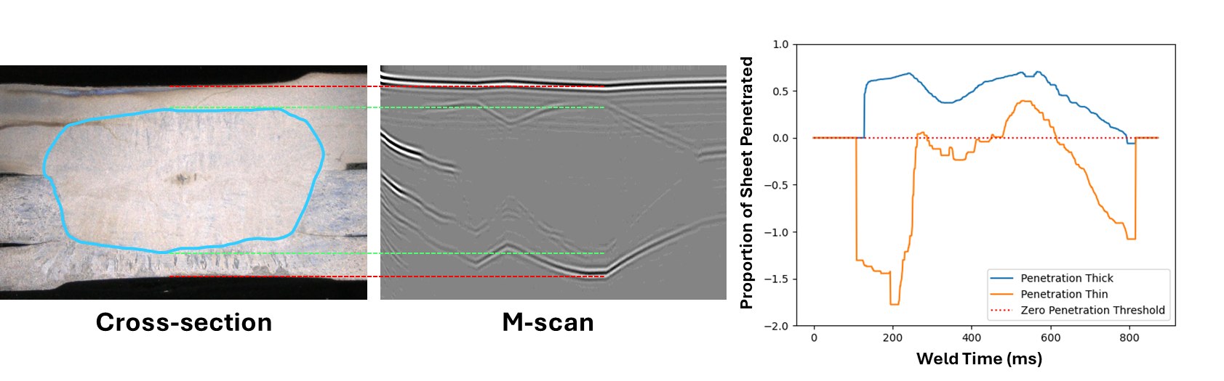

**Figure 3: Correlation between cross section, ultrasonic M-scan, and measurements of penetration into each outermost sheet derived in real time via the AI system. The AI system estimates a maximum of 70.4% penetration of molten nugget into the top thick sheet, and 39.4% penetration into the bottom thin sheet. Negative penetration indicates how far molten nugget is from outermost sheet.**

CONCLUSION

This work demonstrates that interpretation of NDE data using DL, while accounting for AI uncertainties and leveraging known physics to extract measurements from semantic segmentation outputs, can provide significant practical benefits, enable new use cases, and produce new value for existing NDE solutions. Deployment of such AI in inline NDE systems, in a manner that aligns with Industry/NDE 4.0 ideals, can revolutionize manufacturing in automotive and other industries. Such AI can enable closed-loop feedback mechanisms at various scales, which can greatly improve efficiencies, reduce waste, and increase product quality and safety, by bringing the zero-defect dream closer to reality for many manufacturing processes.

REFERENCES

(1) Perez-Regalado WJ, Ouellette A, Chertov AM, Leshchynsky V, & Maev RGr (2013) Joining Dissimilar Metals: A Novel Two-step Process with Ultrasonic Monitoring. *Materials Evaluation*, 71(7):828-833.

(2) Dugmore. A., New composites target EV applications, Advanced Materials Feature, *SAE International Automotive Engineering*, Sep 2021.

(3) Maev, R. Gr., Chertov, A. M., Paille, J. M., Ewasyshyn, F. J. (2016) Ultrasonic in-process monitoring and feedback of resistance spot weld quality. (US Patent No. 9296062). U.S. Patent and Trademark Office.

(4) Ultrasonic In-Process Monitoring And Feedback Of Resistance Spot Weld Quality, United States Patent 9,296,062 B2. Inventors: Maev, Roman Gr., Chertov, Andriy M., Paille, John M., Ewasyshyn, Frank J. Issued 29 March 2016.

(5) Maev, R. Gr., Chertov, A.M., Perez-Regalado, W., Karloff, A., Tchipilko, A., Lichaa, P., Clement, D., Phan, T., 2014, In-Line Inspection of Resistance Spot Welds for Sheet Metal Assembly, *Welding Journal*, pp. 58-62.

(6) Scott R., Chertov A., Tusinean V., Stocco D., Chertov A.M., Maev R.Gr. (2023) Post-Process Semantic Segmentation of Ultrasonic M-scans from Resistance Spot Weld Process Monitoring. ASNT Research Symposium 2023 Proceedings.

(7) Tusinean V., Scott R., Stocco D., Chertov A.M., Gras, R., Maev R.Gr. (2023) Real-Time In-Process Ultrasonic M-Scan Segmentation of Resistance Spot Welds using Deep Learning. ASNT Research Symposium 2023 Proceedings.