Automated Robotic Approach for Source Localization of Minor Gas Leak Using a Two-Microphone Array
Nihar Masurkar¹, Pouria Meshki Zadeh¹, and Ehsan Dehghan-Niri¹

¹Intelligent Structures and Nondestructive Evaluation (ISNDE), School of Manufacturing Systems and Networks
Arizona State University, Mesa, AZ 85212, USA
(575) 646 3514; Email: nde@asu.edu

ABSTRACT
Efficient detection and repair of compressed air leaks in extensive industrial pipelines is essential for optimizing system performance, potentially leading to significant energy savings and cost reductions for companies. Acoustic imaging technologies have become a prevalent method for gas leak detection across various industries due to their capability to identify unique sound patterns emitted by escaping gases, aided by statistical methods like Time Delay of Arrival (TDOA), Phase Delay of Arrival (PDOA) along with Beamforming Techniques for localization. However, relying solely on manual processes with conventional acoustic imaging devices featuring 32-microphone or 64-microphone arrays can yield inconsistent and inaccurate results. To mitigate these limitations, integrating multiple microelectromechanical systems (MEMS) microphones into acoustic imaging cameras has shown promise in improving performance and signal-to-noise ratio. Despite this advancement, this approach remains cost-prohibitive and computationally intensive. In response, we propose a robotic system featuring two evenly distributed microphones (Xarion Eta250) mounted on a robotic arm (UR5e) to overcome these challenges. An integrated algorithm based on the Open Motion Planning Library (OMPL) with microphone signal feedback will be developed to control the robotic arm, directing it toward the gas leaks to enhance source localization accuracy.

Keywords: robotic inspection, acoustic imaging, source-localization, leakage detection

INTRODUCTION
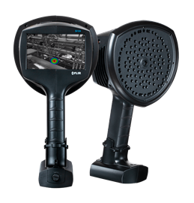 | 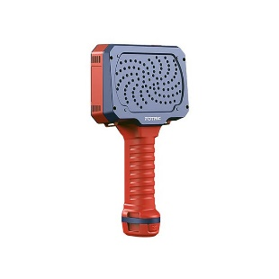
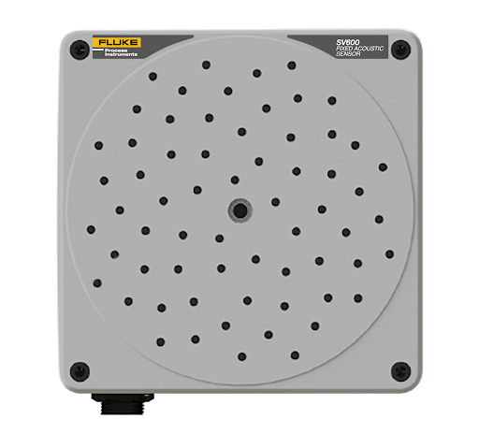 | 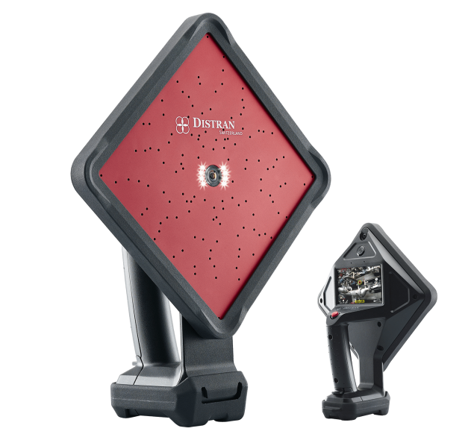
Figure 1: Current state-of-the-art technologies using multi-microphone array used for leakage detection (a) FLIR Si124-PD Industrial Acoustic Imaging Camera for Partial Discharge Detection (b) Fotric TD3-LD Handheld Acoustic Imaging Camera for Leak Detection (c) Fluke SV600 Acoustic Imager (d) Distran ULTRA PRO – Ultrasonic Leak Detector [9][10][11][12].
Tubular systems, like steam generator tubes, pipelines, and gas lines, play essential roles across various sectors, including power generation and oil and gas transmission. They serve as a highly efficient and reliable mode of gas transportation, meeting stringent safety standards. However, issues like corrosion, aging, and external damage can lead to occasional leaks, resulting in severe risks [1]. With the rapid expansion of pipeline infrastructure globally, there is a growing need for enhanced monitoring to ensure safe operations [2][3]. The characteristics of gas leakage signals from pipelines vary depending on factors such as pipeline type, operating conditions, size of leaks, and direction of leakage [4]. Establishing a robust and dependable monitoring system for pipeline leaks is essential to guarantee the safety of pipeline projects. When gas leaks from a pipeline, it emits a unique acoustic signal (usually in the frequency range of 10 kHz – 40 kHz), providing a means for leak detection. Acoustic sensors capture internal pipeline noise, either integrated into handheld detection devices utilized by personnel conducting pipeline inspections or embedded within intelligent pipeline inspection gauges (PIGs) traversing the pipeline for inspection [5]. These acoustic signals provide critical details about the leak, including its dimensions, whereabouts, and potential impact on pipeline integrity [6]. Leveraging acoustic signals for gas leak detection offers several advantages, such as rapid response times, extensive detection ranges, and precise pinpointing [3][7]. However, a hurdle arises from the reduced sensitivity of acoustic signals as sensors move farther from the source due to significant attenuation [8], particularly with higher-frequency sounds like ultrasound, often associated with minor leaks. One effective solution to overcome this challenge involves deploying a large multi-microphone array (usually operating around 49 kHz) in conjunction with acoustic imaging techniques, as shown in Figure 1 [9][10][11][12]. Nevertheless, this approach yields substantial data, which may not align with the near-real-time requirements of a semi-autonomous platform, necessitating prompt responses [11]. The spacing between these sensors is adjusted based on sensor sensitivity and working area constraints; too wide vertical spacing increases the risk of undetected leaks, while overly close placement escalates the system costs. Various sensor types, including acoustic sensors, accelerometers, microphones, and dynamic pressure transducers, have been utilized to identify gas-related sounds [13].
This project aims to integrate robotic control algorithms with wideband acoustic microphones, aligning them strategically with respect to the leakage source to reduce the Time Delay of Arrival (TDOA) and Phase Delay of Arrival (PDOA). This integration would be incorporated with beamforming techniques to produce noise maps, enabling the precise localization of gas leaks using only two microphones.

EXPERIMENTAL SETUP
In the experimental configuration, two Xarion Laser Acoustic Eta250 Microphones are affixed to the end effector of a Universal Robotics robotic arm (UR5e), depicted in Figure 2. Xarion Eta250 was primarily chosen for its exceptional sensitivity and resolution, enabling precise detection of material defects [14]. Its fast-scanning speed and contactless inspection capability enhance efficiency and minimize downtime. Moreover, its versatility and ease of integration across various industries streamline NDT processes, ensuring reliable and high-quality inspections compared to traditional microphones. A camera is positioned on the end effector alongside the microphones to provide positional feedback, facilitating the generation of a noise map using beamforming techniques. A path-planning algorithm will dictate the desired position of the robotic manipulator based on the noise map generated by the two microphones.

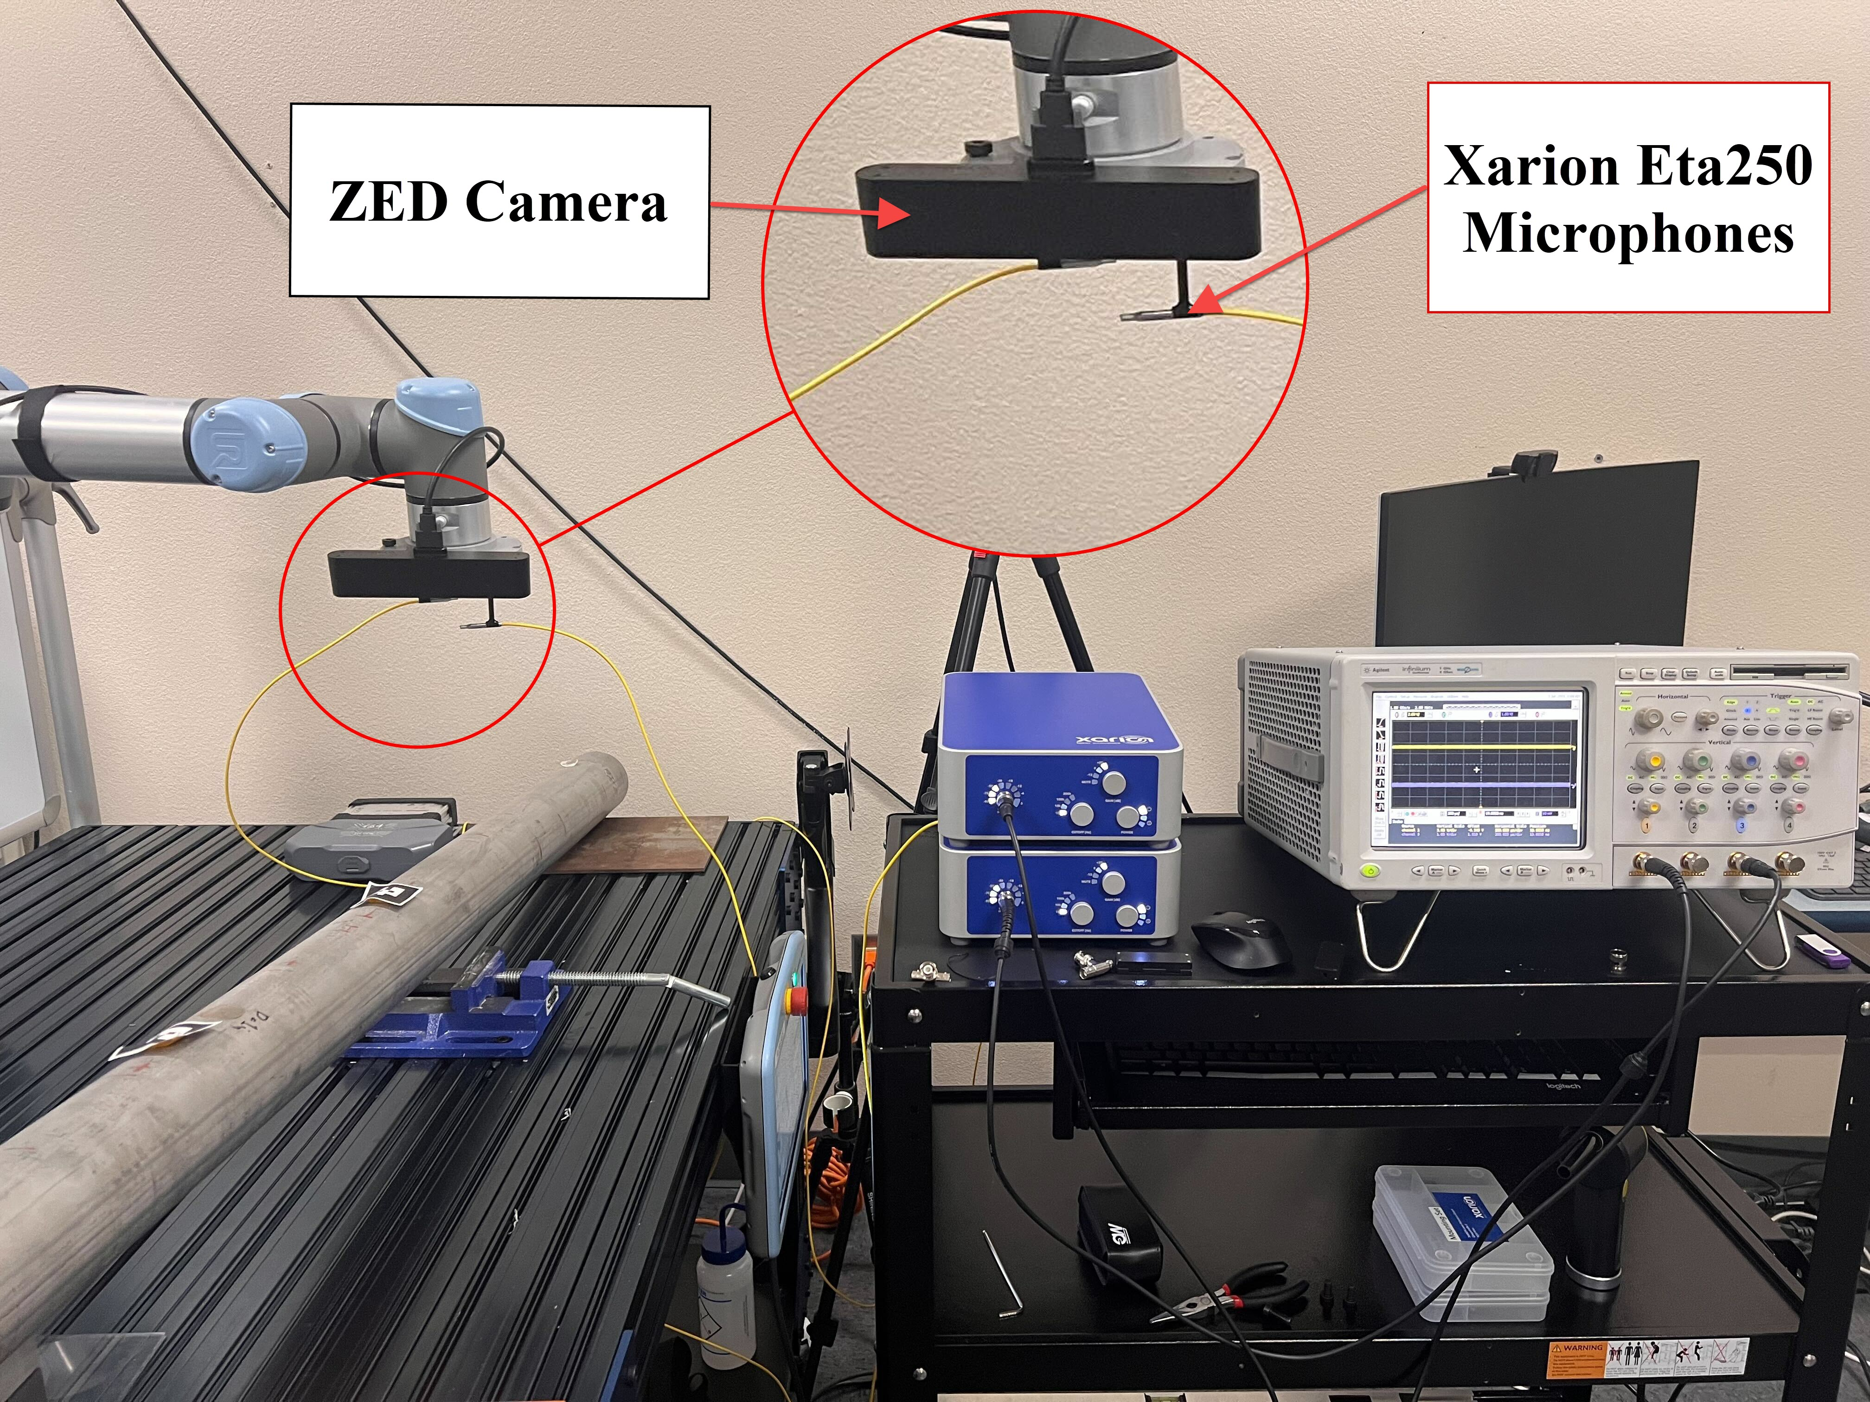
Figure 2: Experimental Setup using two Xarion Eta250 Microphones mounted on a robotic arm integrated with a ZED Stereo camera to create a noise map of the system.

METHODS
Beamforming has become a standard technique for generating spatial noise maps, with sensor array methods finding success in various applications such as aeroacoustics, geophysical processing, astronomy, and speech recognition [16]. The concepts, operational principles, and diverse techniques of microphone arrays are thoroughly explained in the book authored by Johnson and Dudgeon [15]. The most straightforward beamforming algorithm, akin to the fundamental "delay-and-sum" beamformer in the time domain, is described therein. The microphone array is effectively directed towards each point on the measurement plane (or object in 3D), and the relative signal time delays between microphones are computed. The signals captured by the microphones are adjusted for each focus point using the corresponding propagation delay, then combined and normalized by the total number of microphones. Throughout this study, computations of distances and delays will be employed. This information will be utilized to refine the controller algorithm for the robotic arm, enabling it to transition between points by utilizing the phase delays acquired at each location. A critical aspect involves creating the cross-spectral matrix (CSM), which is essential for the beamforming process, requiring one CSM for each frequency. The output power of the beamformer provides a reliable estimate of single-source power. However, in scenarios with multiple sources, the accuracy of this estimation relies on the beamformer's characteristics, including source locations, frequency, and the number and distribution of microphones in the array. Estimating source location and power may be inaccurate, particularly for frequencies with wavelengths not significantly smaller than the array aperture or for sources near each other. This limits the use of conventional beamformer methods [16]. To eliminate microphone self-noise, the main diagonal of the cross-spectral matrix is typically removed because self-noise lacks coherence between microphones and thus does not affect the off-diagonal elements. This procedure enhances the contrast (dynamic range) of the noise maps. However, removing the diagonal may unpredictably impact the absolute value of the beamformer. As advanced algorithms are often easier to implement in the frequency domain, numerous techniques have been used to enhance the mapping of acoustic sources, such as deconvolution methods like the Deconvolution Approach for the Mapping of Acoustic Sources (DAMAS) [17] by Brooks and Humphreys or CLEAN-SC [18] by Sijtsma, both of which are now standard tools in aeroacoustics measurements. In our investigation, we examine a resilient deconvolution technique presented by Sarradj [16], aligning it with the controller algorithm for the robotic arm. Based on the literature, this method provides an improved computational efficiency compared to [17][18] and conventional beamforming with diagonal deletion.

CONCLUSION
Building upon our prior investigations, we have meticulously optimized the controller of the UR5e to accurately track a predefined path trajectory utilizing analog inputs from various sensors. Additionally, we have incorporated spatial mapping of the environment, enabled the determination of object geometry, and facilitated the navigation of acoustic sensors into different orientations and positions for data collection from the microphones. Moreover, our forthcoming endeavors involve the integration of a two-microphone array to produce noise maps, enabling us to pinpoint the source of leakage by manipulating the arm based on TDoA or PDoA values and filtering them using standard beamforming algorithms. In the future, we aim to develop a universal configuration that exhibits hardware independence in forthcoming endeavors. This entails the flexibility to employ various microphones within this experimental setup, tailored to specific use cases. The overarching goal is to utilize this adaptable setup for generating noise maps and localizing leaks; all achieved with a minimal sensor configuration and by automating the orientation of the sensors.

REFERENCES
[1] Liang, W., Zhang, L., and Wang, Z., 2004, “State of Research on Negative Pressure Techniques Applied to Leak Detection in Liquid Pipelines,” 2004 International Pipeline Conference, Volumes 1, 2, and 3.
[2] Li, S., Wen, Y., Li, P., Yang, J., and Lili, Y., 2014, “Determination of Acoustic Speed for Improving Leak Detection and Location in Gas Pipelines,” Review of Scientific Instruments, 85(2).
[3] Liang, W., Zhang, L., Xu, Q., and Yan, C., 2013, “Gas Pipeline Leakage Detection Based on Acoustic Technology,” Engineering Failure Analysis, 31, pp. 1–7.
[4] Ebrahimi‐Moghadam, A., Farzaneh–Gord, M., and Deymi‐Dashtebayaz, M., 2016, “Correlations for Estimating Natural Gas Leakage from Above-Ground and Buried Urban Distribution Pipelines,” Journal of Natural Gas Science and Engineering, 34, pp. 185–196.
[5] McAllister, E. W., 1988, Pipe Line Rules of Thumb Handbook : A Manual of Quick, Accurate Solutions to Everyday Pipe Line Problems.
[6] Wang, S., and Yao, X., 2020, “Aeroacoustics Measurement of the Gas Leakage Rate for Single Hole,” Review of Scientific Instruments, 91(4).
[7] Adnan, N. F., Ghazali, M. F., Amin, M. M., and Hamat, A. M. A., 2015, “Leak Detection in Gas Pipeline by Acoustic and Signal Processing - A Review,” IOP Conference Series: Materials Science and Engineering, 100, p. 012013.
[8] Liu, C., Li, Y., Fang, L., and Xu, M., 2017, “Experimental Study on a De-Noising System for Gas and Oil Pipelines Based on an Acoustic Leak Detection and Location Method,” International Journal of Pressure Vessels and Piping, 151, pp. 20–34
[9] Teledyne FLIR SI124-LD Plus Acoustic Imaging Camera. Available: https://www.flir.com/products/si124-ld-plus/?vertical=condition+monitoring&segment=solutions.
[10] TD3-LD Acoustic Camera | FOTRIC,” FOTRIC [Online]. Available: https://www.fotric.com/td3-acoustic-camera.
[11] SV600 Fixed Acoustic Imager | Fluke Process Instruments,” Fluke Process Instruments. Available: https://www.flukeprocessinstruments.com/en-us/products/imaging-solutions/acoustic-imaging-solutions/sv600-fixed-acoustic-imager.
[12] Distran Ultra Pro - Ultrasound Camera for Gas Leak Detection, Distran. Available: https://distran.swiss/en/ultra-pro/.
[13] Loth, J., Morris, G. J., Palmer, G. M., Guiler, R., & Mehra, D. (2003), “Technology assessment of on-line acoustic monitoring for leaks/infringements in underground natural gas transmission lines.”, USA: West Virginia University.
[14] Engljähringer, T., “ETA250 Ultra - XARION Laser Acoustics” [Online]. Available: https://xarion.com/en/products/eta250-ultra.
[15] Johnson, D. H., and Dudgeon, D. E., 1993, Array Signal Processing: Concepts and Techniques.
[16] Sarradj, E., 2010, “A Fast Signal Subspace Approach for the Determination of Absolute Levels from Phased Microphone Array Measurements,” Journal of Sound and Vibration, 329(9), pp. 1553–1569.
[17] Brooks, T. F., and Humphreys, W. M., 2006, “A Deconvolution Approach for the Mapping of Acoustic Sources (DAMAS) Determined from Phased Microphone Arrays,” Journal of Sound and Vibration, 294(4–5), pp. 856–879.
[18] Sijtsma, P., 2007, “CLEAN Based on Spatial Source Coherence,” International Journal of Aeroacoustics, 6(4), pp. 357–374.

