Resonant Dual Rectangular Waveguide Probe for Nondestructive Material Characterization Applications
Jayaram Kizhekke Pakkathillam¹, Matt Dvorsky¹ and Mohammad Tayeb Al Qaseer^{1,2}

¹Center for Nondestructive Evaluation (CNDE)
²Electrical and Computer Engineering Department (ECpE)
Iowa state University (ISU)
Ames, IA 50011
[jram, mdvorsky, alqaseer] @iastate.edu

ABSTRACT

In this work, a nondestructive technique utilizing dual rectangular waveguide probe is proposed for accurately measuring complex relative permittivity ($ε_{r}$) of materials. As shown in figure 1, this technique utilizes two open-ended waveguide side-by-side with a common ground plane that can be placed onto a dielectric sheet, i.e., the material under test (MUT), backed by a conductor. The transmission coefficient between the two waveguides, representing coupling through the MUT is measured. The transmission coefficient sharply increases when the electrical thickness ($Thickness×\sqrt{ε_{r}}$ ) is greater than half wavelength. Thus, the measurement of the transmission coefficient over a range of frequencies can be directly related to the complex permittivity. The technique is analyzed using numerical simulation for investigating the effect of design parameters of the probe (e.g., separation between the probes) on the sensitivity of this technique to complex permittivity.
An advantage of this technique compared to other nondestructive material characterization techniques is that probe calibration is not as critical since only magnitude is being measured. In contrast, other nondestructive microwave material characterization techniques require accurate magnitude and phase measurements which in turn require more stringent calibration. For example, when using the open-ended rectangular waveguide technique, a phase error of a few degrees can result in significant error in the calculated complex permittivity.
This presentation will show simulation results for optimizing the probe design, and analysis of the sensitivity of this technique compared to other nondestructive material characterization techniques (e.g., open-ended waveguide technique). In order to demonstrate the efficacy of this technique, a probe will be fabricated and used to characterize a number of MUTs with varying dielectric properties. The performance of the probe in measuring low loss and lossy MUTs will be evaluated through these measurements and corroborated with simulation.

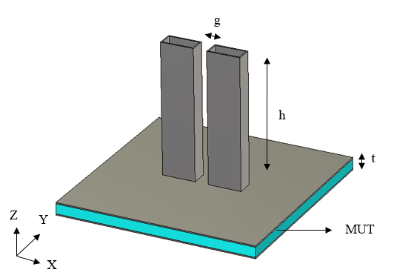
Figure 1: Isometric view of the dual waveguide probe in shot wall parallel arrangement.

