**Design of a Compact 120 GHz Millimeter Wave Imaging Radar with 20 GHz Bandwidth for SAR Imaging**

**Aaron McCarville, Vy Pham, Gunnar Hageman, Noah Gaffney, Benjamin Podjenski, and Mohammad Tayeb Al Qaseer**

*Electrical and Computer Engineering Department*

*Iowa State University*

*Ames, Iowa 50011*

(515) 236-6380; adm1@iastate.edu

ABSTRACT

This work presents an imaging radar design, constructed using a high frequency and high bandwidth commercial off-the-shelf transceiver, TRA_120_045, from Indie Semiconductor. This radar is capable of generating high resolution Synthetic Aperture Radar (SAR) 3D images of the internal structures of non-conductive materials as well as imaging surfaces of conductive material for surface flaws. The radar operates in the industrial, scientific, and medical (ISM) band of 120 GHz and provides a cross-range spatial resolution of less than 1 mm in air. Additionally, the 20 GHz of available bandwidth (113.9 - 134.1 GHz) provides a range resolution of 7.5 mm in air. These resolution figures improve inside dielectric material due to due to the shorter wavelength inside dielectrics. The small size of the transceiver IC (5x5mm), shown below, also allows for a small form factor of the overall system as shown in Figure 1.

This system is designed to be a standalone radar system that contains all control and data acquisition hardware in a single package. An FPGA and a high-speed two channel analog to digital converter (ADC), not shown in Figure 1, allow for fast frequency sweep (~10 ms) and data acquisition. The overall goal is to produce a system that can be easily deployed and used for SAR imaging, with minimal setup requirements, including hardware and software. The system was used to scan a one inch thick polycarbonate sample containing conductive foreign object debris (FOD), primarily copper wires and carbon fibers. Figure 2 shows a picture of the sample along with the produced SAR image. The SAR image shows clear indications of the FOD in this sample.

The design of the system will be presented along with a brief description of SAR imaging principles. The efficacy of the system in producing 3D SAR images for a variety of applications such as FOD detection, composite inspection, and metallic surface inspection will be demonstrated.

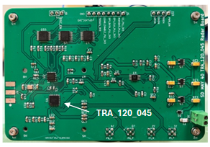

*Figure 1. Picture of the initial prototype radar PCB with a size of 105 x 70mm.*

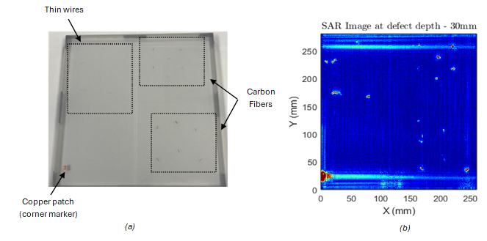

*Figure 2. (a) Picture of the polycarbonate sample containing FOD, and (b) its SAR image obtained using the designed radar.*