**Qualification of Guided Wave NDE Technology for Hanford Primary Tank Inspections**

**Kayte M Denslow1**

1Pacific Northwest National Laboratory

902 Battelle Blvd.

Richland, Washington 99354

(509) 375-2232; Kayte.Denslow@pnnl.gov

ABSTRACT

Underground double-shell tanks are critical assets for storing millions of gallons of radioactive waste on the Hanford nuclear reservation located in southeastern Washington state. The 38- to 54-year-old carbon steel infrastructure is aging and will require unique service life extension efforts in the form of inspection, corrosion control, and potentially in situ refurbishment to maximize the likelihood that they can support the Hanford cleanup mission for another 4-5 decades (i.e., a second lifetime). Two complementary inspection technologies (RAVIS and RREVIS) have been engineered to overcome a “grand challenge” related to DST inspection – volumetric inspection of primary tank floor plates that are 90% inaccessible. The primary tank floors are at high risk for corrosion, have not been thoroughly inspected since tank construction (1968-1986), and require unmanned/remote inspection from the outside the tanks while the 27 1-1.5-million-gallon DSTs are in service (i.e., while they contain waste).

RAVIS and RREVIS are robotic ultrasonic guided wave inspection systems that were both matured to (1) mitigate the risk of tank conditions preventing inspections and (2) provide the potential for complementary or confirmatory inspection data sets. Each system will deploy, position, and dry-couple its low-frequency transducer to accessible/touchable parts of a primary tank to inspect the inaccessible/untouchable 3/8- to 7/8-in. thick carbon steel primary tank floor plates from standoff transducer positions. The unconventional ultrasonic guided wave transducer technologies – a 150-165 kHz piezoelectric guided wave phased-array transducer and a 43-57 kHz electromagnetic acoustic transducer – require qualification testing to evaluate their non-destructive evaluation reliability and gain insight into the inspection performance that can be inspected during primary tank floor plate inspections.

The Hanford tank operations contractor Washington River Protection Solutions and the Pacific Northwest National Laboratory have designed a qualification program for the long inspection range ultrasonic guided wave inspection systems. The qualification tests require a full-scale mock-up of a swath of a 75-ft. diameter primary tank floor and a multi-stage process to meet qualification testing flaw set requirements. The technical approach to qualification testing, the mock-up that facilitates testing, and qualification progress are summarized.

**Keywords:** Hanford, double-shell tanks, DST, nuclear, radioactive, ultrasound, ultrasonic, guided wave, qualification, volumetric, non-destructive evaluation, NDE, RAVIS, RREVIS, EMAT, GWPA

**ADAPTATION OF ULTRASONIC GUIDED WAVE NDE TECHNOLOGY FOR HANFORD DOUBLE-SHELL TANK APPLICATIONS**

Table 1 summarizes the general framework for selecting non-destructive evaluation (NDE) transducer technology and robotic deployment technology for Hanford double shell tank (DST) inspections; maturing/adapting them for the DST environment, integrating and verifying them; qualifying them on NDE Objectives 1-2 (detect and locate flaws); and supplementing them with inspection data analysis tools to meet NDE Objective 3 (characterize flaw type and size). The framework was developed to guide and support development of the Robotic Air-slot Volumetric Inspection System (RAVIS) and the complementary Robotic Remote Electromagnetic-acoustic-transducer Volumetric Inspection System (RREVIS) designed for primary tank floor inspections.

Table 1. Framework for selecting, adapting, and qualifying NDE technology for Hanford DST applications.

|  |  |  |
| --- | --- | --- |
| **Program Phase** | **Step** | **Description** |
| Phase I:  Identify NDE methodology and down-select transducer technologies | 1 | Define tank inspection requirements that pertain to the DST region of concern (e.g., primary tank floor plates) to support work in Steps 2-6. |
| 2 | Screen candidate NDE transducer technologies to characterize flaw detection capabilities and extent to which the capabilities meet flaw requirements in Table 2. Use the results to select NDE technology to be adapted in Phase II. |
| Phase II:  Mature selected NDE transducer technologies and robotic delivery systems to meet DST inspection requirements and render compatible with the DST environment. | 3 | Adapt selected NDE transducer technology selected in Phase I and continue to characterize flaw detection capabilities throughout adaptation process via verification testing on open/visible test flaws to optimize transducer design. |
| 4 | In parallel, adapt/mature robotic crawler system(s) that enable safe NDE transducer deployment, positioning, coupling, and position tracking. Integrate adapted NDE transducer technology with adapted robotic crawler technology. |
| 5 | Verification testing of the integrated sensor/robotic systems on open/visible flaws to confirm the extent to which the adapted technology meets inspection requirements. |
| Phase III:  Performance demonstration of adapted/integrated technologies on a full-scale test platform that challenges flaw detection and deployment. | 6 | Qualification testing of verified/optimized adapted robotized volumetric NDE transducer technology on blind flaws to assess NDE reliability. |
| 7 | *If needed*: Machine learning using empirical data from testing, synthetic data (augmented empirical data), simulated data from modeling and simulation, or a combination thereof, to create analysis software that supports NDE inspectors/analysts with flaw detection and location (NDE Objectives 1 and 2) and flaw type and size characterization (NDE Objective 3), followed by verification and qualification of the machine learning model. |

Table 2: Flaw acceptance criteria and actions established for Hanford waste tanks [1-3].

|  |  |  |  |
| --- | --- | --- | --- |
| **Degradation/Flaw Type** | **Reportable Level Valuesa**  **(for Documentation)** | **DOE Acceptance Criteria**  **Action Level Valuesa** | **Corrective Action Level** |
| Pit (pitting corrosion) | 25% t | 50% t | >75% t |
| Crack/weld seam opening | Any linear indication greater than 6 in. long and 0.1 in. deep | If >12 in. long, 20% t  If <12 in. long, 50% t |
| Wall thinning (general corrosion) | 10% t | 20% t |
| t = thickness of plate | | | |

The ultrasonic guided wave phased-array transducer and marsupial robotic system that comprise the RAVIS and are at the end of Step 6 (qualification) and Step 5 (verification), respectively. The RREVIS, a pre-integrated robotized transducer system, is at the end of Step 5 and ready to begin qualification under Step 6 [4].

**Qualification Test Mock-up**

A test mock-up that represents a full-scale swath of a primary tank floor is required to accommodate the long-distance ultrasonic guided wave standoff inspections performed by the RAVIS and RREVIS transducers and ensure qualification test results adequately represent the performance that can be expected during real primary tank floor plate inspections. The mock-up also needs to contain a statistically significant set of corrosion test flaws that are blind to technology providers and NDE inspectors. A mock-up that meets these requirements was designed and fabricated in 2020 to initiate Phase III qualification testing (Step 6). A photograph of the mock-up is provided in Figure 1. Important characteristics of the qualification tank floor test mock-up are:

* The 24 ft. x 48 ft. area has a usable (inspectable) area that is a full-scale representation of approximately 1/8th of a Hanford DST’s primary tank floor. The width represents the distance between two neighboring 4-in. diameter ventilation lines that run along the full height of a primary, are located every 45 degrees around a typical tank’s circumference, protrude into the annulus, and will restrict RAVIS and RREVIS movement from one ventilation-line-bound swath to the next.
* The weld pattern represents that which will be encountered by RAVIS and RREVIS when they are deployed through the 24-in. diameter access risers in 21 of 27 in-service DSTs located in the AN, AP, and AW tank farms.
* The carbon steel plate sizes, thicknesses, and welds represent those used in the construction of the tanks.
* The mock-up contains realistic corrosion flaws (types, sizes, quantities, and locations will not be disclosed to protect the true state of the mock-up from disclosure).
* The surface conditions are representative of those in tank farms (mill scale, oxidation, and severely corroded/peeling/blistered surface conditions).
* Masking material is applied to the surfaces of the mock-up to (1) represent physically inaccessible regions of that plate that would be blocked by the refractory pad under an actual tank and thus not available for transducer access or visual inspections, and (2) protect the location/type/quantity/size of test flaws, i.e., true state, from disclosure.

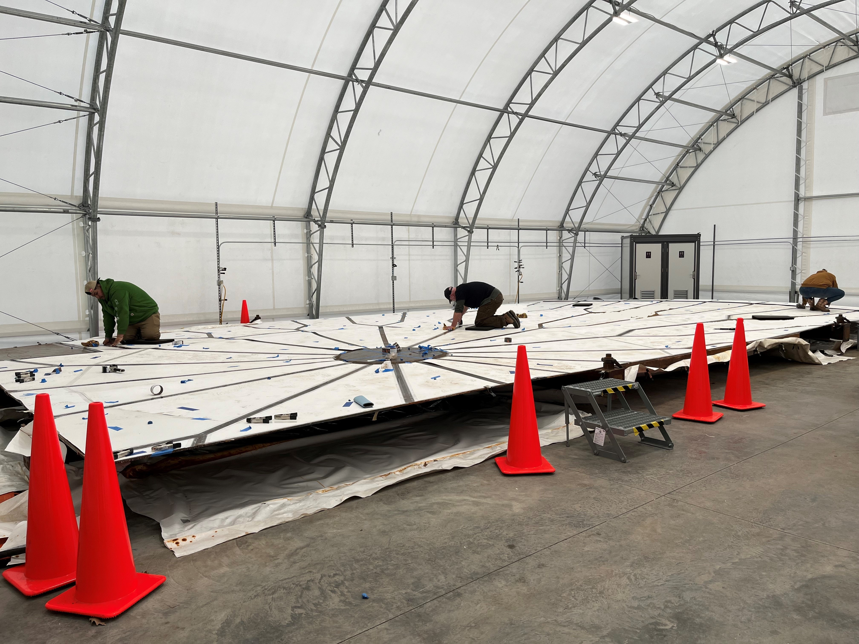

Figure 1: Photo of the 24-ft-wide, 48-ft-long qualification tank floor plate test mock-up where white masking material is applied to simultaneously hide the true condition of the mock-up and represent the area of the underside of a tank that is blocked by a refractory concrete pad.

**Qualification Test Process**

Qualification testing under Step 6 (Phase III) of the framework consists of multiple 1- to 2-week-long “blind” NDE performance demonstration test campaigns (test stages) on the mock-up, where the condition of the mock-up changes between each campaign and the true condition of the plates is never disclosed to test participants or stakeholders. The multi-stage approach to qualification testing was adopted in lieu of a single test campaign because a single campaign would have required a full tank floor mock-up to accommodate all the scenarios required to qualify NDE technologies. A multi-stage qualification process also prevents test participants from “learning” the mock-up since it is always changing. Table 3 summarizes the NDE performance demonstration test campaigns that were performed to qualify the RAVIS’s guided wave phased array transducer (without the marsupial robotic system).

Table 3: Example of a NDE performance demonstration test campaigns test schedule.

|  |  |  |
| --- | --- | --- |
| **NDE Performance Demonstration Test Campaign for Technology Qualification** | **Qualification Tank Floor Test Condition\*** | **Test Schedule** |
| **Stage 1** | Undisclosed | Year 1 |
| **Stage 2 – Part 1** | Undisclosed, different from Stage 1 | Year 2 |
| **Stage 2 – Part 2** | Undisclosed, different from Stage 2-Part 1 | Year 3 |
| **Stage 3** | Undisclosed, different from Stage 2-Part 2 | Year 4 |
| * Flaw matrices for the test campaigns are controlled information. | | |

The total quantity of flaws used for qualification testing, how they are distributed across the test campaigns, and the flaw matrix for each test campaign (flaw type, quantity, size, shape, location, surface connectivity, and orientation) is controlled information that is never disclosed or published. However, the following general information can be shared:

* The flaw matrix ultimately includes flaw criteria in Table 2.
* The flaw matrix satisfies at least the minimum quantities of flaws required to achieve confidence levels of 90+% in the probability of detection, as defined in equipment qualification standards such those in the Boiler and Pressure Vessel Code by the American Society of Mechanical Engineers [5].

Qualification testing culminates with hit/miss results for a statistically significant set of flaw scenarios that are used to calculate true positives (flaw detection) and false negatives (flaw misses) for different flaw types, sizes, and placement scenarios, false positives (false alarms), and true negatives (confirmation of flaw-free material) for base plate material. The results are ultimately used to generate probability of detection (POD) curves that show the likelihood of flaw detection (true positives) as a function of flaw size and geometry. False call probability (FCP) curves are also generated that show the likelihood of false positives as a function of inspection area or weld length. Results from qualification testing represent the NDE performance that can be expected of the RAVIS and RREVIS units during real inspections of Hanford primary tank floors. The goal is to achieve a POD of at least 90% at a confidence level of 90% or greater with one or both units. However, data from unconventional low-frequency ultrasonic guided wave transducers are lower in resolution and often noisier than data from high-frequency traditional ultrasonic testing, so it is expected that the POD achieved with RAVIS and/or RREVIS will be lower than 90%. The minimum acceptance criteria would be a POD of 80% for flaw sizes that are equal to or greater than the DOE action-level criteria in Table 2. The FCP would preferably be 0 but should be no greater than 5-10%.

**Qualification Progress**

The RAVIS guided wave phased array (GWPA) transducer referred to as Hanford-Probe A’ was the first to undergo a full series of qualification testing, which started in July 2020 and finished in August 2023. The GWPA transducer was qualified separate from its robotic deployment system, which will deploy the transducer in air vents under a tank, to baseline the transducer’s NDE performance without influence from robotic variables that may affect the transducer’s performance such as coupling force. A manually positioned pressure coupler was used as a stand-in for the robotic crawler to apply the required 150-165 lb. of coupling force to the 150-165 kHz transducer every 12 in. along exposed “strips” on the top surface of the mock-up during testing shown in Figure 1. The exposed strips mirror the 10% of the underside tank area that is physically accessible from air vents in the refractory concrete pad under a tank. The refractory pad that blocks access to 90% of the underside of a tank is represented by the white masking material in Figure 1. The transducer was dry coupled to the topside of the mock-up instead of the underside like it will be during real tank floor inspections, because (1) the particle displacement is uniform across plate thickness since the GWPA transducer relies on the fundamental shear-horizontal guided wave mode (SH0), and (2) testing is safer and more practical from the topside of the mock-up. The GWPA transducer used its array of piezoelectric elements to focus and steer ultrasonic energy 360 degrees around the transducer to achieve standoff inspections of floor plates several feet beyond the topside strip in which the transducer was coupled (i.e., masked plates and neighboring unmasked strips the represent refractory-blocked plates and plates over neighboring air ventilation channels). Additional details on GWPA transducer operation are described in prior publications [6].

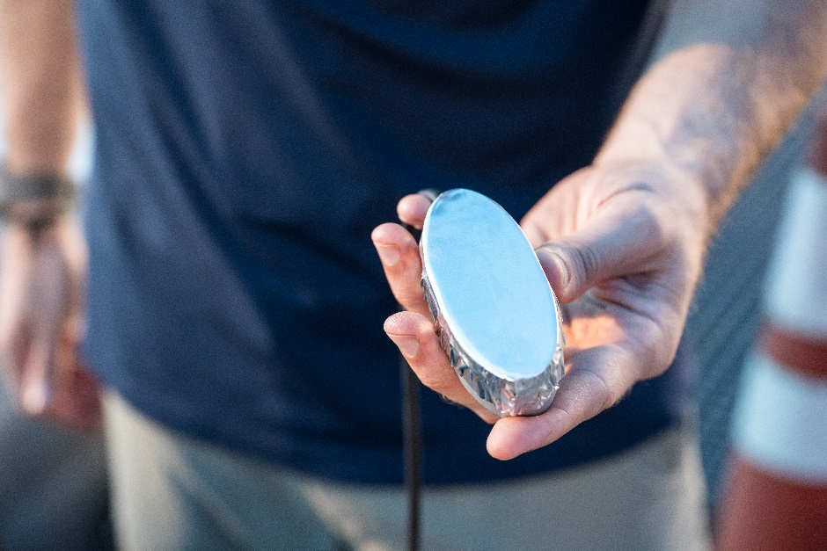

Figure 2: (a) GWPA transducer with dry couplant membrane. (b): Top-down view of the pressure coupler placed over the transducer to pressure-couple the transducer face against the plate surface during testing.

Development of the POD and FCP curves that quantify GWPA performance, is it pertains to Hanford primary tank floors, are in progress. Most of the blind test flaws were detected by the GWPA transducer; however, numerous undesirable high-amplitude ultrasonic indications associated with noise/artifacts were comingled with desired ultrasonic indications from flaws in the GWPA images. The noise/artifacts made it challenging for the analysts to discriminate between the flaws and the noise/artifacts, which negatively affected POD. The incorrect calls were a combination of false positives and false negatives and were not insignificant. Most of the false calls were false negatives (missed flaws) and a minority were false positives (false alarms). A data review showed that approximately half of the false negatives appeared to be due to flaw indications not meeting analyst criteria, not due to the absence of ultrasonic indications. The GWPA transducer POD would increase by 15-20% if the uncalled flaws (that had ultrasonic indications) were reported as flaws. It is possible to realize an increase in POD (to meet NDE Objectives 1-2 with high accuracy) by equipping NDE inspectors/analysts with advanced analysis software that is trained to discriminate between flaws, reflections from other wave modes (e.g., SH1), and artifacts such as ringing noise due to poor coupling. The same signal features that support flaw/noise/artifact discrimination can also be used to train the software classify flaws by type and size to meet NDE Objective 3, which is a general challenge for guided wave NDE.

**REFERENCES**

1. J. R. Follett, 2017, “Leak Inspection Report for Tank 241-AY-102,” RPP-RPT-60320, Rev. 0, Washington River Protection Solutions, Richland, WA.
2. C. L. Girardot, et al., 2019, “Double-shell Tank Integrity Program Plan,” RPP-7574, Rev. 6, Washington River Protection Solutions and AEM Consulting, Richland, WA.
3. K. Bandyopadhyay, et al., 1997, “Guidelines for Development of Structural Integrity Programs for DOE High-Level Waste Storage Tanks,” BNL-52527, Brookhaven National Laboratory, Upton, NY.
4. Hede A.L., A.R. Rodriguez, K.D. Boomer, G.E. Soon, J.R. Gunter, and K.M. Denslow, 2023, "*Hanford Double-Shell Primary Tank Bottom Inspection Technology Development,* Waste Management Symposia, March 10-14, 2024, Phoenix, AZ.
5. American Society of Mechanical Engineers, 2023, “ASME Boiler and Pressure Vessel Code (BPVC),” Section V-Nondestructive Examination, Article 14: Examination System Qualification, ASME International, New York, NY.
6. C. J. Borigo, 2019, *Volumetric Inspection of Inaccessible Tank Bottom Plates with Ultrasonic Guided Wave Phased-Array Sensors*, American Society of Nondestructive Testing Annual Meeting, November 18-22, 2019, Las Vegas, NV.