Developments in Modeling Air-Coupled Ultrasonic Testing of Porous Composites with Variability in Pore Geometry
Maureen Morton¹, John C. Aldrin², Tyler Lesthaeghe¹, and Alexander Douglass³

¹University of Dayton Research Institute
Dayton, OH 45419
email maureen.morton@udri.udayton.edu; tyler.lesthaeghe@udri.udayton.edu

²Computational Tools
Gurney, IL 60031
email aldrin@computationaltools.com

³Air Force Research Laboratory
Wright-Patterson AFB, OH 45433
email alexander.douglass.1@us.af.mil

ABSTRACT
This work presents recent advances in computational modeling of air-coupled ultrasonic testing (ACUT) of porous composites. We examine the propagation and scattering of waves in a specimen for simulated pore geometries and investigate the effects of variability in pore geometry on ACUT responses.

Keywords: air-coupled ultrasonic testing (ACUT), composites, modeling, porosity, variability, statistics

INTRODUCTION
This work presents recent advances in computational modeling of air-coupled ultrasonic testing (ACUT) of porous composites. We examine the propagation and scattering of waves in a specimen for simulated pore geometries and investigate the effects of variability in pore geometry on ACUT responses. This investigation is valuable because variability in porosity is a likely contributor to noise in ACUT measurements and severe levels of porosity will impact material integrity and performance.

This research into ultrasonic NDE models is a continuation of previous work [1]. Porosity was represented in previous models via regularly spaced, equally sized pores with radii well below the wavelength. Both direct numerical simulation (DNS) and homogenization of pore geometry were considered. The ACUT physics were solved with COMSOL finite element method (FEM) software. Through-transmission results indicated that amplitude increases with a moderate increase in percent porosity. Preliminary experimental results supported this trend. In those models, frequency shifts also occurred when pores had elongated shapes. Homogenization of pore geometry was found to be an effective means of simplifying model geometry to obtain more efficient computations that agreed with directly modeled small pore results. Note, a large pore with dimensions approaching the wavelength of the signal was found to decrease ultrasonic amplitude transmission.

Current work extends the previous work with small pores to investigate the effects of variability in pore size and location on ACUT responses. This extension is important because variability in pore geometry occurs in real materials.

DESCRIPTION OF MODELING AND SIMULATION STUDIES
ACUT models were built and solved in COMSOL with 2D geometry and DNS of pore geometry. Within a model, each pore’s radius and location were randomly generated from defined parameter distributions. Repeated random instances of such models were generated at set values of three factors: variability in pore radius, variability in pore location, and percent porosity. A design of experiments simulation study was conducted, and linear least squares analyses were performed in JMP with different combinations of factors and interactions. The effects of factors on amplitude and frequency responses were analyzed. Figure 1 shows an overview of the simulation process. The representative ACUT model in the figure also shows an example of the randomly generated pore geometry.

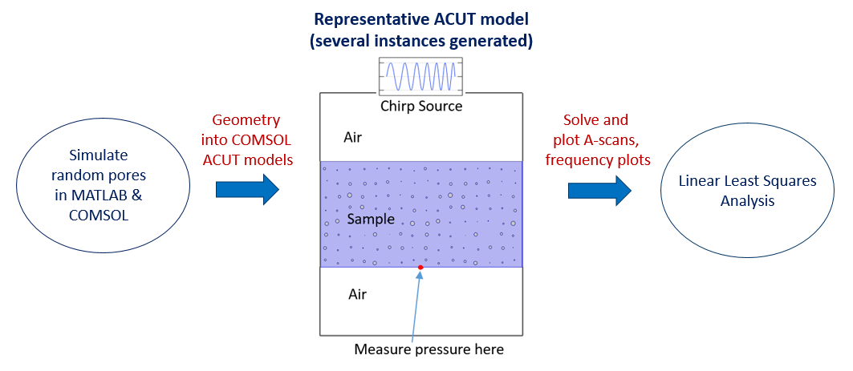
Figure 1: Visualization of Simulation Process with Example of Randomly Generated Variable Porosity Field

RESULTS
In models, percent porosity was found to be statistically significant and often linearly related to changes in amplitude and frequency. In general, these linear relationships agreed with previous trends for non-varying pore geometry, with some exceptions. Although variability in pore size and location were not found to have statistically significant effects on responses, confidence and prediction bounds indicate that small changes in percent porosity may be masked by variability. Scatter plots for amplitudes (left) and frequencies (right) of the first mode are shown in Figure 2, where percent porosity is the sole factor. The regression line, confidence bounds, and prediction bounds demonstrate some of these conclusions. Analyses for the other factors and some interactions were also performed but not shown.

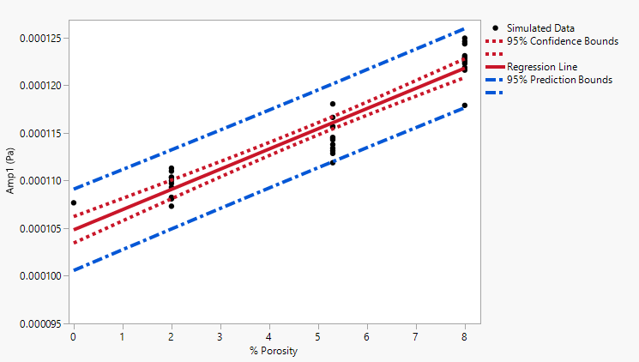 | 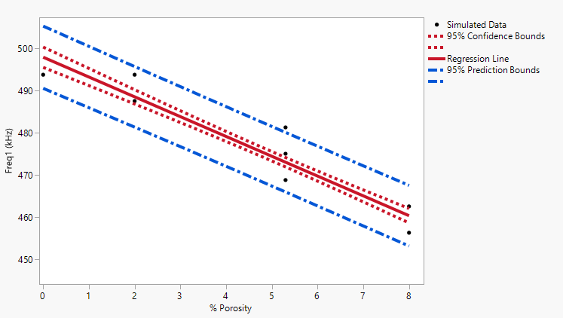
Figure 2: Scatter Plots for First Mode with Regression Line, Confidence Bounds, and Prediction Bounds

Also, 3D simulations were performed using Pogo to study the sensitivity of the resonance behavior to variability in porosity in a representative CT (computed-tomography) acquired porosity field. The position of the transducer pair was varied in both x- and y-directions to simulate varying ACUT responses over the porosity field. Correlations were observed between the frequency and amplitude responses and local percent porosity at different transducer positions.

Some simulations with homogenized pore geometry were also performed in COMSOL. Global homogenization averaged out the effects of variability, unsurprisingly. Work is therefore ongoing to incorporate localized homogenization to maintain the effects of variability on ACUT responses without the computational expense of directly modeling pore geometry.

CONCLUSIONS
Modeling and simulation studies of the effects of variability in small pore geometry on ACUT responses were performed. Percent porosity was found to be a statistically significant factor and was often linearly related to changes in amplitude and frequency. Variability in pore size and location were not found to have statistically significant effects on responses, but small changes in percent porosity may be masked by the variability. Comprehensive experimental benchmarking of the effects of variability on ACUT responses has not yet been performed.

ACKNOWLEDGEMENTS
Portions of this work are funded by the U.S. Air Force through contracts FA8650-19-F-5231 (UDRI) and FA8650-15-D-5231 TO 001 (Computational Tools). The authors would like to acknowledge technical discussions with Michael Uchic and Christine Knott of AFRL/RXNW and Victoria Kramb of UDRI.

REFERENCES
- Morton, M., J.C. Aldrin, J. Tiller, T. Lesthaeghe, and A. Douglass, 2023, “Developments in Modeling Air-Coupled Ultrasonic Testing of Porous Composites for Aerospace Applications,” ASNT Research Symposium, ASNT, Columbus, OH.

