**Title** The Te Kūiti Access to Cardiology Pilot Study (TKACPS) – Outcomes of people who required tertiary services referral following TKACPS screening protocol.

**Background:**

TKACPS was designed to assess whether a simple local screening protocol could identify patients requiring cardiology referral, who would be missed by normal GP care, in a high proportion Māori, >10% cardiovascular risk (CVR) GP population (Te Kūiti). As previously reported, 51.2% of those screened required directed local cardiology investigations of whom 41.2% were referred to cardiology, for treatment or tertiary referral vs 8.2% for the normal care control group. Here we provide cardiology follow-up information for both groups from first patient contact of study (May 2022) to January 2025.

**Method:**

Te Kūiti GP patients aged 35-74, with a 5 year CVR of ≥10% (PREDICT CVD) were eligible for inclusion. Current cardiology patients (or those seen within two years), were excluded. Screening protocol (Phase 1: symptom questionnaire, electrocardiogram and plasma Troponin T, NTproBNP and ST-2) was followed by, if cardiologist and GP felt indicated, Phase 2 locally performed investigations (screening echo, Holter Monitor or exercise tolerance test (ETT)). Patients were referred to cardiology / tertiary services, as indicated. We reviewed the outcomes of tertiary referrals made. The control group is split into GP referrals and referrals necessitated by hospitalisation.

**Results:**

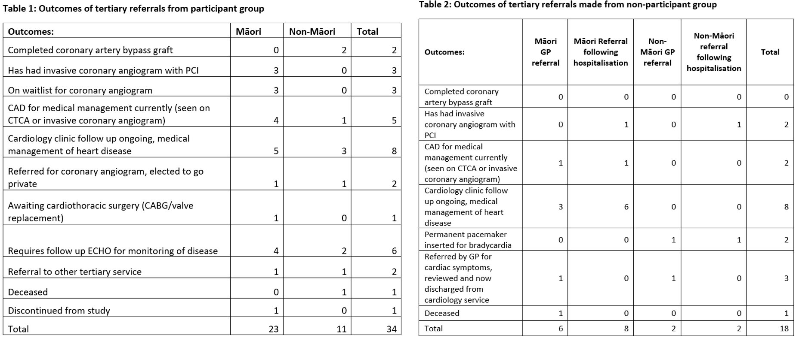

**Conclusion:**

While this study was not designed to demonstrate statistical differences between TKACPS patient tertiary outcomes versus vs normal care due to sample size. More people in the active group have had active procedural treatment and follow-up than the control group. Only half the investigations in the control group were initiated due GP referral, the rest from emergent hospitalisation.