A CT‑based alternative to SPECT for regional assessment of pulmonary ventilation and perfusion
Eikelis N¹, Hatt CR¹, Nilsen K¹, Dusting J¹, Siddharthan T², Dwyer A^{3,4}, Sharma D³, Mogel G¹, Fouras A¹, Ludwig KD¹
¹4DMedical Limited, Melbourne, Australia; ²University of Miami, Miami, Florida, USA; ³SAHMRI, ⁴National Imaging Facility, Australia

Introduction/Aim:
SPECT VQ is the reference test for regional lung function mapping but is limited by low spatial resolution, logistics and radiation exposure. We evaluated a non‑contrast CT derived method (CT:VQ) that generates 3D ventilation and perfusion maps from routine CT, using SPECT VQ as the benchmark. Our aim was to quantify lobar-level agreement between CT:VQ and SPECT for ventilation and perfusion.
Method:
Seventy-seven adults (mean age 59.5 years; BMI 28.2 kg/m²) underwent SPECT/CT and paired inspiratory/expiratory chest CT imaging. The anatomical CT from free-breathing SPECT was co-registered with the CT:VQ expiratory CT for spatial alignment. A lobar mask from the expiratory CT was applied to compute lobar percentage ventilation (V) and perfusion (P) for each participant. Agreement was assessed using Pearson correlation across lobar distributions for V and Q between the two modalities, reported as a lung total percentage. Pearson regression analyses were conducted on CT:VQ’s regional variability metrics (coefficient of variation (CV=s/m) and heterogeneity (H=IQR/m)) against PFT measurements (DLCO and FEV1/FVC).
Results:
Strong lobar-level correlations were observed between CT:VQ and SPECT for V (r=0.842, p<0.001) and Q (r=0.872, p<0.001). CT:VQ perfusion heterogeneity metrics showed greater negative correlations with DLCO % predicted than SPECT (CVQ: r=-0.778 vs. r=-0.617; HQ: r=-0.766 vs. r=-0.542; all p<0.001). CT:VQ ventilation heterogeneity metrics showed moderate negative correlations with FEV1/FVC % predicted (CVV: r=-0.553; HV: r=-0.551; both p<0.001).
Conclusion:
CT:VQ produces lobar ventilation and perfusion distributions closely matching SPECT VQ, validating it as a fast, high-resolution, non-contrast alternative that can derive from routine CT data. CT:VQ could facilitate regional functional assessment where SPECT is unavailable or impractical. Further studies should explore its diagnostic performance in specific diseases and its connection to clinical outcomes.

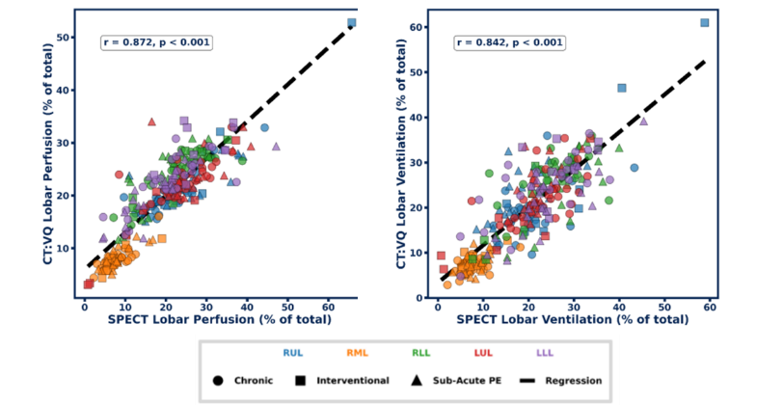
Figure 1: Lobar-level comparison of perfusion (left) and ventilation (right) between SPECT and CT:VQ. Each data point represents the ventilation or perfusion in a lobe as a percentage of the total ventilation or perfusion in the lungs. Different lobe regions are indicated by marker colour, and each cohort is indicated by marker style. The dashed line represents the linear regression fit.

Key words: SPECT VQ, ventilation perfusion, imaging
Grant Support: This study was supported by a grant from 4DMedical
Declaration of Interest Statement: Eikelis, Hatt, Nilsen, Dusting, Mogel, Fouras and Ludwig are employees of 4DMedical

