Establishing in vitro models of PCD airways: a personalised medicine pipeline
Frohlich M^{1,2,3}, Ebrahimi N^{3,4}, Pandzic E⁵, Kardia E^{3,4}, Fernando BS^{3,4}, Allen K^{3,4}, Owens L^{1,2}, Jaffe A^{1,2}, Morgan L^{6,7}, Waters S^{1,2,3,4}
¹Discipline of Paediatrics and Child Health, School of Clinical Medicine, Faculty of Medicine and Health, UNSW Sydney, NSW, Australia. ²Department of Respiratory Medicine, Sydney Children’s Hospital, NSW, Australia .³Molecular and Integrative Cystic Fibrosis Research Centre (miCF_RC), UNSW Sydney, NSW, Australia. ⁴School of Biomedical Sciences, Faculty of Medicine and Health, UNSW Sydney, NSW, Australia. ⁵Katharina Gaus Light Microscopy Facility, Mark Wainwright Analytical Centre, UNSW Sydney, NSW Australia. ⁶Department of Respiratory Medicine, Concord Hospital, Sydney, NSW, Australia. ⁷Faculty of Medicine, University of Sydney, NSW, Australia.
Introduction/Aim: Primary Ciliary Dyskinesia (PCD) is a rare, incurable, genetic disorder characterised by abnormalities in ciliary structure and function. Although PCD is genetically heterogenous, with mutations identified in over 40 genes, there is a notable correlation between a patient’s genotype and the ultrastructural defect observed through electron microscopy assessment of cilia. Despite this correlation, the presentation of lung disease remains varied across all genotype and ultrastructural categories. The variability in genetics, clinical presentation and drug responses has made research into optimal PCD management challenging in the past. Personalised medicine aims to customise treatments based on individual patient profiles, optimising clinical outcomes. We have developed stem cell-derived airway organoids that facilitate in vitro examination of the ciliary function in PCD patients. Our goal is to utilise these PCD organoids to assess response to various drugs, aiming to discover individualised treatment strategies for patients.
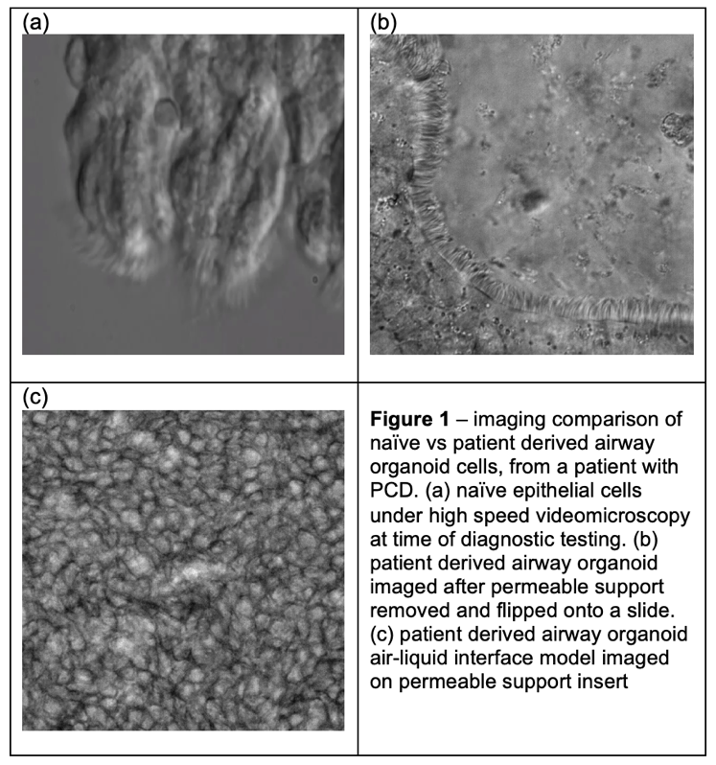
Methods: Participants of all ages with a confirmed or suspected diagnosis PCD are being recruited from Sydney Children’s Hospital and Concord Repatriation Hospital. Nasal epithelial cells are collected from each participant by nasal brushing of the inferior turbinate. Once collected, the epithelial cells undergo conditionally co-culture methodology¹ to create a biobank of patient specific stem cells at the University of New South Wales. For differentiation to a pseudostratified epithelium an Air-Liquid Interface (ALI) model is used. Ciliary beat frequency (CBF) and pattern (CBP) are assessed using a live-cell imaging microscope.¹ This data is then compared with the CBF and CBP values derived from the participant’s original nasal epithelial sheets during diagnostic testing (figure 1).

Results: 13 patients have been enrolled so far, and we have successfully created stem cell models from all participants. Differentiation to ALI and drug testing is ongoing.

Conclusion: This study will establish the use of PCD patient derived airway organoids to model their ciliary dysfunction in vitro. This will provide the foundations for personalised medicine research in the future.
Grant Support: This project is supported by grants received by Dr Megan Frohlich from the Rotary Club of Sydney Cove and the National Health and Medical Research Council (NHMRC).

References:
1. Allan KM, Wong SL, Fawcett LK, et al. Collection, Expansion, and Differentiation of Primary Human Nasal Epithelial Cell Models for Quantification of Cilia Beat Frequency. J Vis Exp. 2021(177).

