An Audit of The Diagnostic and Management Concordance of Pulmonary Lymphangioleiomyomatosis with American Thoracic Society (ATS)/Japanese Respiratory Society (JRS) Guidelines in a Tertiary Interstitial Lung Disease Respiratory Department
Caitriona Murphy¹, Jeremy Wrobel^{1,2}
¹Advanced Lung Disease Unit, Respiratory Medicine, Fiona Stanley Hospital (FSH), WA
²Department of Medicine, University of Notre Dame Australia, WA
Introduction/Aim:
Pulmonary lymphangioleiomyomatosis (pLAM) is a rare, progressive cystic lung disease mostly affecting women that can lead to respiratory failure. PLAM can occur in association with tuberous sclerosis (TSC-LAM) or be sporadic. The diagnosis of pLAM is based on HRCT chest findings in combination with other clinical, histological, radiological or serological features. Although there are published guidelines for diagnosing pLAM, it can sometimes be a difficult diagnosis to establish. The management options include surveillance, mTOR inhibitors and lung transplantation. Our aim is to identify the concordance with current guidelines for the diagnosis and management of pLAM in our tertiary ILD department.

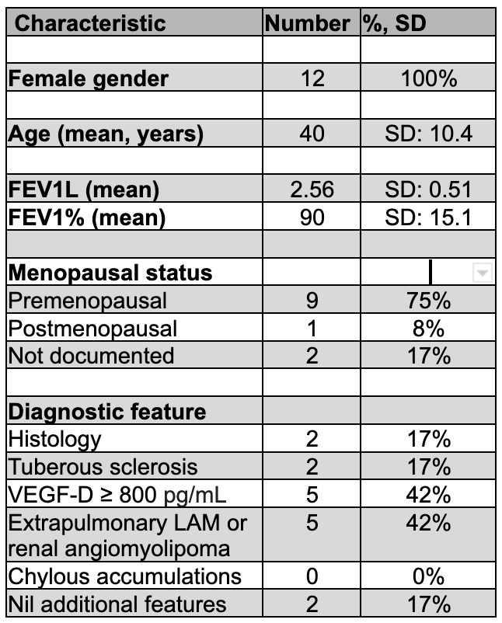
Methods:
We undertook a literature review of current guidelines for the diagnosis and management of pLAM. We then identified all patients in our department with a working diagnosis of pLAM and reviewed their clinical records for concordance with the guidelines.

Results:
15 patients with a working diagnosis of pLAM were identified. Three patients were excluded as they were still undergoing diagnostic assessment. Figure 1 outlines patient demographics. As per ATS/JRS guidelines a clinical diagnosis of LAM can be made if a patient has CT chest findings characteristic of LAM and either tuberous sclerosis, renal angiomyolipoma, extrapulmonary LAM, chylous effusions or raised VEGF-D. Definitive diagnosis requires presence of LAM cells on histology. Treatment with an mTOR inhibitor is recommended if FEV1 < 70% predicted. Of 12 patients, only 2 had definite pLAM based on histology and 7 patients had a clinical diagnosis of LAM consistent with guidelines. Only 2 patients were treated with mTOR inhibitors although 2 others had FEV1 < 70% predicted.
Figure 1. Demographic data of our pLAM cohort. VEGF, vascular endothelial growth factor. Some patients had more than 1 diagnostic feature.

Conclusion:
Amongst pLAM cohort in our tertiary ILD department, there is suboptimal diagnostic concordance at 75% and management concordance at 75% with published guidelines. Reasons for suboptimal concordance with guidelines should be further explored.

Grant Support: None

