Paper
Lessons from Climate Smart Shrimp Implementation in Indonesia: A Case Study in Lalombi Village, Central Sulawesi

Introduction
The Government of Indonesia has set ambitious targets for increasing shrimp production and restoring mangroves. Both targets may be achieved simultaneously by intensifying shrimp production combined with obligatory mangrove restoration.

Objectives
To integrate shrimp pond technology and mangrove restoration, we are conducting a project called Climate Smart Shrimp (CSS). This project aims to increase shrimp production sustainably while improving water quality by constructing treatment wetlands and restoring blue carbon ecosystems through mangrove restoration. To achieve the goal of this project, we work with a private sector partner, university researchers, local communities, and local government to innovate climate-resilient food production and at the same time restore the mangrove ecosystem.

Methodology
Climate Smart Shrimp is one of the methods for Nature-based Climate Solution (NbCS). It uses a combination of “green" conservation and mangrove restoration efforts that rely on natural processes and ecosystems to address environmental challenges and "grey" engineering techniques to provide greater benefits for both the environment and people.

Findings
During the process of site selection, we surveyed more than 40 locations to identify potential suitable CSS locations in Indonesia. Here, we present a story and lessons from the construction of an intensive shrimp pond (with a stocking density of 170 individuals/m²) on a 6.5-hectare site, an assessment of the biodiversity ecosystem habitat structure, the design and planning of hydrological restoration areas and wastewater treatment systems, and the results of mangrove restoration on a 3.5-hectare area to show a first example of CSS in Indonesia.

Significance of the work for policy and practice
We hope that the CSS model can inspire sustainable improvement of shrimp ponds for a wider audience. What was once thought as the cause of mangrove land conversion can adopt a concept of nature-based solutions, where mangroves act as biofilters of pond water effluents. We also hope that this initiative can be taken up by policymakers in Indonesia as an integrated protection and production policy model and can be replicated in other regions.

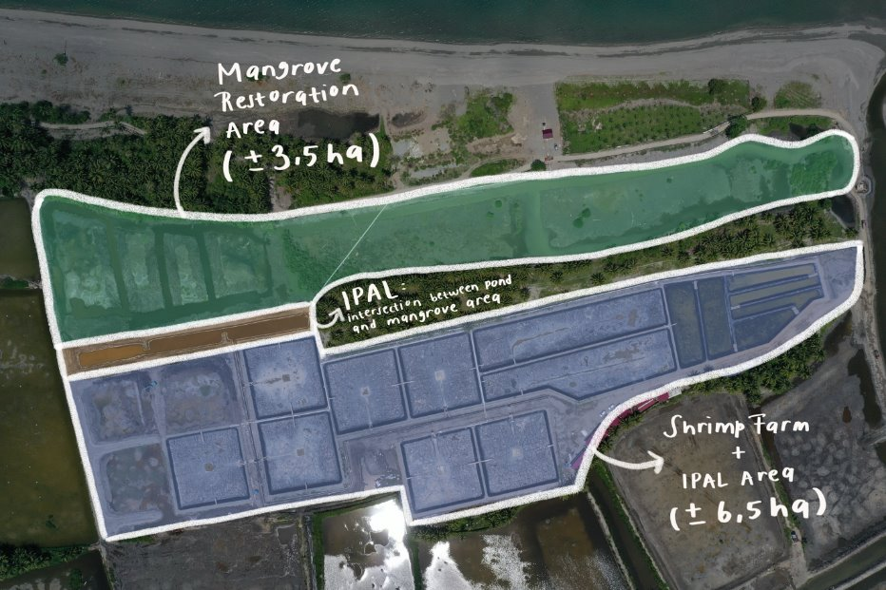
Source: Konservasi Indonesia
Figure 1. Illustration of CSS Pilot Location in Indonesia

Reference
Goto, G. M., Corwin, E., Farthing, A., Lubis, A. R., & Klinger, D. H. (2023). A nature-based solutions approach to managing shrimp aquaculture effluent. PLOS Sustainability and Transformation, 2(8), e0000076. https://doi.org/10.1371/journal.pstr.0000076.

