Clinical value of shunt estimation test using 100% oxygen
Abbey Mahon¹, Paul Kelly², Jun Yang¹
¹Respiratory Physiology Laboratory, Christchurch Hospital, New Zealand
²Department of Respiratory Medicine, Christchurch Hospital, New Zealand
Introduction/Aim: Anatomic right-to-left shunting is a rare but important aetiology of hypoxaemia. The classical 100% oxygen shunt estimation test allows calculation of shunt fraction, which may assist identifying pathological intracardiac / intrapulmonary shunt and distinguishing causes of hypoxaemia. Its clinical value, however, is yet established. This study aimed to evaluate the clinical value of the shunt estimation test in the establishment of diagnosis in patients with unexplained hypoxaemia in a tertiary hospital.

Method: All shunt estimation tests performed between June 2012 and September 2023 were audited. Data collection included reason/s for referral, demographics and shunt test results. Any post-hoc imaging investigations were reviewed from the patient electronic medical record. The testing procedure and calculation were based on Ruppel¹. The interpretive strategies of the calculated shunt fraction were: < 5% (no shunt); 5-10% (likely shunt); >10% (significant shunt)¹.

Results: Thirty-eight tests were performed within the study window, however, 9 were excluded due to repeated tests (n=4) and established shunting before testing (n=5). Twenty-nine tests were therefore included for the analysis (19F/10M, mean ± SD age, BMI were 61±14 yrs, 33.7 ± 7.0). All patients were referred for investigating unexplained hypoxaemia and associated dyspnoea / syncope. Patients with a shunt >10% (n=17) had lower baseline arterial PO₂ (55.6 ± 10.7 mmHg vs 70.4 ± 14.6 mmHg, p = 0.004) and saturation (87.8 ± 6.1% vs 93.5 ± 4.4%, p=0.016) compared with those with a shunt < 10% (n=12). The categorized shunt fractions, further post-hoc imaging investigation and their findings are tabulated as below.
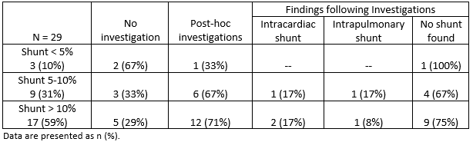

Conclusion: Subjects with a shunt fraction > 10% had lower arterial PO₂ and saturation. While a low shunt fraction appeared to help rule out significant right-to-left shunt, a surprisingly high percentage of patients with a shunt fraction suggesting likely or significant shunt were not further investigated. In patients who were investigated by imaging, only small percentages (34% in likely shunt and 25% in significant shunt) were confirmed by imaging, suggesting the sensitivity of the shunt estimation test in detecting significant right-to-left shunt is low, but can be used as a useful, simple and non-invasive screening test.

Key Words: Shunt, hypoxaemia, pulmonary function test
Nomination for New Investigator Award: NO
Grant Support: None
Reference: 1. Ruppel G (2008). Manual of pulmonary function testing (9th Ed). Mosby.

