The rate of decline in blood glucose affects the acceleration of gastric emptying induced by hypoglycaemia in type 1 diabetes

Word count: 225

Background

Acute insulin-induced hypoglycaemia markedly accelerates gastric emptying (GE) in individuals with type 1 diabetes (T1D). Whether the rate of decline in blood glucose to hypoglycaemia influences the magnitude of this effect is unknown.

Aims
To determine, whether a slow, compared to rapid, onset of hypoglycaemia differentially affects gastric emptying in T1D.

Methods
Twelve adults with T1D (5 females, age 41(19) years, HbA1c 6.8 (1.0)%), were randomised in a crossover design to euglycaemia (blood glucose clamped at 6.0mmol), ‘rapid’ hypoglycaemia (blood glucose reduced from 6.0mmol/L to 2.8mmol/L over 15 minutes), and ‘slow’ hypoglycaemia (blood glucose reduced from 6.0mmol/L to 2.8mmol/L over 2 hours). The target blood glucose of 2.8mmol/L was maintained for 60 minutes during hypoglycaemic study visits. Glycaemia was controlled with intravenous insulin (Actrapid) and 25% glucose infusions. Gastric emptying of a 100g minced beef meal labelled with 20 MBq ^{99m}technetium-sulfur colloid was measured using scintigraphy. The primary outcome was area under the gastric emptying curve at 60 minutes (AUC0-60) expressed as % retention and analysed using a linear mixed-effects model.

Results
Mean (SE) gastric retention at 60 minutes was 91.3(1.8)% during euglycaemia, 85.1(1.9)% in rapid hypoglycaemia and 78.8(1.8)% in slow hypoglycaemia. GE was faster during slow-onset, compared to rapid-onset hypoglycaemia (P < 0.05).

Figure 1 Gastric emptying during rapid and slow hypoglycaemia and euglycaemia (mean ± SE). 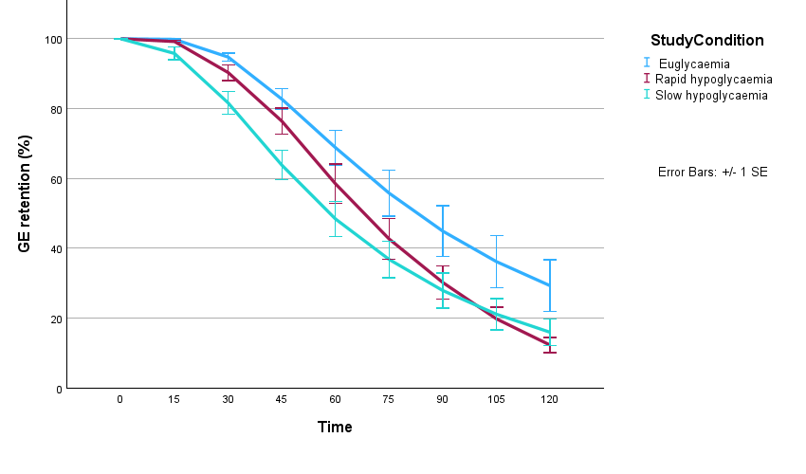
Raw gastric emptying data presented as %retention across all measured time-points, and SE bars. Study conditions are in blue (euglycaemia) red (rapid hypoglycaemia) and green (slow hypoglycaemia).

Conclusion
Insulin-induced hypoglycaemia markedly accelerates gastric emptying in T1D, with a greater effect when hypoglycaemia develops slowly rather than rapidly.

