Oropharyngeal metagenome is associated with respiratory tract infection and mortality in residential aged care
Sophie Miller^{1,2}, Frank D Zhang³, Steven Taylor^{1,2}, Lito Papanicolas^{1,2,3}, Geraint Rogers^{1,2}, GRACE Investigator Group¹
¹Microbiome and Host Health Program, South Australian Health and Medical Research Institute, Adelaide, SA, Australia
²College of Medicine, Flinders University, Bedford Park, SA, Australia.
³Microbiology and Infectious Diseases, SA Pathology, Adelaide, SA, Australia
Introduction/Aim: Those living in residential aged care experience high rates of adverse health outcomes, including respiratory tract infection (RTI), hospital admission, and all-cause mortality. The aim of our study was to investigate whether oropharyngeal (OP) microbiota characteristics can identify those at elevated risk.
Methods: The Generating evidence on Resistant bacteria in the Aged Care Environment (GRACE) was a cross-sectional multisite study that explored relationships between human associated microbiota with clinical outcomes in residential aged care facilities in South Australia. OP swabs were collected from 237 individuals and underwent shotgun metagenomic sequencing. Clinical data from electronic medical records were related to metagenomic features over a 12-month follow-up period.
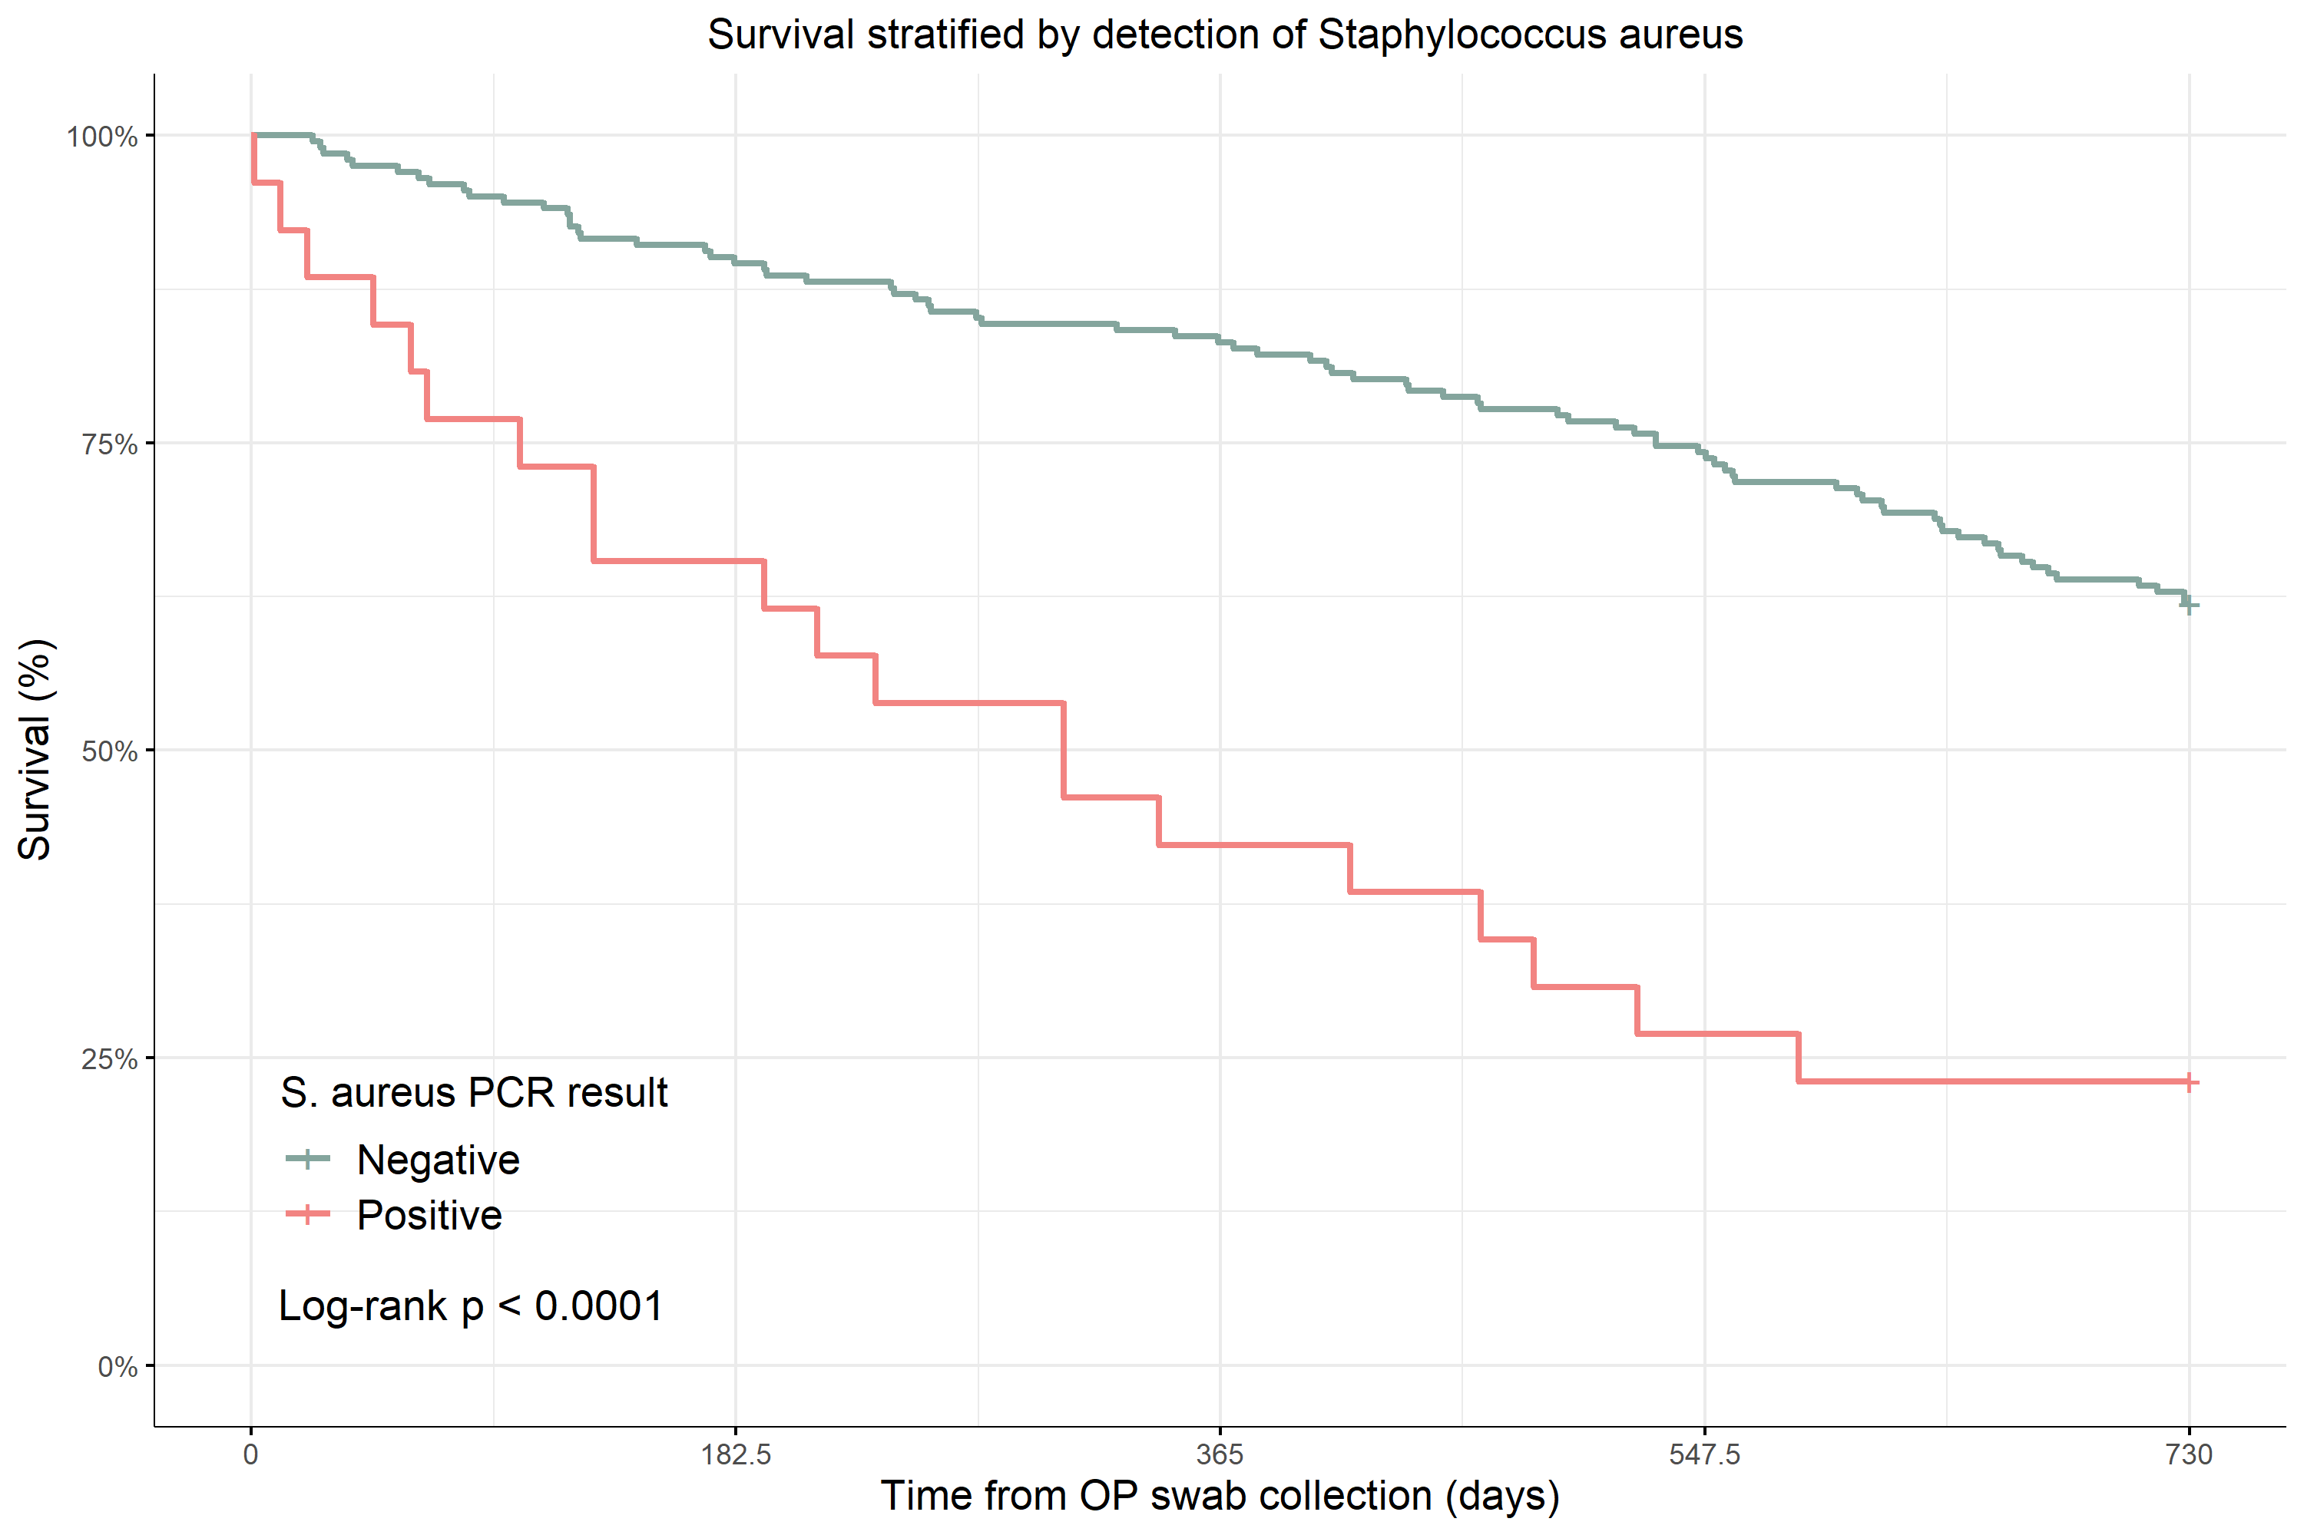
Results: In the 12 months following OP swab collection, 62 of the 237 participants (26.2%) experienced one or more RTI, 87 (36.7%) presented to hospital once or more, and 49 (20.7%) died. OP microbiota composition differed significantly between individuals who subsequently developed RTI or died and those who did not. The strength of association with RTI diminished with time and was significant for events occurring within 90 days (p=0.02) of sample collection, but not 12 months (p=0.06). The association with mortality was similarly significant for death within 90 days (p=0.04) but not 12 months (p=0.11). Mortality was also associated with increased microbiota dispersion at 12 months (p=0.02). Of the bacterial taxa associated with adverse outcomes, the strongest associations were observed for Staphylococcus aureus. Further investigation using quantitative PCR identified S. aureus in 27 participants, and detection was strongly associated with increased 90-day mortality (23.1% vs 5.0%, p=0.002) and 12-month mortality (57.7% vs 16.8%, p<0.001) (see Figure).
Conclusion: Oropharyngeal microbiota composition is associated with increased risk of respiratory tract infection and all-cause mortality in aged care residents. Notably, S. aureus detection is strongly associated with high 90-day and 12-month all-cause mortality risk.
Grant Support: Medical Research Future Fund GNT1152268
Key words: Oropharyngeal microbiome, respiratory tract infection, all-cause mortality

