Paper

From Rooftops to Resilience: Socio-Economic Determinants of Urban Agriculture in Indian Cities

Introduction
With India projected to have nearly half of its population residing in urban areas by 2050 (UN DESA, 2019), the country is undergoing an unprecedented urban transition that presents significant socio-economic and environmental challenges. Amidst concerns over food security, land use, and urban sustainability, Urban Agriculture (UA) has emerged as a viable intervention, integrating food production within urban settings while fostering resilience and well-being (Maxwell et al., 1999; Azunre et al., 2019; Rao et al., 2022). However, the socio-economic dimensions influencing UA adoption remain underexplored.

Objectives
The primary objective of this study is to examine the socio-economic factors that shape UA in Indian cities, assess their impact on participation, sustainability, and urban resilience, and propose policy recommendations for effectively integrating UA into urban planning frameworks.

Methodology
This research employs a mixed-method approach, using primary data from the Urban and Peri-Urban Agriculture as Green Infrastructure (UPAGrI) study. Data collection included an online survey (2021–2022) across 29 Indian cities (441 responses from formal and informal settlements), 50 key informant interviews in Bengaluru and Pune, and stakeholder engagement with NGOs, policymakers, and community organizations. A policy and literature review, along with insights from an online exhibition, enriched the analysis. Quantitative statistical visualization and qualitative thematic analysis were combined for a multidimensional understanding of UA’s socio-economic landscape.

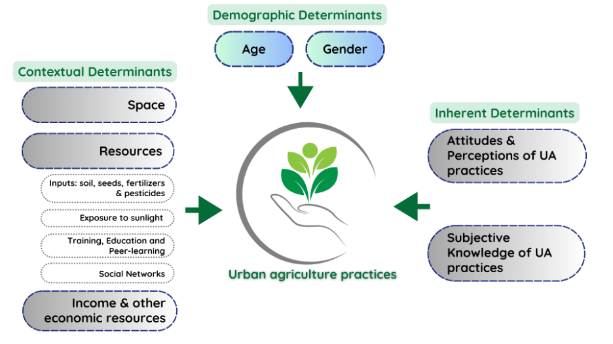
Figure 1: Depicting socio-economic determinants of UA practices. Source: Authors’ depiction
(adapted from Alemu et al., 2020)
Findings
Findings indicate that three primary determinants shape UA adoption.
- Demographic factors such as age and gender influence participation, with middle-aged individuals (41–60 years) representing the largest group of practitioners. Men primarily engage in UA for economic and health benefits, whereas women’s participation is driven by food security, aesthetics, and household well-being.
- Contextual factors such as land tenure, resource availability, income, and social networks significantly impact UA adoption. Limited land access in informal settlements constrains large-scale UA, while wealthier urban residents invest in hydroponics and advanced farming techniques. Additionally, access to essential inputs such as soil, seeds, fertilizers, and training dictates UA’s feasibility and success.
- Inherent factors, including attitudes, perceptions, and knowledge systems, further shape UA engagement. Individuals with farming backgrounds demonstrate greater resilience, while amateur urban farmers rely on workshops and peer learning for knowledge transfer (Singh et al., 2021). Positive perceptions of UA’s benefits—such as enhanced nutrition, mental well-being, and social cohesion—motivate engagement, whereas skepticism surrounding economic sustainability deters some urban residents (Koduganti & Singh, 2022).

Significance of the work for policy and practice
This study highlights the urgent need for policy interventions to integrate UA into India’s urban planning. Key recommendations include tax incentives, land access for urban farmers, expanded municipal support, and peer-learning networks (Roy & Rao, 2021; Kiran et al., 2022). Recognizing UA as green infrastructure can enhance food security, sustainability, and resilience, making cities more equitable and climate adaptive. Addressing socio-economic barriers and optimizing urban resources can position UA as a key transformative force of sustainable urban development.

References:
Alemu, M. H., & Grebitus, C. (2020). Towards sustainable urban food systems: Analyzing contextual and intrapsychic drivers of growing food in small-scale urban agriculture. PloS one, 15(12), e0243949. https://doi.org/10.1371/journal.pone.0243949

Azunre, G. A., Amponsah, O., Peprah, C., Takyi, S. A., & Braimah, I. (2019). A review of the role of urban agriculture in the sustainable city discourse. Cities, 93, 104-119. https://doi.org/10.1016/j.cities.2019.04.006

Kiran, A., Mahalingam, A., Singh, C., Mayavel, D., Koduganti, M., Roy, P., Poonacha, P., Patil, S., Sharma, S., & Malladi, T. (2023). An Action Agenda for Urban Agriculture in India. Indian Institute for Human Settlements. Retrieved September 19, 2023, from https://iihs.co.in/knowledge-gateway/wp-content/uploads/2023/05/An-Action-Agenda-for-Urban-Agriculture-in-India.pdf

Koduganti, M., & Singh, C. (2022, October 20). Green Shoots of Health, Happiness and Wellbeing. Growing Greener Cities. Retrieved September 6, 2023, from https://exhibition.upagri.net/exhibition-rooms/healthier-happier-citizens/green-shoots-of-health-happiness-and-wellbeing/

Maxwell, D., Larbi, W. O., Lamptey, G. M., Zakariah, S., & Armar-Klemesu, M. (1998). Farming in the shadow of the city: Changes in land rights and livelihoods in peri-urban Accra. Cities feeding people series; rept. 23.

Rao, N., Patil, S., Singh, C., Roy, P., Pryor, C., Poonacha, P., & Genes, M. (2022). Cultivating sustainable and healthy cities: A systematic literature review of the outcomes of urban and peri-urban agriculture. Sustainable Cities and Society, 85, 104063. https://doi.org/10.1016/j.scs.2022.104063

Roy, P., & Rao, N. (2021). The Role of Urban Agriculture in India’s Green Building Policy. Urban and Peri-urban Agriculture as Green Infrastructure (UPAGrI). Retrieved January 8, 2023, from https://8a6ac3e7-e78e-4937-baf4-bbb9f028d464.filesusr.com/ugd/d6ecfb_903c17f542cf423d888597823909fd2c.pdf

Singh, C., Patil, S., Poonacha, P., Koduganti, M., & Sharma, S. (2021). When the “field” moves online: reflections on virtual data collection during COVID-19. Ecology, Economy and Society–the INSEE Journal, 4(2), 149-157. https://doi.org/10.37773/ees.v4i2.414

