Prediction models underestimate lung cancer risk in asbestos exposed individuals
Kirsten Bennett^{1,2}, Chellan Kumarasamy¹, Kim Betts³, Peter Franklin⁴, Nola Olsen⁴, Nick de Klerk⁴, Fraser Brims^{1,2,5}
¹Curtin Medical School, Curtin University, WA, Australia
² Department of Respiratory Medicine, Sir Charles Gairdner Hospital, WA, Australia
³School of Population Health, Curtin University, WA, Australia
⁴School of Global and Population Health, University of Western Australia, WA, Australia
⁵Institute for Respiratory Health, Curtin University, WA, Australia
Introduction: Lung cancer screening is only effective when targeting high risk populations. Australia will commence nationwide lung cancer screening in July 2025. Occupational (particularly asbestos) exposures increase the risk of lung cancer but are not included in current screening eligibility criteria. This study aims to assess the performance of existing lung cancer screening criteria and risk prediction models in an asbestos exposed population.
Method: The Western Australian Asbestos Review Program has used CT imaging for lung cancer screening for the last 11 years. Inclusion requires minimum 3 months asbestos exposure, regardless of smoking status. The performance of 5 cancer risk prediction models (PLCO_{m2012}, PLCO_{asb}, PLCO_{m2014}, LLP_{v2} and Bach) and 2 screening criteria (Medical Services Advisory Committee, MSAC and US Preventative Services Task Force, USPSTF2021) was assessed in this cohort. Calibration was conducted via 2 methods – calibration at large, and Mean Adjusted Deaths Compared Against Predictions (MADCAP) plots.
Results: 2,126 participants were included. 85.4% were male with a median age of 70 and median asbestos exposure 0.2 fibres/ml-year (IQR 0.005-0.864). 36.2% of the cohort were never smokers, and 8.7% were current smokers. 2.4% of participants developed lung cancer during the screening period, with 9/51(18%) cancers occurring in never smokers. The area under the receiver operating curve was highest for LLP_{v2} (0.675), followed by Bach (0.669), PLCO_{m2014} (0.623) and PLCO_{m2012} /PLCO_{asb}(0.602). Both USPSTF2021 and MSAC had poor sensitivity at 0.21 (0.10-0.37) and 0.07 (0.01-0.19) respectively. All risk prediction models underestimated risk using calibration at large and MADCAP plots, except for the LLP_{v2} model which overestimates risk using both methods (figure 1).
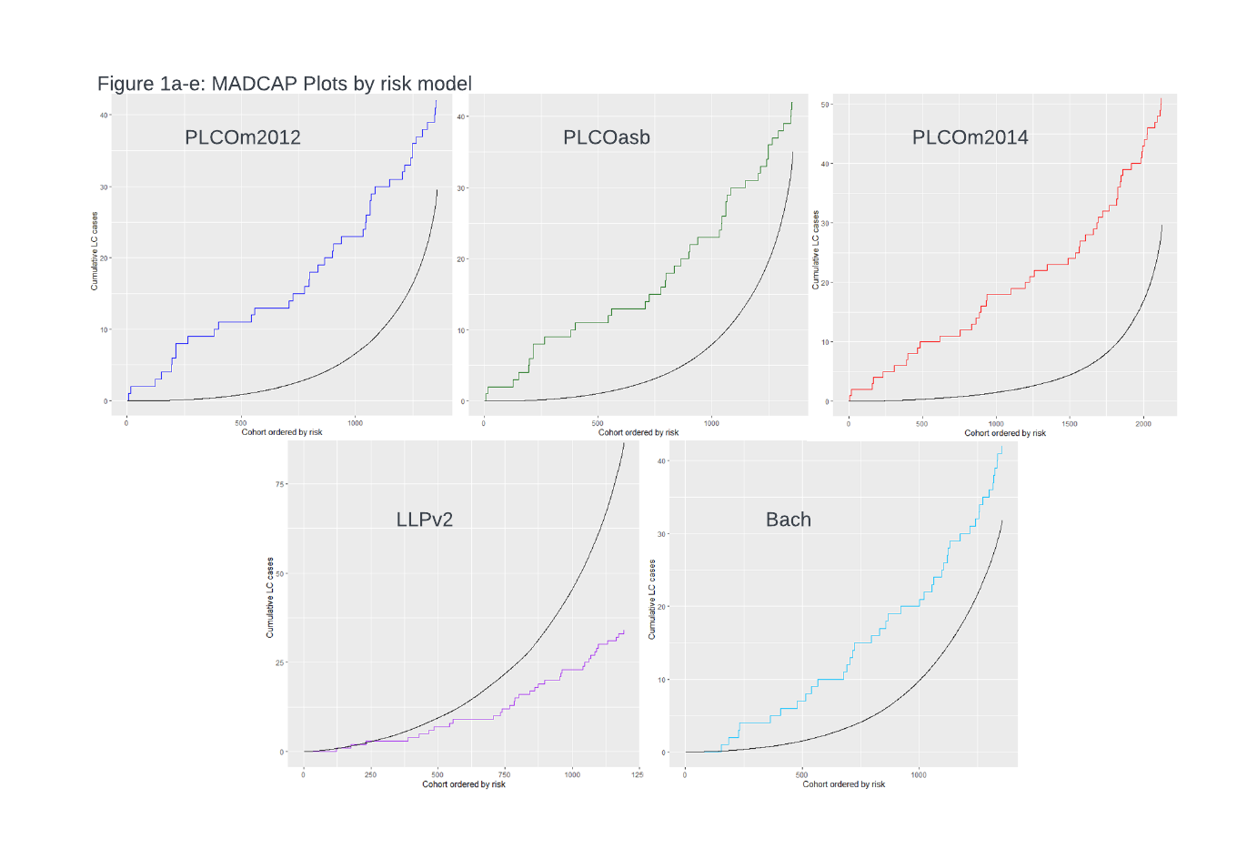Conclusion: Current risk prediction models and screening criteria perform poorly in this high risk cohort. Future models need to account for the relative excess risk by interaction of tobacco and asbestos exposure.
Grant support: Research Training Program Scholarship, Charlies Foundation, NHMRC.
Key words: risk prediction, lung cancer, screening, asbestos

