Quantifying Novel 3-dimensional Lung Mechanics Measurements in patients with ILD and COPD
K. Nilsen², B.Levvey¹, G.Westall¹, D.Bushell¹, A. Fouras², N. Eikelis², G. Snell¹
¹Respiratory Medicine, The Alfred Hospital, Australia, ²4DMedical Limited, Australia
Introduction/Aim: The processes of inspiration (an active process) and expiration (a passive process) are affected by the mechanics of the respiratory system (compliance/elastic recoil). Respiratory elastic recoil is increased in fibrotic diseases like ILD and reduced in COPD. X-ray Velocimetry (XV, 4DMedical Limited, Australia) enables dynamic imaging of lung motion. Novel 3-D lung mechanics measurements allow quantification of spatially mapped lung expansion and deflation at a voxel level. This study aims to compare these XV-derived lung mechanic measurements between patients with COPD and ILD. Further, correlations between XV lung mechanics with structural assessment from CT and pulmonary function tests were performed.
Methods: In a prospective cross-sectional study at the Alfred Hospital, 9 ILD and 11 COPD patients undergoing lung transplant assessment have been recruited. Each subject underwent spirometry, gas transfer, CT, and XV imaging. Spatial measurements were conducted to determine the ratio between inspiratory expansion to expiratory deflation rates (Ir:Er) at a voxel level (Figure 1). CT lung structural assessment was performed using IMBIO’s Lung Density Analysis (LDAi). The Ir:Er ratios were compared between ILD and COPD groups and correlated with CT structure and lung function parameters.
Results: Across the whole lung, COPD subjects demonstrated an increased ratio of voxel inspiratory expansion to expiratory deflation rates compared with ILD subjects (Ir:Er = 1.8±0.21 vs 1.4±0.18, p=0.03). In ILD, Ir:Er correlated with FVC and high-density CT measures from LDAi, demonstrating fibrosis causes increased stiffness (Elastic Recoil). In COPD, the FRC/TLC ratio correlated with Ir:Er, demonstrating that hyperinflation causes increased stiffness.
Conclusion: This study introduces a new method for assessing lung mechanics in 3-D, offering insights into the mechanical alterations associated with ILD and COPD. XV technology has the potential to spatially identify disease-specific mechanical changes, potentially improving targeted clinical interventions.
Grant Support: Supported by a grant from 4DMedical.
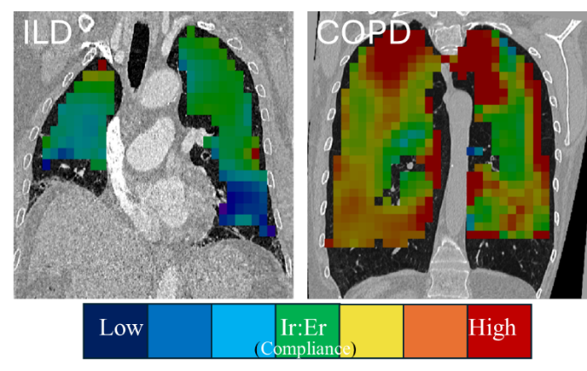
Figure 1: An example of a single coronal slice demonstrating spatial measurements of lung mechanics (Ir:Er) in an ILD and COPD subject. Blue colour indicates increased lung stiffness which is characterised by low compliance and high elastic recoil present in ILD. Red colour indicates low stiffness (high compliance/low elastic recoil) present in COPD.

