Risk factors of pulmonary hypertension in interstitial lung disease
Hui Li Ang¹, Max Schulte², Roseanne Kimberley Chan³, Hann Hsiang Tan⁴, Amelia Harrison⁵, Christopher J Ryerson^{6,7}, Yet Hong Khor^{2,8,9}
¹ Royal Melbourne Hospital, Victoria, Australia
² Institute for Breathing and Sleep, Victoria, Australia
³ Department of Cardiology, Western Health, Victoria, Australia
⁴ Royal Sussex County Hospital, Brighton, United Kingdom
⁵ Department of Respiratory and Sleep Disorders Medicine, Western Health, Victoria, Australia
⁶ University of British Columbia, Vancouver, British Columbia, Canada
⁷ Centre for Heart Lung Innovation, Vancouver, British Columbia, Canada
⁸ Central Clinical School, Monash University, Victoria, Australia
⁹ Department of Respiratory and Sleep Medicine, Austin Health, Victoria, Australia
Introduction/Aim:
Pulmonary hypertension (PH) is a key complication of prognostic significance in interstitial lung disease (ILD), with recent advances in therapeutic strategies. This systematic review appraised current literature on risk and associated factors for PH in ILD patients.
Methods:
We searched Ovid MEDLINE, Embase and CENTRAL databases for original research evaluating pulmonary hypertension in participants with ILD of any aetiology. The definition of pulmonary hypertension was based on the investigators’ criteria. Other inclusion criteria were participants aged ≥ 18 years and a minimum sample size of 10 to evaluate clinical features. Eligibility of studies was assessed by two independent reviewers, with any discrepancies resolved by a third reviewer.

Results:
369 studies were included in our analysis. Commonly evaluated parameters included patient demographic characteristics, pulmonary physiology, ventilatory responses, functional status, radiological assessments, and serum biomarkers (Table). Lower diffusion capacity for carbon monoxide, worse resting and exertional desaturation, reduced exercise capacity as measured by 6-minute walk distance, increased pulmonary artery to aortic ratio and pulmonary artery diameter, and elevated serum brain natriuretic peptide were consistently associated with the presence or at-risk of PH in at least 60% of reported studies. Most studies reporting age, sex, weight or body mass index, spirometry parameters, and the extent of lung fibrosis on computed tomography demonstrated no significant associations for the presence or at-risk of PH.

Conclusion:
Several clinically available risk factors are associated with PH, which warrant prospective evaluation to develop a clinical prediction model for risk-stratified assessments of PH in patients with ILD.

Table of risk factors and associations
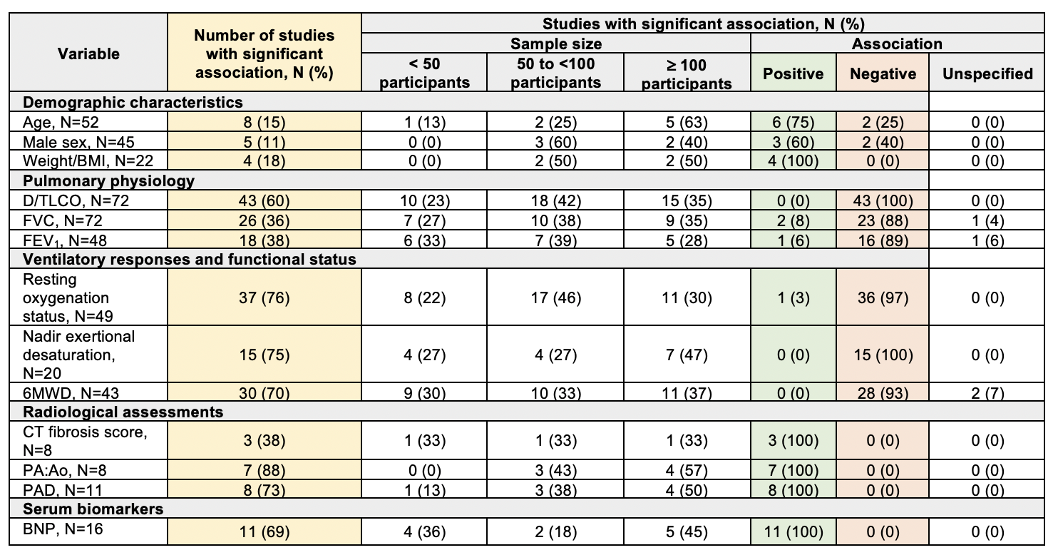
N, number of studies; BMI, body mass index; DLCO, diffusion capacity for carbon monoxide; TLCO, transfer capacity for carbon monoxide; FVC, forced vital capacity; FEV₁, forced expiratory volume in 1 second; 6MWD, 6-minute walk distance; PA:Ao, pulmonary artery to aortic ratio; PAD, pulmonary artery diameter; BNP, brain natriuretic peptide

Grant Support: Nil. Key words: pulmonary hypertension, interstitial lung disease
Word Count: 245 words

