Whey protein intervention to mitigate hypoglycaemia risk in people with type 1 diabetes

Aims: In people with type 1 diabetes (T1D), ingestion of fast-absorbing protein (e.g. whey protein) stimulates glucagon secretion. This study aims to characterise the glycaemic response to whey protein ingestion in T1D.

Methods: Twelve adults (6F/6M) with T1D (Age: 49.0±16.8y; Weight: 79.4 ±12.5kg; Diabetes duration: 27.4±13.0y) using insulin pumps each received three interventions in random order after an overnight fast: i) water (CON), ii) low-dose whey protein (LP; 0.25g/kg), iii) medium-dose whey protein (MP; 0.5g/kg). On test days, subcutaneous insulin was replaced with IV insulin. After 4h for subcutaneous insulin wash-out, insulin infusion was fixed, the test drink ingested, and blood sampled every 10min for 3h.

Results: AUC and peak increase in plasma glucose were higher, and the time-to-peak was delayed, for MP versus LP (Fig. 1A), while the rate of change from t=0min to peak was similar for MP and LP. Similarly, postprandial plasma glucagon was higher for MP versus LP (Fig. 1B).

Conclusion: Whey protein ingestion stimulates glucagon secretion in a dose-dependent manner in people with T1D. While MP increased peak glucose to a greater degree than LP, rate of increase was similar. This provides initial data demonstrating the potential for whey protein to mitigate hypoglycaemia in T1D.

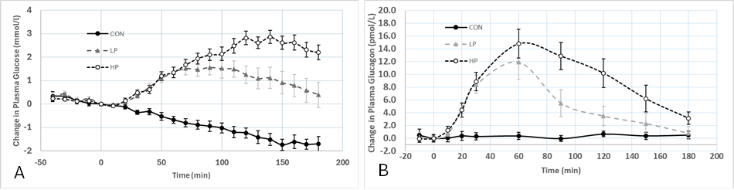

Figure 1. Plasma glucose (A) and plasma glucagon (B) after ingestion of water (CON), low-dose protein (LP), medium-dose protein (MP). All values are delta-change from t=0min. Data presented as mean ± SEM, n=12.