From crisis to control: DE-led 12‑month pathway for a young adult with T1D, intellectual disability, and recurrent DKA (single-case improvement evaluation)

Background & Aim:
Young adults living with type 1 diabetes (T1D) who also experience cognitive or psychosocial complexity commonly present with highly unstable glycaemia and frequent diabetic ketoacidosis (DKA). Engagement with traditional clinic-based models is often inconsistent, leading to repeated episodes of acute metabolic decompensation. This case describes a 19-year-old young adult with T1D, diagnosed at age 14, who also has an intellectual disability (IQ 58) and is a new parent. At intake to the Young Adult Diabetes Service (YADS), the patient demonstrated extreme dysglycaemia with CGM Time-in-Range (TIR) 0%, Very High 97%, estimated GMI ~12.3%, and three DKA events across January–May 2025. The aim of this evaluation was to examine the impact of a structured, diabetes-educator-led (DE-led) 12-month pathway on glycaemia, engagement, and safety.
Methods:
A single-case service-improvement design was used within YADS. The intervention consisted of weekly DE phone contact for 12 months, supplemented by two-monthly team reviews and ad-hoc endocrinology registrar input for safety concerns. Education focused on sick-day management, ketone management, insulin adjustment, and CGM interpretation. Data included CGM summaries (Dexcom/Glooko), pump downloads, and clinical documentation. The patient transitioned to YpsoPump on 16 February 2026.
Results:
Substantial glycaemic improvement occurred from baseline to pump start and through to current data (March 2026). TIR increased from 0% to 75%, with Very High glucose decreasing from 97% to 1%. No further DKA episodes occurred following early 2025, with one self-initiated ED presentation for illness in October 2025. Pump therapy resulted in a physiological insulin distribution (60% basal / 40% bolus) and improved bolus consistency.
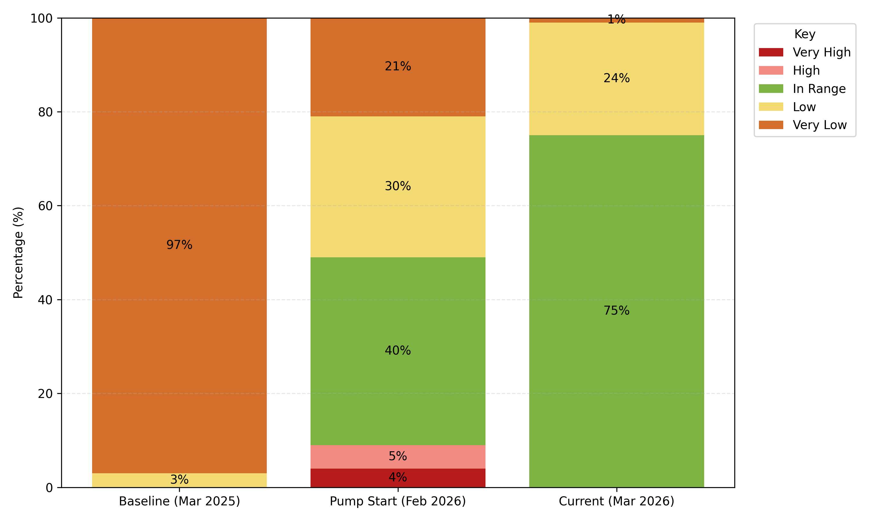
Figure 1. CGM distribution across time points.
Conclusion:
A high-frequency DE-led model supported significant stabilization of glycaemia, reduced acute presentations, and improved self-management behaviours in a young adult with cognitive vulnerability. Findings highlight the potential of proactive outreach and flexible pump pathways for complex young adults.

