Lack of concordance between subcutaneous continuous glucose monitoring and venous blood glucose during hypoglycaemia in type 1 diabetes

Background
Continuous glucose monitoring (CGM) is standard of care in type 1 diabetes (T1D). However, data pertaining to the precision of CGM during hypoglycaemia are limited.

Aims
To compare CGM values with plasma glucose during mild and severe hypoglycaemia in individuals with T1D.

Methods
On separate days, participants with T1D underwent a ‘rapid’ (15 min) or ‘slow’ (120 min) hyperinsulinaemic-hypoglycaemic clamp to 2.8mmol/L maintained for one hour, or a euglycaemic clamp (6 mmol/L), in randomised order. Plasma glucose (hexokinase method) measurements were paired with concurrent CGM readings. Mild and severe hypoglycaemia were defined as blood glucose levels ≤3.9mmol/L and ≤2.9mmol/L, respectively. Agreement between methods was assessed using the mean(SD) difference, CGM true hypoglycaemia rate ($≤$0.83 mmol/L error), and mean bias with limits of agreement (LoA).

Results
Ten participants were studied with Dexcom G6 (n=7), Dexcom G7 (n=2), or Medtronic Guardian 4 (n=1) monitors. CGM correctly identified mild hypoglycaemia in 29% of instances and severe hypoglycaemia in 25%. During mild and severe hypoglycaemia, CGM overestimated plasma glucose by a mean (SD) of 1.66 (1.68) mmol/L and 1.75 (1.82) mmol/L respectively. Across the measured glucose range CGM values were consistently higher than plasma glucose with a bias (LoA) of 2.06 (0.75, 4.87)mmol/L during rapid hypoglycaemia and 1.57 (0.32, 2.82)mmol/L during slow hypoglycaemia.

Figure.1 Relationship of glucose measured by CGM and in plasma
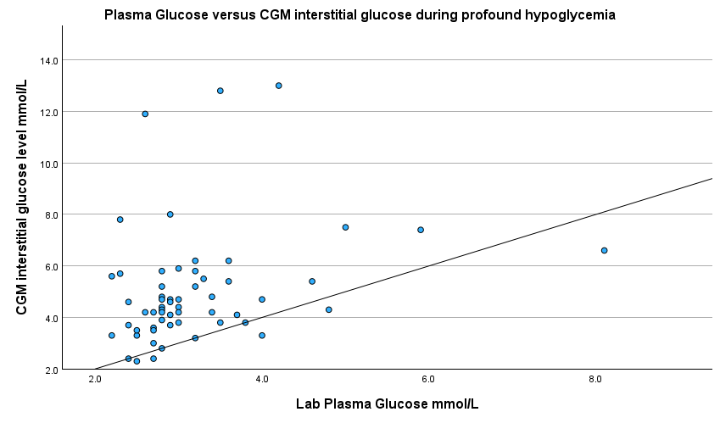
Conclusion
CGM overestimates glucose in the hypoglycaemic range and frequently fails to detect clinically significant hypoglycaemia. These findings have important implications for the management of hypoglycaemia in T1D.

