X-ray Velocimetry Visualises Ventilation Changes from Endobronchial Valve Placement
Ronan Smith^{1,2}, Charlotte Thomas³, Phan Nguyen⁴, Arash Badiei⁴, Nina Eikelis³, Kris Nilsen³, David Parsons^{1,2}, Martin Donnelley^{1,2}
¹ University of Adelaide, Adelaide, SA, 5000
² Women’s and Children’s Hospital, Adelaide, SA, 5000
³4DMedical Limited, Melbourne, Vic, 3053
⁴ Royal Adelaide Hospital, Adelaide, SA, 5000
Introduction/Aim:
X-ray Velocimetry (XV) is a novel imaging technique that enables time-resolved measurements of regional ventilation to provide detailed insights into the respiratory function. The placement of endobronchial valves (EBV) is a minimally-invasive lung volume reduction procedure for the treatment of emphysema with gas-trapping. EBVs restrict airflow to emphasematous lung, thereby improving ventilation in the remainder of the lung. The aim of this study was to demonstrate that XV can be used to visualise and quantify local ventilation changes.
Methods: EBVs were implanted in two sheep. XV and CT scans were conducted immediately before and after the procedure. After 14 days, the same scans were performed before and after removing the EBVs. CT scans were used to segment regions restricted by the EBV.
Results: XV showed an immediate decrease in ventilation in the lungs directly downstream of the EBV. This decrease in ventilation was visible in regions where no change could be seen in CT (See Fig.1). After removal, a partial return to pre-insertion ventilation values was seen.
Conclusion: Non-invasive XV functional lung imaging is able to detect ventilation changes in the lungs of sheep after EBV placement, even in the absence of any structural changes.
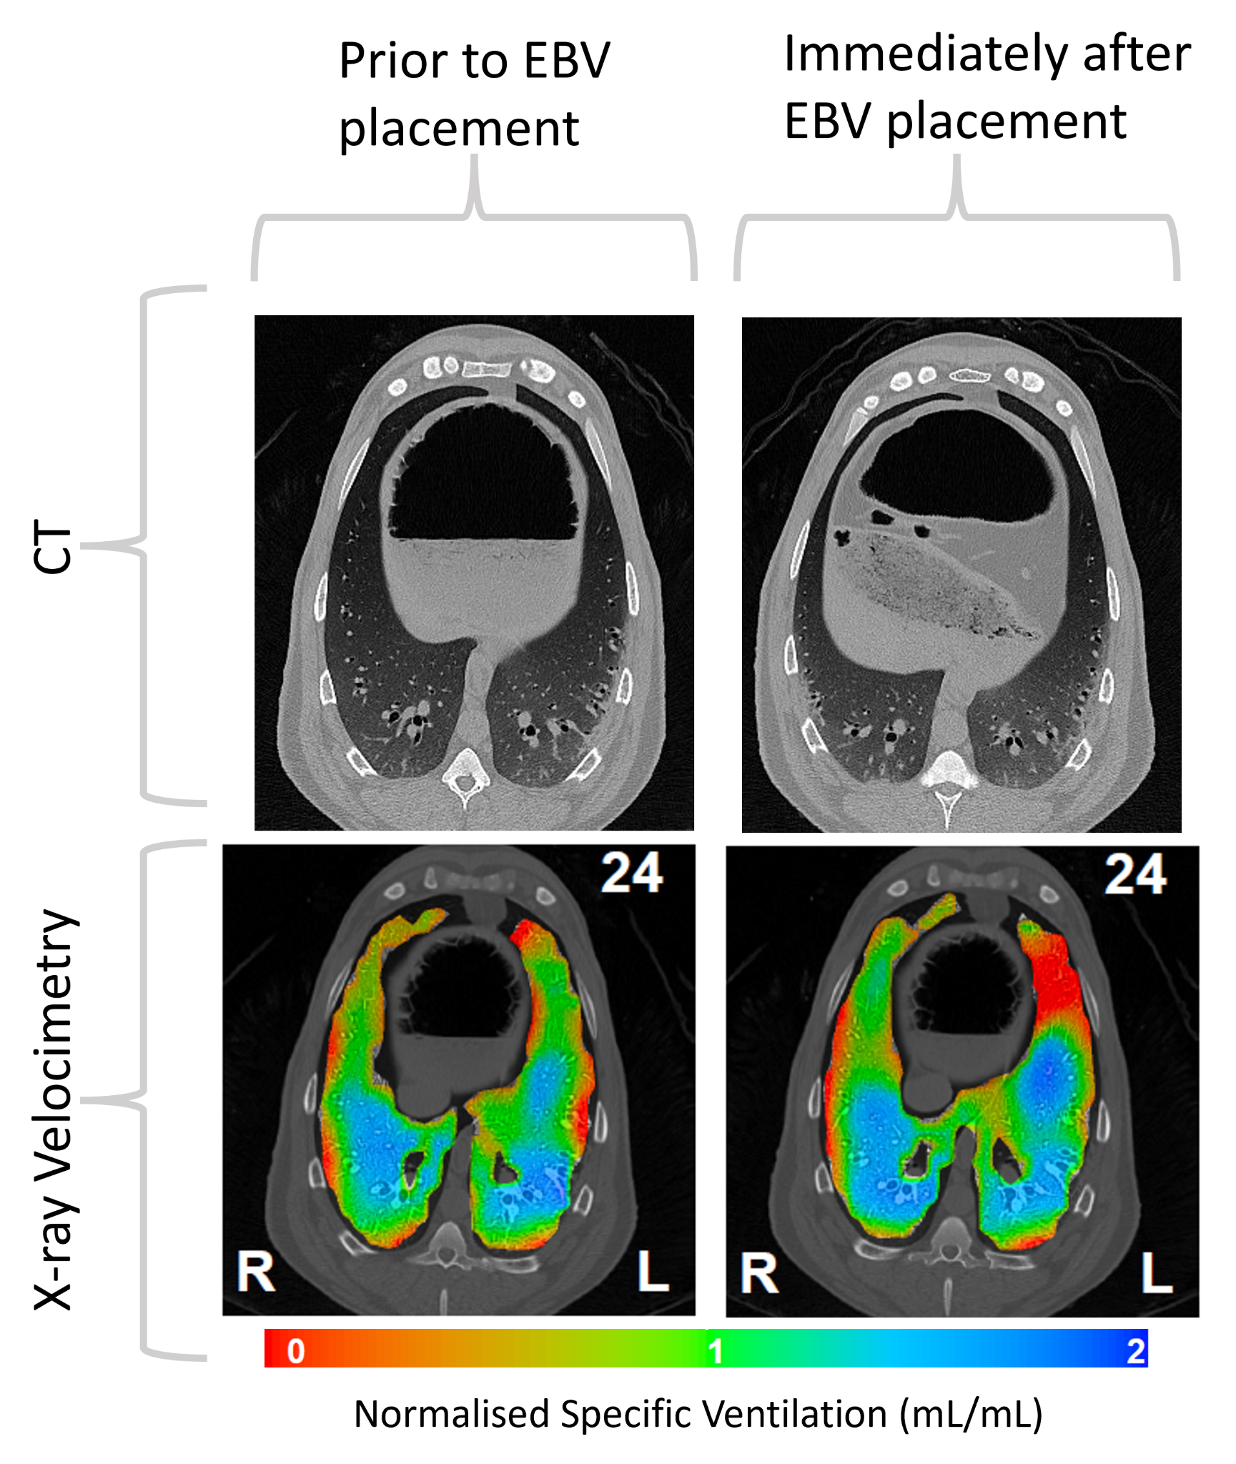
Figure 1: CT and XV scans of a sheep immediately before and after placing a single EBV device into the left lung. No change is visible in this slice of the CT scan. However in the same slice of the X-ray velocimetry scan, reduced ventilation (enlarged red region) can clearly be seen in the left lung.

Key Words: X-ray Velocimetry, Endobronchial Valve, Pre-clinical, Imaging.

Grant Support: This work was supported by the Medical Research Future Fund Grant RFRHPSI000013.

Declaration of Interest: CT, NE and KN are employees of 4DMedical Limited who commercialised XV. DP and MD purchased shares in the company.

