Hands-on activity
Adaptation scenarios for integrating wildfire risk into residential planning and design processes: An interactive workshop approach

Summary
Wildfire risk is increasingly recognised as a critical challenge for urban planning and infrastructure resilience in Aotearoa New Zealand. Previous research into wildfire risk mitigation in Aotearoa New Zealand has identified that, under current planning and residential development practices, households may be constrained in their ability to mitigate or adapt to increased wildfire risk (Wegner and Langer, 2022). However, current planning and development frameworks provide limited opportunities for adaptation, as they remain embedded in past rationales with insufficient consideration of wildfire hazards. This co-creation session presents an interactive, scenario-based workshop methodology designed to engage professionals from planning, architecture, engineering, and policy sectors in identifying, discussing, and integrating wildfire risk into urban fringe development decisions (Wegner et al., in progress). Using wildfire as an example, we propose a workshop methodology and approach that can be used for other natural hazards when conducting adaptation planning exercises.
Participants will engage in a hands-on exercise that replicates elements from research workshops conducted in Nelson, Christchurch, and Wellington. These previous workshops involved 45 professionals working with hypothetical urban expansion scenarios containing multiple hazards, with wildfire considerations initially omitted. The goal was to observe if and how wildfire risk was recognised and addressed, what mitigation strategies were proposed, and which information sources participants drew from. This interactive workshop adapts that methodology to guide participants through our research process and builds on these and other findings. Participants in this workshop will critically explore a residential planning development, consider the roles of different professionals involved, and discuss how the introduction of key concepts can address gaps in legislation and other planning tools. Finally, participants will reflect on the methodology and approach to assess how new knowledge can be incorporated into existing frameworks and develop adaptive strategies for improving cross-sector collaboration in hazard-resilient urban design.

Aims and Expected Outcomes
Our research aims to accelerate adaptation of existing rules and practices using wildfire risk in an Aotearoa New Zealand context as an example, where we can learn from the experiences of diverse participants including but not limited to wildfires as experienced worldwide. In Aotearoa New Zealand we have approached the problem with a wide system view that recognizes regulatory conditions that inhibit adaptive approaches.
Our focus is on embodying adaptive capacity by working closely with professional practice communities and increasing capability for working with new knowledge. Our social research is aligned with our physical research efforts and leading toward new methods of co-designing learning materials for professional communities. It also indicates the importance of bridging between professional communities and research organisations to increase adaptation potential and enhance mitigation based on ongoing research-practice communication networks. In this workshop we will extend those interests with a wider group of participants attending Adaptation Futures to role-play through our adaptation scenarios using key concepts to incorporate wildfire considerations in practice.
Our research will benefit from the diverse perspectives and expertise of participants, in similar or different adaptation contexts, helping us refine and enhance the methodology for integrating wildfire adaptation into planning processes.
We will use feedback from attendees to test the applicability of our methods with other contexts and learn from the experiences of participants to enhance the co-design of our learning materials. This will inform the development of processes for co-designing learning materials and training modules for professional communities, ensuring that our recent research continues to evolve in response to real-world planning challenges and professional needs.
Through this participatory approach, we aim to strengthen the research-practice-policy interface, accelerating the integration of wildfire risk adaptation into decision-making and regulatory frameworks.
Workshop Format
We propose a workshop using scenario-based and gamified methods, particularly relevant for adaptation planning, as it mirrors real-world decision-making contexts, allowing participants to explore adaptation pathways dynamically.

Structure:
Introduction
The session will begin with a brief presentation of our research findings (Forkink et al., 2025; Wegner et al., in progress), outlining how wildfire risk is currently implemented in Aotearoa New Zealand’s planning and development processes. Participants will be provided instructions to describe a hypothetical urban expansion scenario, containing multiple hazard risks initially emphasising wildfire considerations. A 5-minute video tutorial with four basic concepts useful for wildfire planning will be presented. Then a policy brief with key wildfire risk considerations will be introduced, prompting participants to reassess their strategies in light of this additional knowledge.
Workshop development
Part A. Depending on the number of and expertise of participants, we will employ a role-playing negotiation approach (Avendaño-Uribe, 2022) to explore the trade-offs and decision-making challenges in planning processes. Participants will be assigned roles—as civil engineers, architects, planners, and policy makers—to simulate real-world scenarios and negotiate diverse perspectives of residential development in a multi-hazard area. Through facilitated small-group discussions using game-based role-playing simulations, they will identify challenges for residential planning and develop some potential resolutions.
Following the scenario exercise, a debriefing session will ask participants to discuss barriers to integrating wildfire mitigation into the planning scenario. Discussion will be facilitated through prompts regarding urban development and overlapping priorities for addressing current and future wildfire risks.

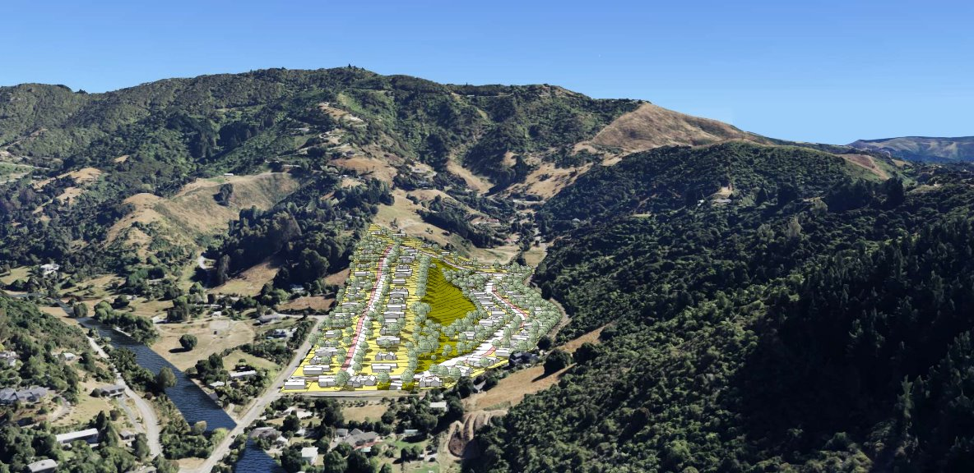Example of Scenario Planning. Credits: The Authors.
Break
Part B. In the second part of the session, we will introduce the background of legislative systems and the complex regulatory environment, highlighting limited recognition of wildfire risks. Specifically, we will address the lack of distinct policies regarding the interface between buildings and landscape wildfire risk, an area often overlooked. To help practitioners reflect on the limitations of existing rules in addressing wildfire risk at the urban interface, we propose to introduce four key concepts using a 5- minute training video, created to train planners and policy makers four aspects of wildfire behaviour. These concepts aim to foster a deeper understanding of the gaps in current planning frameworks and provide professionals with tools to consider wildfire risk more effectively in future urban development projects. Participants will be asked to discuss the ways they might incorporate the new planning concepts to existing legislation and practice.
A revision of the earlier planning discussion will be prompted with the question: How does this change the way you think about the planning scenario? Participants will be asked to share key insights.
Debriefing
A final debriefing discussion will be facilitated. During this time, participants will reflect on the methodology as a tool for integrating wildfire considerations into urban planning and enhancing adaptation capacity. Although wildfire is used as our primary example, we invite participants to consider how this approach might be applied to other hazards or adaptation planning contexts. This discussion aims to explore the broader relevance of the methodology and its potential to inform adaptation planning practices.
References
Avendano-Uribe, B., Lukosch, H., & Milke, M. (2022). Playing With Uncertainty: Facilitating Community-Based Resilience Building. Urban Planning, 7(2), 278-294. https://doi.org/10.17645/up.v7i2.5098
Forkink, A., Tang, X., Langer, L., Grant, A., Wegner, S., Avendano, B., McCaffrey, S., Lovreglio, R. (2025). Planning for extreme wildfire. Lower Hutt (NZ): GNS Science. 6 p. Policy Brief 2025/01. https://doi.org/10.21420/RPVQ-P995
Wegner, S., Avendano-Uribe, B., Langer, E.R. (Lisa), McCaffrey, S., et al. (In progress). Wildfire risk salience and barriers to risk mitigation among planning and design professionals in New Zealand
Wegner, S. and Langer, E.R. (Lisa). (2022). Building today for a wildfire future. Build. Build 191 Fire Safety.Build-191-57-Feature-Fire-Safety-Building-Today-For-A-Wildfire-Future.pdf
PARTICIPANTS
Participant 1
Full Name: Andrea Grant
Organisation: Scion
Bio: Dr. Andrea Grant a social scientist with a PhD on communicating risk and experience in systems thinking to support integration of different perspectives for embedding change in awareness and practice. Andrea has conducted research on informal and formal institutions to better understand power relations and generative potential of behavioural change.

Participant 2
Full Name: Bryann Avendano
Organisation: University of Canterbury
Bio: Dr. Bryann Avendaño, a humanitarian engineer and scientist with a PhD in Civil and Natural Resources Engineering, bridges policymakers and scientists by translating complex data into actionable insights. His work focuses on public engagement, participatory engineering, and interactive modeling tools to support evidence-driven decision-making and planning for resilience to natural hazards.

Participant 3
Full Name: Simon Wegner
Organisation: Scion
Bio: Simon Wegner is a social scientist at Scion who focuses on risk perception, behaviour, decision-making and policy in the context of wildfire and other environmental threats. His work considers how policy, scientific information and psychological factors interact to shape behaviour.

Participant 4
Full Name: Lisa Langer
Organisation: Scion
Bio: Lisa Langer, senior scientist at Scion, New Zealand Forest Research Institute has led Scion’s social wildfire research since 2003. Currently she leads research to investigate how decisions made at different points throughout the planning, design and housing development construction influence wildfire risk within Scion’s Extreme wildfire research programme.

